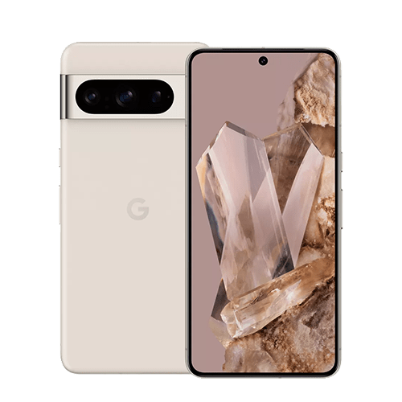

$300

Pixel 8 Pro

* Processor: Google Tensor G3 (4 nm)
* Front Camera:10.5 MP
* Rear Camera:48 MP
* Display:6.1 “
* NFC:Yes:
* Colors:Obsidian, Porcelain, Bay, Mint
* Operating System:

Android 14

* Charging Type:USB Type-C
* SIM:Nano-SIM,Esim
* Fingerprint:Yes
* Release Date:2023, October 12

RAM

12

GB

ROM

01

TB

BATTERY

5050

mAh



+001-28272300-2466-2469



webmaster@cellinfo.com



A-65, ACME Co. ,

Street No. 12,

New York

Ask Me Ltd.