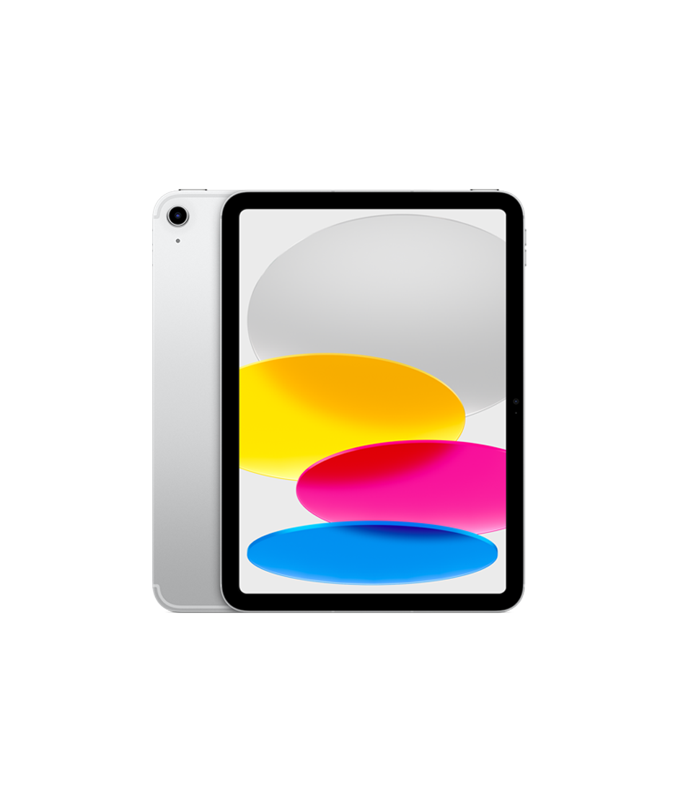

$455

IPad 10

* Processor: Apple A14 Bionic (5 nm)
* Front Camera:12 MP
* Rear Camera:12 MP
* Display:10.9 “
* NFC:No
* Colors:Silver,Blue,

Pink,Yellow

* Operating System:

iPadOS 16.1

* Charging Type:USB Type-C
* SIM:Nano-SIM,Esim
* Fingerprint:Yes
* Release Date:2022, October 26

RAM

4

GB

ROM

256

GB

BATTERY

7606

mAh



+001-28272300-2466-2469



webmaster@cellinfo.com



A-65, ACME Co. ,

Street No. 12,

New York

Ask Me Ltd.