**Introduction:**

The data warehouse represents the stock market values of a series of companies, The data of this database is extracted from the Thomson-Reuters Eikon Datastream database (available at the University Library). Every market day (stock markets are not open every day and this depends on the market country) company shares values and some market index are recorded. Companies are classified according to administrative information (mainly relative to the stock market and the nationality of the headquarters of the company) as well as three business classifications (the Thomson Reuters Business Classification—TRBC, the Global Industry Classification Standard—GICS and the North American Industry Classification System—NAICS). Companies put on sale on a stock market place financial instruments (usually shares, but this may be obligations, bonds, etc.). Stock market places monitor the exchanges through indexes (Dow Jones, Nikkei, CAC40, etc.) that represent the average activity of a certain number of financial instruments from some of the highest capitalized companies.

Entity/Relationship that presents the data warehouse :

-The database was implemented in ORACALE and data was imported from csv files, the company csv file have a column called instrument name not available in the database schema so it was not imported because its not important and the suitable date format was chosen.

**Queries :**

Descriptive Queries :

The above queries are used to describe the Tables in the database.

Get the companies details and the location sorted by Found date.

Show The company and its Classification.

-Show the number of companies per Classification.

-The number Markets in The whole database.

--Select markets and their price close on a specific date.

-The number of companies in each Market.

**Analytical Queries :**

-The Query Above show How many times did the stock price of each company closed below the average price.

-The above query show the variation of priceclose over Interval of time.

Get Date Where the stock gap was at its maximum where I calculate the difference between price open and price close and get the date where the gap was at its maximum ,and if its positive there was increase and negative there was a decrease.

Get the dates where the priceclose fell below average (‘Amzn company’)

**Business Object universe :**

-Conceptual Modal

The conceptual modal for Count of companies and Average priceclose As Facts according to different dimensions such as classification and market and time.

-Dictionary :

**Business Objects reports :**

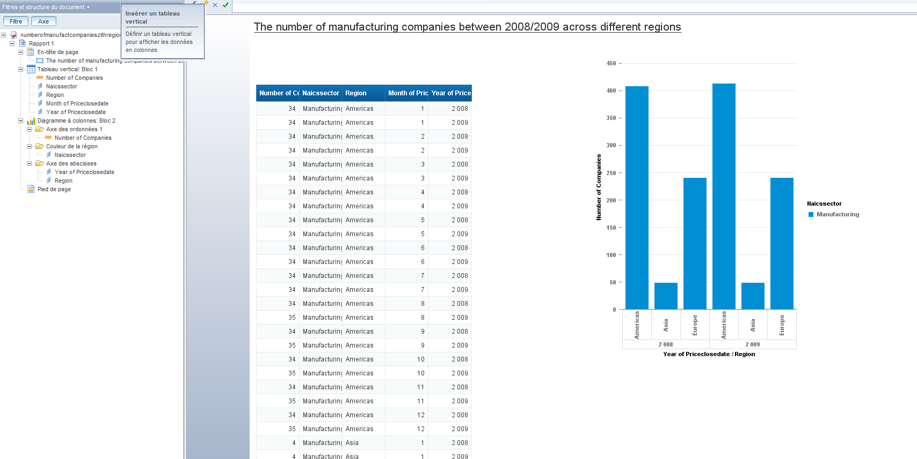

The above report show the number of companies in the manufacturing sector in different regions between year 2008-2009 where is small increase in America while the other stay the same.

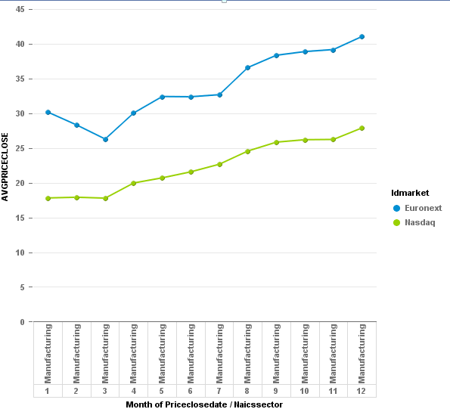

The above report shows the Average price close of the manufacturing companies in the Euronext market and the Nasdaq market Where there is increase in both markets in the manufacturing sector.

The above 2 reports show the Average price close of the companies in the GICSsector in the Nasdaq market and the Euronext during the year 2008 Where the prices decrease during the year.