Template: summary_template.docx

This is a placeholder template. Content will be replaced during report generation.

**HEALTH & FITNESS SUMMARY REPORT**

Generated on: August 03, 2025

____________________________________________________________

**PERSONAL INFORMATION**

**Name:** John Smith

**Age:** 35

**Gender:** Male

**Height:** 5'10"

**Weight:** 180 lbs

**HEALTH ASSESSMENT OVERVIEW**

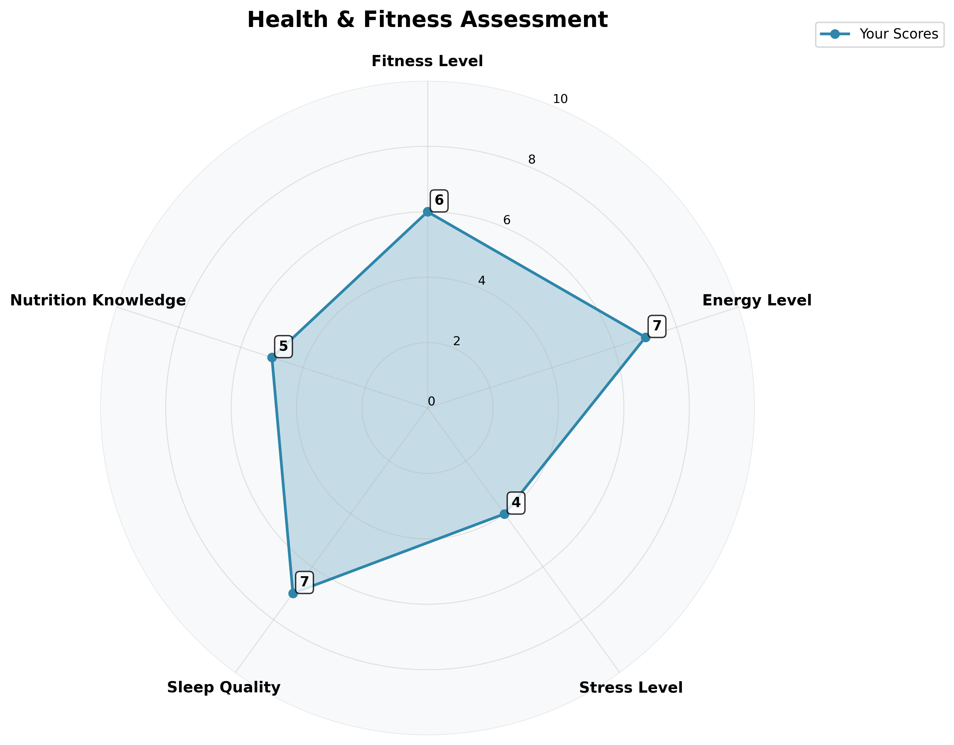

**ASSESSMENT SCORES (1-10 SCALE)**

**Fitness Level:** 6/10

**Energy Level:** 7/10

**Stress Level:** 4/10

**Sleep Quality:** 7/10

**Nutrition Knowledge:** 5/10

**ASSESSMENT SUMMARY**

HEALTH & FITNESS SUMMARY REPORT

Thank you for completing the questionnaire. Based on your responses, here are some general recommendations:

CURRENT STATUS:  
Your questionnaire responses have been recorded and will be used to create personalized recommendations.

KEY RECOMMENDATIONS:  
1. Maintain consistency with your current exercise routine  
2. Focus on balanced nutrition with adequate protein intake  
3. Ensure proper hydration throughout the day  
4. Prioritize quality sleep for recovery  
5. Track your progress regularly

NEXT STEPS:  
1. Review your detailed training plan  
2. Follow the personalized nutrition guidelines  
3. Monitor your progress weekly  
4. Adjust plans as needed based on results

Note: This is a basic summary. For detailed recommendations, please ensure your LLM connection is working properly.

**YOUR FITNESS GOALS**

* Lose Weight
* Gain Muscle
* Improve Endurance
* Increase Strength
* General Fitness
* Rehabilitation

____________________________________________________________

*This personalized plan was generated based on your questionnaire responses. Please consult with healthcare professionals before starting any new fitness or nutrition program.*