RAQBO — Point-by-Point Assessment
Development team’s reply to the “Comprehensive Website Review, Improvements & Additional Features” · November 2026
This document answers section 24 of the review. Every suggestion in sections 1–23 is listed with its status on the website today, what was built, and any difficulty. Screenshots are taken from the current version of the website (demo data).
Status | Meaning
Done | Working on the website now
Partly done | Working, but part of the suggestion needs more development or a decision
Not done | Not built — needs information or a business decision from RAQBO

Summary (section 24, points 1–6 and 8)

1. Already functioning
- Homepage, menu and the seven option tiles; QuickSell with four options and nine stages; auctions with all suggested information and rules; RAQBO Direct roles.
- Listing accuracy (landmarks, availability, marla standard, price history, last confirmation), all suggested filters, confirmation and expiry, sponsored labels, site-visit booking.
- RAQBO Verified levels, numbered verification reports with QR check, the full Property Passport with private land records.
- Services catalogue (29 services and tools, fees, tracking numbers), RAQBO Overseas, stronger Property Wanted, role-based My RAQBO, supplier comparison and specifications.
- Complaints centre, refunds register, revenue & expenses, new KPIs, admin two-factor sign-in, location pages for Google, structured data, WhatsApp tracking, Fees & refund rules page, cost calculator, price guide, advertiser profiles with reviews, projects page, smart match, agent packages, service quotations, photo duplicate check, account checks, data backup.

2. Partially developed
- Smart matching is rule-based (a language-model AI can be added later); payment-provider confirmation; backup restoration test; Search Console verification; business identity details to be entered by RAQBO.

3. Need modification or more development
- Branded email addresses (needs an email provider chosen by RAQBO). Everything else in the review is built.

4. Technical and commercial difficulties
- Customer funds: auction deposits and protected payments need legal and bank clearance before real money is held. Until then the site uses the words “RAQBO Protected Payment”, never “escrow”.
- Payment confirmation: automatic confirmation needs a merchant account with a bank or wallet provider; today the admin matches bank statements.
- Fees: every amount on the site is a placeholder that RAQBO should confirm; all are editable in the admin panel.
- Professional services: legal, valuation and design services need RAQBO to appoint qualified professionals in each city.
- QR code: drawn by a small library loaded from a public CDN; if it is blocked the printed link still works.

5. Can be done immediately (by RAQBO)
- Run the database updates 16–23 in Supabase (in order), then publish the new website files.
- Confirm all fees and refund rules in Admin → Services & fees and Security & tools.
- Each admin sets up an authenticator app; then switch on “Require two-factor sign-in”.
- Verify raqbo.pk in Google Search Console and submit raqbo.pk/sitemap-properties.xml; optionally paste a GA4 ID.

6. Suggested priority and effort for the remaining work
Item | Priority | Effort | Needs from RAQBO
Legal identity on website, receipts and contracts | 1 | ½ day | Registered name, address, NTN
Deposit / protected-payment clearance | 1 | Depends on bank | Legal and bank advice
Payment-provider confirmation | 2 | 3–5 days | Merchant account
Live end-to-end launch tests and backup restore test | 1 | 2 days | Live accounts, a tester
Confirm agent package names and prices | 3 | ½ day | Packages and prices
Branded email addresses | 2 | ½ day | Email provider choice
Language-model AI for smart match | 4 | 1 week | AI API account

8. Further recommendations
- Launch city by city (for example Lahore first) so verification, inspections and overseas services can be delivered reliably.
- Keep basic listings free, and make verification the main trust signal — buyers can already filter to verified properties only.
- Use the complaints and refunds registers from day one; they protect RAQBO’s reputation and give the evidence the review asks for.
- Review the KPIs weekly: verified share of listings, enquiry-to-visit rate, QuickSell offers and WhatsApp clicks show real business progress.

Point-by-point assessment (sections 1–23) with screenshots (point 7)

1. Homepage — first impression
Suggestion | Status | What is on the website now | Notes / difficulties
Heading “Your Complete Property Platform” with the suggested text | Done | Hero heading and supporting text changed exactly as suggested; page title and search description updated.
Prominent options: Buy, Sell, Rent, QuickSell, Auctions, RAQBO Verified, Property Services | Done | Seven option tiles directly under the hero — one tap each, no menus.
Clean premium design in black, gold and white; not overcrowded | Done | Same brand palette; the old hero panel below the search was removed to keep the page short.
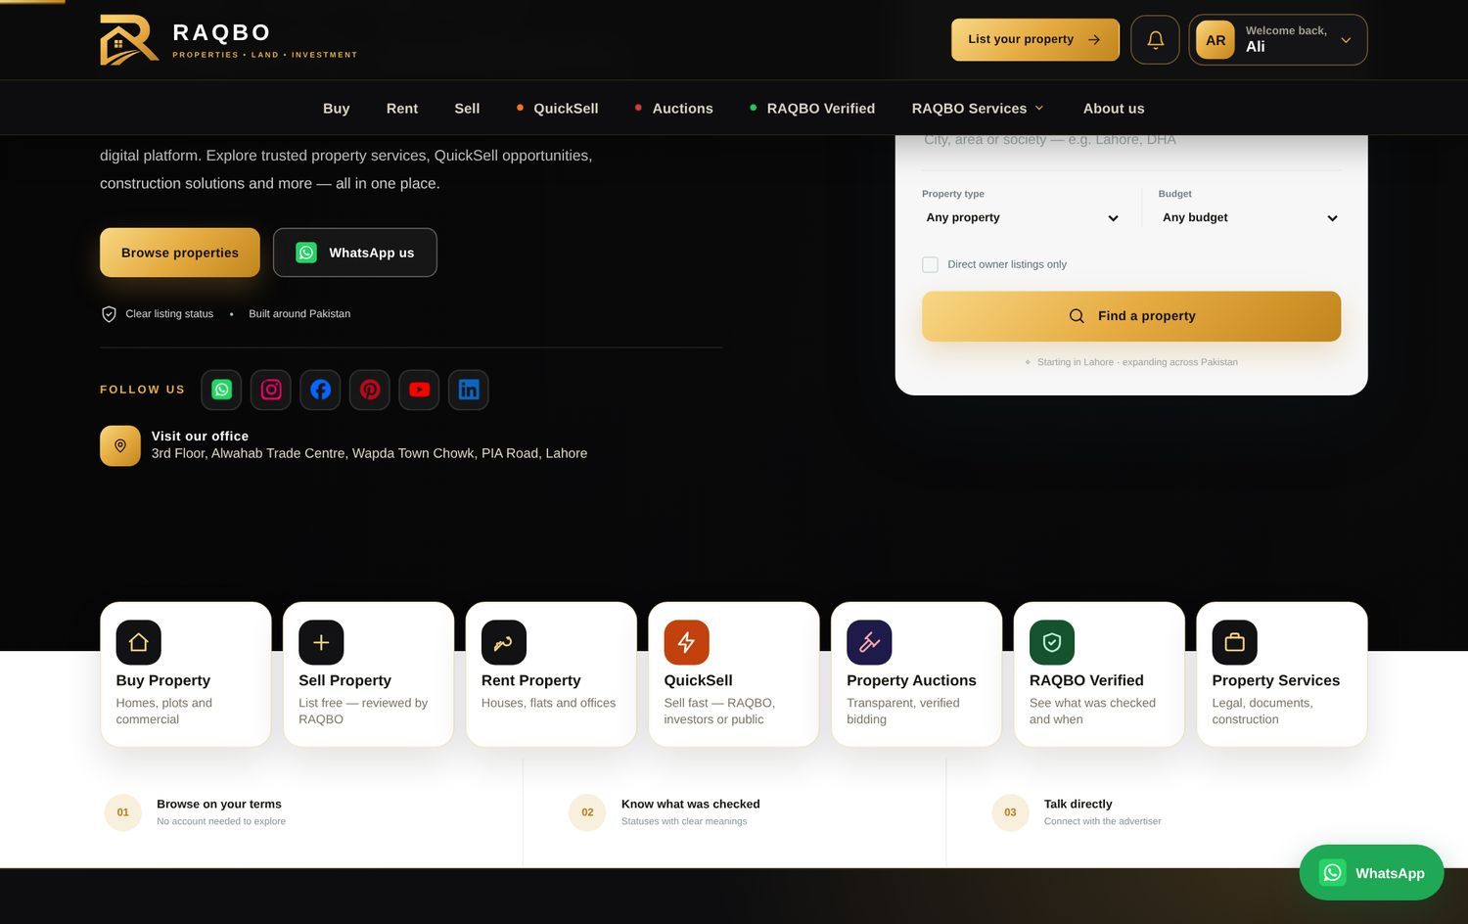
Homepage: new heading and the seven option tiles

2. Navigation and structure
Suggestion | Status | What is on the website now | Notes / difficulties
Main menu: Buy | Rent | Sell | QuickSell | Auctions | RAQBO Verified | Services | About Us | Done | Menu rebuilt in exactly this order (“Services” is shown as “RAQBO Services”, as agreed earlier).
RAQBO Direct, Passport, Construction Materials, Property Wanted in submenus / sections | Done | Inside the RAQBO Services menu, homepage rails and the footer.
Clear separation of buying/selling, verification & legal, auctions & QuickSell, materials, membership & investors | Done | Services catalogue in five groups (section 11); investors under My RAQBO.
Mobile navigation | Done | Compact header, bottom tab bar on phones, full-screen menu.
The new main menu
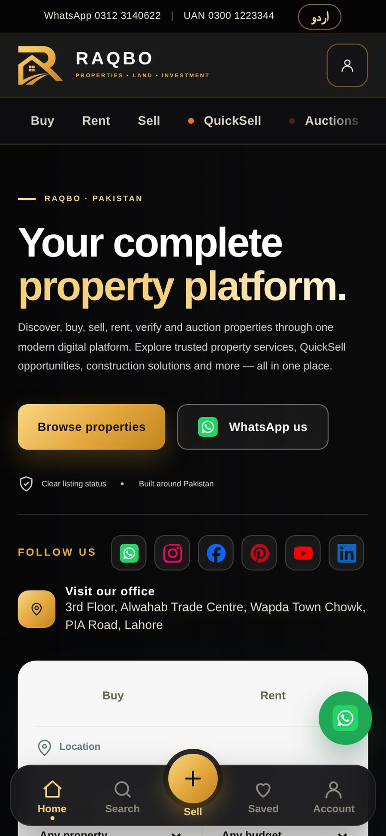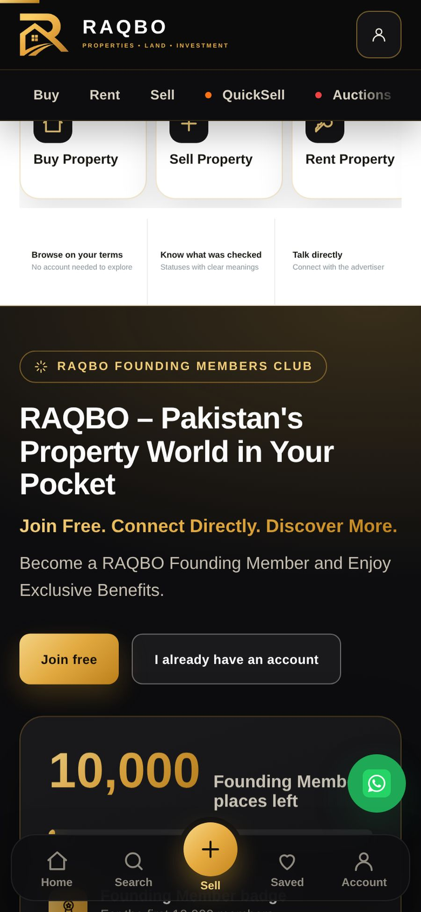
Mobile: header and option tiles

3. Property listings and search
Suggestion | Status | What is on the website now | Notes / difficulties
A. Category, transaction type, location, landmarks, dimensions, demand price, price history, advertiser category, possession, availability, verification level, last confirmation date | Done | All shown in a “Listing facts” box on every property. Owners enter landmarks, availability and marla standard; price changes are recorded automatically.
B. Filters: direct owner, agent, verified, urgent sale, auction, newly listed, price reduced | Done | All available as filters; “Newest first” sort is truly by date.
C. Duplicate listings | Done | Two automatic checks for the admin: details (same city, area and type; size within 5%; price within 15%) and photos (a fingerprint of each cover photo finds the same property listed by different agents). A chip marks listings in review.
D. Periodic confirmation; unconfirmed listings become inactive | Done | Reminder after 60 days; paused after a further 15 days until the owner confirms. RAQBO Direct listings are excluded. Both periods are admin settings.
E. Correct marla standard | Done | Each listing records its marla standard (225 / 250 / 272 sq ft); price per marla uses it.
F. Sponsored listings clearly distinguished | Done | Paid listings show “SPONSORED”; “Newest first” is never influenced by payment.
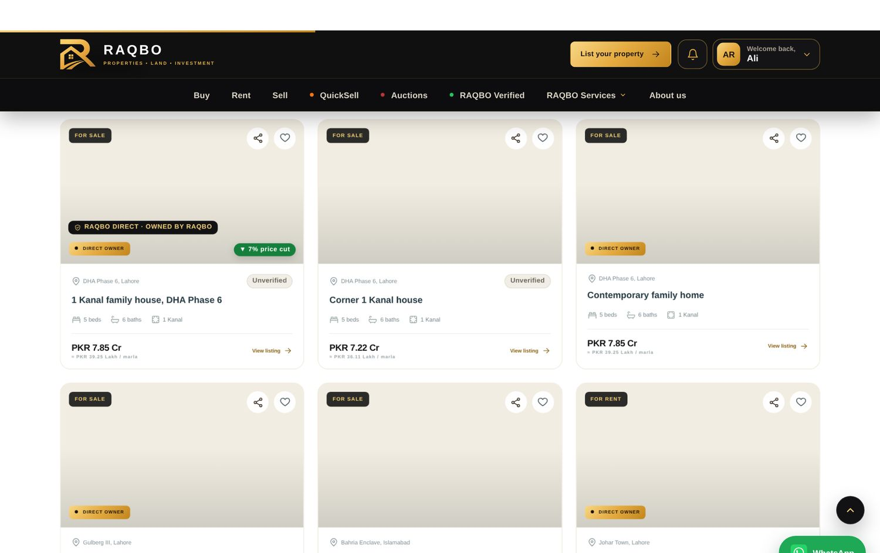
Listing cards: availability, price-cut and NEW chips
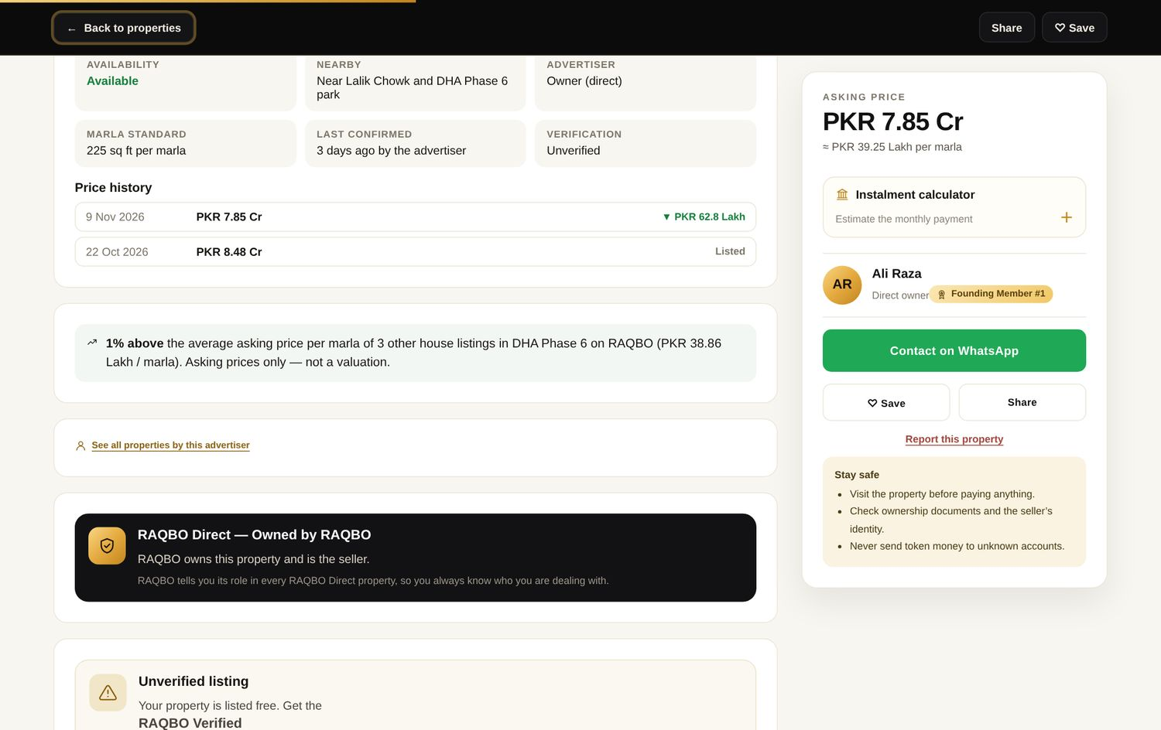
Property page: listing facts, price history and comparison with the area
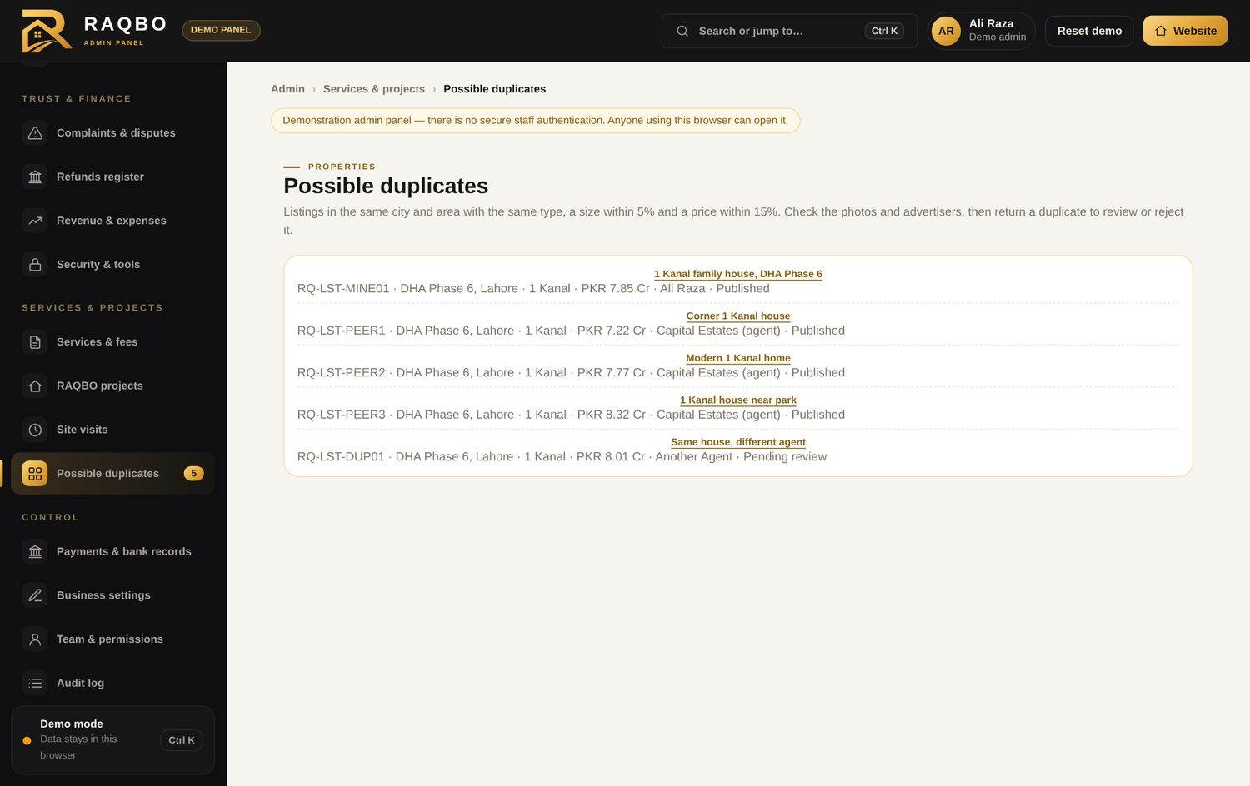
Admin: possible duplicates

4. RAQBO Verified
Suggestion | Status | What is on the website now | Notes / difficulties
Level 1 Identity Verified · Level 2 Documents Reviewed · Level 3 Enhanced Property Verification | Done | Levels renamed throughout; RAQBO Verified explainer page with the three levels and fees.
Report discloses what was examined, what could not be examined, date, status/limitations and concerns | Done | Admin ticks each check and fills “Not examined”, “Concerns found” and “Limitations” when approving.
No implied guarantee of clear legal title | Done | Stated on the badge box, the explainer page, the report and the Passport.
Downloadable report with unique number and QR check | Done | Report number RQ-VR-YYYY-NNNNNN; printable / PDF; QR code opens raqbo.pk/#verify/<number>, which shows “genuine and valid” or “no longer valid”. | QR image is drawn by a small library loaded from cdnjs; if it cannot load, the check link is printed instead.
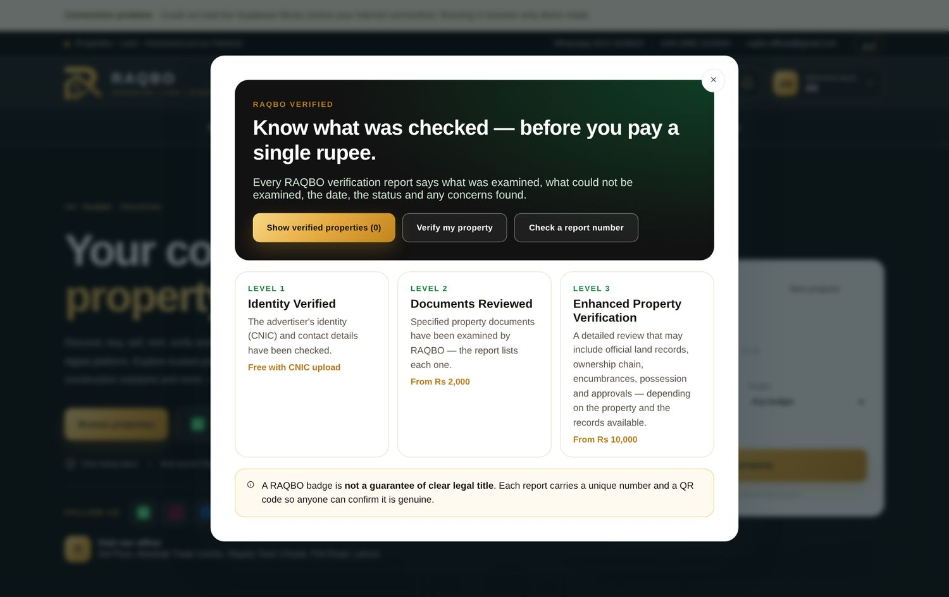
RAQBO Verified explainer page
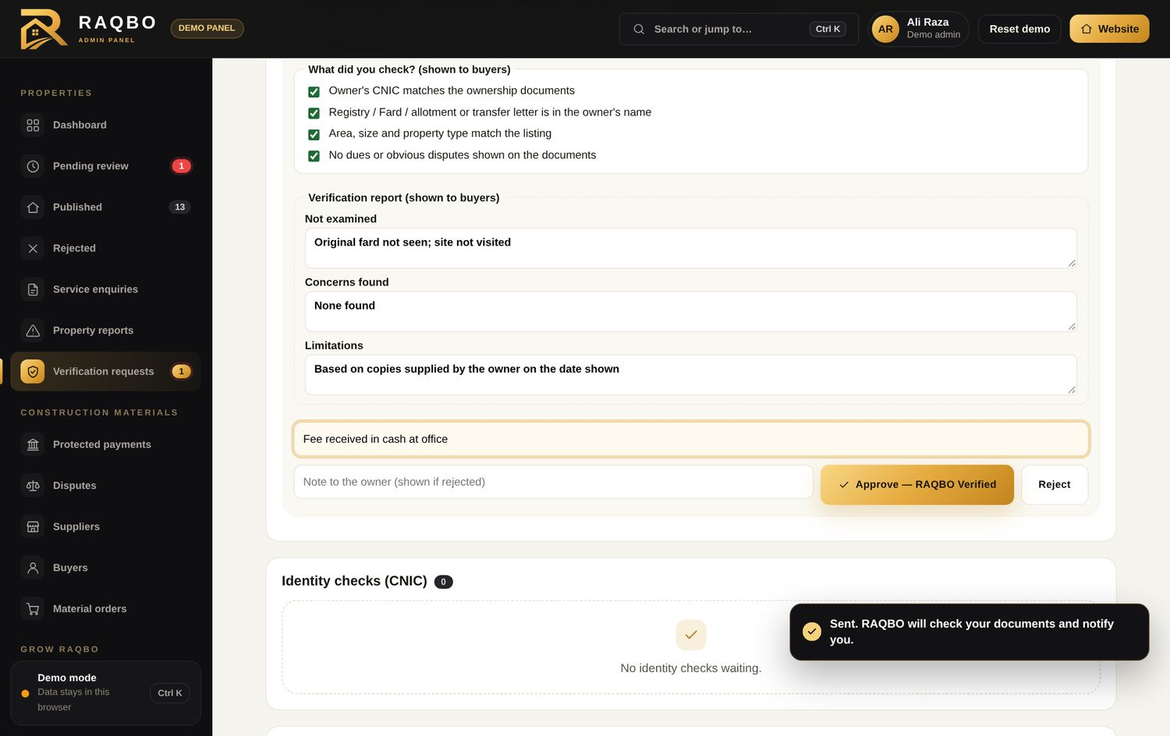
Admin approval with the three report boxes
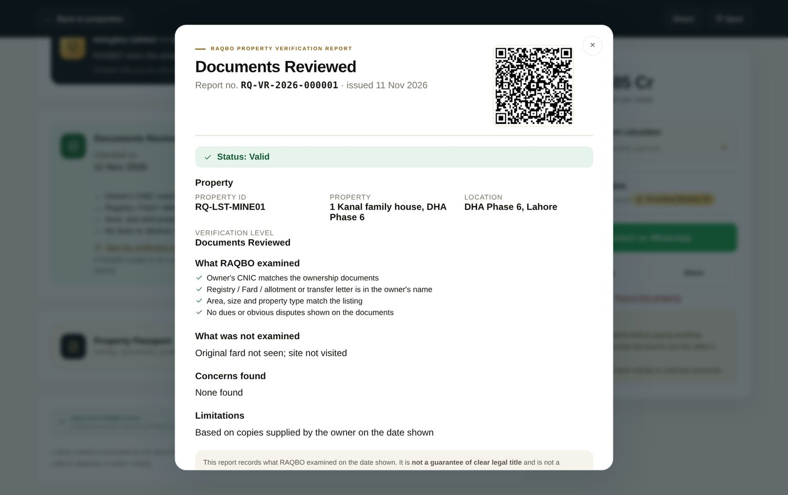
Verification report with number and QR code
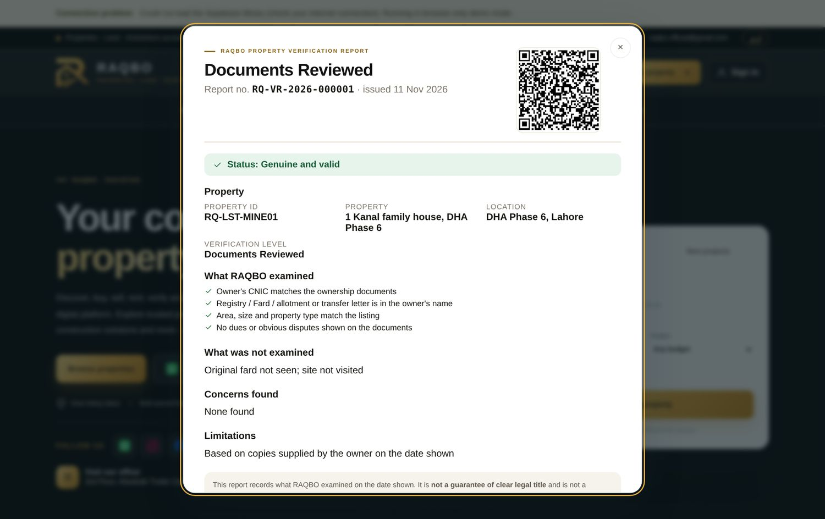
Public check of a report number

5. Property Passport
Suggestion | Status | What is on the website now | Notes / difficulties
Unique Property ID, location, category, dimensions, plans, utilities, verification reports | Done | Sections 1–8 of the Passport.
Ownership information subject to privacy; land-record references | Done | Khasra / khewat / fard / plot numbers stored privately — visible only to the owner and RAQBO; the public sees only “on file”.
Photograph and location history | Done | Recorded automatically from uploads and from changes to city, area, size or type.
Transaction history through RAQBO | Done | QuickSell and auction outcomes are listed.
Public summary vs confidential documents | Done | Confidential sections are labelled; documents never shown to buyers.
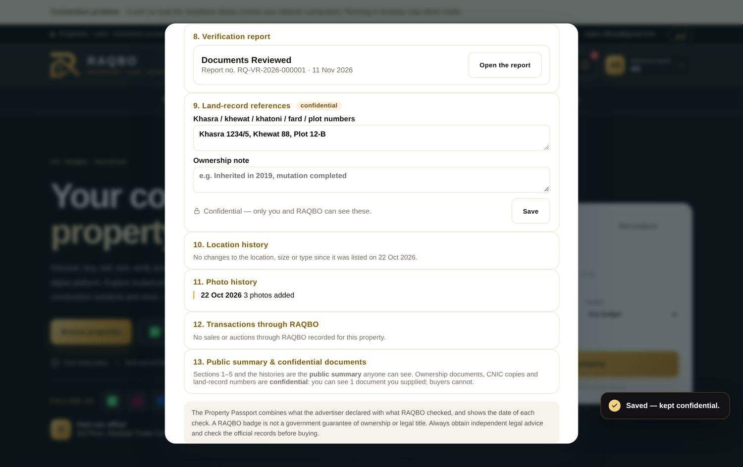
Passport: report, confidential land records and histories

6. RAQBO QuickSell
Suggestion | Status | What is on the website now | Notes / difficulties
Four seller options (RAQBO offer, private investors, public urgent listing, assisted sale), more than one allowed | Done | All four, multi-select.
Nine-stage workflow and seller dashboard | Done | Submission → Initial review → Document check → Market assessment → Buyer & investor matching → Purchase offers → Negotiation → Agreement → Completion, with timeline in My RAQBO.
Confidential minimum price | Done | Never shown publicly.
Private Investor Matching System | Done | Approved investors (identity check first) see matching opportunities and make offers.
No guaranteed purchase or sale | Done | Stated on the page and in the form.
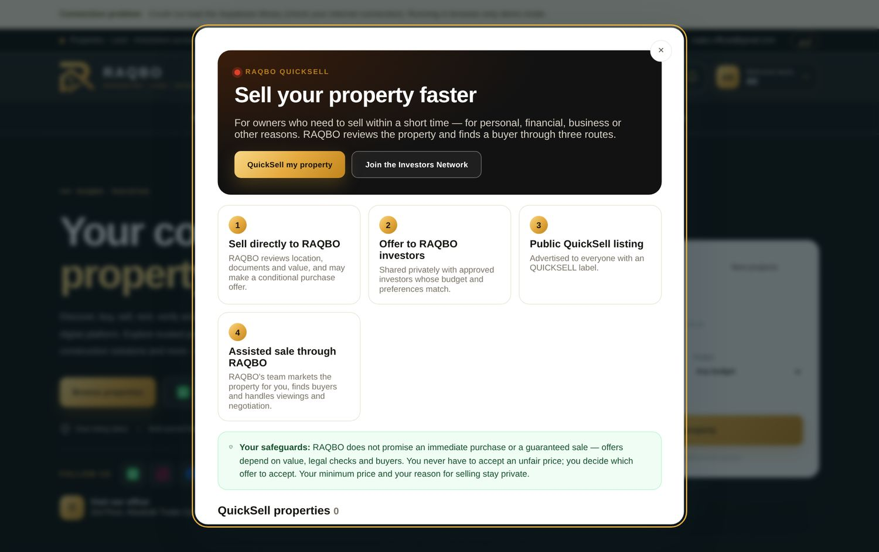
QuickSell page

7. RAQBO Property Auctions
Suggestion | Status | What is on the website now | Notes / difficulties
Heading, description and the two buttons | Done | Exactly as suggested.
Live, Closing soon, Upcoming, Completed | Done | Category tabs with counts.
Every auction displays details, verification, starting/highest/next bid, reserve conditions, bid count, countdown, closing time, inspection, terms | Done | Auction room shows all of these.
Identity-verified bidders, server-timestamped bids, rejection of invalid/late/duplicate bids, one extension rule, hidden identities | Done | Bids are accepted only by the database (one at a time, locked), bidders appear only as numbers.
Provisional winner; no automatic transfer of ownership | Done
Cancellation, default, refund and dispute procedures | Done | Published in “How auctions work”; refunds go through the refunds register.
Bidder deposits legally reviewed and bank-approved | Partly done | Deposits are recorded and matched to bank statements by the admin. | Needs legal and bank review before real deposits are taken (RAQBO decision).
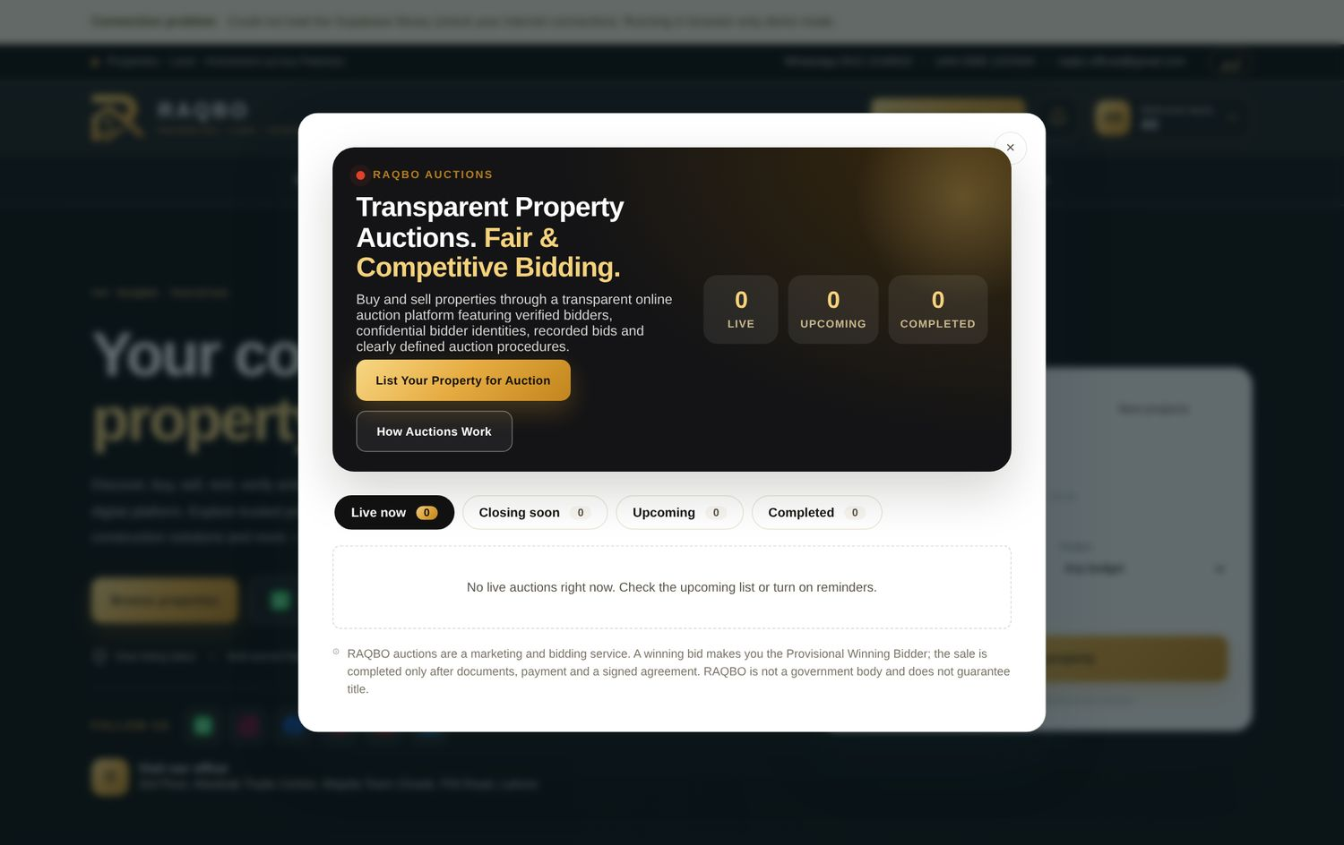
Auctions home

8. RAQBO Direct
Suggestion | Status | What is on the website now | Notes / difficulties
RAQBO’s role shown on each listing (owns, sells for owner, partner development, considering purchase, facilitating) | Done | Five roles; label on cards and an explanation box on the property page.
For RAQBO properties: progress updates, payment plans, site-visit booking, transaction status | Done | Admin posts updates with % complete and a payment plan; people who saved the property are notified; site visits and availability shown.
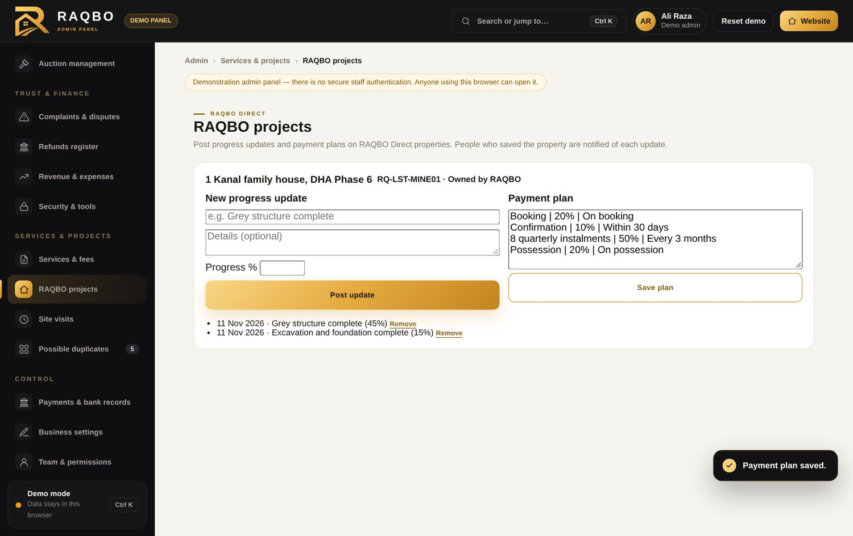
Admin: progress updates and payment plan
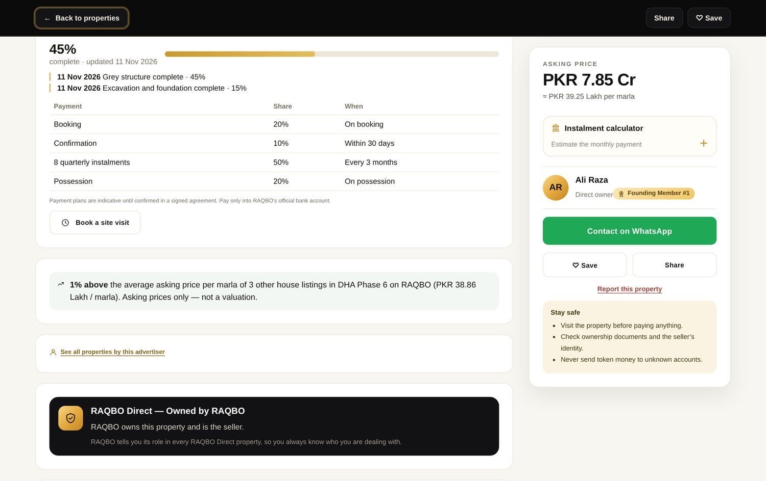
Property page: progress and payment plan

9. Construction Materials Marketplace
Suggestion | Status | What is on the website now | Notes / difficulties
Separate from property listings; headings “Construction Materials Marketplace” and “Become a Supplier” | Done | “Sell With Us” removed everywhere.
Supplier comparison, product specifications, price & availability updates, delivery areas, request for quotation, bulk enquiries, verified suppliers, ratings after genuine orders | Done | Compare up to 4 suppliers; brand and specifications per product; live rates and stock; delivery radius and note; Request Quote; one bulk enquiry to RAQBO.
Replace screenshots with bank reconciliation or payment-provider confirmation | Partly done | Bank statement import and matching exist; admin cannot approve unmatched payments without a recorded reason. | A payment-gateway confirmation needs a merchant account (bank / JazzCash / Easypaisa).
No “escrow” until legal and banking clearance | Done | Wording changed to “RAQBO Protected Payment”.
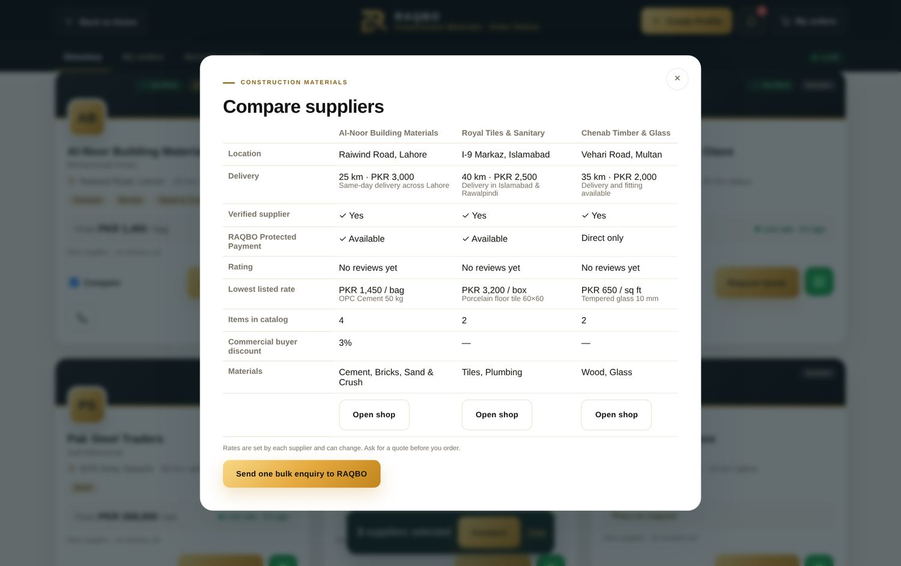
Compare suppliers

10. Membership, Founding Members and rewards
Suggestion | Status | What is on the website now | Notes / difficulties
Benefits: service discounts, alerts, saved searches, enquiry management, referral credits, notifications | Done | Existing rewards module plus My RAQBO alerts and enquiries.
Rewards only after validated activity; anti-abuse; genuine Founding Member numbers | Done | Credits only after a listing is approved; the admin approves redemptions; numbers come from database records. New Account checks page flags accounts sharing a phone or CNIC name and members with many referrals in one day.

11. Services section
Suggestion | Status | What is on the website now | Notes / difficulties
Five groups: Transactions, Legal & Documentation, Construction & Development, Investment, Support | Done | 29 services and tools in the five groups, plus 7 Overseas services.
Introduction, request form, fee information and tracking number for each | Done | Fees are admin-editable; each request gets RQ-ENQ number tracked in My RAQBO → Service requests.
Qualified persons for licensed work | Done | Marked on each such service. | Operational: RAQBO must appoint the professionals.
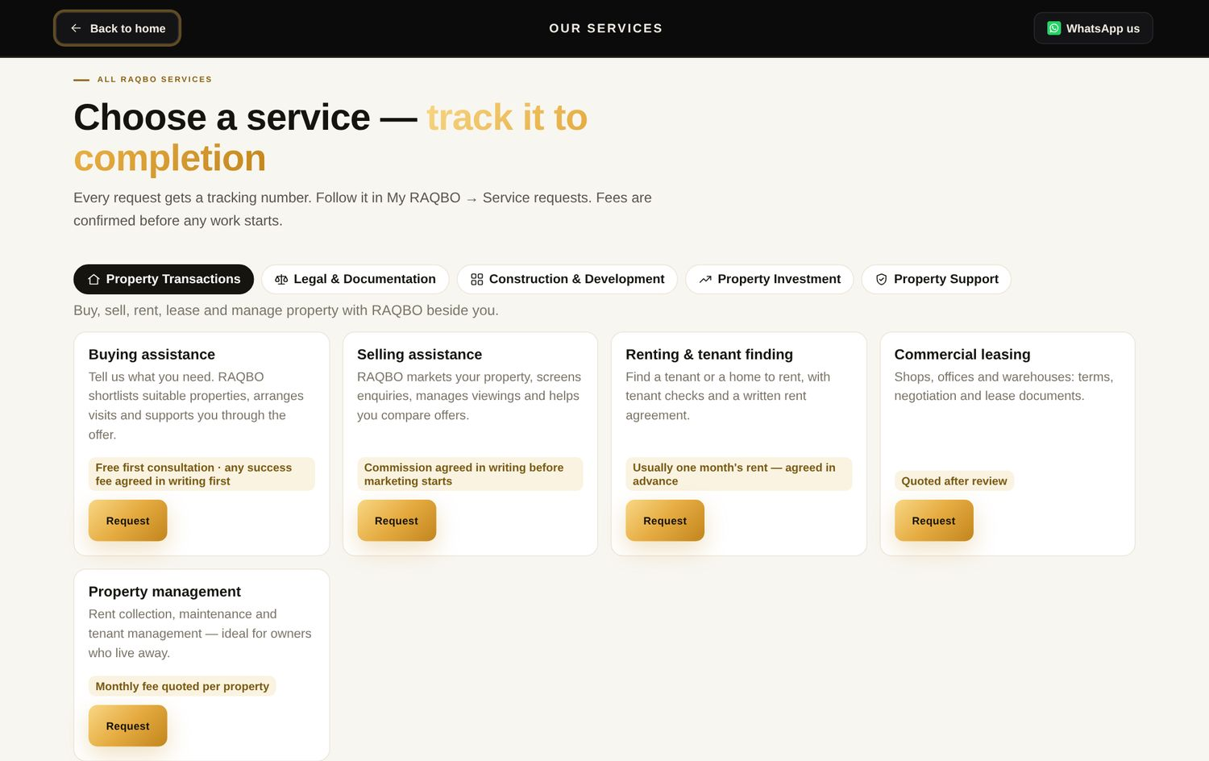
Services catalogue
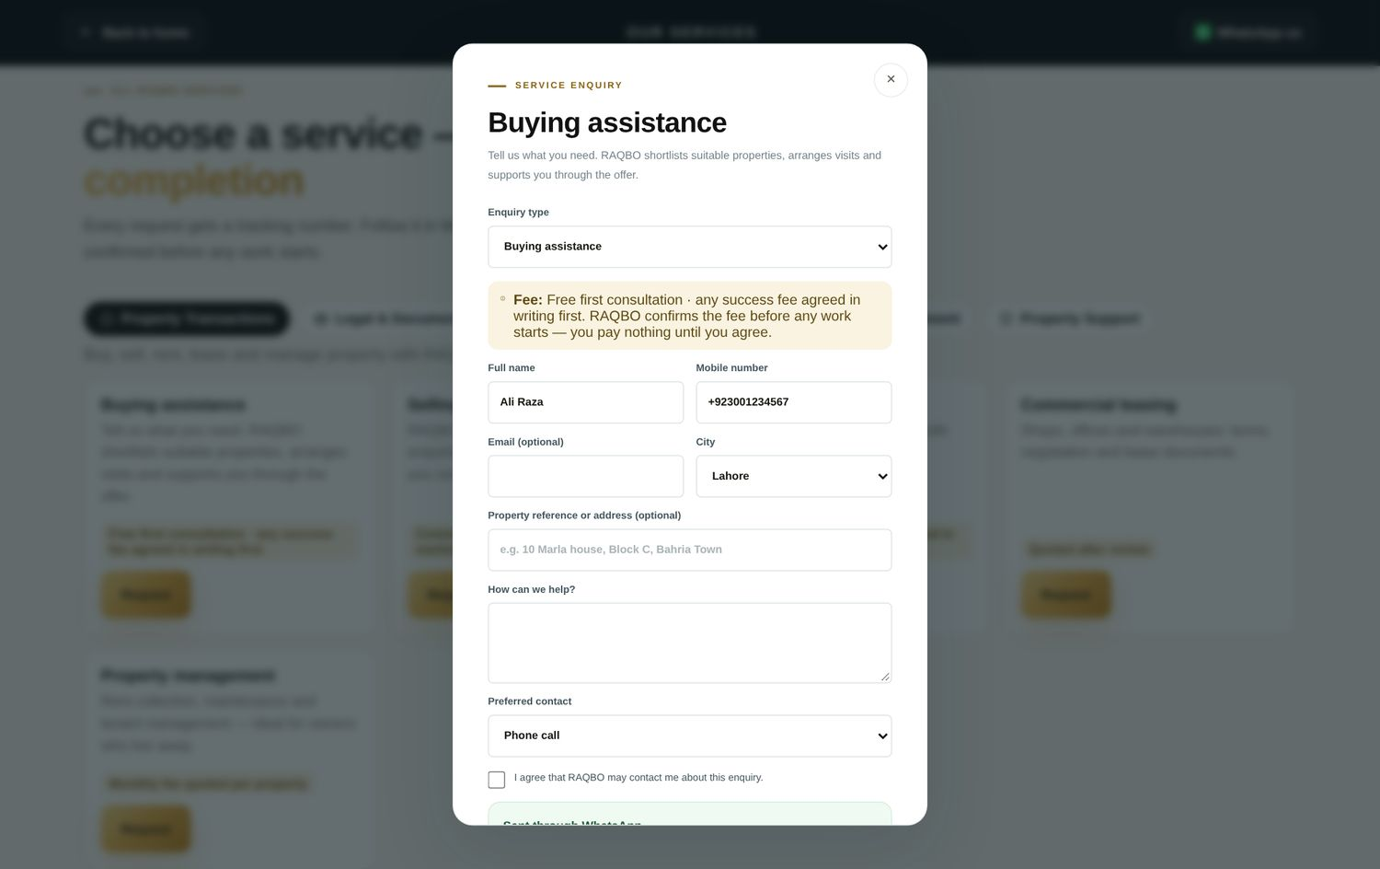
Request form showing the fee and tracking
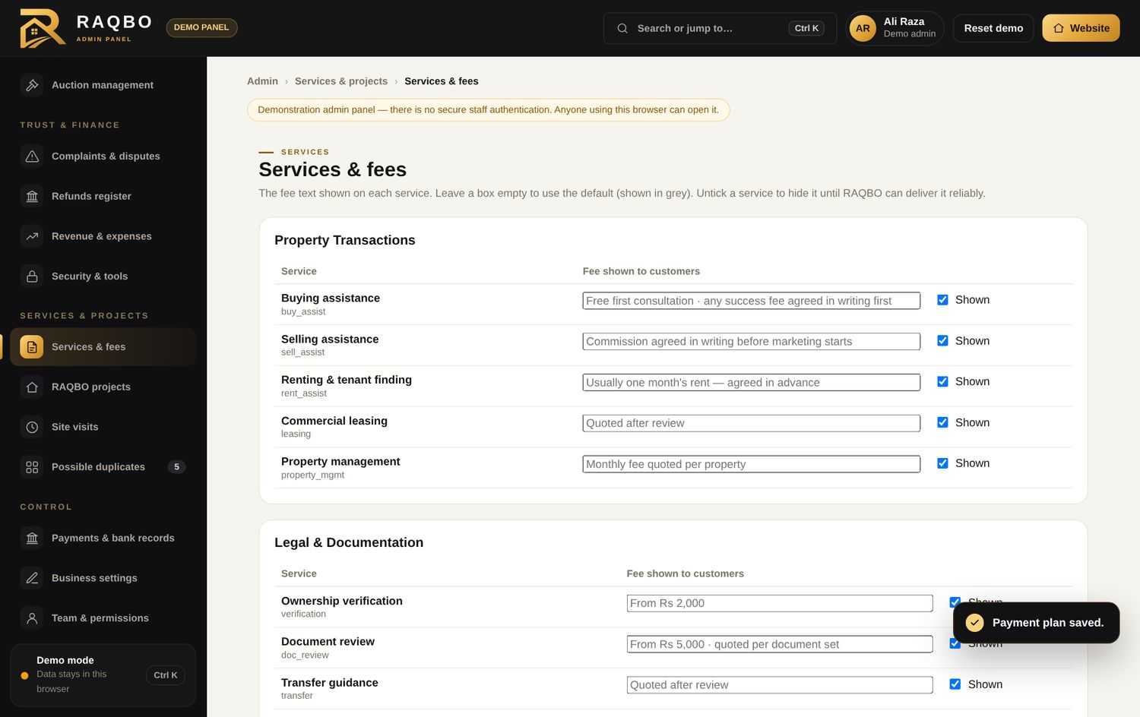
Admin: services and fees

12. Overseas Pakistanis
Suggestion | Status | What is on the website now | Notes / difficulties
RAQBO Overseas Property Services (verification, video inspection, buy/sell, management, construction monitoring, documents, appointments) | Done | Dedicated page with all seven services; asks country and best time to call.
Offer only services with a reliable arrangement | Done | Admin can hide any service until it can be delivered. | Operational decision per city.
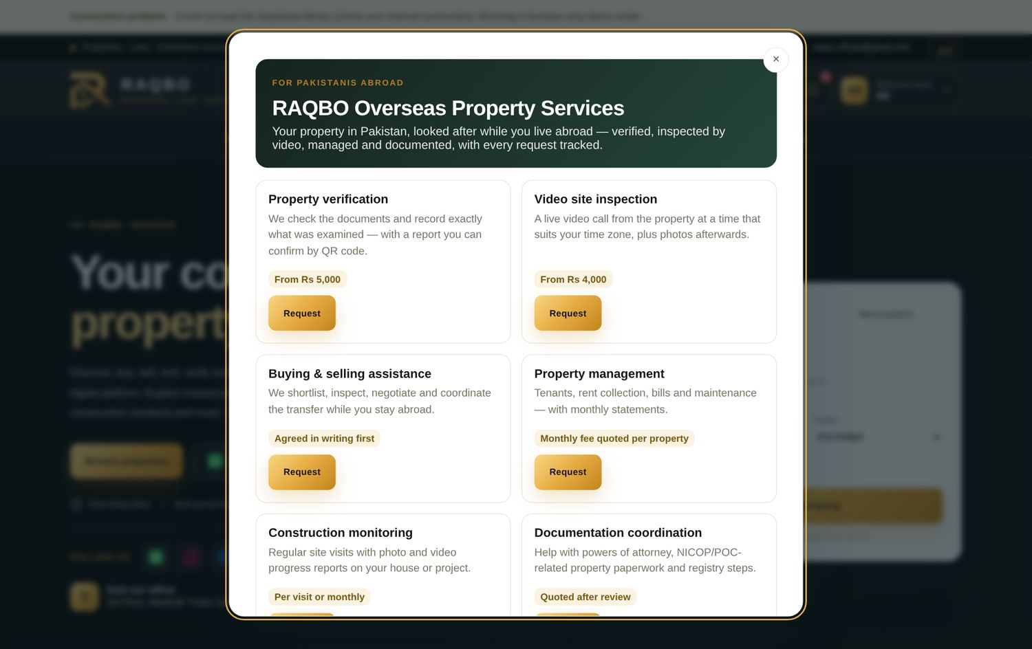
RAQBO Overseas

13. Property Wanted
Suggestion | Status | What is on the website now | Notes / difficulties
Location, category, budget, size, possession, preferences | Done | Added minimum budget, possession, bedrooms and preference tags.
Matching and notifications | Done | Matching owners are notified; each request shows “N matching properties now”; buyer gets alerts.
Owners respond confidentially | Done | Replies go through RAQBO messages; phone numbers stay hidden.
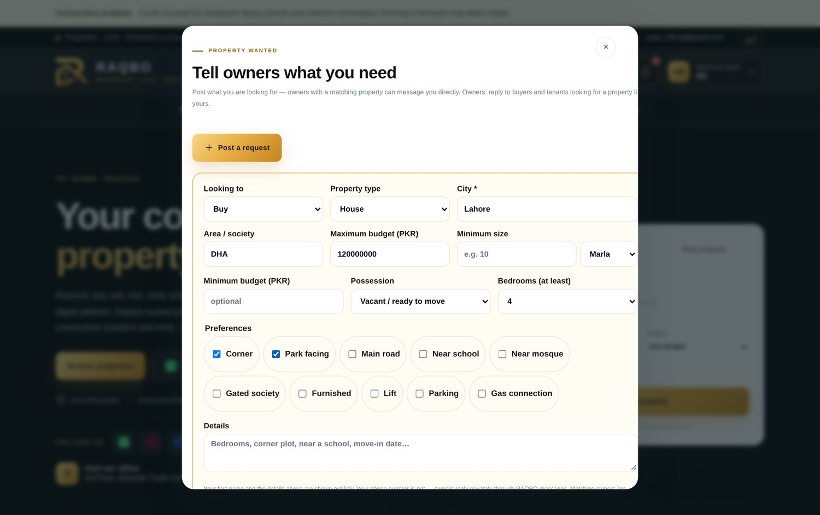
Property Wanted form
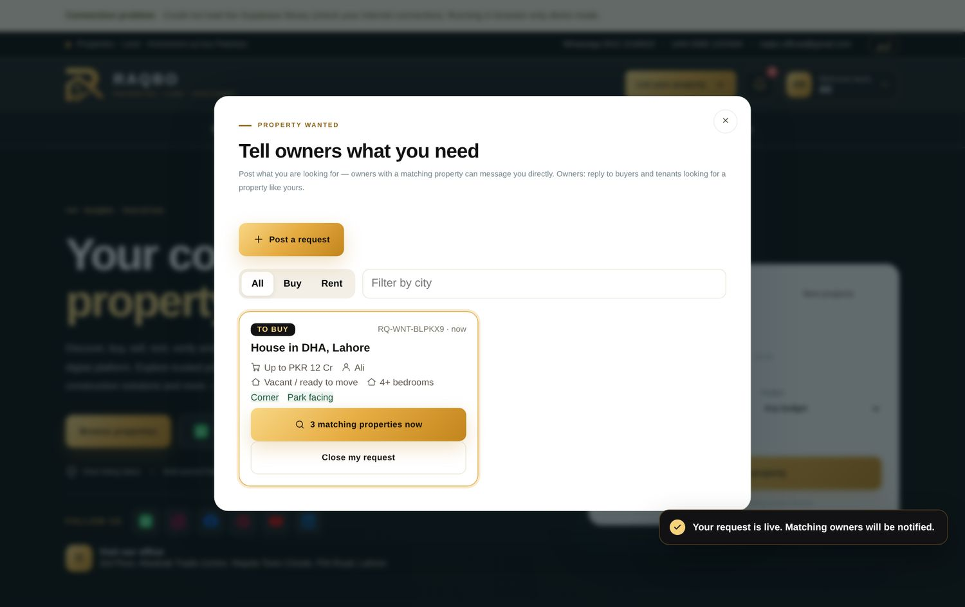
Request with live match count

14. Member dashboard by role
Suggestion | Status | What is on the website now | Notes / difficulties
Seller: properties, enquiries, offers, QuickSell, auctions, service requests | Done | My RAQBO with a Selling / Buying / Investing switch.
Buyer: saved, alerts, offers, bids, inspection appointments | Done
Investor: preferences, matches, offers, pending and completed transactions | Done
Separate business dashboards for suppliers and agents | Done | Suppliers have “My shop”. Agents have Listing performance (saves, enquiries, visits, offers, WhatsApp clicks per property) and an Agent package page.
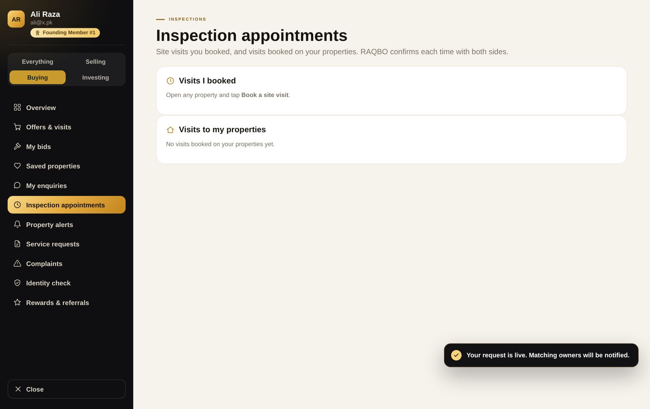
My RAQBO in “Buying” mode

15. Admin panel — business control
Suggestion | Status | What is on the website now | Notes / difficulties
Role-based staff permissions; activity and security logs | Done | Nine permission areas; every sensitive action in the audit log.
Verification, enquiries, QuickSell pipeline, investors, auctions & bid history, suppliers, service requests and quotations | Done | Admin sends a quotation (amount, validity, what it includes); the member accepts or declines in My RAQBO.
Payment reconciliation and refunds | Done | Bank matching plus a new Refunds register (approve → paid with bank txn; second admin or recorded reason).
Complaints and disputes | Done | New centre with reference numbers and written outcomes.
Advertising and promotion controls | Done | Sponsored listings and growth settings.
Revenue and expense reporting | Done | Monthly income/expenses by category, refunds included, CSV export. | Income is entered by the admin; automatic posting from each module can follow.
Recorded explanations for sensitive actions | Done | Required for payment, verification, auction and financial adjustments.
Business dashboard KPIs | Done | Listings, registrations, verified, enquiries, site visits, QuickSell, offers, auctions, completed transactions, agent packages, open quotations, complaints, refunds, income/expenses, WhatsApp clicks.
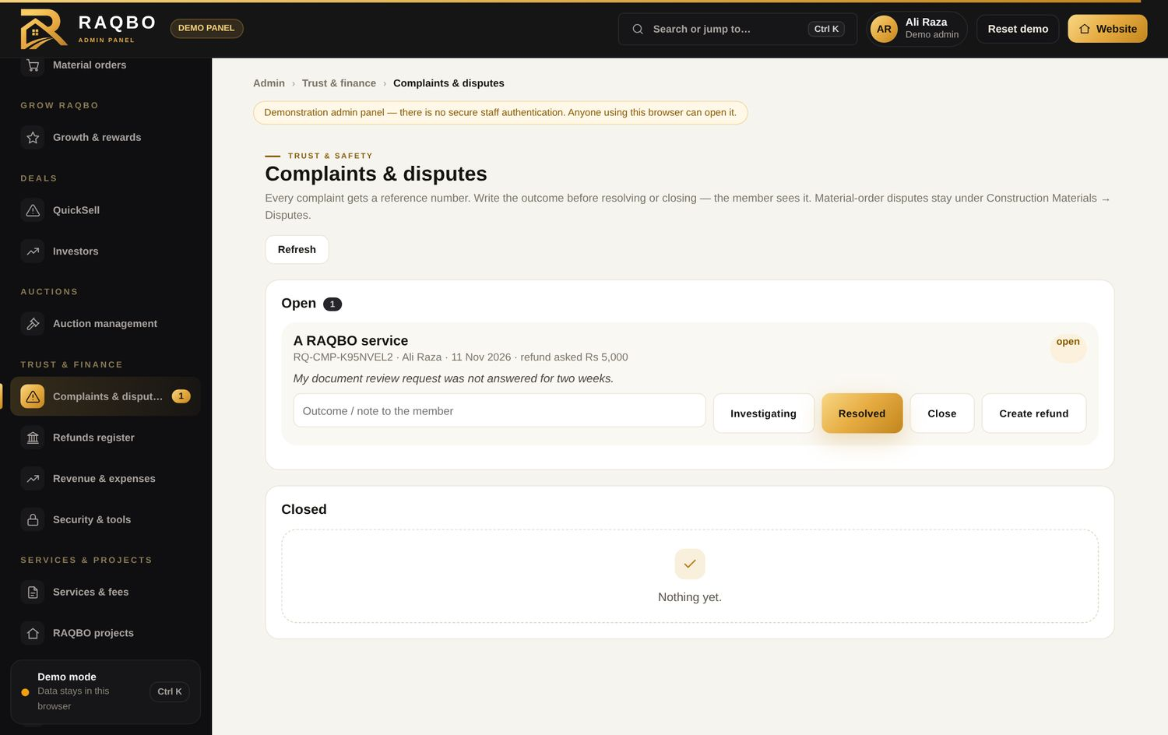
Complaints & disputes
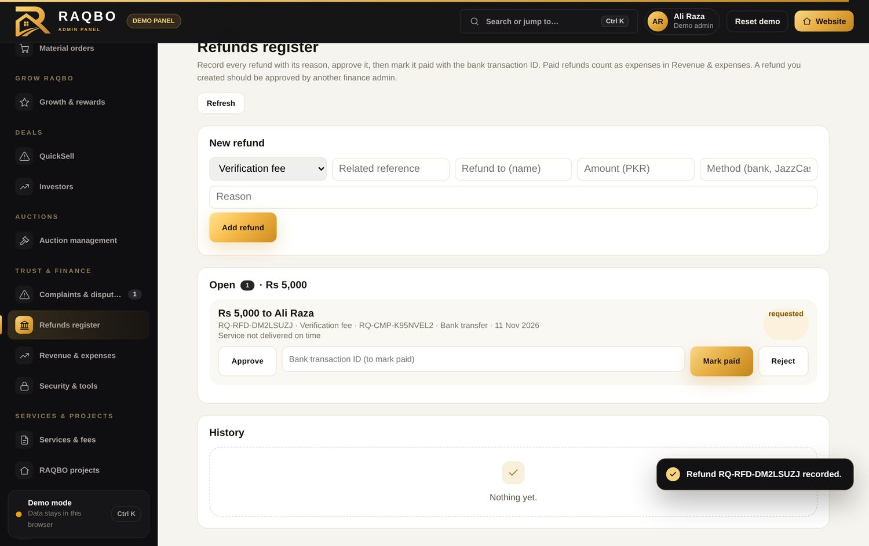
Refunds register
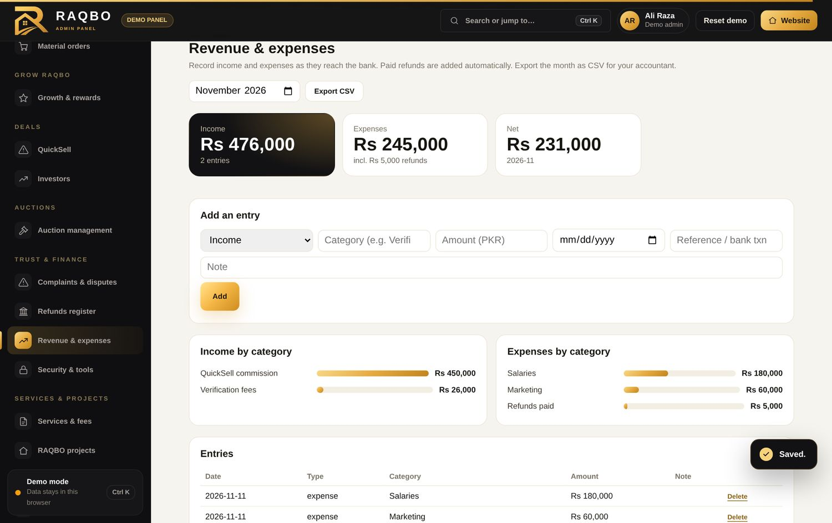
Revenue & expenses
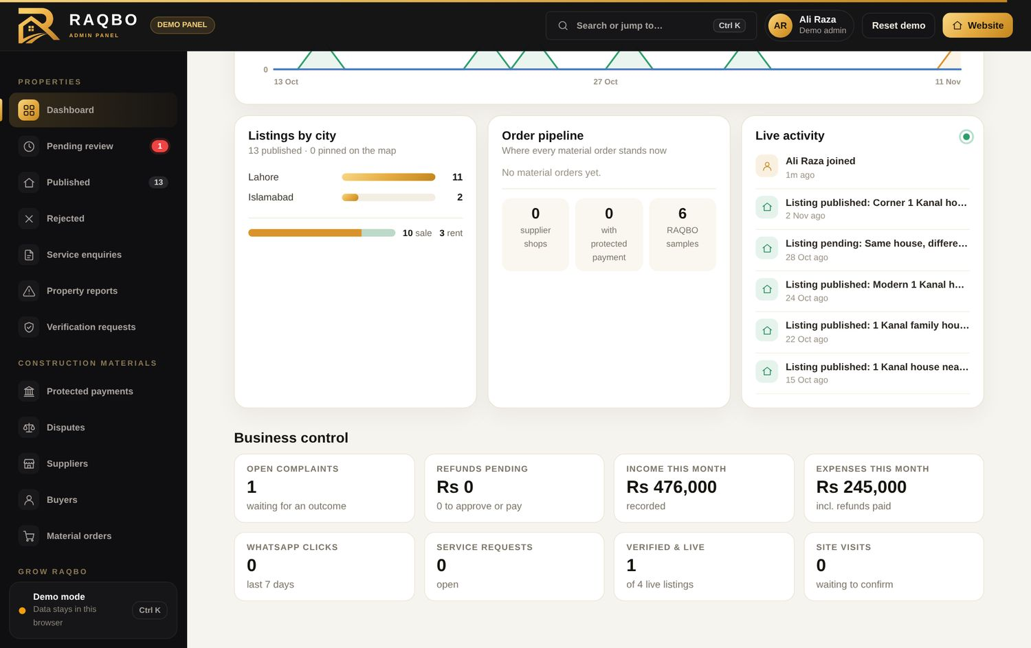
Dashboard: business control KPIs

16. Design and mobile experience
Suggestion | Status | What is on the website now | Notes / difficulties
Mobile-first: brand consistency, compact header, readable fonts, refined filters, no horizontal scrolling, quick search, WhatsApp buttons, compressed photos, clear empty states, no oversized banners | Done | Checked at phone width; photos are resized in the browser before upload; auction filters restyled to match the banner.
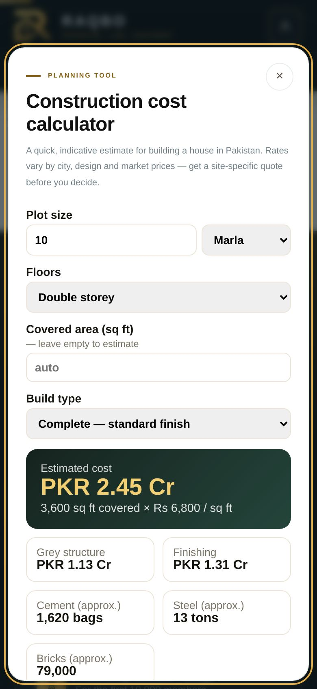
Mobile view of a tool

17. About Us and brand
Suggestion | Status | What is on the website now | Notes / difficulties
“RAQBO — Inspired by Land. Built on Trust.” and the Raqba (رقبہ) story | Done | New name section on About Us.
Founder shown as District & Sessions Judge (R) without the personal name | Done | Name removed as instructed.
No suggestion of government or judicial endorsement | Done | Disclaimer added.
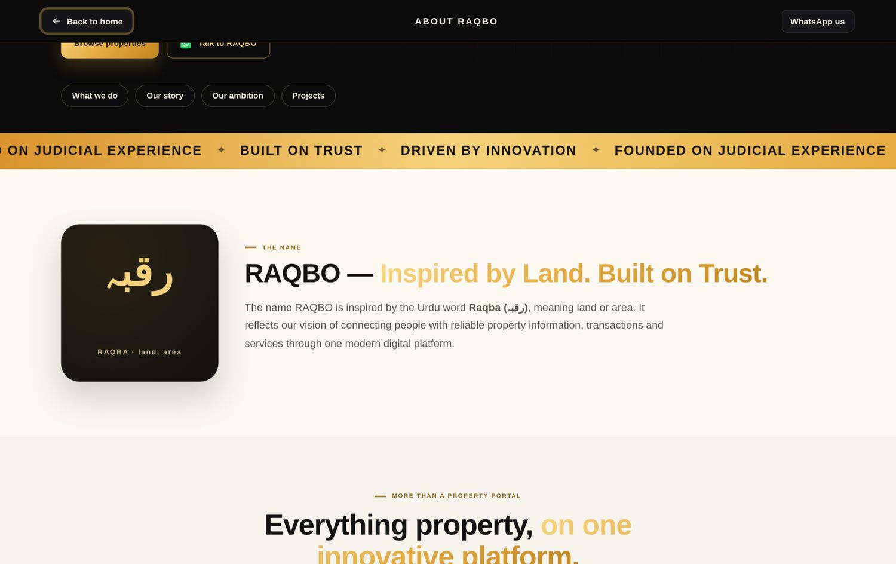
About Us: name story

18. Security, privacy and compliance
Suggestion | Status | What is on the website now | Notes / difficulties
Secure document storage; limited employee access; activity logs | Done | Private storage with short-lived links; permissions; audit log.
Two-factor authentication for administrators | Done | Authenticator-app sign-in for admins; can be made compulsory. Off by default so nobody is locked out. | Each admin must set up the app before it is switched on.
Secure password reset | Done | Email reset link through Supabase.
Automated backups and restoration testing | Partly done | Supabase daily backups (Pro plan) plus a “Download data backup” button for full admins. | Restoration test to be done on the live project with RAQBO.
Protection against fake listings and accounts | Done | Review before publishing, duplicate check, reports, rate limits, identity checks.
Privacy Policy, Terms, transparent fees and refund rules | Done | New Fees & refund rules page (admin-editable rules).
Customer due diligence; complaints procedure | Done | CNIC checks for bidders, investors and verification; complaints centre.
Legal identity of the business on website and receipts | Partly done | Business identity fields in Admin → Security & tools; shown in the footer and on verification reports once filled. | RAQBO to enter the registered name, number, NTN and address.
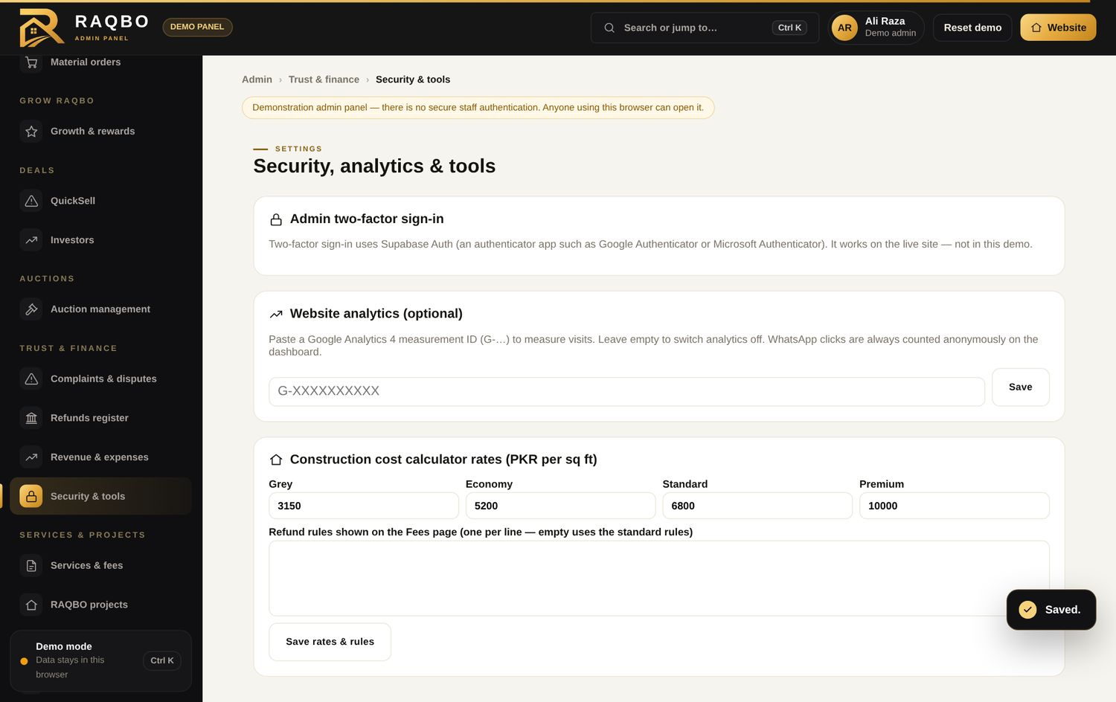
Admin: two-factor sign-in, analytics and calculator rates
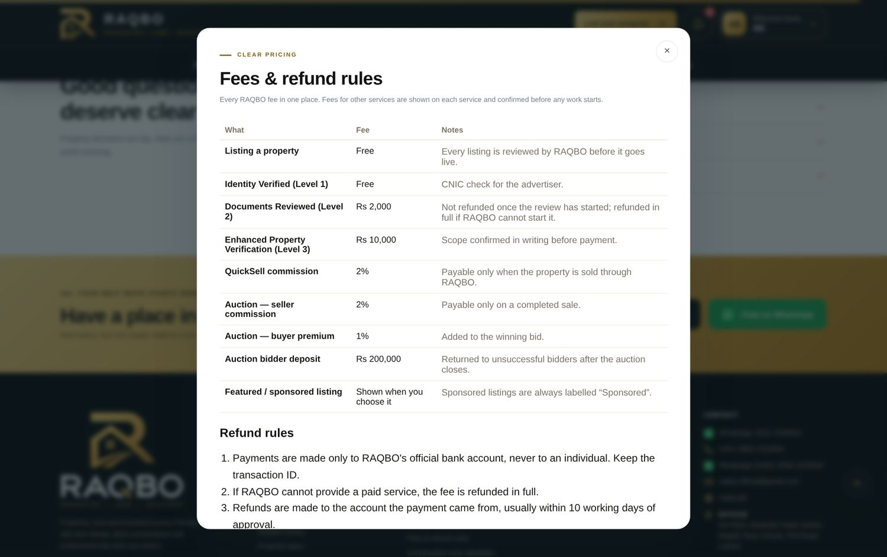
Fees & refund rules page
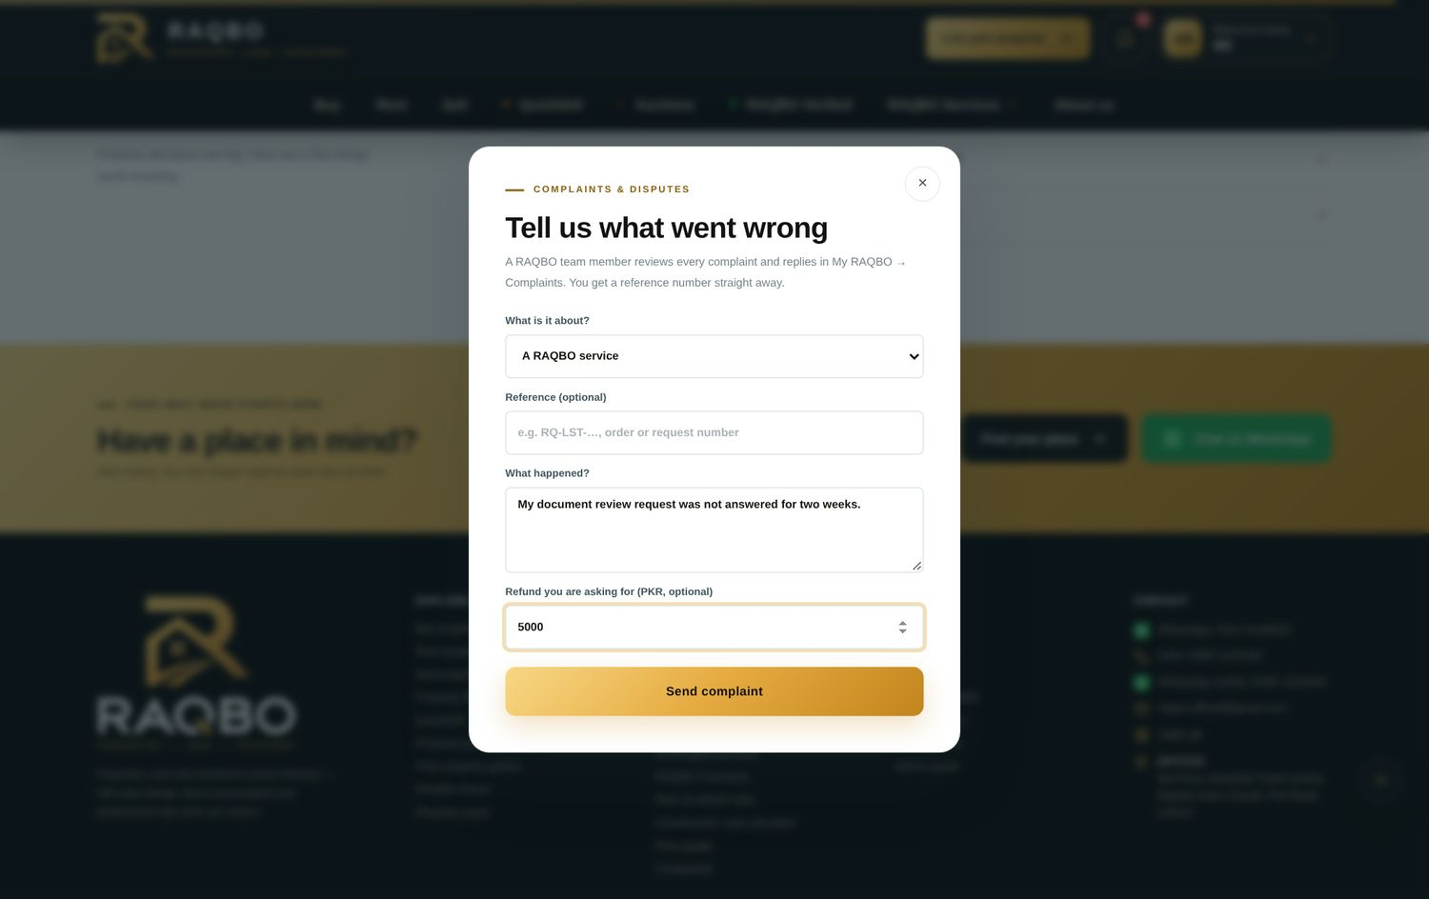
Member complaint form

19. Search engines and marketing
Suggestion | Status | What is on the website now | Notes / difficulties
Search-friendly property pages, titles, descriptions, share links with photos | Done | raqbo.pk/p/<ref> pages with preview image.
Location-based pages | Done | raqbo.pk/property/<city> and /property/<city>/<area>, listed in the sitemap.
Structured data; sitemap and indexing controls | Done | Organisation, website, breadcrumbs and property lists.
Google Search Console and analytics | Partly done | Optional Google Analytics 4 — paste the ID in admin. | Search Console must be verified by the domain owner.
WhatsApp enquiry tracking | Done | Anonymous click counts on the dashboard.
Branded email addresses; permanent domain tested | Not done |  | Needs the domain email provider set up (e.g. Google Workspace / Zoho).

20. Future features (delivered early where practical)
Suggestion | Status | What is on the website now | Notes / difficulties
A. Price intelligence | Done | Price guide by area from approved listings, and “x% above/below area average” on each property — labelled as asking prices, not valuations.
B. Construction cost calculator | Done | Area, floors, finish level, rough material quantities; rates editable in admin. | Default rates are indicative Lahore 2026 figures.
C. Site visit booking | Done
D. Agent and developer profiles | Done | Public advertiser profile: live and verified listings, sold/rented history, package badge and reviews only from people who visited a property or made an offer.
E. Project showcase | Done | Projects page with developer, approvals, possession date, units, layout plan and map links, progress and payment plans.
F. AI-assisted matching | Partly done | Smart match: customers describe the property in their own words; RAQBO reads purpose, type, city, area, budget, size and preferences and ranks properties with a match score. Also used for Property Wanted and investors. | Rule-based today; an AI language model can be added later with an API account.
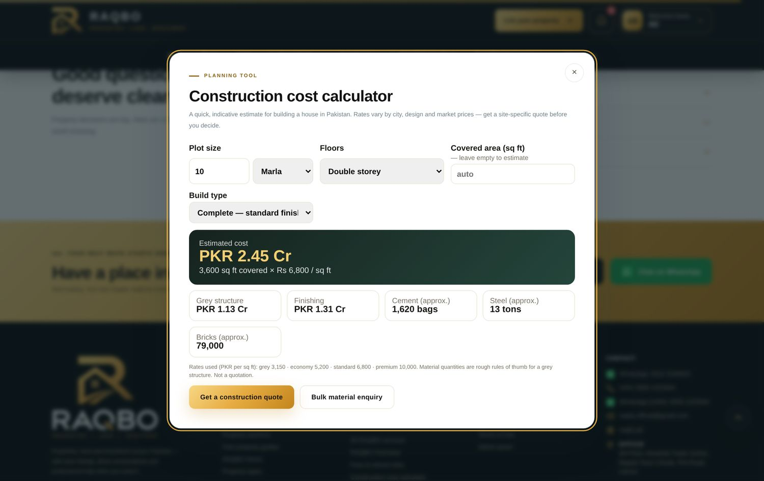
Construction cost calculator
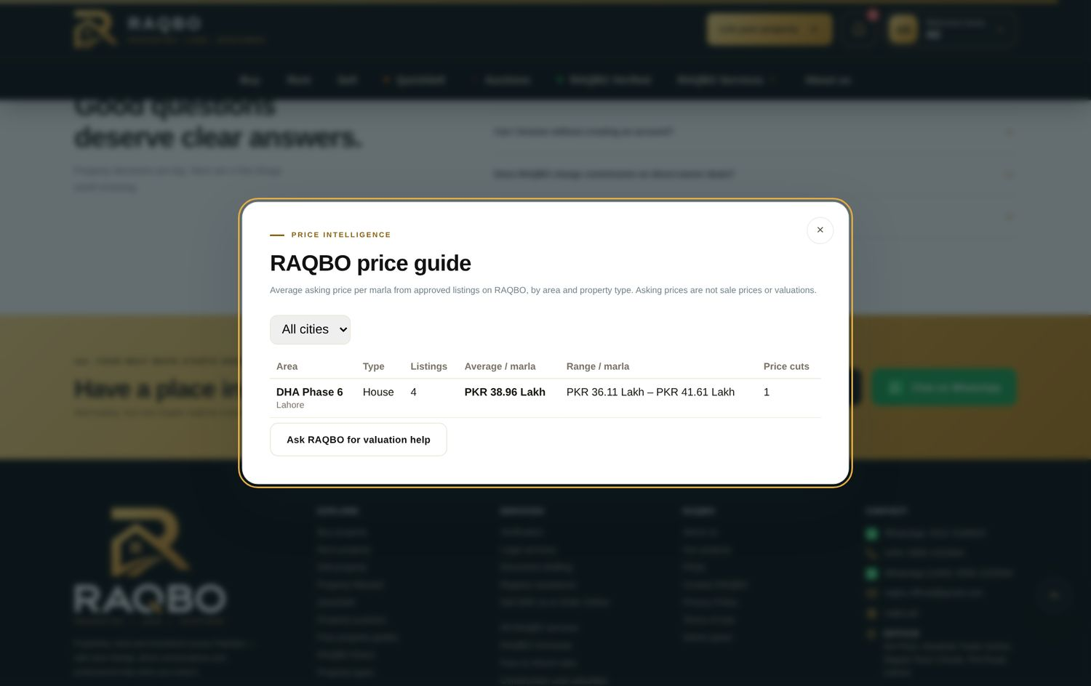
Price guide
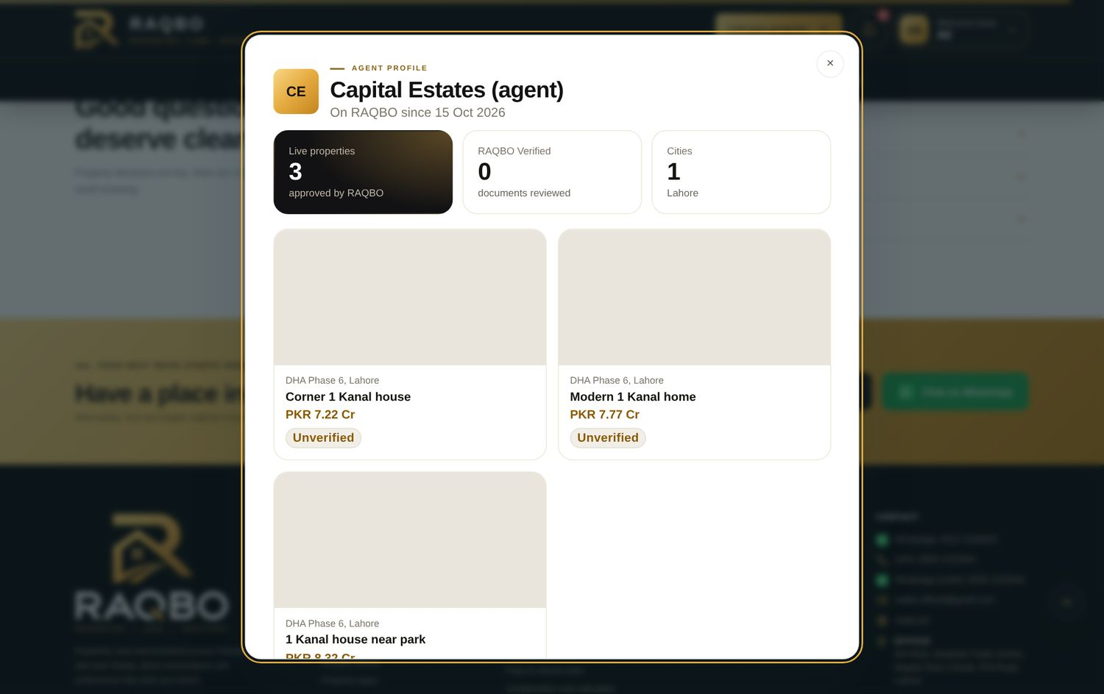
Advertiser profile
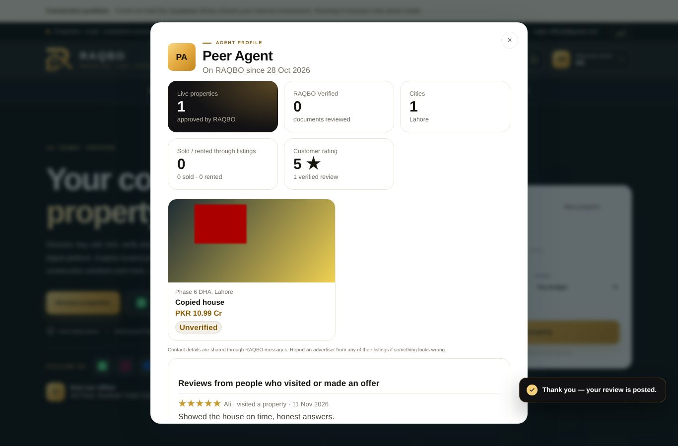
Advertiser performance and verified reviews
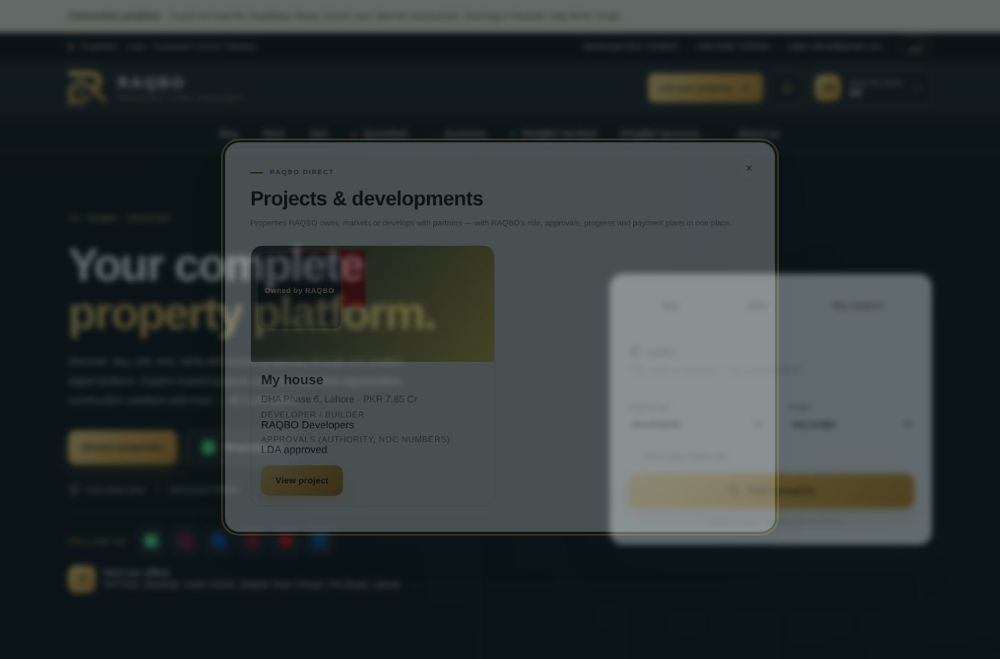
Projects & developments page
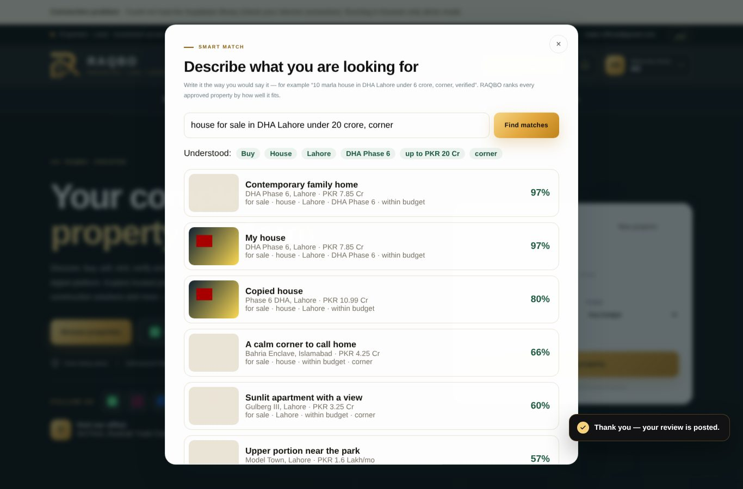
Smart match

21. Commercial and revenue model
Suggestion | Status | What is on the website now | Notes / difficulties
Fees for featured listings, verification, QuickSell, auctions, services, marketplace | Done | All configurable; shown on the Fees page. | Amounts are placeholders until RAQBO confirms.
Clear pricing, refund conditions and revenue recording | Done | Fees page, refund rules, refunds register, revenue report.
Subscription packages for agents | Done | Three packages (Agent Starter, Agent Pro, Developer) with request, bank payment and admin activation; badge on the profile. | Names and prices are placeholders for RAQBO to confirm.
Free basic listings | Done

22. Testing before launch
Suggestion | Status | What is on the website now | Notes / difficulties
Automated journeys: registration, listing review, enquiries, verification & report, QuickSell & investors, auctions with several bidders, last-minute bids, reserve failure, supplier orders/refunds/disputes, referrals, permissions | Done | About 49 browser test scripts and 24 database test scripts are run on each release, including invalid and duplicate actions.
Live tests with real Google sign-in, payments, app install and shared links; recovery from outages and backups | Partly done | Shared link pages tested with sample data. | Needs the live domain and real accounts — to be done together before launch.

23. Implementation priorities
Suggestion | Status | What is on the website now | Notes / difficulties
Priority 1 — security, financial, legal, data integrity | Done | Two-factor admin sign-in, refunds register, escrow wording removed, accuracy features. | Legal identity and deposit clearance pending (RAQBO).
Priority 2 — listings, Verified, QuickSell, Auctions, transactions | Done
Priority 3 — investors, profiles, materials, paid services | Done
Priority 4 — price intelligence, AI matching, reporting | Done | Price guide, smart match and reporting done. | Language-model AI optional later.

