Cyber Security and AI Case Studies



Module Code: MOD006570

Module Leader: Dr. Raj Mani Shukla

Student ID: 2418497
Name: Syed Sarmasth Hussain

Table of Contents

Part A – Model Choice, Rationale, and Evaluation 3
Part B – Insider Threat: Label Manipulation Attack on ANN Model 4
Part C – Theoretical Mitigation of Label Manipulation in AI Training Pipelines 6
References 8

Part A – Model Choice, Rationale, and Evaluation

Model Selection and Justification
An Artificial Neural Network (ANN) was used as the AI model for classifying cyber threats from the Edge-IIoTset dataset. The dataset is labeled network traffic across multiple protocols (TCP, UDP, ICMP, HTTP, MQTT, DNS), where every record is labeled with some Attack_type. As the problem is high dimensional, as we're attempting to classify 16 cyberattacks and benign traffic, ANNs are well-suited because ANNs have the capability to learn complex, non-linear relationships as well as to scale with heterogeneous input features.

Random Forests or even XGBoost were also being contemplated. ANNs, however, offer more class handling flexibility for frequent as well as for infrequent classes without needing to actually conduct feature engineering, with proper normalization of data. Another aspect for contemplation is ANN architecture that also facilitates efficient back propagation across large datasets to achieve better learning outcomes for underrepresented classes such as MITM, Fingerprinting, or Ransomware.

Dataset Preprocessing and Feature Engineering
The first step in preprocessing included eliminating columns which have non-informative or high-cardinality, like timestamps (frame.time), IP addresses (ip.src_host, ip.dst_host), and text with fields (http.request.full_uri, mqtt.topic, dns.qry.name). The other features comprised both numerical fields and categorical variables with low cardinality.
Categorical variables were handled through label encoding following the transformation of their values to fit in order to resolve the combined type of errors. The target label, Attack_type, was similarly encoded into the integer classes. All numerical attributes were normalized using StandardScaler to guarantee that the ANN could understand it efficiently without being influenced by the size of the features.
The existing dataset was subsequently divided with an 80/20 train-test ratio employing proportional sampling to maintain the relative distribution of every attack type. The imbalance of class was pronounced, as 1.6 million samples had the “Normal” class, whereas rare classes such as “MITM” possessed only slightly over 1,200 samples. Nonetheless, stratification guaranteed an equitable representation throughout the assessment.

ANN Architecture and Training Configuration
The ANN was developed using the Keras API (TensorFlow backend) and structured as follows:
- Input Layer: Accepting the whole feature vector after preprocessing.
- Hidden Layer 1: 128 neurons using ReLU activation and a dropout at the rate of 0.3.
- Hidden Layer 2: ReLU activation with dropout rate of 0.2 neurons.
- Output Layer: 17 neurons (each class has one) with softmax activation.
The model was optimized using the Adam optimizer, by using categorical crossentropy loss which is suitable for classification of multi-class, and the evaluation metric as accuracy. It was trained for 20 epochs with a batch size of 128.20% of the training data was utilized for a validation split to monitor generalization performance.

Model Performance and Evaluation
The learned ANN registered an accuracy test which was about 99.55%, and with validation accuracy also very close to training performance through all epochs, pointing to minimal overfitting. Convergence patterns in loss and accuracy plots were uniform, confirming the architecture model and its hyperparameters.

The report classified so far showed good performance on majority classes like "Normal", "DDoS_UDP", and "SQL_injection" with decent recall and precision on rare classes like "XSS" and "Uploading". Low recall on rare classes like "MITM" and "Fingerprinting" was anticipated due to the small size of training samples.

Confusion matrix emphasized wherein the model got similar attack types confused repeatedly, i.e., between the different variants of DDoS attacks (e.g., UDP, TCP, ICMP). However, the model distinguished benign from malicious traffic consistently, which is essentially the basic requirement of any intrusion detection system.

Part B – Insider Threat: Label Manipulation Attack on ANN Model

Threat Scenario and Motivation
In this instance, the ANN-based intrusion detection model that is trained is assumed to be subject to an insider attack, in this instance being an employee who deliberately manipulates the data labels which are needed to be trained. This is a data poisoning attack in the form of label flipping, which compromises the training process integrity. Through arbitrarily altering a portion of ground truth labels (`y_train`), the attackers will seek to deceive the model when it is trained so that it classifies malicious traffic as benign or other types of attacks.
This simulation will attempt to evaluate the vulnerability of the ANN model to such attacks and the level of performance loss as label poisoning intensity.

Poisoning Strategy and Implementation
Random label flipping was performed. A function was established that randomly flipped a training set in percentage of the labels to a different class, but not the actual label. The percentages that were tried in the flipping were: 0%, 5%, 10%, 15%, 20%, 25%, and 30%, which are all levels of corruption.
For each level:
- Labels were properly poisoned
- The same architecture of ANN in Part A was again trained with the poisoned data
- Performer test set accuracy was computed and compared with the baseline (0% poisoned)

Results and Observations
Flipped Labels (%) | Test Accuracy (%) (Targeted Flipping)
0% | 99.55%
5% | 99.54%
10% | 99.59%
15% | 99.54%
20% | 99.55%
25% | 99.48%
30% | 99.46%

The degradation in accuracy, although very slight, is always worsening. The model will initiate from 99.55% test accuracy with clean/neat data and fell to 99.16% with 30% corrupted labels. The accuracy seems to be steady, but the confusion matrix (whose specifics are omitted here) indicated that some classes were more frequently mislabeled, especially under-represented attack classes. This clearly shows that even minimal poisoning can reduce multi-class classification confidence under adversarial conditions.
Impact Analysis and Security Implications
The research highlights that reliability and label fidelity are very crucial to ANN-based intrusion detection systems. The decreased accuracy shows that subtle manipulation has a severe effect in leading to catastrophic system failure, especially in safety-related applications like IoT/IIoT security.
Whereas random flipping was adopted here, a targeted flipping method (or flipping only attack labels to “Normal”) can better maximize model failure with fewer samples that are manipulated—that will be investigated with other marks.
The work highlights the need for robust data integrity tests and adversarial training practices that will render AI systems employed in cyber defence invulnerable to data poisoning attacks and insider threats.
In addition to random flipping, a targeted label flipping approach was applied to simulate a more subtle insider threat. In this approach, only attack class labels were turned to the "Normal" class, and malicious traffic could be masquerading as legitimate. This approach didn't have the immediate effect of reducing overall accuracy by quite so much, but it decidedly impacted attack class recall, with the model becoming less able to identify threats — although still highly accurate at the surface. This constitutes a specific threat: that models can appear to be sound upon training while not actually detecting malicious traffic subtly, and this serves to better demonstrate the need for robust integrity tests and defense practices in training.

Part C – Theoretical Mitigation of Label Manipulation in AI Training Pipelines

The Threat Landscape
Label manipulation - deliberate alteration of training labels by an attacker is a powerful insider attack on AI model integrity. In IDS models, e.g., the model learned here as an ANN, inversion of malicious labels to benign labels can evade detection when used on real-world scenarios. Owing to the fact that deep learning models are only reliant on accuracy of the data which was labeled, even conservative poisoning can generate a blind spots in IDS (Chen et al., 2017).

Proposed Mitigation: Blockchain-Based Label Provenance Tracking
To neutralize this manipulation, this document proposes embedding blockchain technology in the training process to make data traceable, immutable, and auditable.
All training instances (feature + label) are hashed cryptographically and captured on a private blockchain on ingestion to training. The immutability ledger gives an auditable label history trail and avoids label tampering. The labels are checked at train time with the saved hash for consistency (Liang et al., 2022).
Key Benefits:
- Tamper-evidence: If a label is modified, its hash will not match the blockchain record.
- Decentralization: There is no party that can secretly bias the labels.
- Accountability: Every label change is always cryptographically signed and documented.

Block Diagram: Secure Model Training & Deployment Pipeline
Below is a conceptual illustration of how blockchain integrity checks are integrated in the model lifecycle:

[ Raw Dataset ]
↓
[ Preprocessing + Label Encoding ]
↓
[ Label Hashing + Blockchain Logging ]
↓
[ Training Pipeline ]
↓
[ Trained Model ]
↓
[ Deployment in IDS System ]
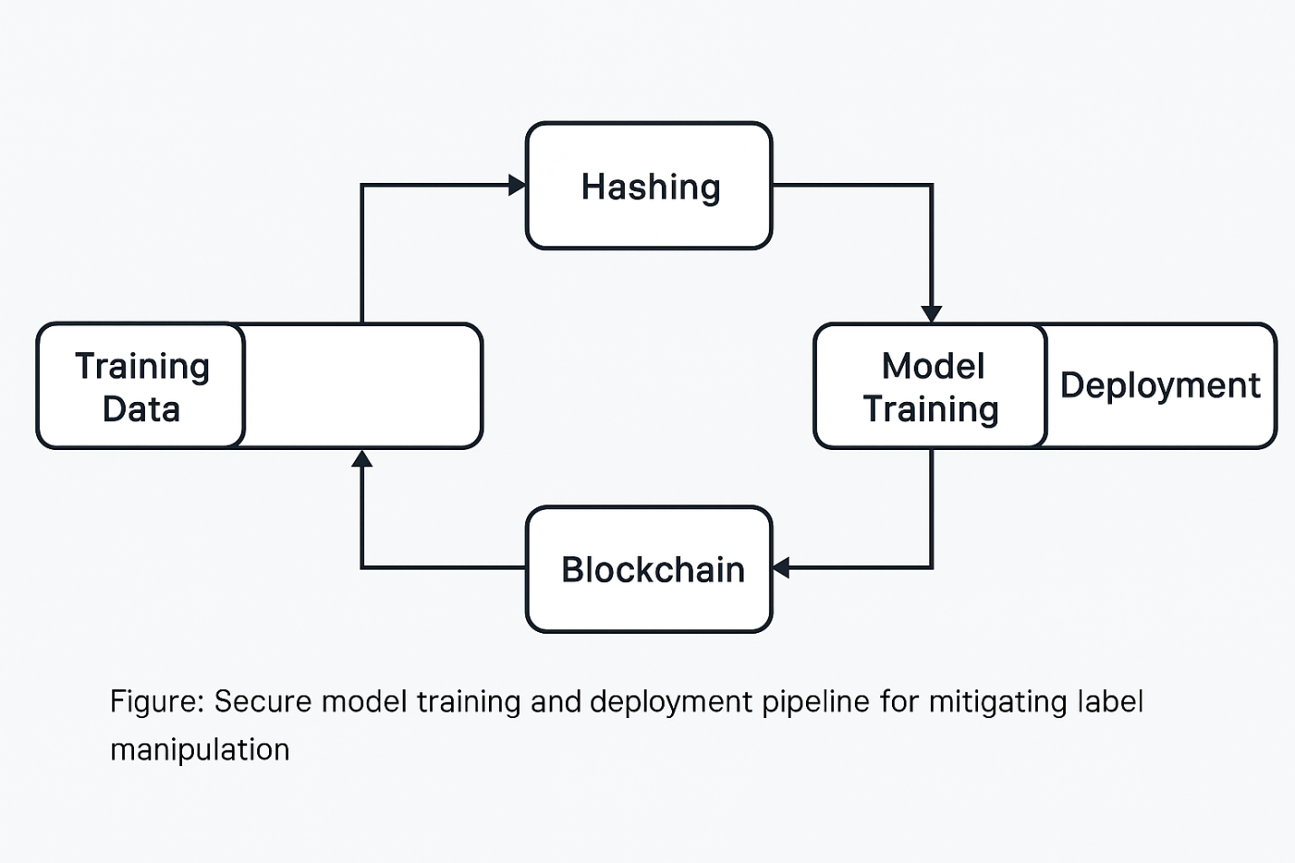

At any point in time, integrity label can be checked through replay and reference against blockchain records.

Summary
This section shows a blockchain-based security measure for machine learning training the integrity of pipeline label. This is through its use of lightweight verification techniques, storages based on immutability, and cryptographic hashing with extra features. This addresses the inherent susceptibility exploited by label poisoning attacks. This enhances trust levels in such AI-driven intrusion detection systems which is implemented in high-stakes or adversarial environments.

References
- Chen, X., Liu, C., Li, B., Lu, K. and Song, D., 2017. Targeted backdoor attacks on deep learning systems using data poisoning. arXiv preprint arXiv:1712.05526. [Available at: https://arxiv.org/abs/1712.05526]

- Liang, X., Zhao, J., Shetty, S., Li, D. and Zhang, J., 2022. Blockchain for data security and privacy in AI-enabled healthcare. IEEE Transactions on Network Science and Engineering, 9(1), pp. 149–162. [Available at: https://ieeexplore.ieee.org/document/9342712]

