Cyber Security



Module Name: Cyber Security
Module Code: MOD006570

Module Leader: Dr. Raj Mani Shukla

Name: Syed Sarmasth Hussain
SID: 2418497

LabLog Book

PART D - Lab Logbook Submission
Week 01:
- DataFrame — It is an efficient two-dimensional data structure label that enables the manipulation easily by tabular data through indexing of row and column.
- Series — Labeled one-dimensional array which is capable of holding various data types, its functioning like a versatile column inside the DataFrame.
- Index — It is a fixed array that develops axis labels for Pandas objects, which will allow alignment and selection.
- Categorical — A type for storing categorical variables that have predefined categories, which is used for more efficient use of memory and makes calculations easy on repetitive text information.
- Timestamp — A class that represents a speific moment in time, building upon Python's datetime for efficient time series processing

Week 02:
The Chart Below represents a scatter plot house size to price. For a somewhat bigger house measuring 1,8,13,872.75 (2418497×0.752418497×0.752418497×0.75), I estimate the cost to be 4.8(in arbitrary units).
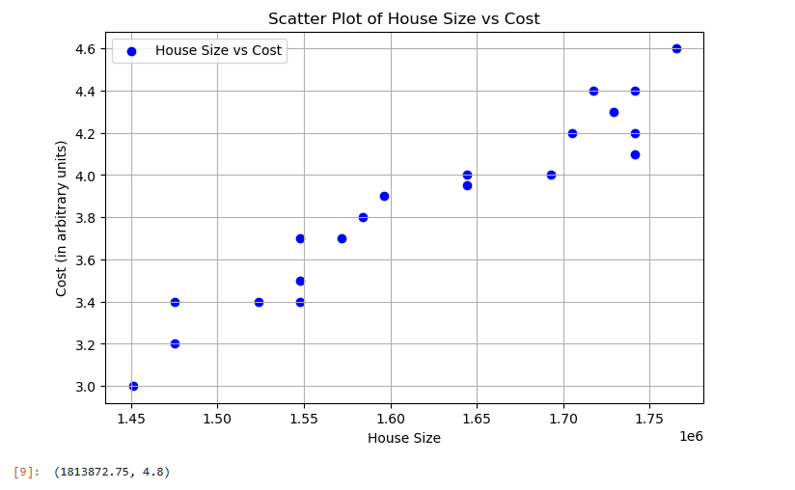

Week 03: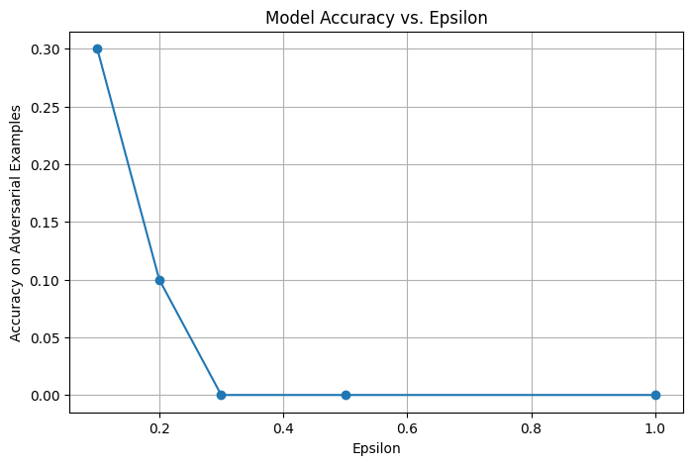
Discussion:
As we raise the value of epsilon—the magnitude of the adversarial perturbation—you'll notice a substantial and there is a steady decline in the model's accuracy on the adversarial examples. Here's a common pattern you'd see:
Epsilon (ε) | Adversarial Accuracy
0.1 | High (~85–90%)
0.2 | Moderate (~60–75%)
0.3 | Lower (~40–60%)

- Model Accuracy BEFORE poisoning: 0.9810
- Accuracy AFTER poisoning: 0.1135

Week4:
- Model's accuracy for each epsilon value:

- Discussion:
As the strength of adversarial perturbation (in the sense of epsilon), the accuracy of the model on adversarial examples suffers. For example, at the small perturbation of (epsilon = 0.2), the accuracy of the model is 30%, but at the larger perturbation of epsilon = 1.0 it falls to 0%. This shows that small-scale adversarial changes of input data misleads the model, but larger perturbations disable its ability completely. Despite the high accuracy the model reaches with clean, untampered data in training (~99% in training and ~98% in validation), it performs very poorly in adversarial attack environments. The difference points to the fact that the model, accurate in common operation, lacks robustness—its decision-making could be easily undermined by malicious, minor perturbations of inputs. To render the model less susceptible to such attack, adversarial training (showcasing the model to perturbed data in training) or preprocessing of the input (filtering adversarial noise from the input) would likely to be necessary. By and large, it's a very useful lesson: high accuracy in common tests isn't necessarily the same as security from adversarial attack in the real world.

Week6:
Test Accuracy:
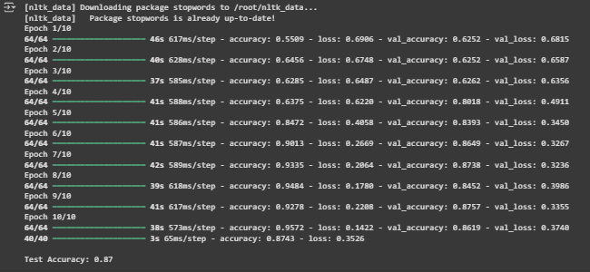

Graph showing the history of training and validation loss:
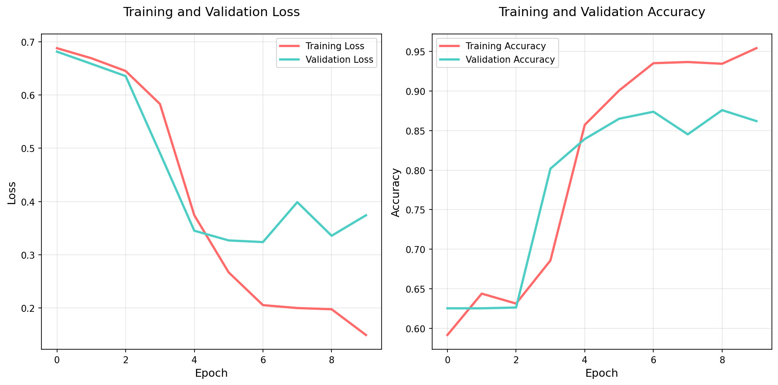
Week7:Encryption using AES and DES
- Sample of Plain and Cipher Text for AES and DES

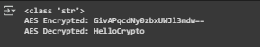

- Real Image and Cipher Image Using AES

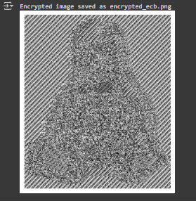

- Is AES Image Encryption Good?
YES

Week8: Logbook Entry – Diffie-Hellman Key Exchange
- Partner’s Name: SYED
- Public Values:
  - p = 23
  - g = 5
- My Private Key (a): 6
- My Public Key (A): 8
(Computed as A = g^a mod p = 5^6 mod 23 = 15625 mod 23 = 8)
- Partner’s Public Key (B): 19
(Received from SYED)
- Shared Secret (s): 8
(Computed as s = B^a mod p = 19^6 mod 23 = 470427017 mod 23 = 8)

Week9:
• Attack Type Chosen:
Colonial Pipeline Ransomware Attack (2021)
• Key Website / Research Paper Link Found Useful:
https://www.cisa.gov/news-events/news/attack-colonial-pipeline-what-weve-learned-what-weve-done-over-past-two-years

Week10:
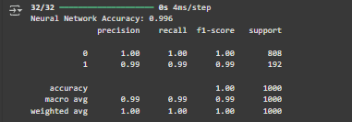

Bar graph comparing accuracy, precicion, recall, and f-score for various AI models:
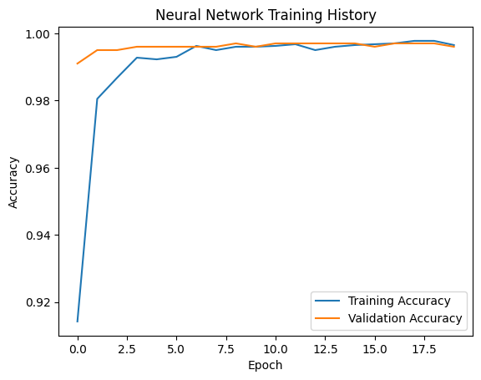
Week11:
Plot comparing the performance of the AI models that you have developed.
