Task: Deploy a Sample index.html File on Apache

Step-by-Step Implementation

1. Start Your Ubuntu VM
Start your Ubuntu virtual machine in VMware.
Log in to your Ubuntu system.

2. Open a Terminal
Press Ctrl + Alt + T to open the terminal.

3. Install Apache Web Server
Run the following commands to update the package list and install Apache:
sudo apt update
sudo apt install apache2 –y
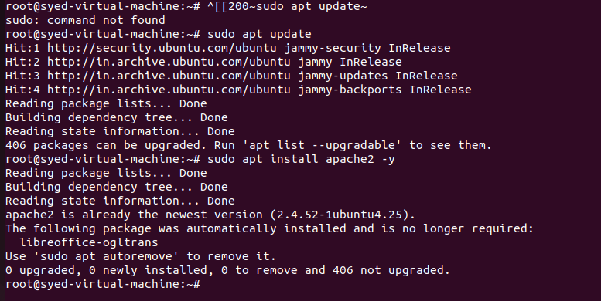

4. Start and Enable the Apache Service
Run the following commands:
sudo systemctl start apache2
sudo systemctl enable apache2
Check the Apache service status:
sudo systemctl status apache2
Expected result: active (running).
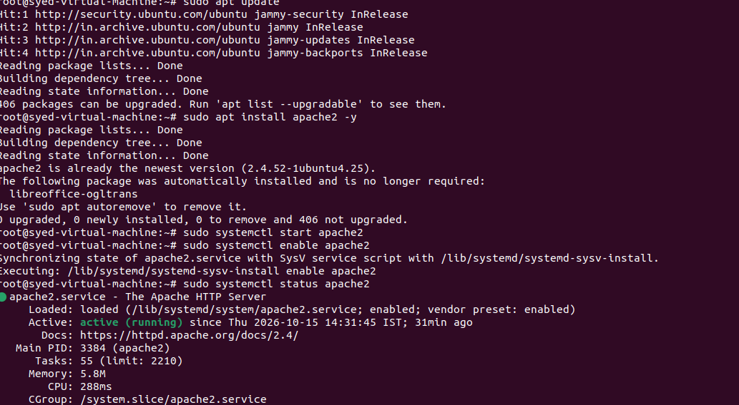

5. Navigate to the Apache Web Directory
The default Apache document root on Ubuntu is /var/www/html.
cd /var/www/html
ls –l
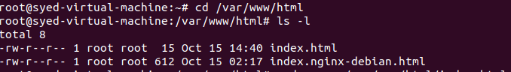

6. Create a Sample index.html File
Open the HTML file using the Nano text editor:
sudo nano /var/www/html/index.html
Enter the following HTML code:
<!DOCTYPE html>
<html>
<head>
<title>My Apache Website</title>
</head>
<body>
<h1>Welcome to My Apache Server!</h1>
<p>This is my sample index.html page.</p>
</body>
</html>
Save and exit Nano: press Ctrl + O to save, press Enter to confirm the filename, then press Ctrl + X to exit.

7. Set the Correct File Permissions
Run the following command:
sudo chmod 644 /var/www/html/index.html
Verify the file:
ls -l /var/www/html/index.html
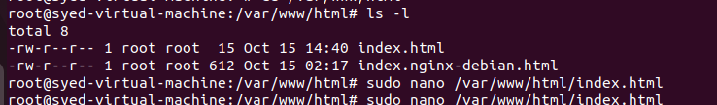

8. Test the Apache Web Page
Open Firefox in Ubuntu and enter:
http://localhost
Expected result: The browser displays “Welcome to My Apache Server!” and the sample paragraph.
If Apache is configured to use a custom port, such as 82, use:
http://localhost:82
The port must match your Apache virtual host configuration.
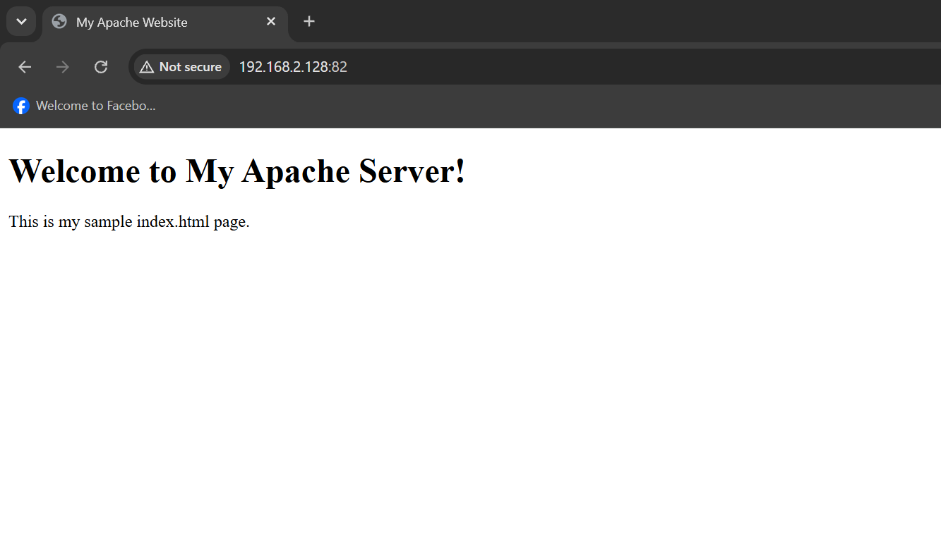

9. Verify the Apache Configuration
Run:
sudo apache2ctl configtest
Expected output:
Syntax OK
If you made configuration changes, reload Apache:
sudo systemctl reload apache2

Outcome
Successfully installed and started Apache, created a sample index.html file in the default document root, and deployed a basic web page accessible through a browser.

