Bash Script Task 8: Calculator
Step-by-step guide | Microsoft Word 2007 compatible

Objective
Create a Bash script that asks the user to enter two numbers and an arithmetic operation, then displays the result. The script supports addition (+), subtraction (-), multiplication (*), and division (/).

Step 1: Open a Linux terminal
Connect to your Linux/EC2 server, or open Ubuntu. These commands are intended for Linux Bash, not Windows Git Bash if you need to use Linux services or tools.

Step 2: Create the script file
Run this command to create a file named calculator.sh:
nano calculator.sh

Step 3: Add the Bash code
#!/bin/bash

echo "===== Bash Calculator ====="

read -p "Enter first number: " num1
read -p "Enter an operator (+, -, *, /): " operator
read -p "Enter second number: " num2

# Check that both inputs are numbers (integer or decimal)
if ! [[ "$num1" =~ ^-?[0-9]+([.][0-9]+)?$ ]] || ! [[ "$num2" =~ ^-?[0-9]+([.][0-9]+)?$ ]]; then
echo "Error: Please enter valid numbers."
exit 1
fi

# Use awk for arithmetic, including decimal values
case "$operator" in
+) result=$(awk -v a="$num1" -v b="$num2" 'BEGIN { print a + b }') ;;
-) result=$(awk -v a="$num1" -v b="$num2" 'BEGIN { print a - b }') ;;
'*') result=$(awk -v a="$num1" -v b="$num2" 'BEGIN { print a * b }') ;;
/)
if awk -v b="$num2" 'BEGIN { exit (b == 0) ? 0 : 1 }'; then
echo "Error: Division by zero is not allowed."
exit 1
fi
result=$(awk -v a="$num1" -v b="$num2" 'BEGIN { print a / b }')
;;
*)
echo "Error: Unsupported operator. Use +, -, *, or /."
exit 1
;;
esac

echo "Result: $num1 $operator $num2 = $result"
Save in nano: press Ctrl+O, press Enter, then press Ctrl+X.
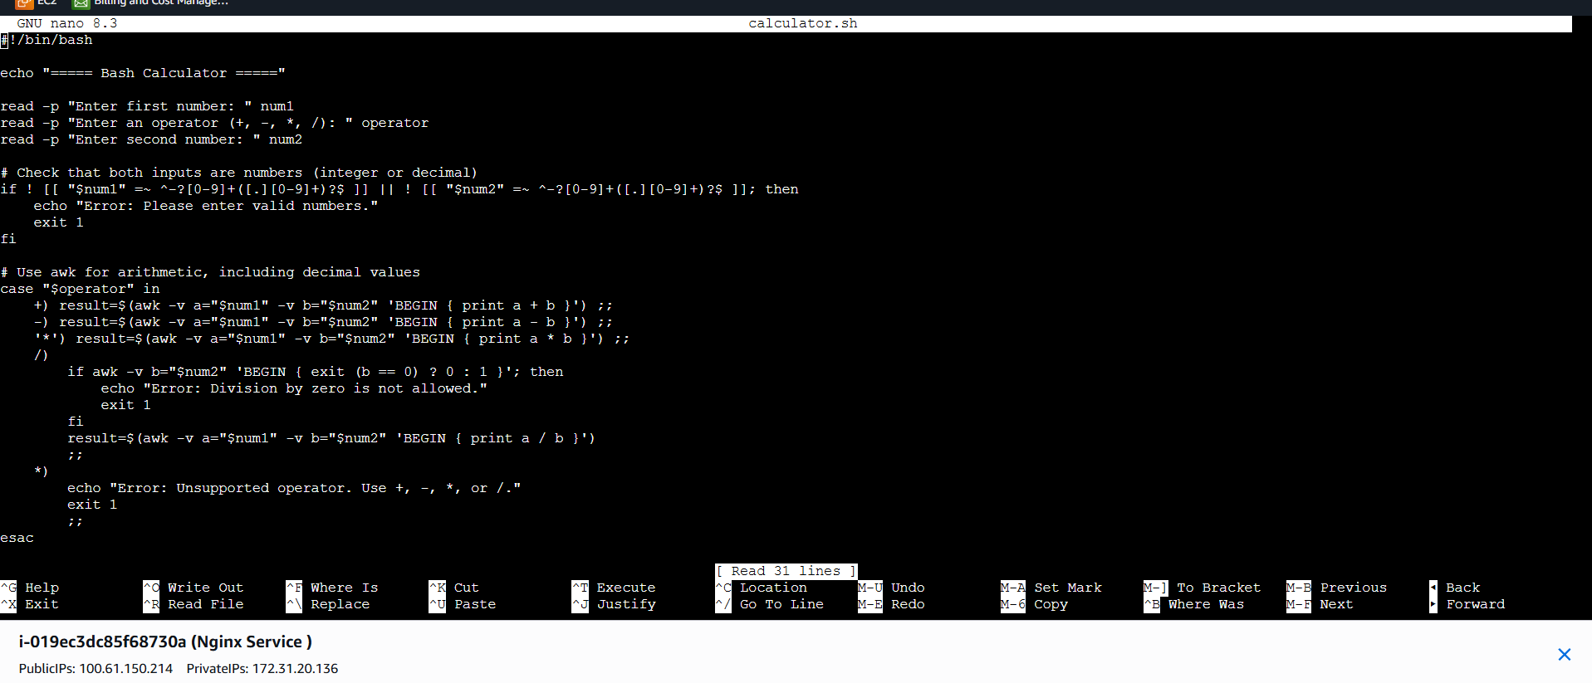

Step 4: Make the script executable
Run:
chmod +x calculator.sh

Step 5: Execute the script
Run:
./calculator.sh

Step 6: Example output
===== Bash Calculator =====
Enter first number: 10
Enter an operator (+, -, *, /): +
Enter second number: 5
Result: 10 + 5 = 15
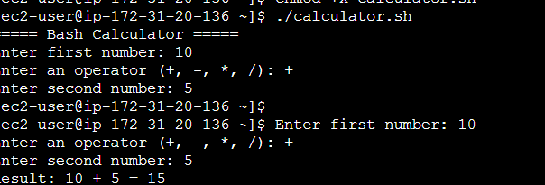

More examples
First number | Operator and second number | Result
10 | - 3 | 7
4 | * 5 | 20
20 | / 4 | 5
2.5 | + 1.5 | 4

How it works
- read -p asks the user to enter values.
- The input check rejects values that are not valid integers or decimals.
- case chooses the calculation based on the operator.
- awk performs arithmetic and supports decimal values.
- The division branch prevents division by zero.
- The final echo prints the calculation and result.

Troubleshooting
If you see “Permission denied”, run chmod +x calculator.sh and try again.
If you see “awk: command not found”, install awk using your Linux distribution package manager. On Amazon Linux, try sudo dnf install gawk -y (or sudo yum install gawk -y on older versions).
If you are using Windows Git Bash, the script may run there too if awk is available, but the steps above are written for a Linux Bash environment.

Expected folder structure
your-folder/
└── calculator.sh
Task complete: the calculator script is created, made executable, and run with example inputs.

