BASH SCRIPT TASK
Check Whether a Directory Exists; Create It If Missing

Objective
Create a Bash script that checks whether a directory exists. If it exists, the script displays a message. If it does not exist, the script creates the directory.

Step 1: Open a terminal
Open Ubuntu/Linux terminal, or use Git Bash on Windows for basic Bash scripting. The commands below are intended for Bash.

Step 2: Create the script file
Run this command to create a file named check_directory.sh:
nano check_directory.sh

Step 3: Write the Bash script
#!/bin/bash
# Directory to check
DIR="my_directory"
if [ -d "$DIR" ]; then
echo "Directory already exists: $DIR"
else
mkdir -p "$DIR"
if [ $? -eq 0 ]; then
echo "Directory created successfully: $DIR"
else
echo "Error: Could not create directory: $DIR"
exit 1
fi
fi

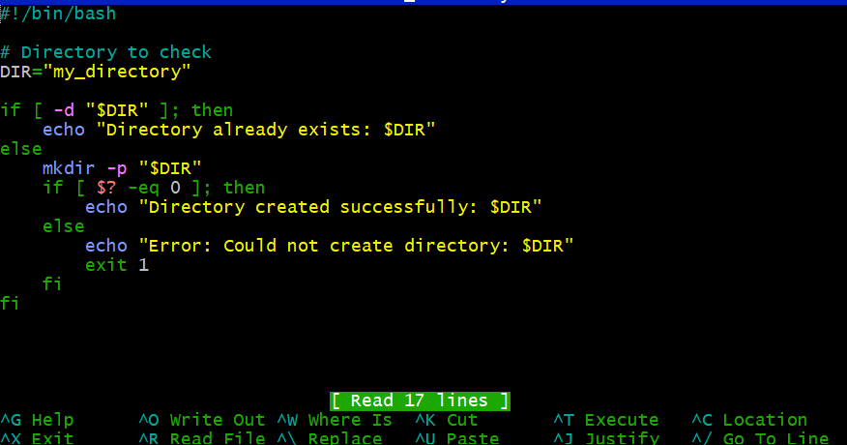

Step 4: Save the file
In nano, press Ctrl+O, press Enter to save, then press Ctrl+X to exit.

Step 5: Give execute permission
chmod +x check_directory.sh

Step 6: Run the script
./check_directory.sh
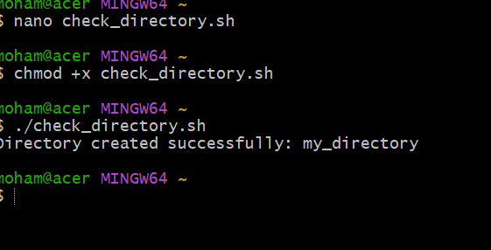

Step 7: Check the result
If my_directory does not exist, the script creates it and prints a success message. Run the script again: it should print that the directory already exists.

Example output (first run)
Directory created successfully: my_directory
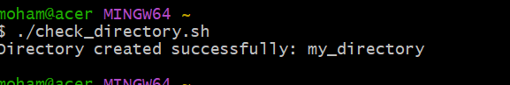

Example output (second run)
Directory already exists: my_directory
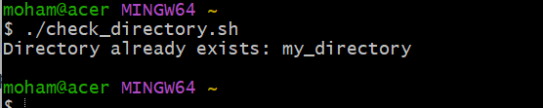

How it works
- if [ -d "$DIR" ] checks whether the path exists and is a directory.
- mkdir -p "$DIR" creates the directory if it is missing. The -p option avoids an error if the directory already exists.
- Quotes around "$DIR" help handle directory names that contain spaces.
- Change DIR="my_directory" to the directory name you want to check.

Note
This script checks the directory relative to the current working directory. If you use an absolute path, such as DIR="/home/ec2-user/my_directory", it checks that exact location. You may need appropriate permissions to create a directory at the chosen location.

