Bash Script: Monitor Disk Space and Send Email Alert Above 80%
Bash Script Tasks | DevOps Cloud Documents

Objective
Monitor disk usage on an AWS EC2 Linux server and send an email notification through Amazon SES when a monitored filesystem exceeds 80% usage.

Step 1: Connect to your EC2 instance
1. Sign in to the AWS Management Console.
2. Open EC2 → Instances.
3. Select your running instance.
4. Click Connect → EC2 Instance Connect → Connect.
5. Confirm that the Linux terminal opens.

Step 2: Check disk space
Run:
df -h
Example output:
Filesystem Size Used Avail Use% Mounted on
/dev/xvda1 20G 17G 3.0G 85% /
In this example, the root filesystem is using 85%, which exceeds the 80% threshold.
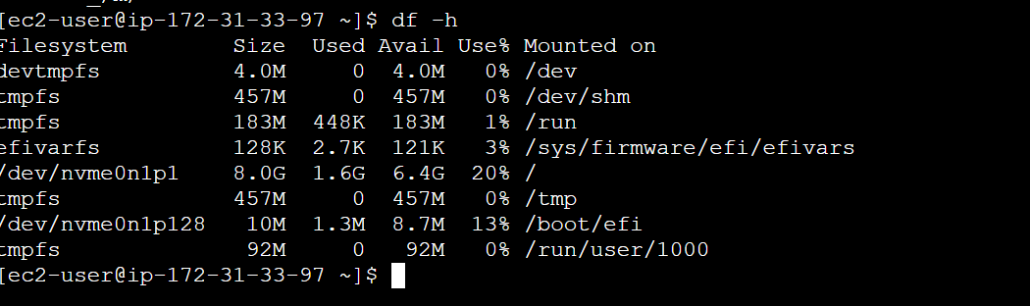

Step 3: Install AWS CLI (if needed)
Check whether AWS CLI is installed:
aws --version
If it is missing, install it using the official AWS CLI installation instructions for your Linux distribution.

Step 4: Create the Bash script
Create the file:
nano disk_monitor.sh
Paste the following script. Replace the example email addresses and Region with your actual verified values.
#!/bin/bash
# Disk Space Monitoring Script
# Send an email if disk usage exceeds 80%
THRESHOLD=80
FROM_EMAIL="verified-syedi7254@gmail.com"
TO_EMAIL="syedi7254@gmail.com"
AWS_REGION="us-east-1"
HOSTNAME=$(hostname)
ALERT=""
# Check disk usage
while read -r filesystem size used available usage mountpoint
do
USAGE=${usage%\%}
if [ "$USAGE" -gt "$THRESHOLD" ]; then
ALERT="${ALERT}
WARNING: Disk space usage is above ${THRESHOLD}%!
Server: ${HOSTNAME}
Filesystem: ${filesystem}
Mount Point: ${mountpoint}
Disk Usage: ${usage}
Used Space: ${used}
Available Space: ${available}
"
fi
done < <(df -P -x tmpfs -x devtmpfs | tail -n +2)
# Send an email if a threshold is exceeded
if [ -n "$ALERT" ]; then
aws ses send-email \
--region "$AWS_REGION" \
--from "$FROM_EMAIL" \
--destination "ToAddresses=$TO_EMAIL" \
--message "Subject={Data=Disk Space Alert on $HOSTNAME},Body={Text={Data=$ALERT}}"
if [ $? -eq 0 ]; then
echo "Email alert sent successfully."
else
echo "Failed to send email alert."
exit 1
fi
else
echo "Disk usage is below or equal to ${THRESHOLD}%."
fi

Step 5: Configure Amazon SES
1. In the SES Console, choose the same AWS Region configured in the script.
2. Verify the sender email address.
3. If SES is in the sandbox, verify the recipient address as well, or request production access.
4. Attach an IAM role to the EC2 instance with permission to send email through SES (ses:SendEmail) for the appropriate identity.
5. Do not store AWS access keys or SMTP passwords in the script.

Step 6: Confirm AWS access and test SES
aws sts get-caller-identity
aws ses send-email \
--region us-east-1 \
--from "verified-sender@example.com" \
--destination "ToAddresses=your-email@example.com" \
--message 'Subject={Data=SES Test},Body={Text={Data=Test email from EC2}}'
Use your actual verified addresses and Region. The test email must succeed before relying on alerts.
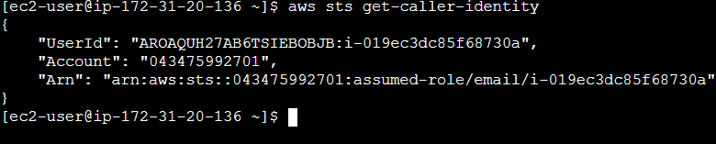
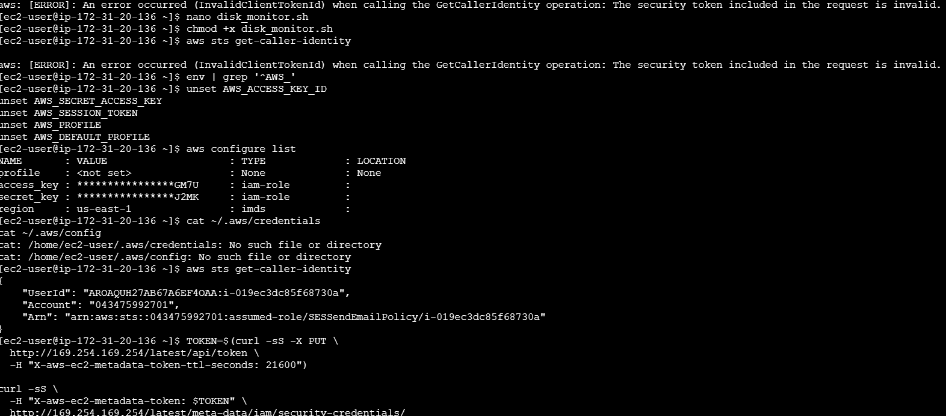

Step 7: Make the script executable and run it
chmod +x disk_monitor.sh
ls -l disk_monitor.sh
./disk_monitor.sh
When no filesystem exceeds 80%, the script reports that usage is below or equal to the threshold. When usage exceeds 80%, it attempts to send an SES email and reports success or failure.
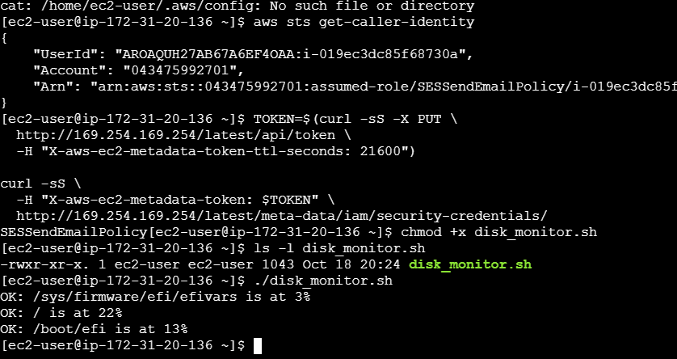

Step 8: Test safely without filling the disk
Temporarily lower the threshold to 1% to test whether the alert path works:
sed -i 's/THRESHOLD=80/THRESHOLD=1/' disk_monitor.sh
./disk_monitor.sh
sed -i 's/THRESHOLD=1/THRESHOLD=80/' disk_monitor.sh
Restore the threshold to 80% after testing.

Step 9: Schedule automatic monitoring with cron
Open the cron editor:
crontab -e
Add the following line, adjusting the path if your script is stored elsewhere:
*/5 * * * * /home/ec2-user/disk_monitor.sh >> /home/ec2-user/disk_monitor.log 2>&1
This runs the script every five minutes. Verify the entry with:
crontab -l
View the log with:
tail -f /home/ec2-user/disk_monitor.log
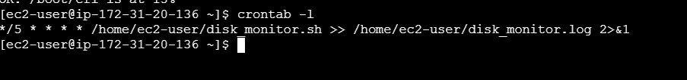

Step 10: Quick reference
Task | Command
Check disk usage | df -h
Create the script | nano disk_monitor.sh
Make executable | chmod +x disk_monitor.sh
Run the script | ./disk_monitor.sh
List cron jobs | crontab -l
View log | tail -f /home/ec2-user/disk_monitor.log

Expected result
The EC2 server checks monitored filesystems, detects usage above 80%, and sends an email through Amazon SES when the SES identity, AWS Region, IAM permissions, and recipient settings are configured correctly.

