BASH SCRIPT TASK 2
Check Whether a Directory Exists

Objective
Create a Bash script that checks whether a directory exists and displays the appropriate message.

Step 1: Create the script file
Open Ubuntu Terminal (Ctrl + Alt + T) or Git Bash and run:
nano check_directory.sh

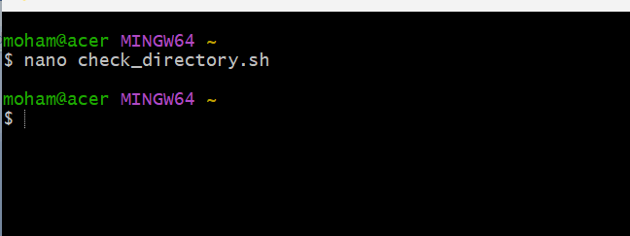

Step 2: Write the Bash script
#!/bin/bash
echo "Enter directory name:"
read dir
if [ -d "$dir" ]; then
echo "Directory exists."
else
echo "Directory does not exist."
fi

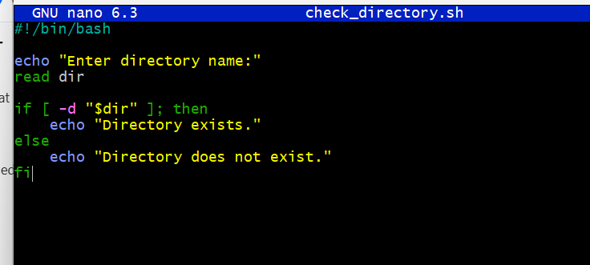

Step 3: Save the file
- Press Ctrl + O to save the file.
- Press Enter to confirm the filename.
- Press Ctrl + X to exit Nano.

Step 4: Give execute permission
Run this command:
chmod +x check_directory.sh
This gives the script permission to run.
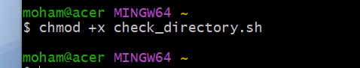

Step 5: Run the script
./check_directory.sh

Step 6: Check the output
Example 1 — directory exists:
Enter directory name:
Documents
Directory exists.
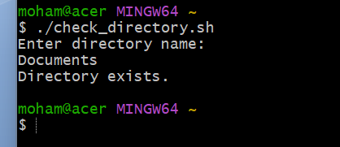
Example 2 — directory does not exist:
Enter directory name:
myfolder
Directory does not exist.

Easy Explanation
Command | Meaning
#!/bin/bash | Runs the script using Bash.
echo | Displays a message.
read dir | Accepts the directory name from the user.
[ -d "$dir" ] | Checks whether the given path is a directory.
then | Runs commands when the condition is true.
else | Runs commands when the condition is false.
fi | Ends the if statement.

Note: The -d condition checks whether a directory exists. It does not treat a regular file as a directory.

