BASH SCRIPT TASK 3
Create Multiple Files

Objective
Create a Bash script that asks how many files to create, then creates that number of text files automatically.

Step 1: Create the script file
Open Ubuntu Terminal (Ctrl + Alt + T) or Git Bash and run:
nano create_files.sh


Step 2: Write the Bash script
#!/bin/bash

touch file1.txt file2.txt file3.txt file4.txt file5.txt

echo "5 files created successfully!
echo "All files created."
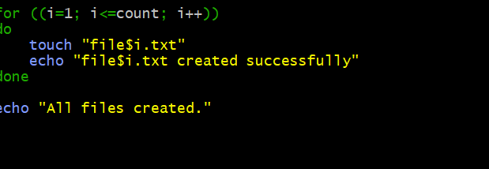

Step 3: Save the file
- Press Ctrl + O to save.
- Press Enter to confirm the filename.
- Press Ctrl + X to exit Nano.

Step 4: Give execute permission
Run:
chmod +x create_files.sh

Step 5: Execute the script
./create_files.sh

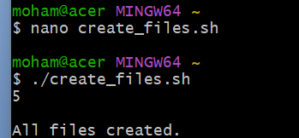

Step 6: Enter the number of files
For example, enter 5. The script creates file1.txt, file2.txt, file3.txt, file4.txt, and file5.txt in the current directory.
Enter the number of files to create:
5
file1.txt created successfully
file2.txt created successfully
file3.txt created successfully
file4.txt created successfully
file5.txt created successfully
All files created.

Step 7: Verify the files
Run:
ls -l file*.txt
This lists the matching text files in the current directory.
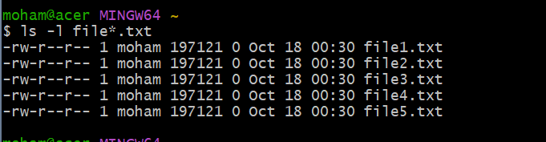

Easy Explanation
Command | Meaning
echo | Displays a message.
read count | Reads the number entered by the user.
for ((...)) | Repeats the commands for each file number.
touch "file$i.txt" | Creates an empty file with the current number in its name.
done | Marks the end of the loop.
chmod +x | Makes the script executable.
./create_files.sh | Runs the script from the current directory.

Important note: Run the script in a test folder. If files with the same names already exist, touch updates their timestamps but does not erase their contents.

