Git Guide: How to Cherry-Pick a Commit
Take a specific commit from one branch and apply it to another branch without merging the entire source branch.
Overview & Setup
Objective: Take a specific commit from one branch and apply it to another branch without merging the entire source branch.
Environment: Git Bash on your New-repository project.
1. Step-by-Step Implementation
Step 1: Open your repository
cd ~/Desktop/New-repository
Check the current branch and working directory:
git branch
git status
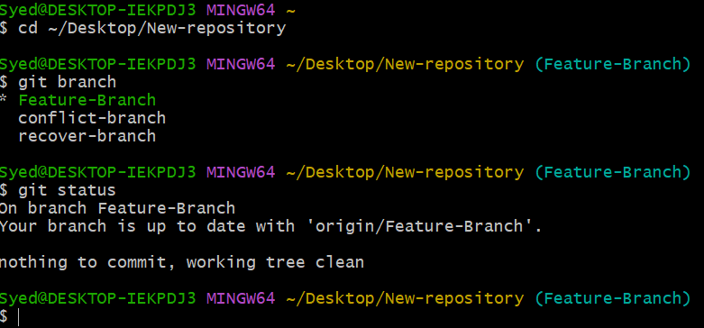
Step 2: Create a source branch and a sample commit
Create a branch named cherry-source:
git switch -c cherry-source
Create a sample file and commit it:
echo "This is a cherry-pick practice file" > cherry.txt
git add cherry.txt
git commit -m "Add cherry-pick practice file"
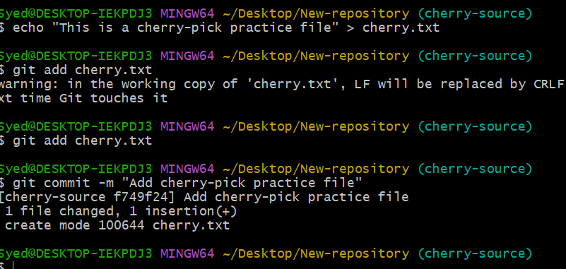
Step 3: Find the commit ID
git log --oneline
Example output:
a1b2c3d Add cherry-pick practice file
Your actual commit ID will be different. Copy the ID shown on your screen.
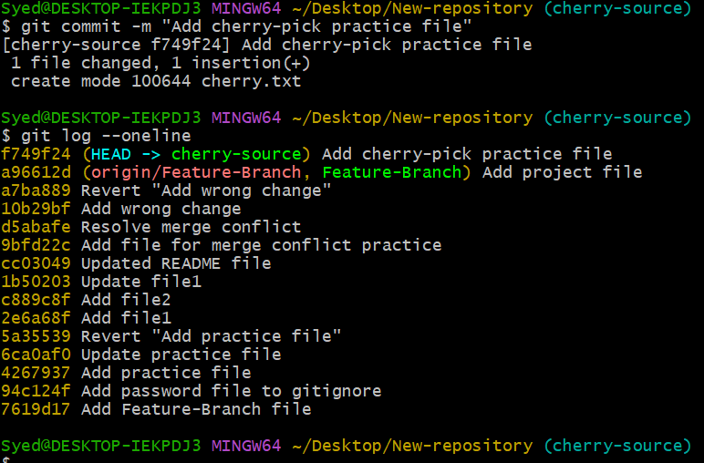
Step 4: Switch to the destination branch
Switch to the branch where you want to apply the commit. For this example, use your existing Feature-Branch.
git switch Feature-Branch
Step 5: Cherry-pick the specific commit
Replace a1b2c3d with your actual commit ID from Step 3.
git cherry-pick f749f24
If successful, Git will create a new commit on Feature-Branch containing the selected changes.
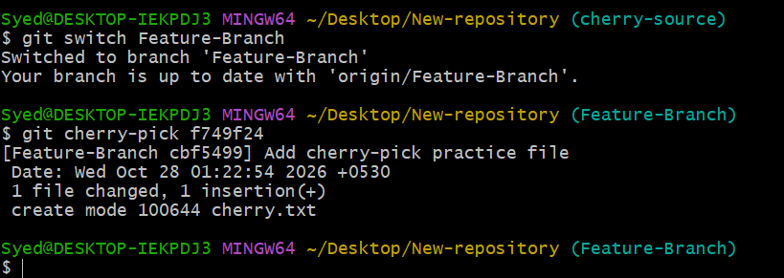
Step 6: Verify the changes
git log --oneline
git status
ls
You should see cherry.txt in the destination branch, and the cherry-picked commit should appear in the commit history.
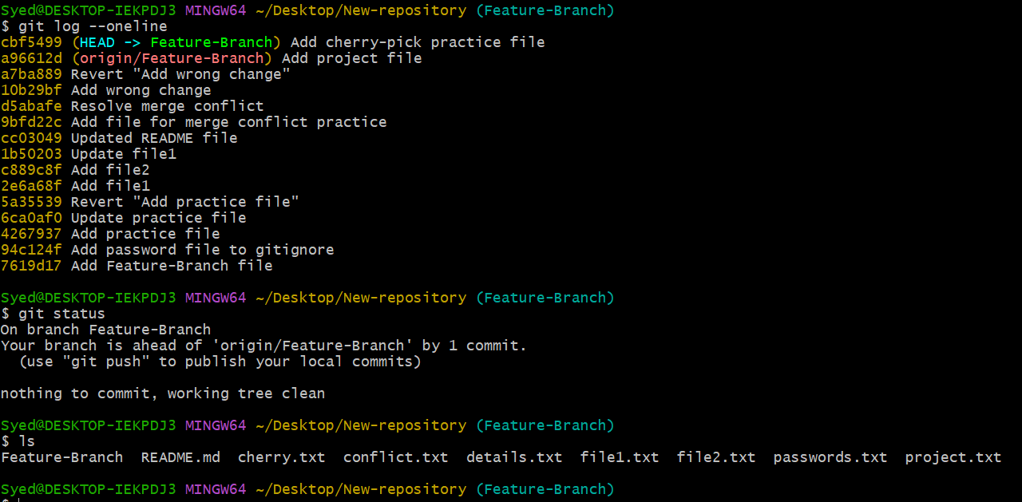
Step 7: Push the destination branch to GitHub (optional)
git push origin Feature-Branch
2. Expected Result
• Source branch (cherry-source): Contains the original commit and cherry.txt.
• Destination branch (Feature-Branch): Receives the selected commit and its file without merging the entire source branch.
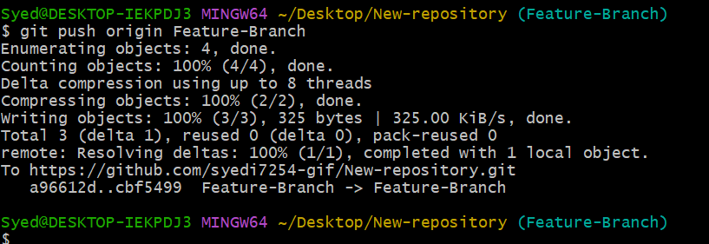
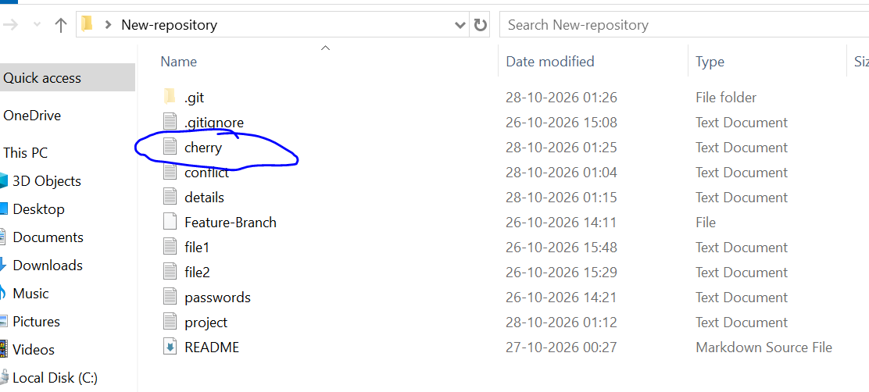
3. Important Commands Reference
Command | Purpose
git log --oneline | View commit IDs
git switch cherry-source | Switch to the source branch
git switch Feature-Branch | Switch to the destination branch
git cherry-pick <commit-id> | Apply the selected commit
git status | Check repository status
git push origin Feature-Branch | Push changes to GitHub

📌 Handling Conflicts
If a cherry-pick conflict occurs, resolve the conflicted files, run git add <file>, and then run git cherry-pick --continue.
Outcome: Successfully apply a specific commit from one branch to another using Git Cherry-pick.

