Task: Clone with Sparse Checkout in Git
Technical Implementation Guide & Lab Guide
1. Objective
To clone a GitHub repository and download only a specific subdirectory instead of checking out all the files in the repository. This is particularly useful when working with large repositories to conserve bandwidth and local disk storage.
2. Prerequisites
- Git installed on Windows.
- Git Bash available.
- A GitHub repository URL.
- A repository that contains at least one subdirectory.
3. Step-by-Step Implementation
We will use your existing New-repository project as a reference, but sparse checkout works best when the repository contains subdirectories. Replace the example URL and directory name below with your actual repository details.
Step 1: Open Git Bash
Open Git Bash and move to the Desktop:
cd ~/Desktop

Step 2: Clone the repository without checking out files
Replace YOUR_USERNAME and YOUR_REPOSITORY with your GitHub details. This downloads the repository's Git history and metadata without checking out the working files.
git clone --no-checkout https://github.com/YOUR_USERNAME/YOUR_REPOSITORY.git sparse-demo

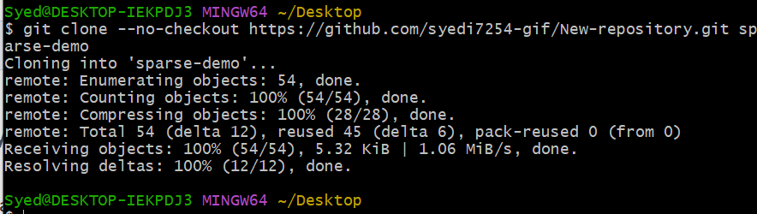
Step 3: Enter the cloned repository
Navigate into the newly created directory:
cd sparse-demo

Step 4: Enable sparse checkout
Initialize sparse checkout in cone mode (the recommended mode for selecting directories):
git sparse-checkout init --cone

Step 5: Select the required subdirectory
Specify the directory you want to check out (e.g., docs). Replace docs with your target subdirectory:
git sparse-checkout set docs

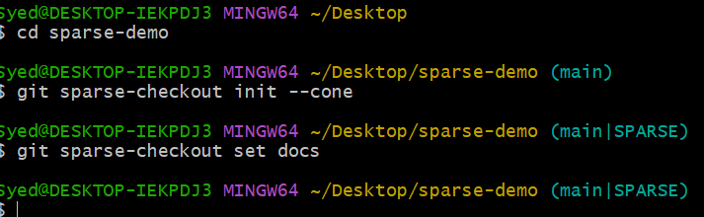
Step 6: Verify the selected directory
List the files in the directory. You should see the docs directory and its contents, rather than all the repository's top-level files:
ls

To confirm the sparse checkout configuration, run:
git sparse-checkout list

Expected output:
docs

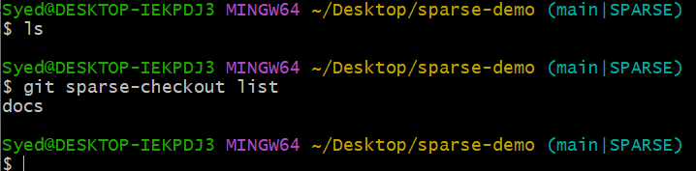
Step 7: Check Git status
Confirm the repository's current working-tree status:
git status
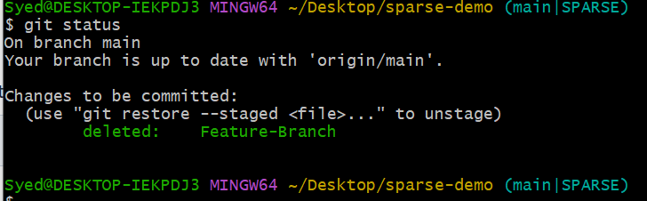
4. Expected Result
- The repository is cloned successfully.
- Sparse checkout is enabled.
- Only the selected directory is checked out into the working tree.
- You can work with files in that directory using normal Git commands.
5. Useful Commands
Command | Purpose
git sparse-checkout init --cone | Enable sparse checkout
git sparse-checkout set docs | Select a directory
git sparse-checkout list | Display selected directories
git sparse-checkout disable | Disable sparse checkout and restore the full working tree

Important: Sparse checkout limits which files appear in your working tree; it does not necessarily limit the Git history downloaded. For a more limited initial clone, you can combine it with --filter=blob:none.

Outcome
You have learned how to clone a Git repository and check out only the subdirectory you need using sparse checkout.

