BASH SCRIPT: DIRECTORY BACKUP
Step-by-step guide for Git Bash (Microsoft Word 2007 compatible)

Objective
Create a Bash script that checks whether a source directory exists and, if it does, creates a compressed backup archive with a date-and-time stamp.

Step 1: Open Git Bash and create a working folder
Enter these commands one at a time:
mkdir backup-task
cd backup-task
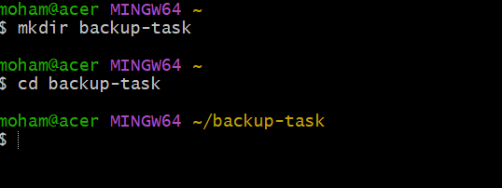

Step 2: Create a sample directory and files
Run the following commands to create example files for the backup:
mkdir mydata
echo "Hello World" > mydata/file1.txt
echo "DevOps Practice" > mydata/file2.txt
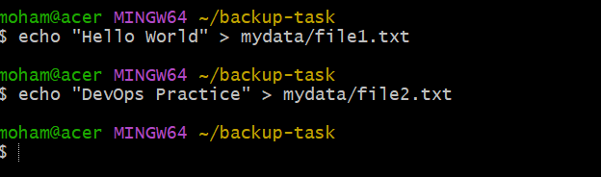

Step 3: Create the backup script
Open a new script file:
nano backup.sh
Copy and paste this script into the editor:
#!/bin/bash

# Directory to back up
SOURCE="mydata"

# Backup destination
DEST="backups"

# Check if the source directory exists
if [ -d "$SOURCE" ]; then
mkdir -p "$DEST"

# Create a timestamped compressed backup
BACKUP_FILE="$DEST/backup_$(date +%Y-%m-%d_%H-%M-%S).tar.gz"

if tar -czf "$BACKUP_FILE" "$SOURCE"; then
echo "Backup completed successfully!"
echo "Backup saved at: $BACKUP_FILE"
else
echo "Error: Backup could not be created."
exit 1
fi
else
echo "Error: Source directory does not exist!"
exit 1
fi
Save in nano: press Ctrl+O, press Enter, then press Ctrl+X. If nano is unavailable, you can use Notepad by running: notepad backup.sh
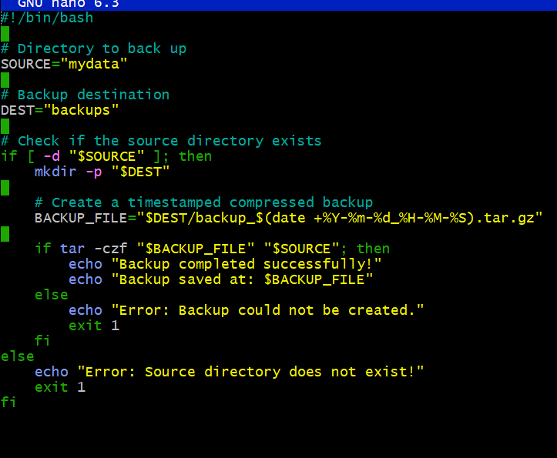

Step 4: Make the script executable
chmod +x backup.sh

Step 5: Run the script
./backup.sh
Example output (the timestamp will be different when you run it):
Backup completed successfully!
Backup saved at: backups/backup_2026-10-18_00-40-00.tar.gz
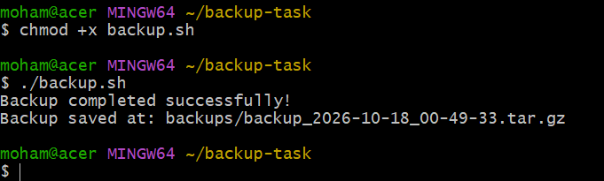

Step 6: Verify the backup
List the folders and files:
ls –R
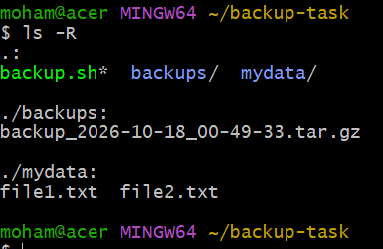
List backup archives:
ls -lh backups
Inspect the contents of a backup archive (use the exact archive name shown by ls):
tar -tzf backups/backup_YYYY-MM-DD_HH-MM-SS.tar.gz
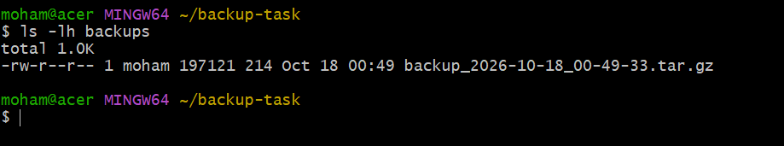

How the commands work
Command / item | Purpose
#!/bin/bash | Runs the script using Bash.
SOURCE="mydata" | Sets the directory to back up.
if [ -d "$SOURCE" ] | Checks that the source directory exists.
mkdir -p "$DEST" | Creates the backup destination if it does not exist.
date +%Y-%m-%d_%H-%M-%S | Adds a timestamp to the backup filename.
tar -czf | Creates a compressed .tar.gz archive.
echo | Displays a message in the terminal.
Use this command in Git Bash:
find . –print
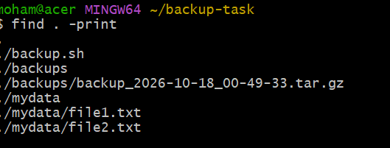

Expected folder structure
backup-task/
├── mydata/
│ ├── file1.txt
│ └── file2.txt
├── backups/
│ └── backup_YYYY-MM-DD_HH-MM-SS.tar.gz
└── backup.sh

Interview answer
“I created a Bash script to back up a directory. The script checks whether the source directory exists, creates the destination folder if necessary, and uses the tar command to create a compressed backup archive with a timestamp.”
Note: This guide is saved as a .docx file, which is supported by Microsoft Word 2007 and later.

