Task: Amend a Commit in Git
Objective: Make a Git commit, identify a missing file, and add that file to the previous commit using git commit --amend without creating a separate commit.

1. Prerequisites
- Git Bash installed on Windows.
- A local Git repository: New-repository.
- Working in the Feature-Branch branch.
- At least one file to commit.

2. Step-by-Step Implementation

Step 1: Open the repository
Open Git Bash and run:
cd ~/Desktop/New-repository
git switch Feature-Branch
git status
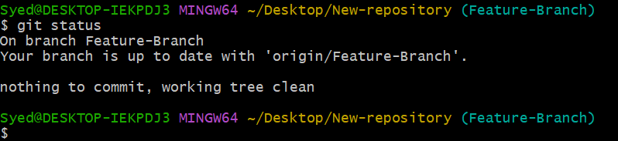

Step 2: Create a sample file
Create a file named project.txt and add some content:
echo "Git amend practice" > project.txt

Step 3: Stage and commit the first file
git add project.txt
git commit -m "Add project file"
This creates the first commit.
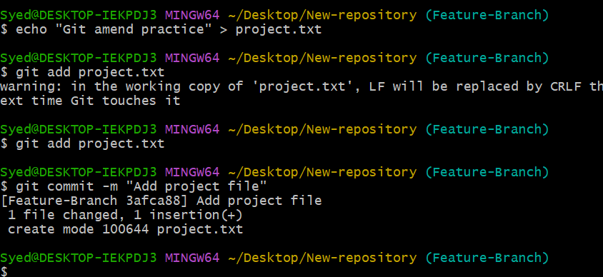

Step 4: Create the missing file
Suppose you forgot to include a file named details.txt. Create it now:
echo "Project details" > details.txt

Step 5: Add the missing file to the previous commit
Stage the missing file:
git add details.txt

Amend the previous commit:
git commit --amend --no-edit

The --no-edit option keeps the existing commit message, Add project file, unchanged.
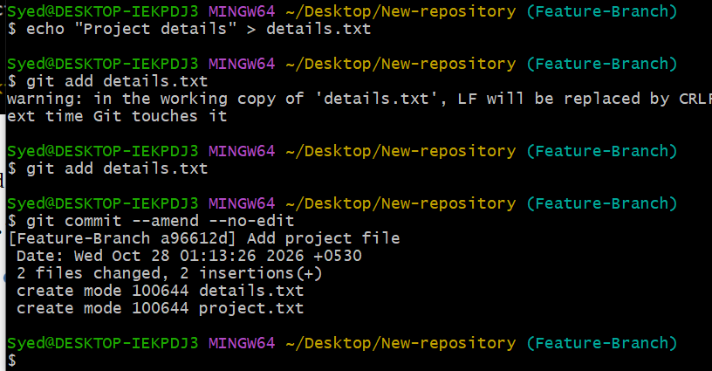

Step 6: Verify the amended commit
Check the latest commit:
git log -1 --oneline

Check which files are included in the commit:
git show --stat HEAD

Check the working directory:
git status

Both project.txt and details.txt should be included in the amended commit, and the working directory should be clean if there are no other changes.
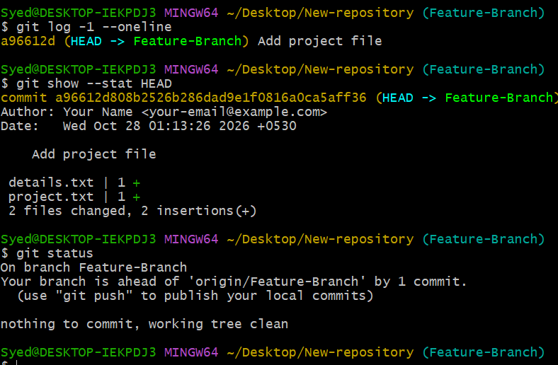

Step 7: Push the changes to GitHub
If this is a commit you have already pushed before, amending it rewrites its history. For your own practice branch, push using:
git push --force-with-lease origin Feature-Branch

Use this carefully on shared branches because rewriting history can affect other contributors.
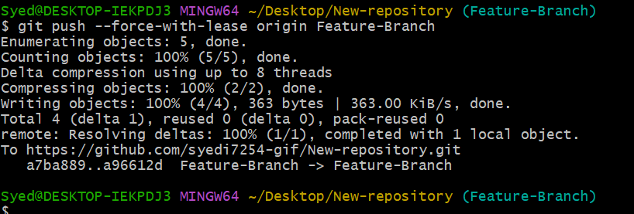

3. Expected Result
- The first commit is created.
- The missing file is added afterward.
- git commit --amend --no-edit updates the previous commit to include both files.
- No separate commit is created for details.txt.
Important: git commit --amend replaces the previous commit with a new commit. If the original commit was already pushed, the remote branch may need updating.

