Git Hands-On Challenge: Detached HEAD State
Objective: Learn how to checkout a specific commit, navigate the detached HEAD state, and safely branch off to continue development.
Task Objective: Checkout a specific commit, enter the detached HEAD state, and create a new branch from that commit to safely save your work.

Step 1: Open Your Repository
Open Git Bash and navigate to your existing practice repository. First, check your active branch:
cd ~/Desktop/New-repository
git branch
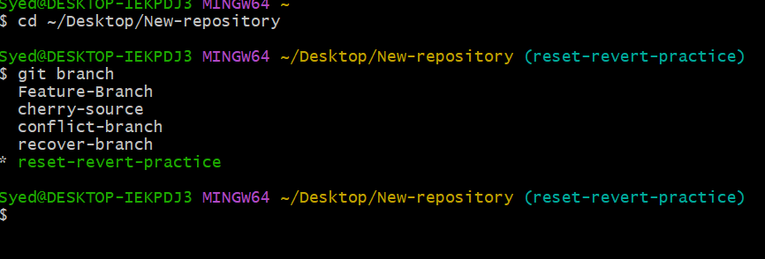
Step 2: Check Commit History
View your recent commit history to obtain a target commit hash:
git log --oneline

Example log output:
81c3817 Revert "Add wrong change"
10b29bf Add wrong change
d5abafe Resolve merge conflict
9bfd22c Add file for merge conflict practice
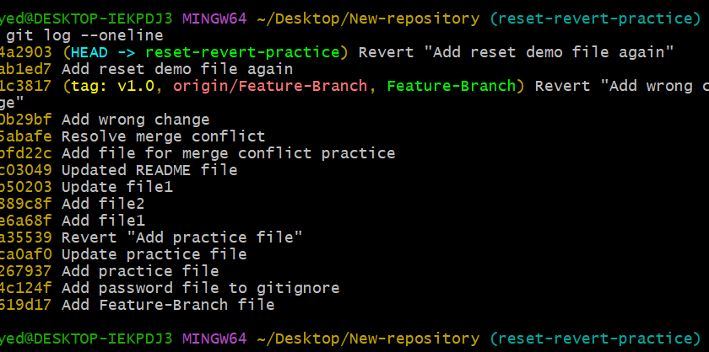
Choose a commit ID from your actual output (for example: 10b29bf).
Step 3: Checkout a Specific Commit
Checkout the selected commit (replace 10b29bf with your target commit ID):
git checkout 10b29bf

Git will display an informative message letting you know that you have entered a detached HEAD state.
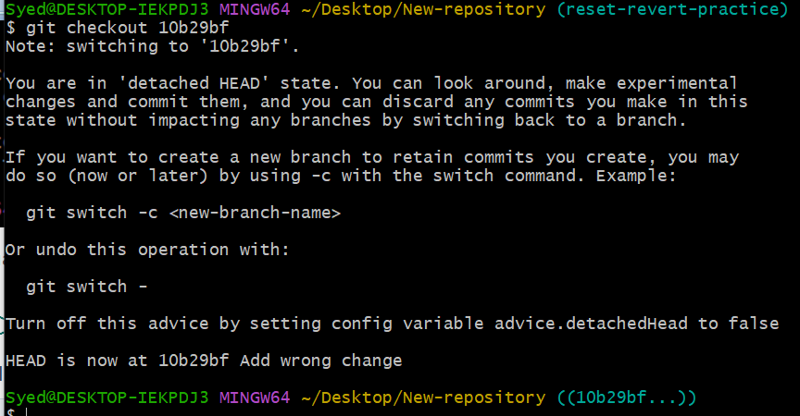
Step 4: Verify Detached HEAD State
Check the current status of your working directory:
git status

Expected output snippet:
HEAD detached at 10b29bf
nothing to commit, working tree clean

Explanation: Being in a detached HEAD state means HEAD points directly to a specific commit rather than a named branch. Any new commits made here will not belong to any branch unless saved to a new branch.
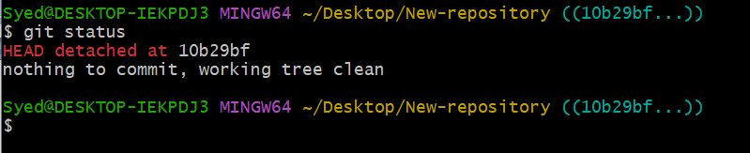
Step 5: Create a New Branch from This Commit
While still in the detached HEAD state, create and switch to a new branch named detached-practice:
git switch -c detached-practice
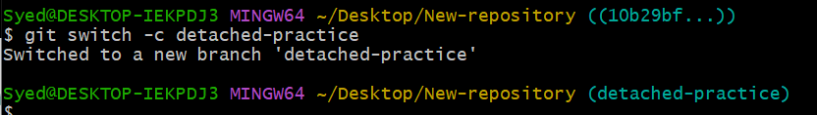
Step 6: Verify the New Branch
Verify that you are now on the newly created branch:
git branch

Expected output (the asterisk indicates your current branch):
* detached-practice
Feature-Branch
conflict-branch
recover-branch

Confirm working tree status:
git status

Expected output:
On branch detached-practice
nothing to commit, working tree clean
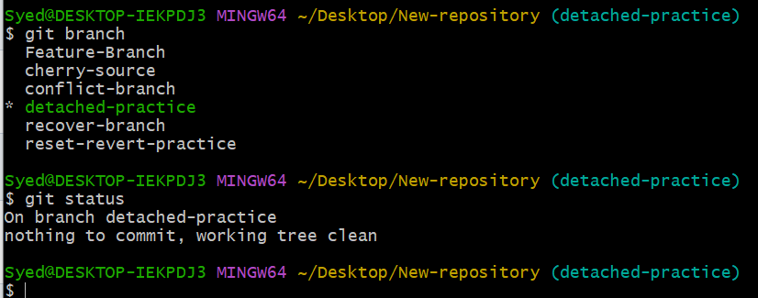
Step 7: Optional — Create a Commit on the New Branch
To demonstrate continuing development on this newly created branch:
echo "Created from detached HEAD" > detached.txt
git add detached.txt
git commit -m "Add detached HEAD practice file"
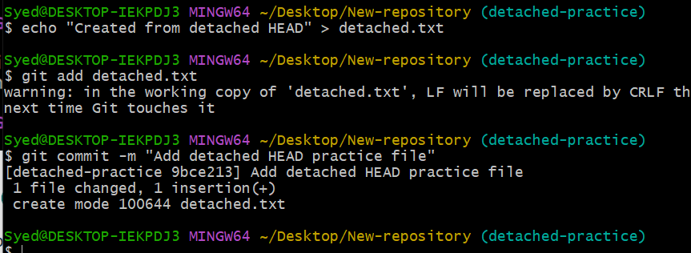
Verify your new commit in the log:
git log --oneline -5
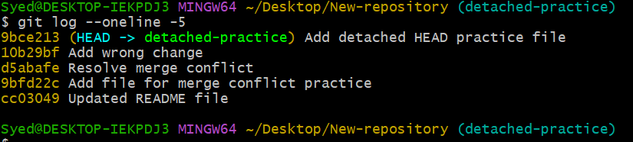
Summary of Important Commands
Command | Purpose
git log --oneline | View simplified commit history
git checkout <commit-id> | Enter detached HEAD state at specified commit
git status | Check current state of repository and HEAD
git switch -c detached-practice | Create and switch to a new branch from current commit
git branch | List existing branches and verify active branch
Publishing to Remote (Optional)
If your assignment or project requires pushing this newly created branch to GitHub, run:
git push -u origin detached-practice
