Git Hooks Challenge
Pre-Commit Message Format Validation Guide

Objective
Configure a Git hook that rejects commits unless the commit message starts with a valid ticket format, such as JIRA-123.
IMPORTANT NOTE
Git uses a commit-msg hook to validate the commit message.
A pre-commit hook runs before the message is finalized, so commit-msg is the correct hook for this challenge.

Step-by-Step Instructions

Step 1: Open Your Repository
Run these commands in Git Bash to navigate to your repository and check your current branch:
cd ~/Desktop/New-repository
git branch
Note: Expected output: You should see your current branch, such as Feature-Branch.
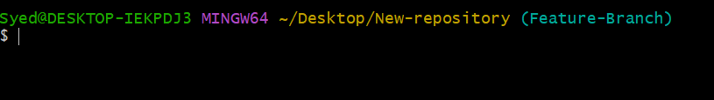

Step 2: Create the Git Hook File
Create the hooks directory if it doesn't exist and open the hook file in Notepad:
mkdir -p .git/hooks
notepad .git/hooks/commit-msg
Note: If Notepad prompts whether to create the file, select Yes.

Step 3: Add the Validation Script
Copy and paste the following shell script into Notepad, then save the file:
#!/bin/sh

commit_msg_file="$1"
commit_msg=$(head -n 1 "$commit_msg_file")

if ! printf '%s\n' "$commit_msg" | grep -Eq '^JIRA-[0-9]+([[:space:]]|:|-|$)'; then
echo "ERROR: Commit message must start with JIRA-XXX."
echo "Example: JIRA-123 Add README file"
exit 1
fi

echo "Commit message format is valid."
exit 0
Note: Save the file as commit-msg inside .git/hooks/. Ensure Notepad does not append a .txt extension.
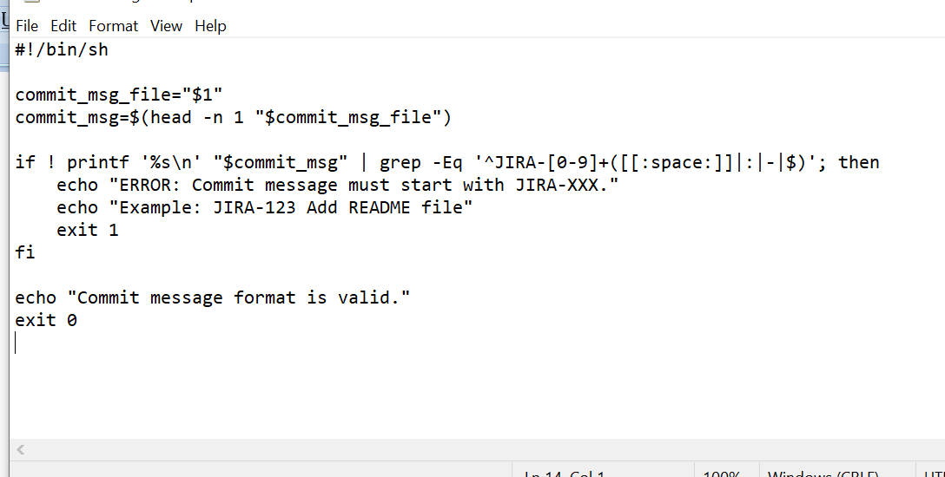

Step 4: Make the Hook Executable
Back in Git Bash, grant execution permissions to the script:
chmod +x .git/hooks/commit-msg

Step 5: Test an Invalid Commit
Make a small change to a file and attempt to commit with an invalid message format:
echo "Testing Git hooks" >> file1.txt
git add file1.txt
git commit -m "Update file1"
Note: Expected Result:
ERROR: Commit message must start with JIRA-XXX.
Example: JIRA-123 Add README file
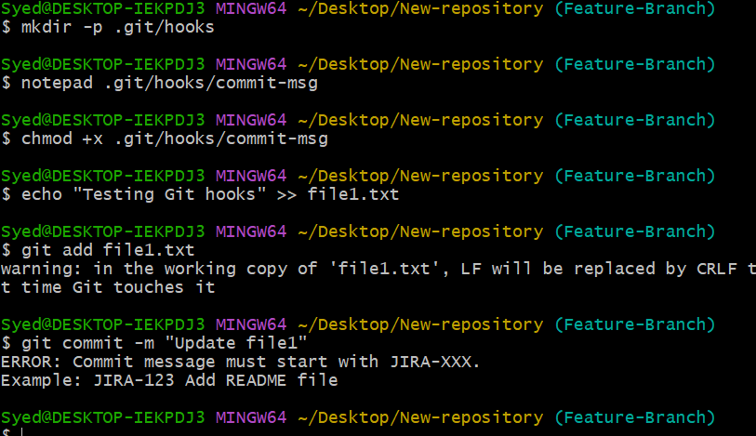
Git should reject the commit. Your changes remain staged/available.

Step 6: Test a Valid Commit
Now attempt to commit using the required JIRA format:
git commit -m "JIRA-123 Update file1"
Note: Expected Result:
Commit message format is valid.
The commit should succeed cleanly.
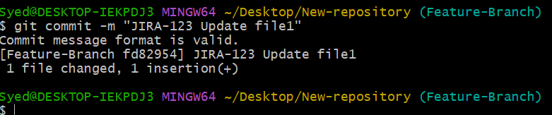

Step 7: Verify the Commit
Verify that your commit was recorded properly in the Git history:
git log -1 --oneline
git status
Note: Expected Output: You should see a commit message beginning with JIRA-123.
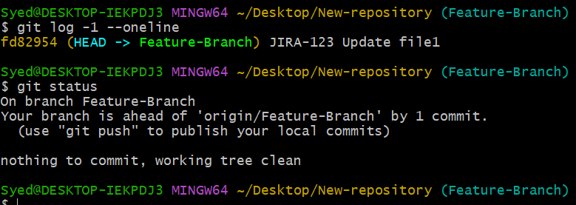

Step 8: Push to GitHub (Optional)
Push your changes to the remote repository:
git push origin Feature-Branch
Note: This assumes Feature-Branch is your current branch and its remote is configured.
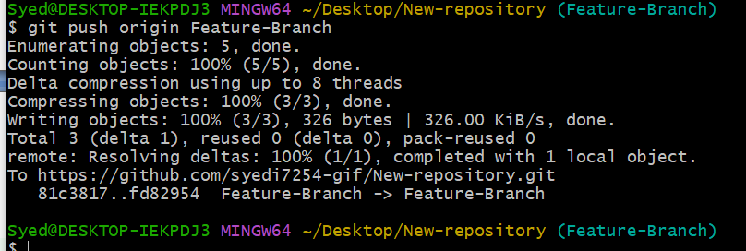

Summary & Key Takeaway
CHALLENGE SUMMARY
Challenge Completed: The commit-msg hook successfully rejects commit messages that do not begin with JIRA- followed by a number (e.g., JIRA-123).
Remember: Git hooks located in .git/hooks/ are local to your client repository. To share hooks across a team, store them in the repository folder (e.g., .githooks/) and configure Git to use them via git config core.hooksPath.

