Reset vs Revert Challenge in Git
Objective: Demonstrate the difference between git reset --hard and git revert

1. Difference between Reset and Revert
Feature | git reset --hard | git revert
Purpose | Moves the branch backward to an earlier commit | Creates a new commit that undoes an earlier commit
Git history | Removes the target commit from the current branch history | Preserves the original commit and adds an undo commit
Working files | Resets tracked files to the selected commit | Applies the inverse of the selected commit
Best use | Local commits that have not been shared | Commits already pushed or shared with others

Important Warning:
git reset --hard can permanently discard uncommitted changes and make commits unreachable from the current branch. Use it carefully, especially on a shared branch.

2. Step-by-Step Implementation

Step 1: Open Git Bash and go to your repository
$ cd ~/Desktop/New-repository
$ git status
Check that you do not have important uncommitted changes. If the working tree is not clean, save or commit your work before continuing.

Step 2: Create a separate practice branch
$ git switch -c reset-revert-practice
This creates a new branch so you can practice without directly changing Feature-Branch.

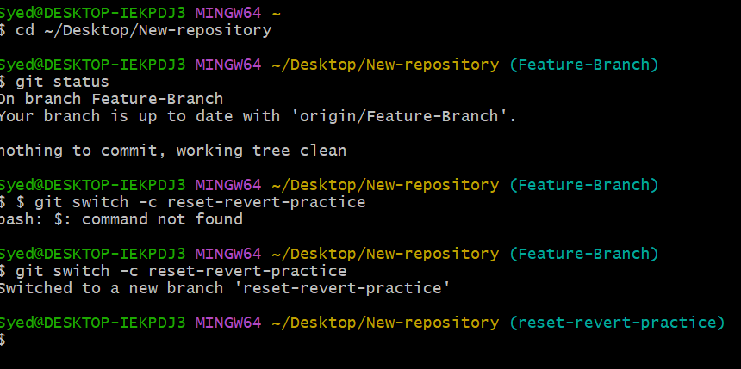

Step 3: Create a file and commit it
$ echo "This is the original content" > reset-demo.txt
$ git add reset-demo.txt
$ git commit -m "Add reset demo file"
$ git log --oneline -5
You should see a commit named Add reset demo file.
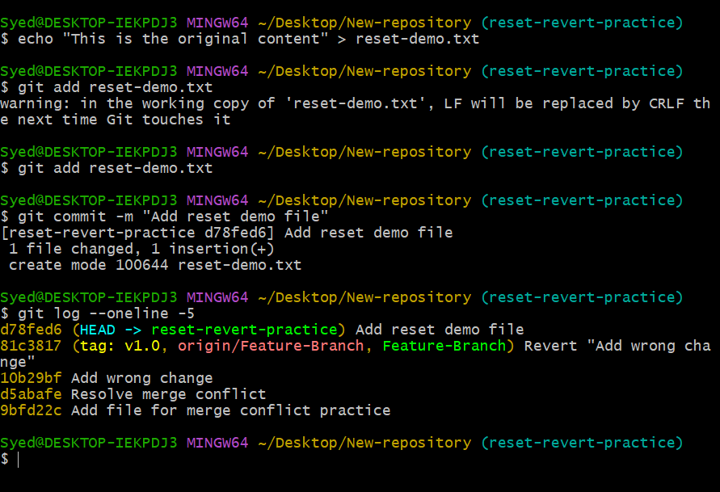

3. Demonstrate git reset --hard

Step 4: Undo the commit using reset
$ git reset --hard HEAD~1
Expected result:
- The latest commit is removed from the current branch's history.
- The tracked file reset-demo.txt is removed because it did not exist in the previous commit.
- The branch points to the previous commit.
Verify the result:
- git status
- git log --oneline -5
- ls
You should no longer see Add reset demo file in the current branch's history.
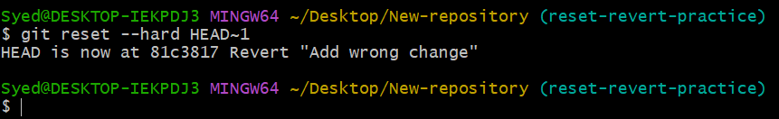
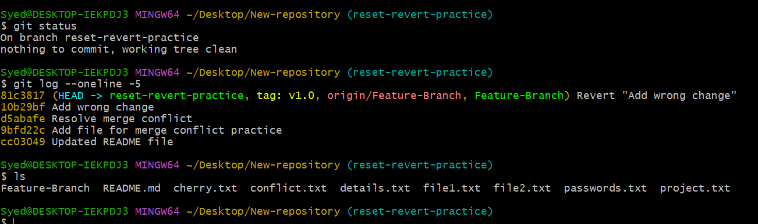

4. Demonstrate git revert

Step 5: Create the file and commit it again
$ echo "This is the original content" > reset-demo.txt
$ git add reset-demo.txt
$ git commit -m "Add reset demo file again"
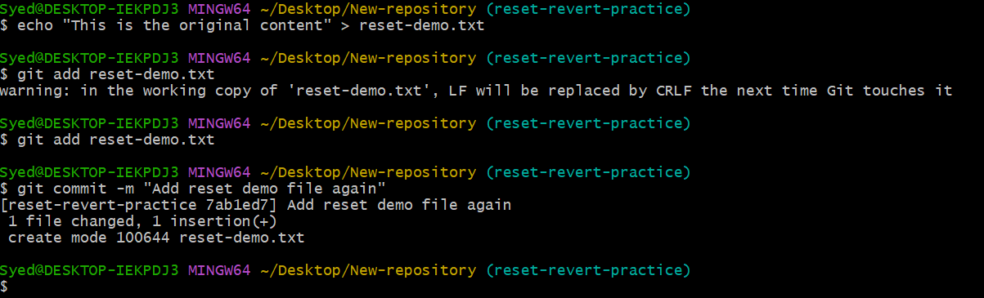

Step 6: Find the commit ID
$ git log --oneline -5
Example output:
abc1234 Add reset demo file again
Your actual commit ID will be different. Copy the ID shown on your screen.
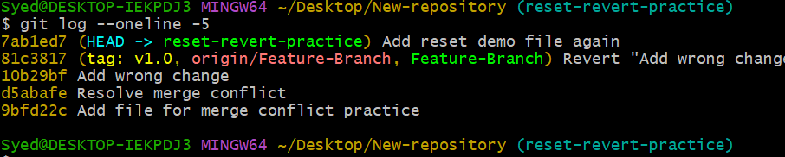

Step 7: Revert the commit
$ git revert abc1234
Replace abc1234 with your actual commit ID.
If Git opens a text editor, save and close it to finish the revert. If a conflict occurs, resolve it before completing the revert.
Verify the result:
- git log --oneline -5
- git status
- ls
Expected result:
- The original commit remains in the history.
- A new revert commit appears.
- The file is removed because the revert undoes the commit that created it.
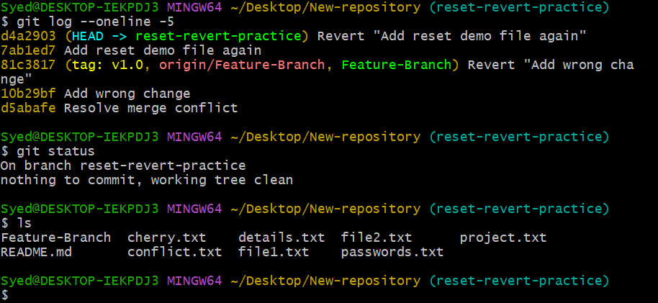

5. Compare the results

Summary of Behaviors
$ After git reset --hard HEAD~1: The branch moves back to the previous commit. The target commit is no longer part of the current branch history.
$ After git revert COMMIT_ID: Git creates a new commit that reverses the earlier change. Both the original commit and the revert commit remain in history.

6. Push the practice branch to GitHub (optional)
$ git push -u origin reset-revert-practice
This publishes the practice branch without pushing changes from your original Feature-Branch.
