Task: Tagging & Release in Git
Objective: Create a version tag v1.0, push it to GitHub, then delete and restore the tag.
1. Prerequisites
- Git Bash installed on Windows.
- GitHub repository created.
- Local repository connected to GitHub.
- Working directory: ~/Desktop/New-repository
- Branch: Feature-Branch
2. Step-by-Step Implementation
Step 1: Open your repository
Run these commands in Git Bash:
cd ~/Desktop/New-repository
git branch
git status
Make sure you are in the correct repository and branch.
Step 2: Create a version tag
Create a tag named v1.0 for the current commit:
git tag -a v1.0 -m "Release version 1.0"
Verify the tag:
git tag
git show v1.0
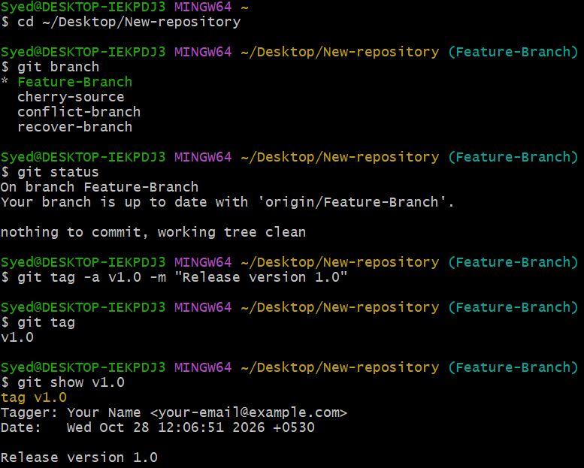
Step 3: Push the tag to GitHub
git push origin v1.0
To verify, open your GitHub repository and select Tags or Releases. The v1.0 tag should appear.
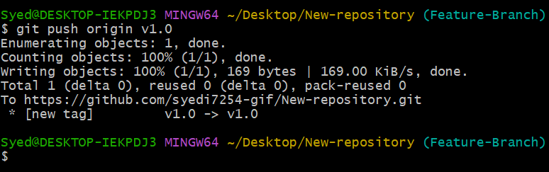
Step 4: Delete the local tag
git tag -d v1.0
Verify that the local tag was deleted:
git tag
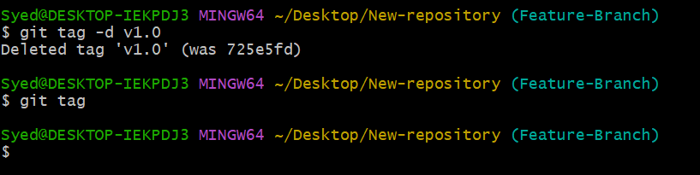
Step 5: Delete the tag from GitHub
git push origin --delete v1.0
This removes the remote tag from GitHub.
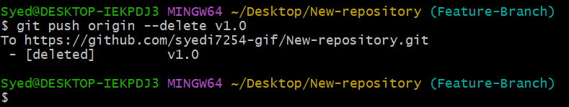
Step 6: Restore the tag
Recreate the tag on the same commit. First, identify the commit you tagged:
git log --oneline
Copy the required commit hash, then run:
git tag -a v1.0 COMMIT_HASH -m "Release version 1.0"
Replace COMMIT_HASH with the actual commit hash.
Push the restored tag to GitHub:
git push origin v1.0
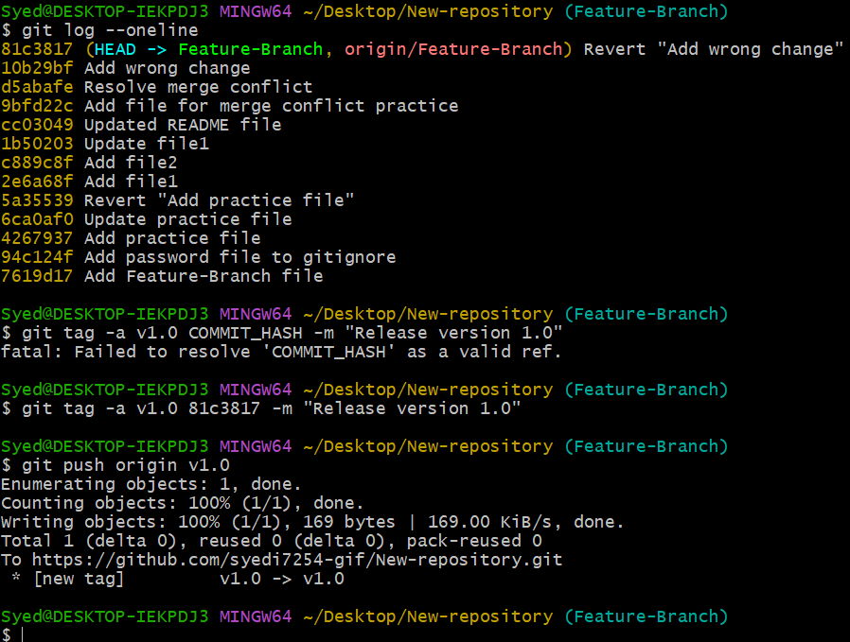
Step 7: Verify the restored tag
git tag
git show v1.0
git ls-remote --tags origin
Confirm that v1.0 exists locally and remotely.
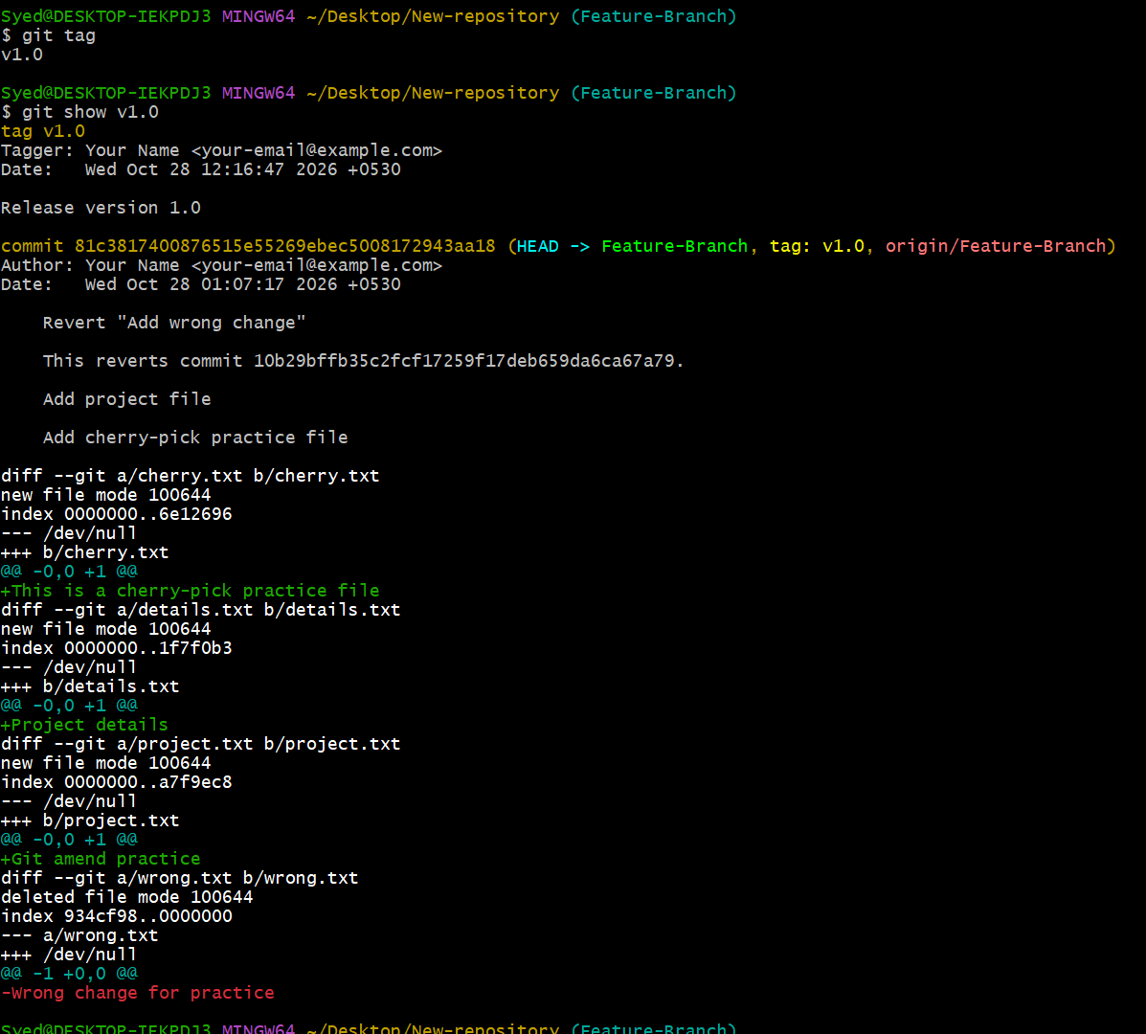
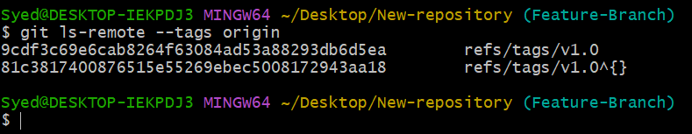
3. Expected Result
- Created the annotated version tag v1.0.
- Pushed the tag to GitHub.
- Deleted the local and remote tags.
- Restored the tag and pushed it again.
- Verified the restored tag.
Important: Deleting a tag does not delete the commit or its files. Save the original commit hash before deleting the tag so you can restore it to the correct commit.

