Git Task: Fork & Pull Request Workflow
Objective: Fork a GitHub repository, make a change in your own copy, push the change to your fork, and submit a Pull Request (PR) to the original repository.
Environment Note: Since you're using Git Bash on Windows and practicing in New-repository, follow these beginner-friendly steps.

Step 1: Understand the Workflow
Stage | Description
Original GitHub Repository | Repository owned by another user.
Fork the Repository | Create your own GitHub copy under your account.
Clone, Edit, Commit & Push | Work in your fork locally using Git Bash, make changes, and push back to GitHub.
Create a Pull Request | Request that the original owner review and merge your changes.

Step 2: Fork a Repository on GitHub

1. Open a public repository that allows you to contribute.
2. Click Fork in the top-right corner of the GitHub interface.
3. Select your GitHub account as the owner.
4. Click Create fork.
Practice Tip: You can use your own repository as the original repository and fork it from a second GitHub account if you have one. Alternatively, use a public practice repository that accepts contributions.
Step 3: Clone Your Fork Using Git Bash
On your forked GitHub repository page, click Code → HTTPS → Copy URL. Then, open Git Bash and execute the following commands (replace YOUR-USERNAME and REPO-NAME with your actual details):
cd ~/Desktop
git clone https://github.com/YOUR-USERNAME/REPO-NAME.git
cd REPO-NAME

Step 4: Create a New Branch
Create and switch to a dedicated feature branch for your changes:
git switch -c feature/update-readme

Verify the current active branch:
git branch
# Expected output:
# * feature/update-readme
# main

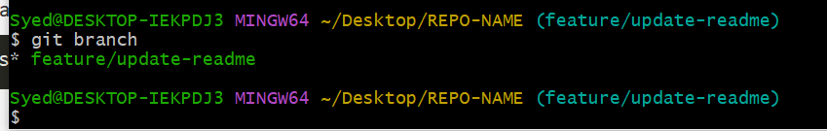
Step 5: Make a Change
1. Create and verify a practice file:
echo "This is my first contribution." > contribution.txt
cat contribution.txt

2. Stage and commit your changes:
git add contribution.txt
git commit -m "Add contribution file"

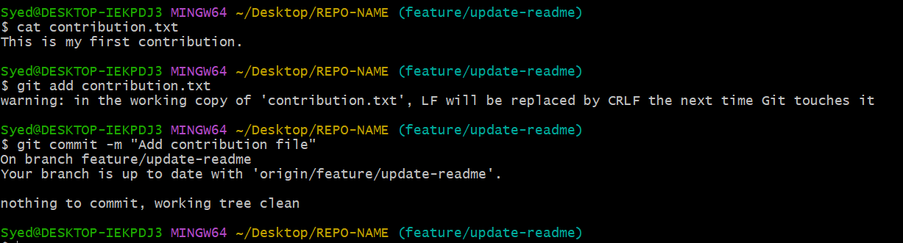
Step 6: Push the Change to Your Fork
Push your feature branch to your GitHub fork:
git push -u origin feature/update-readme
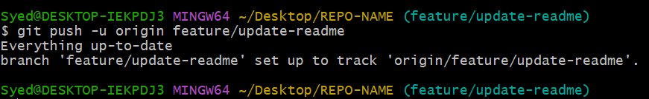
Verification: Verify that the branch appears in your fork on GitHub. Your changes will be visible there, but they have not yet been merged into the original repository.
Step 7: Create a Pull Request
1. Open the original repository: Go to the original repository on GitHub and click Pull requests → New pull request.
2. Compare across forks: Select the original repository and its target branch as the base, then select your fork and feature/update-readme as the compare branch.
3. Submit the Pull Request: Enter a title such as 'Add contribution file', write a short description, and click Create pull request.
Step 8: Verify the Result
Your assignment is complete when you can verify and show all of the following items:
✔ A fork exists in your GitHub account.
✔ A new branch contains your change.
✔ The commit is pushed to your fork.
✔ A Pull Request is open against the original repository.
✔ The Pull Request shows your changed file.

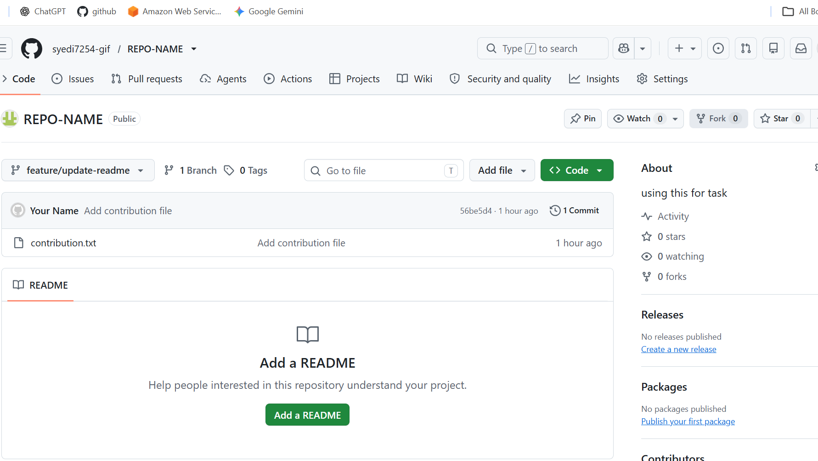

Important: Creating a Pull Request submits your proposed change for review; it does not automatically merge the change into the original repository.

