Git Task: Squash Merge vs Rebase Merge
Objective: Demonstrate the difference between a squash merge and a rebase merge using your Git Bash terminal in the New-repository project, and collect evidence using Git commands.
1. Understand the Difference
Feature | Squash merge | Rebase merge
Purpose | Combines multiple feature-branch commits into one commit | Replays feature-branch commits on top of the target branch
Commit history | One new commit for all changes | Preserves individual feature commits
Commit IDs | Creates a new commit | Replayed commits receive new IDs
History style | Short and clean | Linear, with individual commits visible
Main command | git merge --squash | git rebase

Branch State Comparison
Squash merge — before and after
• Before:
Main branch: A
Feature branch: B → C → D
• After:
Main branch: A → S (one combined commit)
Rebase merge — before and after
• Before:
Main: A → E
• After rebasing the feature branch:
Main: A → E → B′ → C′ → D′
(Note: B′, C′ and D′ represent the replayed commits.)
2. Step-by-Step Practical Demonstration
Note: Use a separate practice repository so your existing New-repository work is not affected.
Step 1: Create the practice repository
Run these commands in Git Bash:
cd ~/Desktop
mkdir merge-demo
cd merge-demo
git init -b main
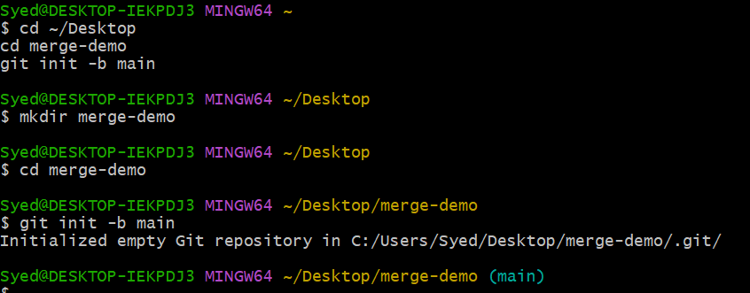
Create the initial commit:
echo "Project started" > README.md
git add README.md
git commit -m "Initial commit"
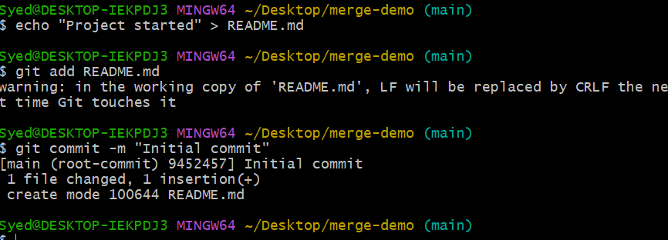
Step 2: Create a feature branch with three commits
git switch -c feature-squash
echo "Feature one" > feature1.txt
git add feature1.txt
git commit -m "Add feature one"

echo "Feature two" > feature2.txt
git add feature2.txt
git commit -m "Add feature two"

echo "Feature three" > feature3.txt
git add feature3.txt
git commit -m "Add feature three"

Check the history:
git log --oneline --graph --all

📷 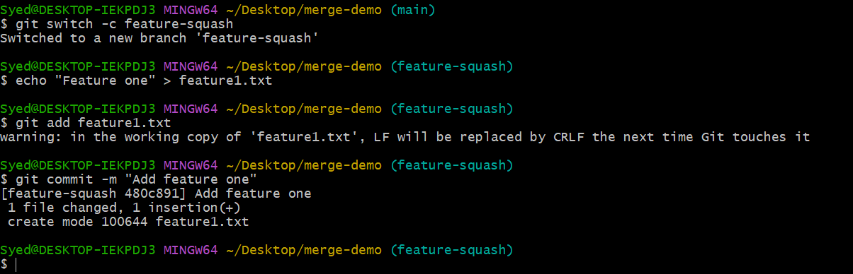
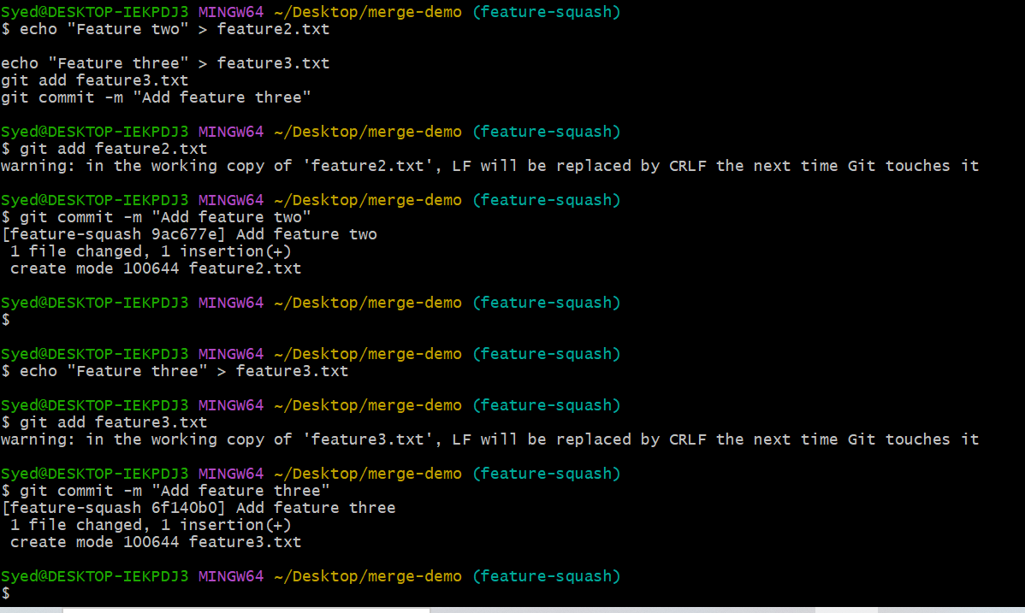
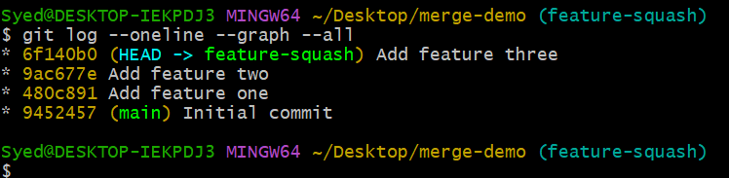
Step 3: Demonstrate squash merge
Return to main and squash the feature branch:
git switch main
git merge --squash feature-squash
git status
git commit -m "Add all features using squash merge"

Verify the history:
git log --oneline --graph

Expected result: The main branch contains the initial commit and one combined feature commit.
📷 Screenshot Evidence 2 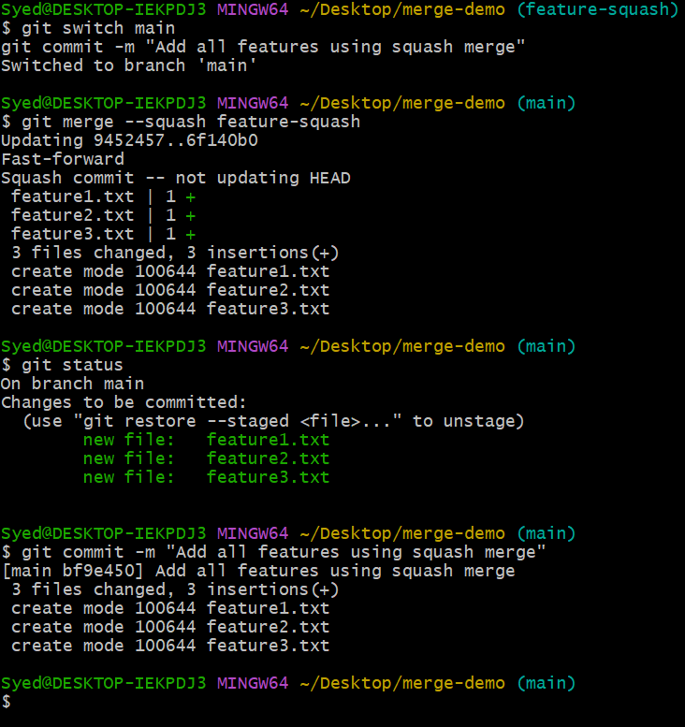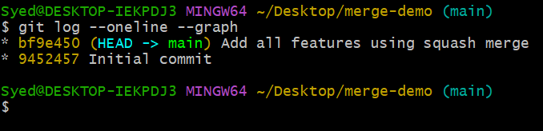
Step 4: Demonstrate rebase merge
Create a new branch from main:
git switch -c feature-rebase
echo "Rebase feature one" > rebase1.txt
git add rebase1.txt
git commit -m "Add rebase feature one"

echo "Rebase feature two" > rebase2.txt
git add rebase2.txt
git commit -m "Add rebase feature two"

echo "Rebase feature three" > rebase3.txt
git add rebase3.txt
git commit -m "Add rebase feature three"
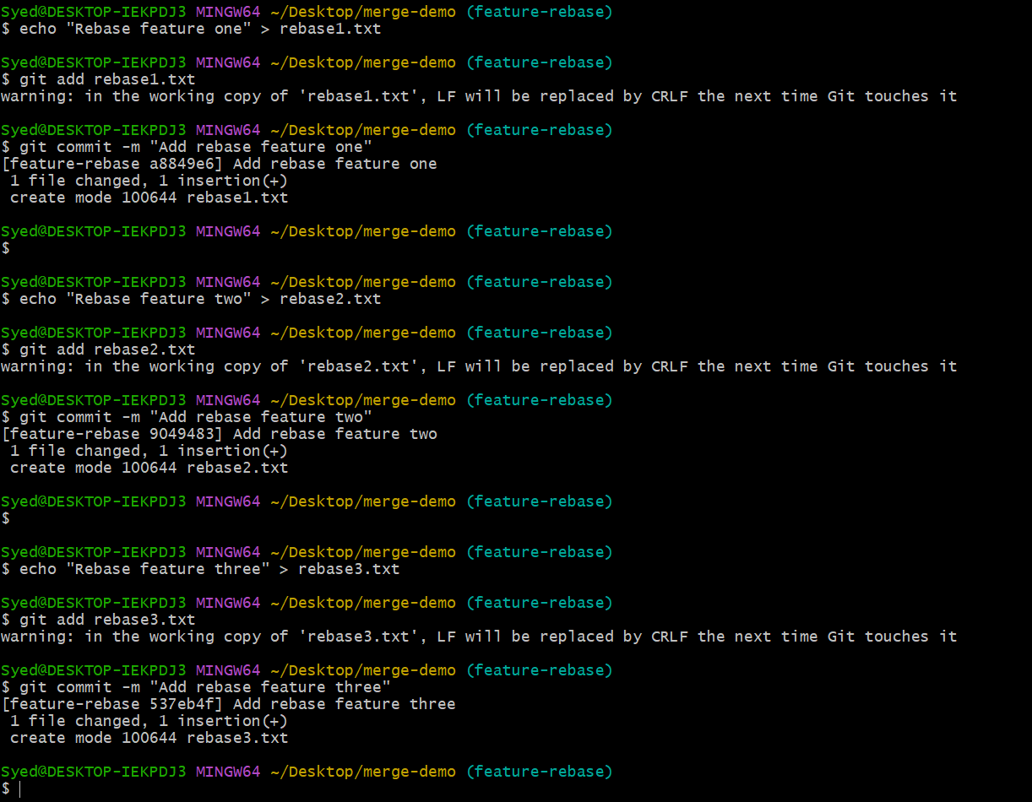
Rebase it onto main:
git rebase main

Then fast-forward main to include the rebased commits:
git switch main
git merge --ff-only feature-rebase
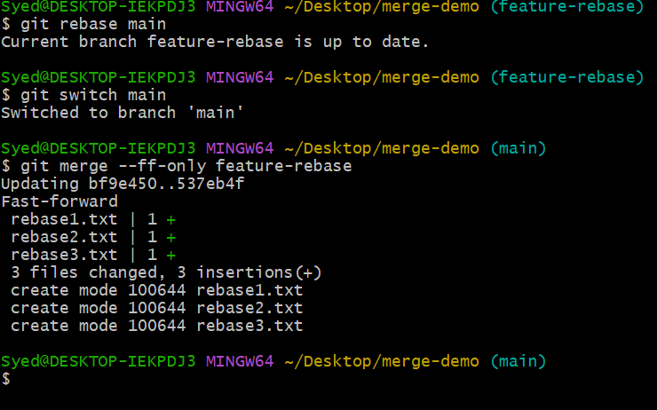
Verify:
git log --oneline --graph --all

Expected result: The three feature-rebase commits remain individually visible on main, without an extra merge commit. This is the result of rebasing followed by a fast-forward merge.
📷 Screenshot Evidence 3: 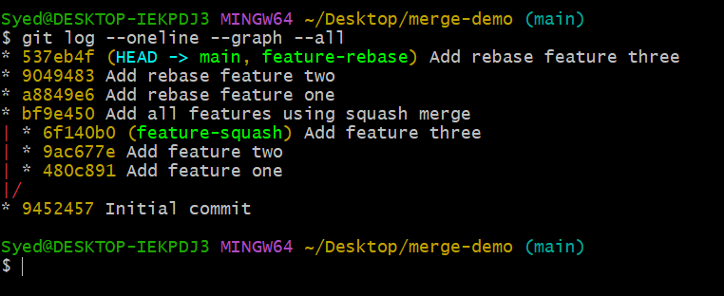
5. Conclusion for Your Assignment
Squash merge combines multiple feature commits into a single commit, producing a concise history. Rebase moves individual feature commits onto the target branch's latest history, preserving their separate identities while creating a linear history.
📌 Important Note
These commands demonstrate both methods locally. You do not need to push anything to GitHub for this exercise.
Avoid rebasing commits that others already use unless your team has coordinated the history change.

