Install Apache Tomcat on an EC2 Server
Bash Script Tasks — Step-by-step guide
Objective: Install Java and Apache Tomcat on an AWS EC2 Linux server, configure Tomcat as a systemd service, start it, and verify that it is running.

Step 1: Connect to the EC2 Server
1. Open https://console.aws.amazon.com/ec2/
2. Go to EC2 → Instances.
3. Select your running EC2 instance.
4. Click Connect and open a terminal session.

Step 2: Check the Linux Operating System
Run:
cat /etc/os-release
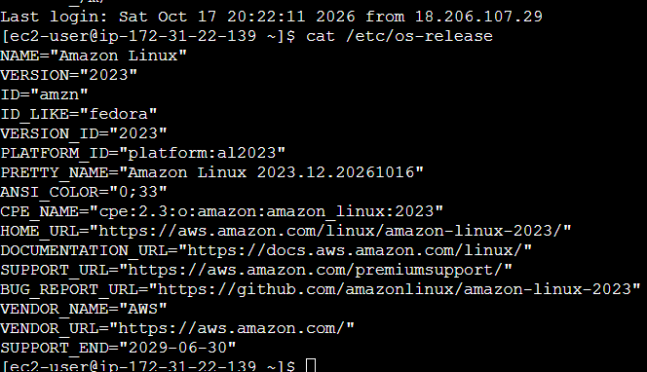

Step 3: Create the Bash Script
nano install_tomcat.sh
Copy the following script into Nano.

Step 4: Bash Script
#!/bin/bash
# Install Apache Tomcat on an EC2 server
set -e
echo "Starting Apache Tomcat installation..."
# Install Java and curl
if command -v apt-get >/dev/null 2>&1; then
sudo apt-get update -y
sudo apt-get install -y openjdk-17-jdk curl
elif command -v dnf >/dev/null 2>&1; then
sudo dnf install -y java-17-amazon-corretto-devel curl
elif command -v yum >/dev/null 2>&1; then
sudo yum install -y java-17-amazon-corretto-devel curl
else
echo "Unsupported Linux distribution."
exit 1
fi
JAVA_HOME_PATH=$(dirname "$(dirname "$(readlink -f "$(command -v java)")")")
echo "Java home: $JAVA_HOME_PATH"
# Create a dedicated Tomcat user
if ! id tomcat >/dev/null 2>&1; then
sudo useradd --system --create-home --home-dir /opt/tomcat --shell /bin/false tomcat
fi
# Example Tomcat version; verify the current supported release before use
TOMCAT_VERSION="10.1.61"
cd /tmp
curl -fLO "https://archive.apache.org/dist/tomcat/tomcat-10/v${TOMCAT_VERSION}/bin/apache-tomcat-${TOMCAT_VERSION}.tar.gz"
sudo mkdir -p /opt/tomcat
sudo tar -xzf "apache-tomcat-${TOMCAT_VERSION}.tar.gz" -C /opt/tomcat --strip-components=1
sudo chown -R tomcat:tomcat /opt/tomcat
# Create systemd service
sudo tee /etc/systemd/system/tomcat.service > /dev/null <<EOF
[Unit]
Description=Apache Tomcat
After=network.target
[Service]
Type=forking
User=tomcat
Group=tomcat
Environment="JAVA_HOME=${JAVA_HOME_PATH}"
Environment="CATALINA_HOME=/opt/tomcat"
Environment="CATALINA_BASE=/opt/tomcat"
ExecStart=/opt/tomcat/bin/startup.sh
ExecStop=/opt/tomcat/bin/shutdown.sh
Restart=on-failure
[Install]
WantedBy=multi-user.target
EOF
sudo systemctl daemon-reload
sudo systemctl enable tomcat
sudo systemctl start tomcat
echo "Checking Tomcat service..."
sudo systemctl --no-pager status tomcat
echo "Tomcat installation script completed."
Save and exit Nano: press Ctrl+O, press Enter, then press Ctrl+X.
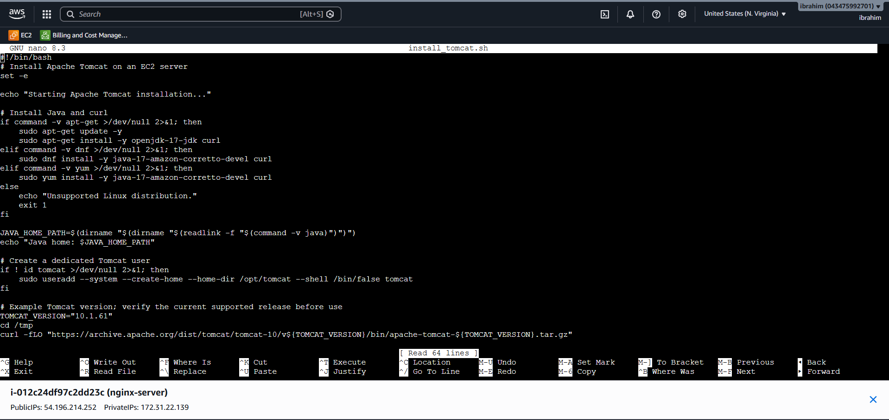

Step 5: Give Execute Permission
chmod +x install_tomcat.sh

Step 6: Run the Script
./install_tomcat.sh
The script installs Java, downloads Tomcat, configures a systemd service, and starts Tomcat. Verify the version and checksum using official Apache Tomcat downloads before production use.
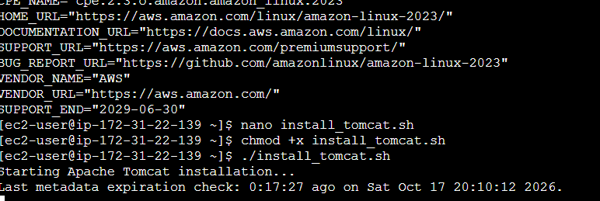

Step 7: Verify the Tomcat Service

Fix the tomcat.service error
Your command:
sudo systemctl status tomcat
Look for: Active: active (running)
If it fails, inspect the logs:
sudo journalctl -u tomcat --no-pager -n 50

Step 8: Open Tomcat in a Browser
1. Open the EC2 instance and its attached Security Group in AWS.
2. Add an inbound Custom TCP rule for port 8080.
3. For testing, restrict the source to your own public IP address.
4. Open the URL below, replacing the placeholder with your EC2 Public IPv4 address:
http://YOUR-EC2-PUBLIC-IP:8080

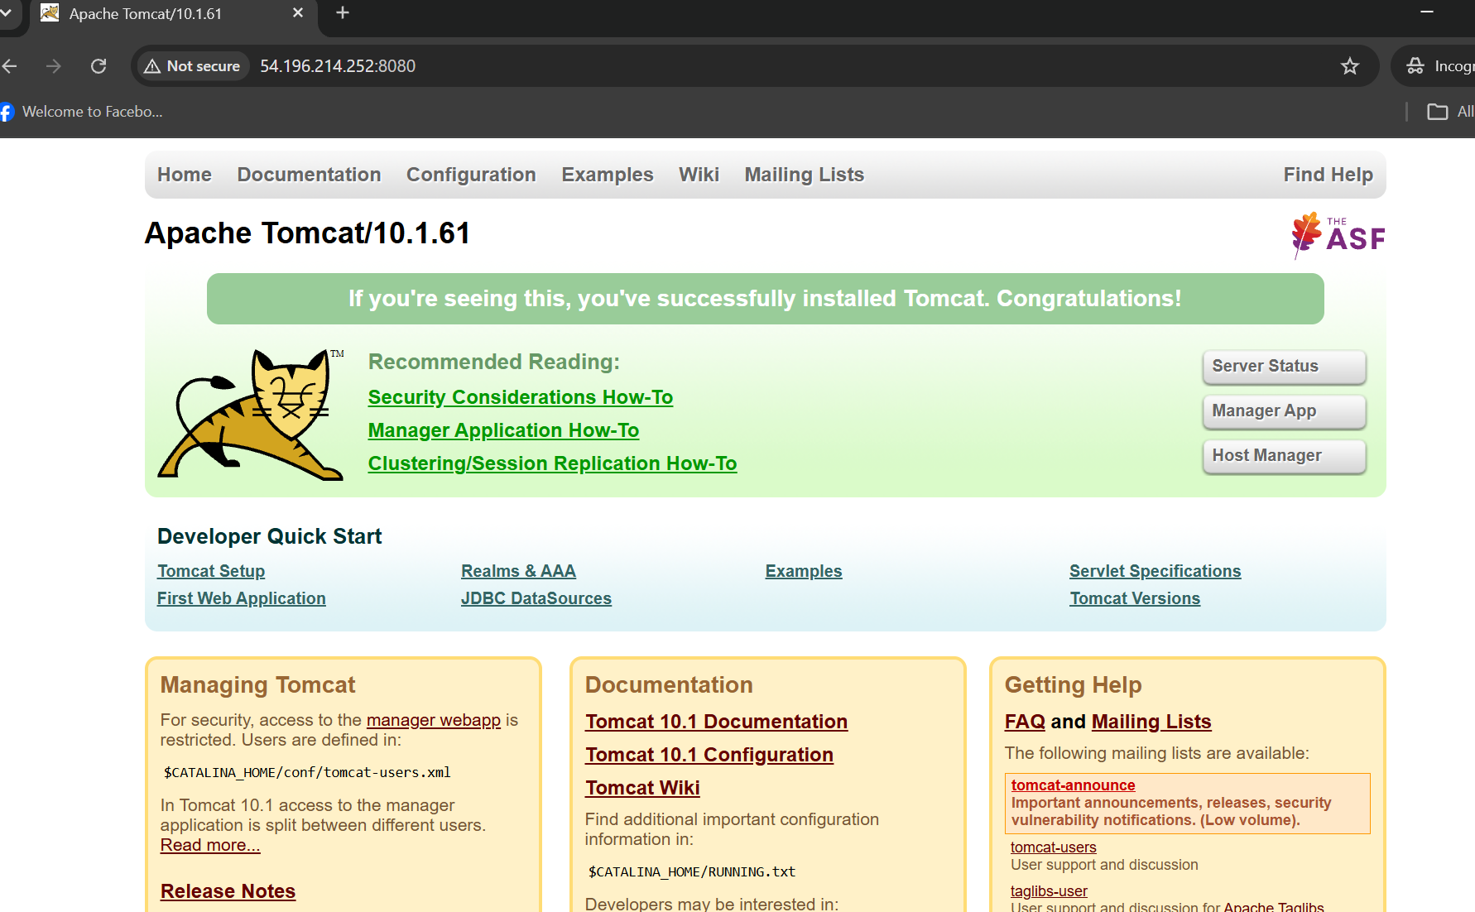

Expected Output
Starting Apache Tomcat installation...
Java home: /path/to/java
Tomcat installation script completed.
Active: active (running)

Troubleshooting Notes
• Run this script on the EC2 Linux server, not in Windows Git Bash.
• If the download fails, verify the version and archive URL on the official Apache website.
• If Tomcat does not start, check JAVA_HOME and review the journalctl logs.
• Ensure the EC2 instance has outbound internet access.

