Bash Script to Install Nginx on an EC2 Server
Task 5: Create a Bash script to install Nginx on an AWS EC2 Linux server, start the service, and verify that it is running.

Step 1: Connect to the EC2 Server
Open the AWS Management Console, go to EC2 → Instances, select your running instance, and click Connect. Open a terminal session. You can also connect using SSH if your key pair is configured.

Step 2: Create the Bash Script
Run this command on the EC2 Linux terminal:
nano install_nginx.sh
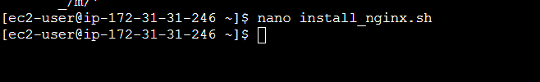

Step 3: Add the Script
#!/bin/bash
# Script to install Nginx on an EC2 server
echo "Starting Nginx installation..."
# Detect the package manager and install Nginx
if command -v apt-get >/dev/null 2>&1; then
sudo apt-get update -y
sudo apt-get install nginx -y
elif command -v dnf >/dev/null 2>&1; then
sudo dnf install nginx -y
elif command -v yum >/dev/null 2>&1; then
sudo yum install nginx -y
else
echo "Unsupported Linux distribution."
exit 1
fi
# Enable Nginx at startup and start it now
sudo systemctl enable nginx
sudo systemctl start nginx
# Verify the service
if systemctl is-active --quiet nginx; then
echo "Nginx installed successfully!"
echo "Nginx service is running."
else
echo "Nginx installation completed, but the service is not running."
exit 1
fi
Save and exit nano: press Ctrl+O, press Enter, then press Ctrl+X.
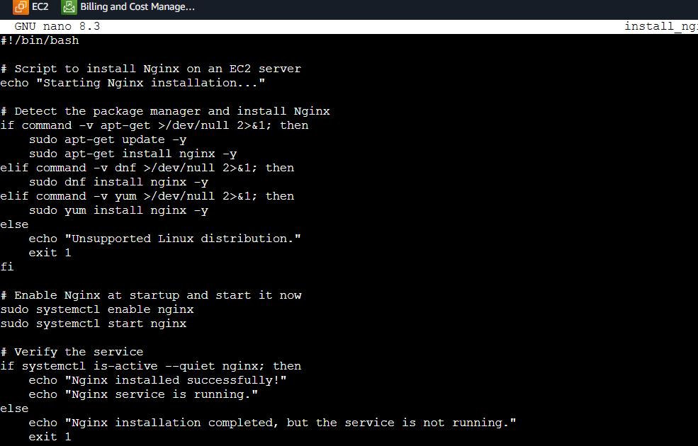

Step 4: Give Execute Permission
chmod +x install_nginx.sh

Step 5: Run the Script
./install_nginx.sh
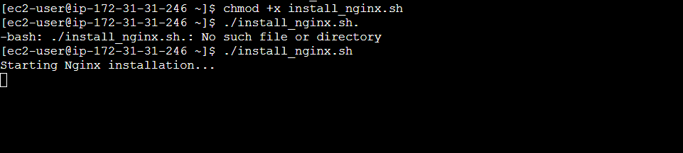
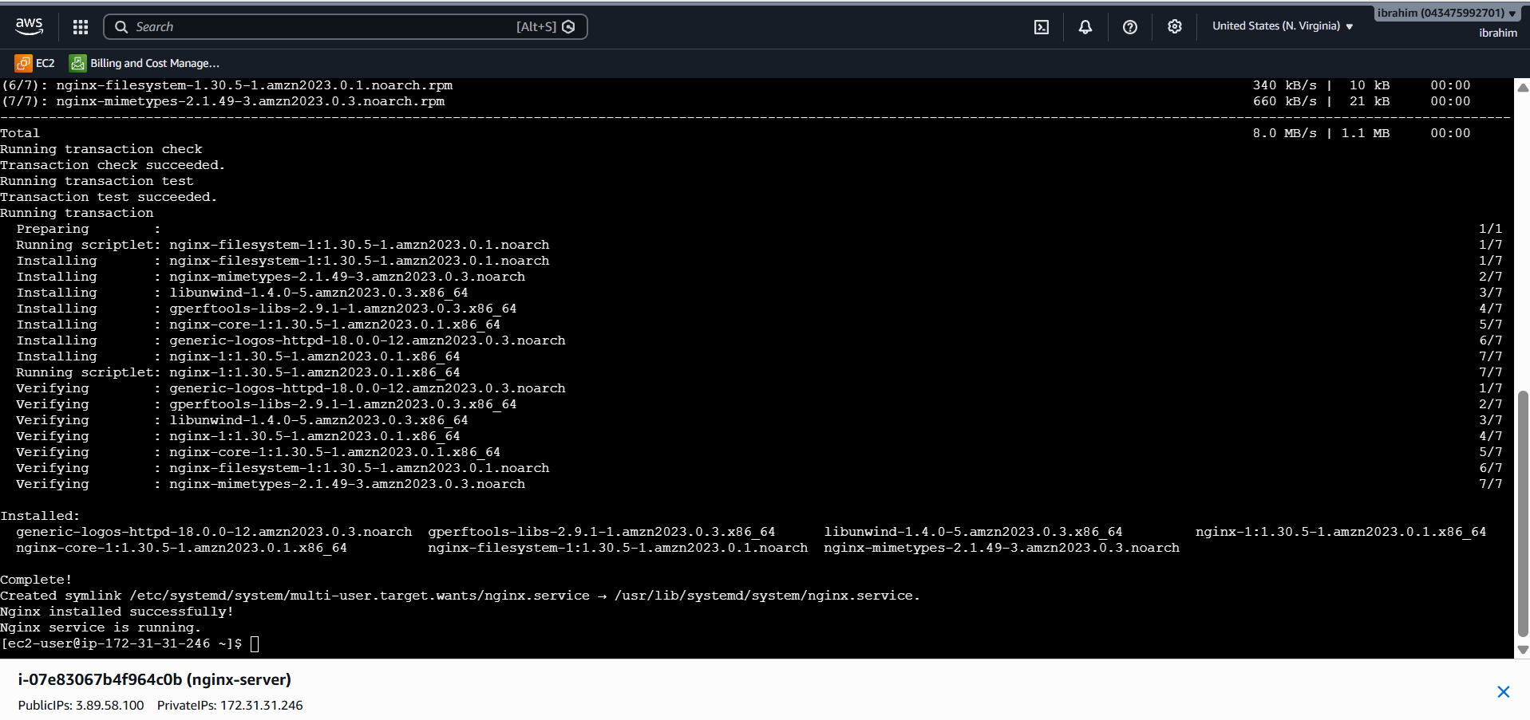

Step 6: Check the Nginx Service
sudo systemctl status nginx
Look for a status similar to: Active: active (running)
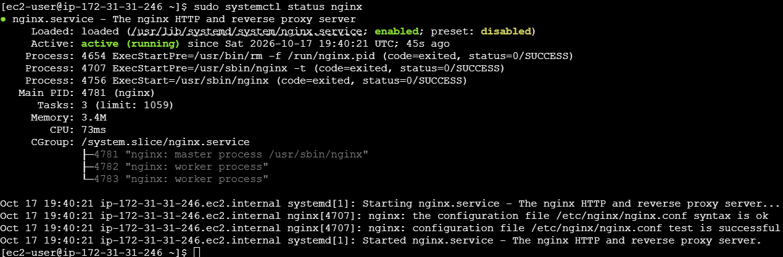

Step 7: Open the Nginx Welcome Page
- Copy the EC2 instance Public IPv4 address.
- In the instance Security Group, add an inbound HTTP rule for TCP port 80. Use source 0.0.0.0/0 only if the website should be publicly accessible.
- Open http://YOUR-EC2-PUBLIC-IP in your browser.
- 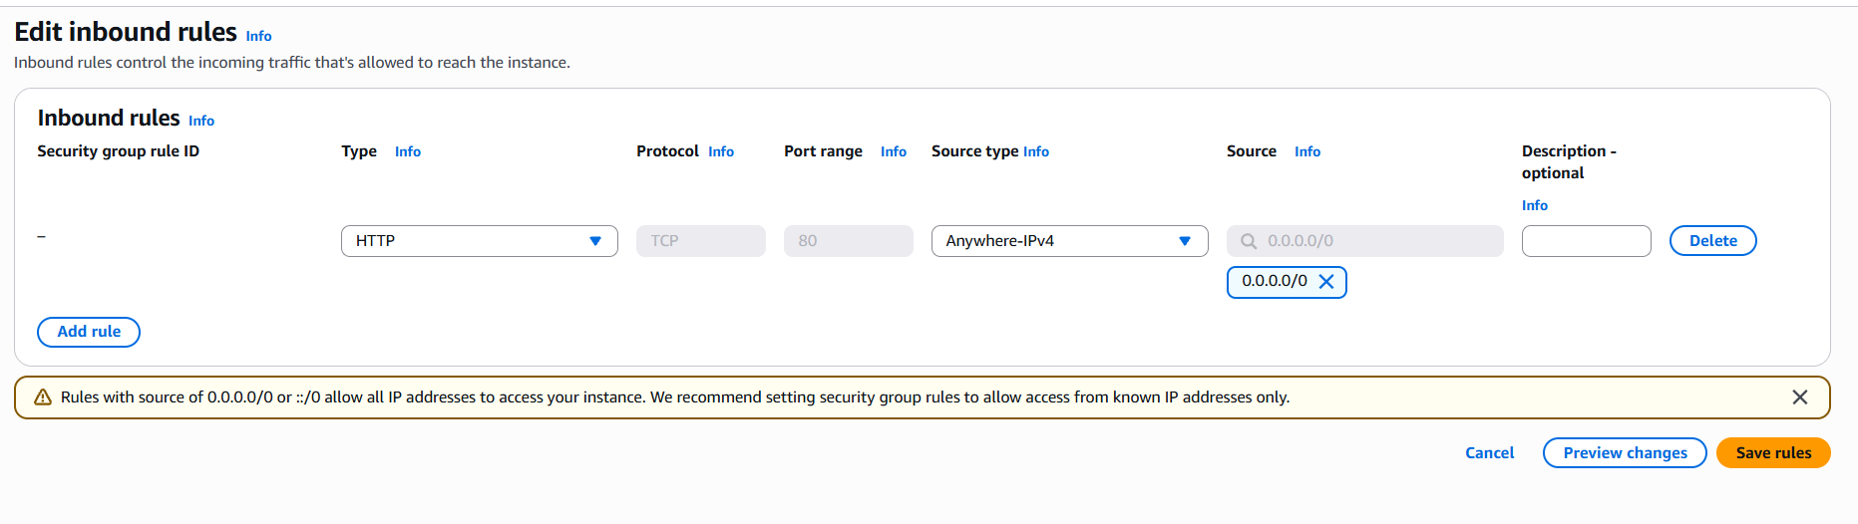
- 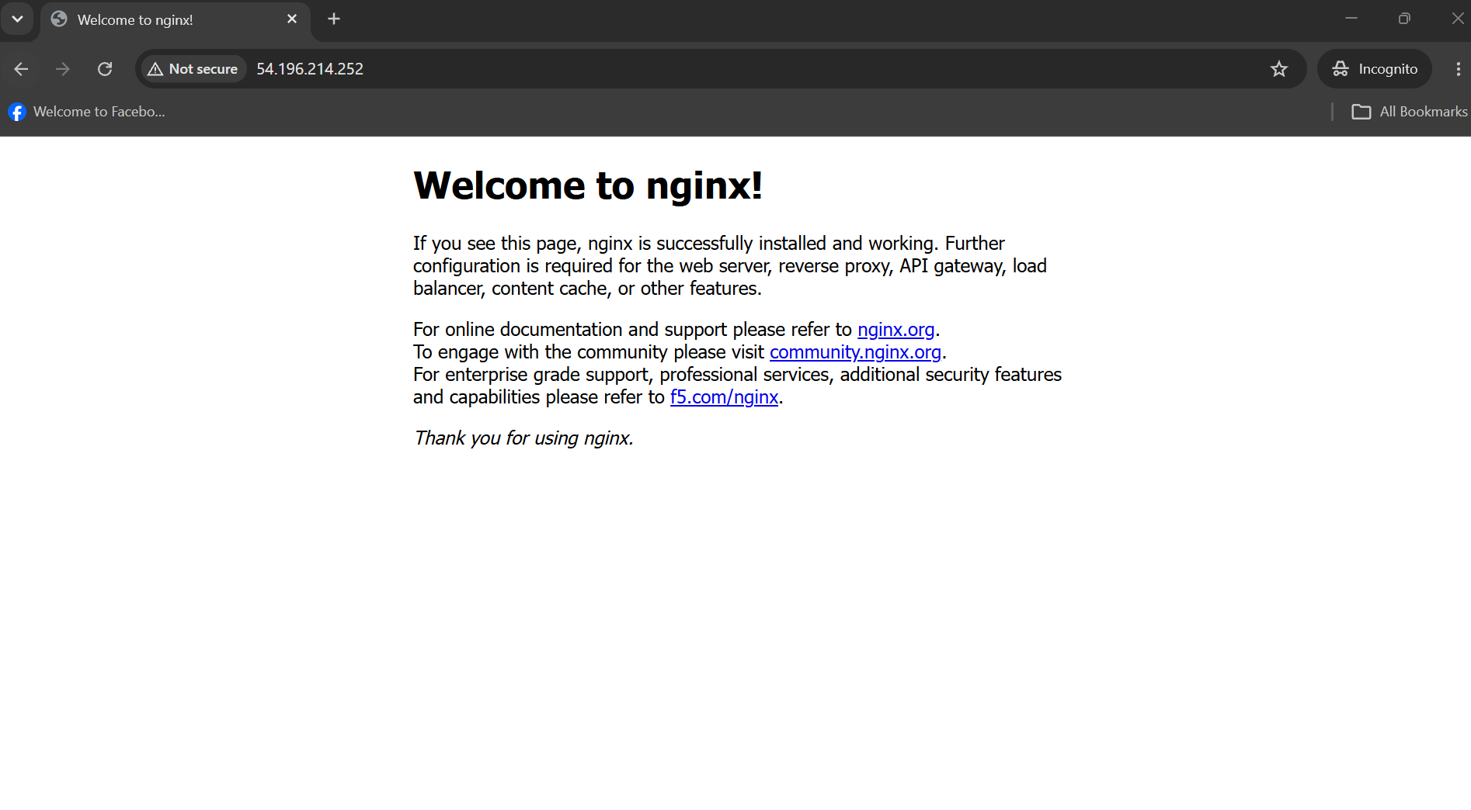

Expected Output
Starting Nginx installation...
Nginx installed successfully!
Nginx service is running.

Important Notes
Run this script on the EC2 Linux server, not directly in Windows Git Bash. The script supports common Ubuntu and Amazon Linux package managers (apt-get, dnf, and yum). If installation fails, check that the instance has internet access and that your user has sudo privileges.

