Git Task Guide: Interactive Rebase
Reorder and Squash Multiple Commits into a Clean History

1. Objective
To use Git Interactive Rebase to reorder multiple commits and squash them into a single clean commit with a meaningful commit message.
2. Prerequisites
- Git and Git Bash installed on Windows.
- Local Repository: New-repository
- At least three commits present in your repository history.
- Active Branch: Feature-Branch
3. Step-by-Step Implementation
Step 1: Open your repository
Open Git Bash and navigate to your working project directory:
cd ~/Desktop/New-repository

Check your current active branch:
git branch

Switch to your feature branch if needed:
git switch Feature-Branch

Step 2: Check commit history
Inspect the recent commit history before rebasing:
git log --oneline

Example output (your commit IDs and messages may vary):
c889c8f Add file2
2e6a68f Add file1
6ca0af0 Update practice file
4267937 Add practice file

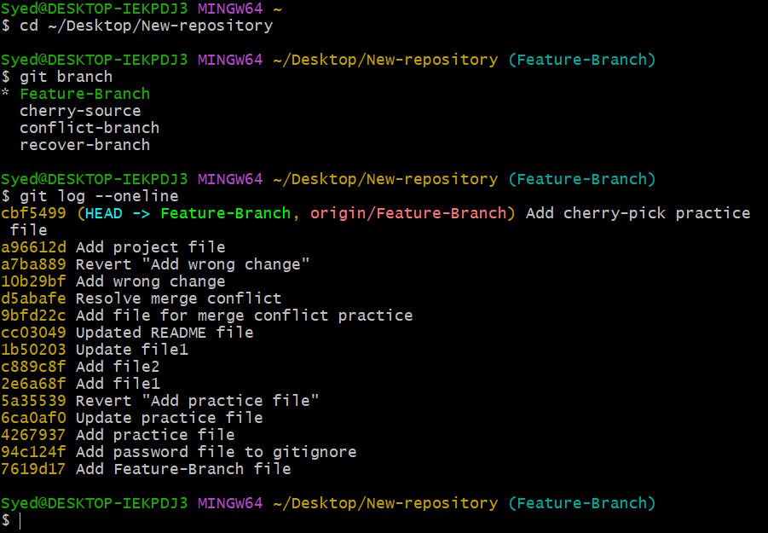
Step 3: Start Interactive Rebase
To edit and combine the latest three commits, run:
git rebase -i HEAD~3

An interactive text editor (such as Vim or Nano) will open displaying the selected commits in oldest-to-newest order.
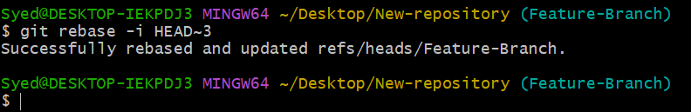
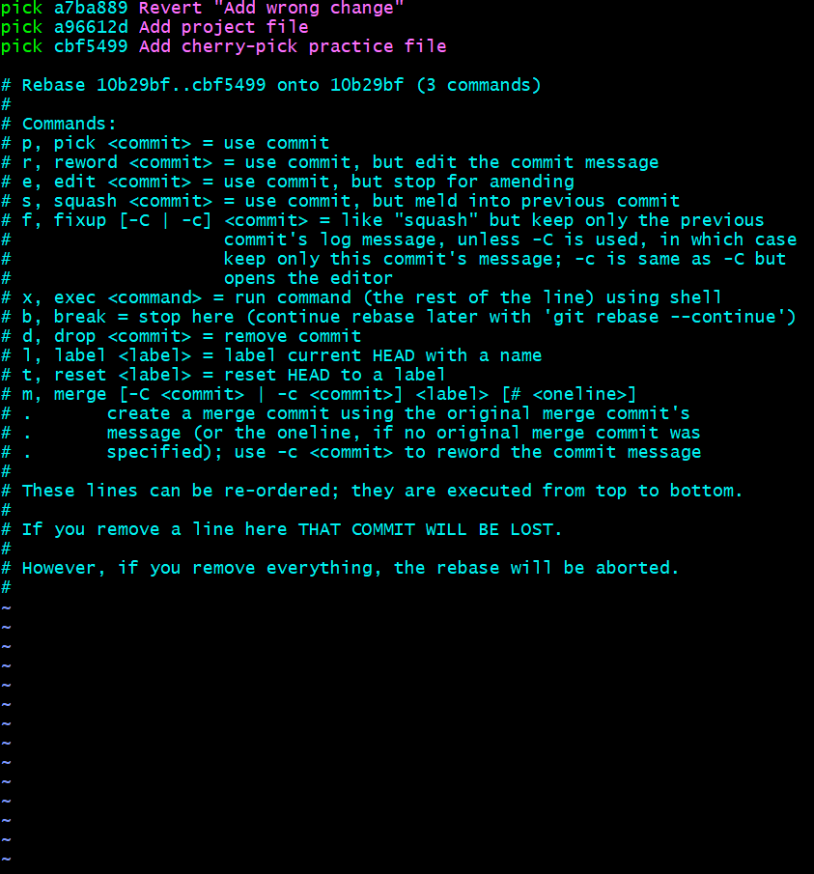
Step 4: Reorder and squash commits
The editor will initially show something like this:
pick 2e6a68f Add file1
pick c889c8f Add file2
pick 6ca0af0 Update practice file

Modify the commands and reorder lines as needed:
pick 2e6a68f Add file1
squash c889c8f Add file2
squash 6ca0af0 Update practice file

- pick: Keep the commit as-is.
- squash: Combine the commit into the previous commit.
- Reordering: Reordering lines changes the sequence in which Git replays the commits.
Important: The first commit line must remain set to pick; mark the subsequent commits as squash to combine them into the first.

Save and close the editor. If using Vim, press Esc, type :wq, and press Enter.
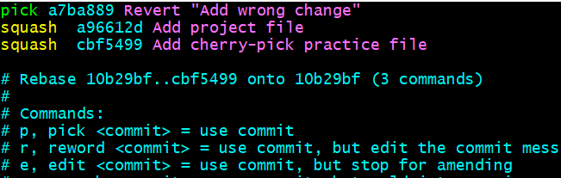
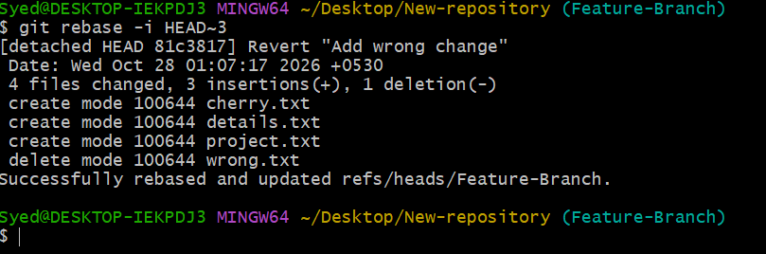
Step 5: Enter the final commit message
Git will open a second editor prompt asking to combine or rewrite the commit messages. Replace the content with a single, clear message, for example:
Combine project setup and README updates

Save and close the editor to complete the rebase.
Step 6: Verify the result
Verify that the commit history has been streamlined:
git log --oneline -5

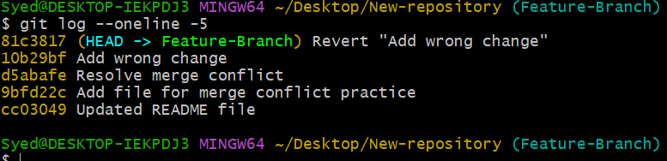Then check the working repository status:
git status

You should now see one combined commit in place of the original three commits. Older historical commits will remain untouched.
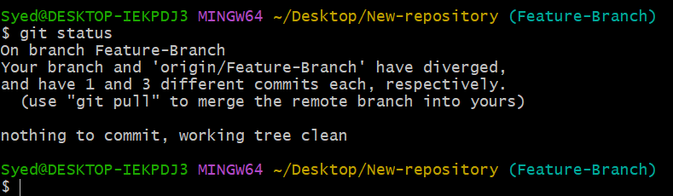
Step 7: Push the changes to GitHub
If these commits have not been previously pushed to remote:
git push origin Feature-Branch

If you rewrote commits that were already pushed to GitHub, coordinate with your team. Updating the remote branch will require force-pushing safely:
git push --force-with-lease origin Feature-Branch

Caution: Use force pushing only when you are certain that rewriting shared branch history is appropriate.
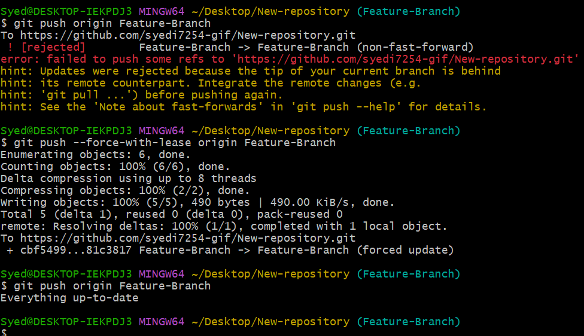
4. Expected Outcome
- Successfully initiated and executed an interactive Git rebase.
- Reordered commits into the desired sequence.
- Squashed multiple granular commits into a single cohesive commit.
- Configured a clear, meaningful commit message.
- Verified updated Git repository history and status.
- Conclusion
Interactive Rebase is a powerful feature in Git that helps maintain a clean, readable project history by reordering commits and combining related, incremental changes into cohesive units prior to merging or sharing with a team.

