Bash Script Task
Check Nginx Service and Start It If Stopped

Objective
Create and execute a Bash script that checks whether the Nginx service is running. If Nginx is stopped, the script starts it and reports the result.

Where to execute this task
Run the script on the Linux EC2 server where Nginx is installed. If your training instruction says to execute scripts from the devops-cloud-documents- channel, save this task there as required, but run the commands on the target Linux server—not in Windows Git Bash unless Nginx is installed in that environment.

Step 1: Connect to your EC2 Linux server
Open AWS Console → EC2 → Instances → select your running instance → Connect. Open the browser-based terminal or connect using SSH.

Step 2: Install Nginx (if it is not installed)
For Amazon Linux 2023:
sudo dnf install nginx -y
For Ubuntu, use: sudo apt update && sudo apt install nginx –y
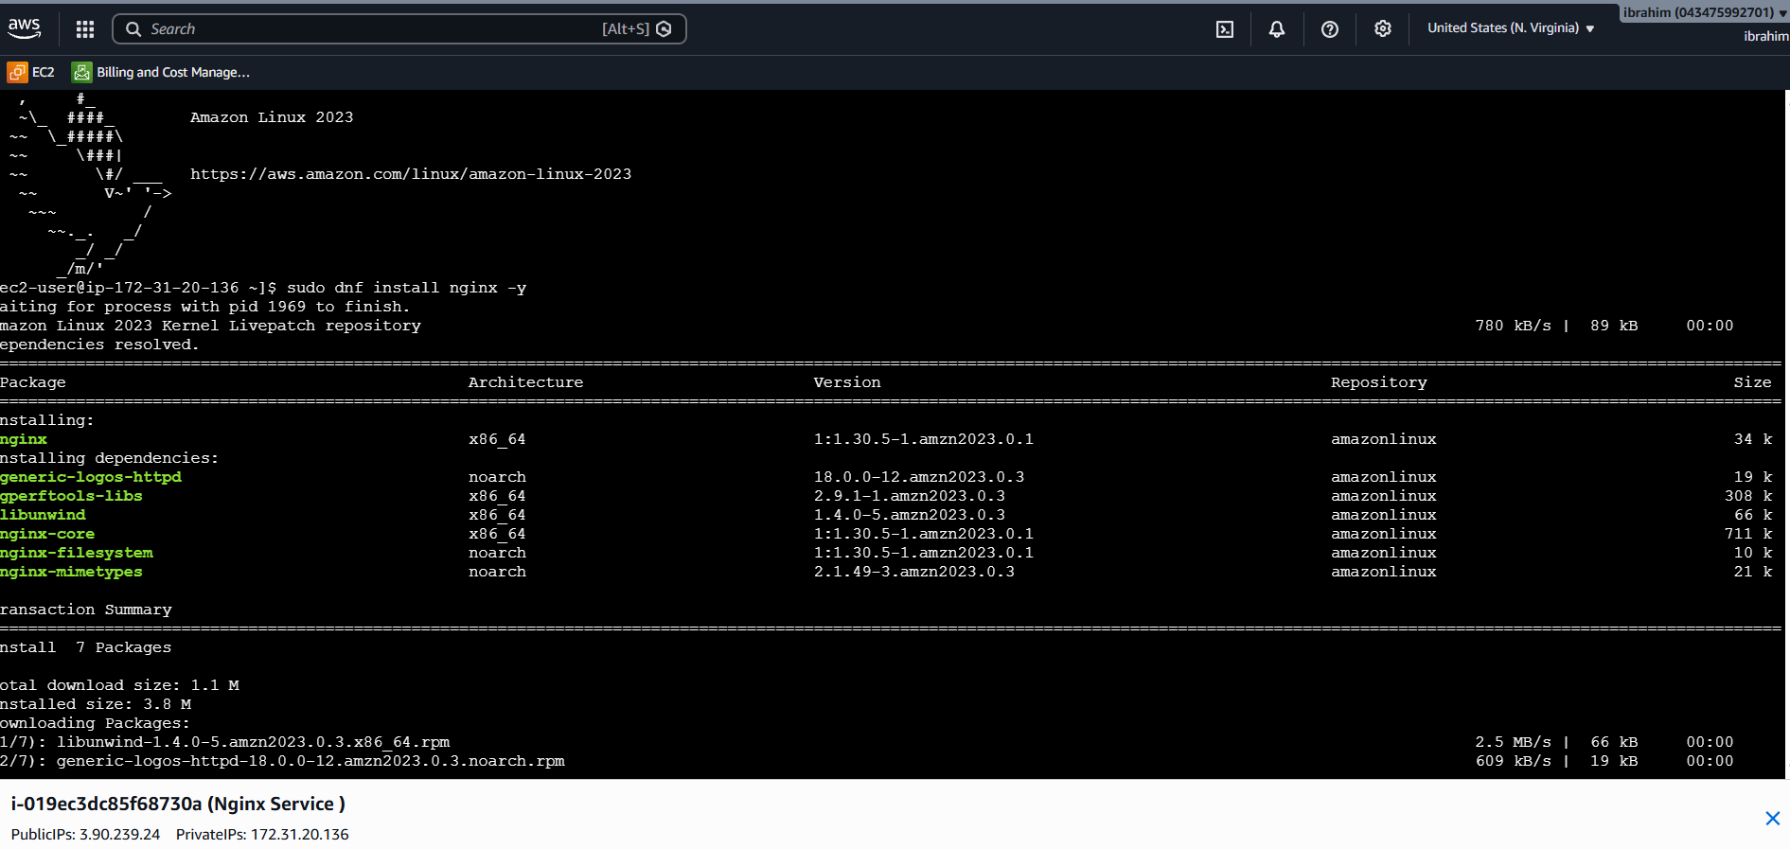

Step 3: Create the script
Run:
nano check_nginx.sh

Step 4: Copy this Bash script
#!/bin/bash
# Check whether the Nginx service is running
if systemctl is-active --quiet nginx; then
echo "Nginx is running."
else
echo "Nginx is not running. Attempting to start it..."
sudo systemctl start nginx
if systemctl is-active --quiet nginx; then
echo "Nginx started successfully."
else
echo "ERROR: Nginx could not be started. Check the service logs."
sudo systemctl status nginx --no-pager
exit 1
fi
fi
Save in nano: press Ctrl+O, press Enter, then Ctrl+X.

Step 5: Make the script executable
chmod +x check_nginx.sh

Step 6: Run the script
sudo ./check_nginx.sh
The script uses systemctl to check Nginx. If it is stopped, it tries to start it and then checks again.
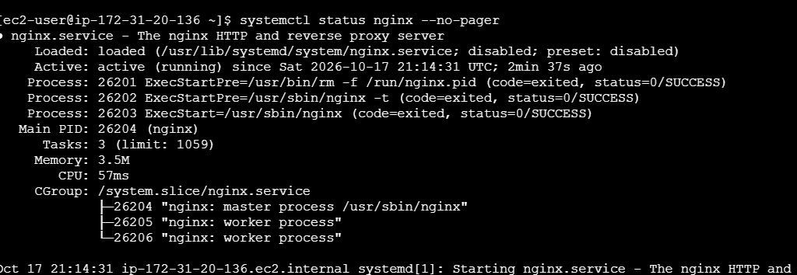
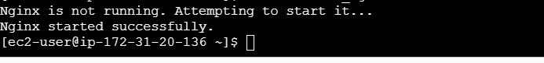

Step 7: Verify the service
systemctl status nginx --no-pager
curl -I http://localhost
A successful service check usually shows “active (running)”. The curl command should return an HTTP response if Nginx is serving locally.
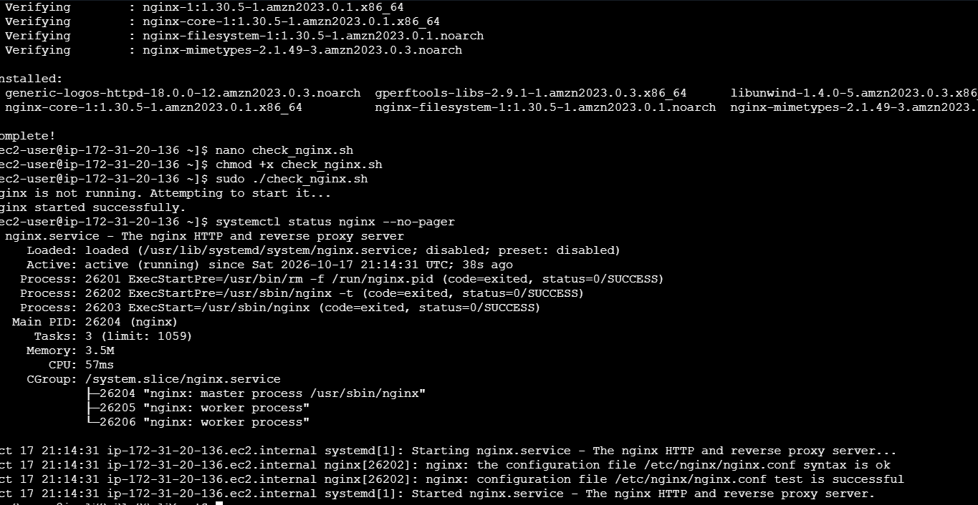

Example output
Nginx is running.

OR, if it was stopped:
Nginx is not running. Attempting to start it...
Nginx started successfully.

Troubleshooting
- Unit nginx.service could not be found: Nginx may not be installed. Install it using the command for your Linux distribution.
- Permission denied: Run the script with sudo, as shown above.
- Service fails to start: Run sudo systemctl status nginx --no-pager and sudo journalctl -u nginx --no-pager -n 50 to inspect the error.
- Website is not reachable from the internet: Check the EC2 security group's inbound rule for TCP port 80 and confirm the instance has network access. Only allow public access if intended.

Important note
This script starts Nginx when it is stopped; it does not enable automatic startup after a server reboot. To enable that separately, run: sudo systemctl enable nginx

