Task: Recover Deleted Branch in Git Using Reflog

1. Objective
To delete a local Git branch and recover it using git reflog, without losing the branch’s previous commit history.

2. Prerequisites
- Git Bash installed on Windows.
- A local Git repository.
- A branch with at least one commit.
- Repository path: ~/Desktop/New-repository
- Working branch: Feature-Branch
Important: Perform these steps carefully. Do not delete a branch containing work you need unless you are following this as a practice exercise.

3. Step-by-Step Implementation

Step 1: Open the repository
Open Git Bash and enter:
cd ~/Desktop/New-repository
git branch
git status
Make sure your important changes are committed or backed up before continuing.
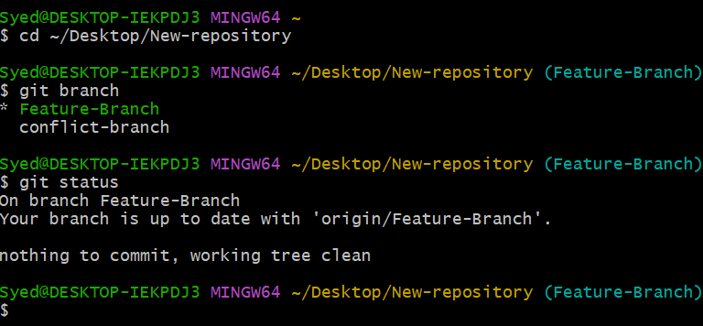

Step 2: Create a practice branch
Create a separate branch for this exercise:
git switch Feature-Branch
git switch -c recover-branch
echo "Practice branch recovery" > recovery.txt
git add recovery.txt
git commit -m "Add branch recovery practice file"

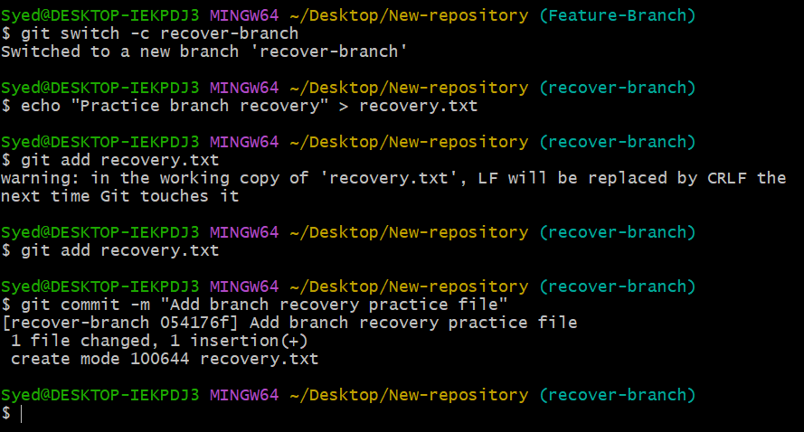

Step 3: Delete the local branch
Switch to another branch before deleting the practice branch:
git switch Feature-Branch
git branch -D recover-branch
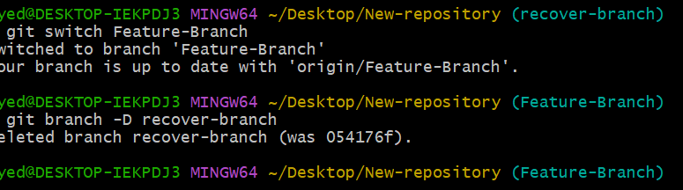
The -D option force-deletes the local branch. Use it only for this deliberate practice exercise.

Step 4: Find the deleted branch in reflog
Run:
git reflog
Look for the commit message “Add branch recovery practice file”. Your commit ID will be different. Copy the actual commit ID shown in your terminal.
Example reflog entry:
abc1234 HEAD@{2}: commit: Add branch recovery practice file
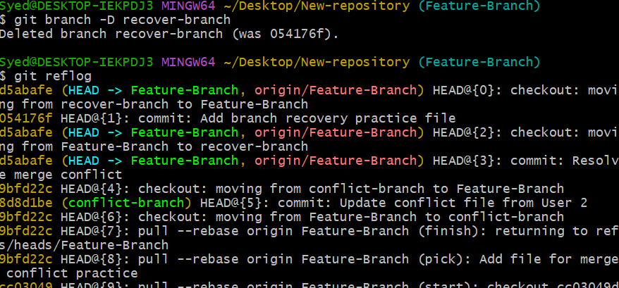

Step 5: Recover the deleted branch
Use the commit ID from Step 4:
git branch recover-branch abc1234
Replace abc1234 with your actual commit ID.
Alternatively, if you have identified the correct reflog entry, you can use:
git branch recover-branch HEAD@{2}
Replace 2 with the correct reflog entry number. The commit ID method is generally easier to follow.
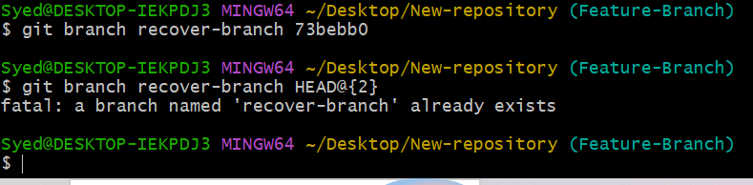

Step 6: Verify the recovered branch
Run:
git branch
git switch recover-branch
git log --oneline -5
cat recovery.txt
git status
Expected file content: Practice branch recovery
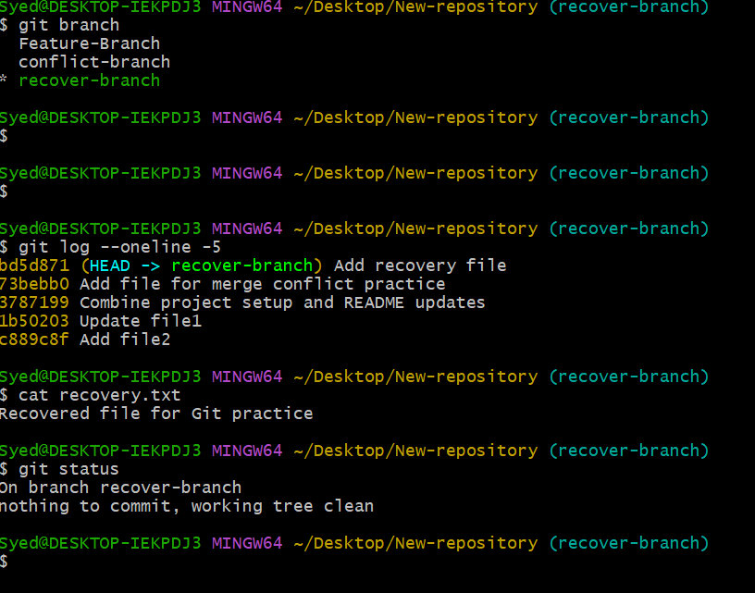

4. Important Git Commands
Command | Purpose
git branch -D recover-branch | Delete the local practice branch
git reflog | View recent HEAD movements and commits
git branch recover-branch <commit-ID> | Recreate the branch at a saved commit
git switch recover-branch | Switch to the recovered branch
git log --oneline | Check commit history

5. Result
The deleted local branch was recovered using Git reflog by locating its previous commit and recreating the branch at that commit.
Note: git reflog helps recover branch references as long as the relevant commit is still available. It is not a guarantee that every deleted commit can always be recovered.

