Recover Lost Commit Using git reflog
Git Practice Task & Documentation

This Git practice task demonstrates how to create a commit, delete it using git reset --hard, and recover the lost commit using git reflog. We will use your existing New-repository project and the Feature-Branch branch.
Task Objective
- Create a practice commit.
- Reset the branch to an earlier commit using git reset --hard.
- Find the lost commit using git reflog.
- Recover the lost commit using git reset --hard <commit-hash>.

Step 1: Open your repository
Open Git Bash and run the following commands:
cd ~/Desktop/New-repository
git switch Feature-Branch
git status

Make sure you are on Feature-Branch and have no important uncommitted changes. Do not run git reset --hard if you have work you need to keep.
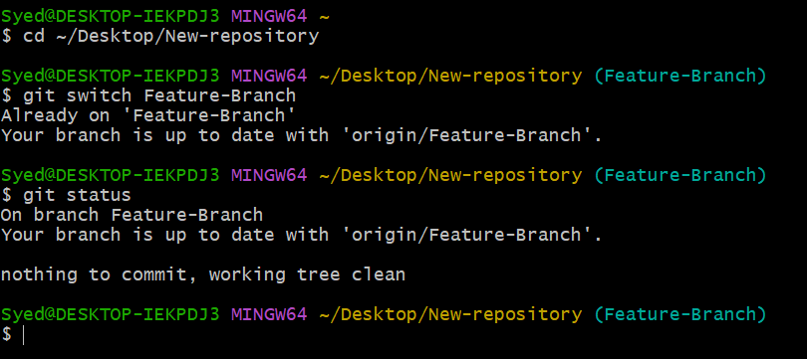
Step 2: Create a practice file
Create a new text file, stage it, and create a practice commit:
echo "This is a practice commit for reflog recovery" > recovery.txt
git add recovery.txt
git commit -m "Add practice commit for recovery"
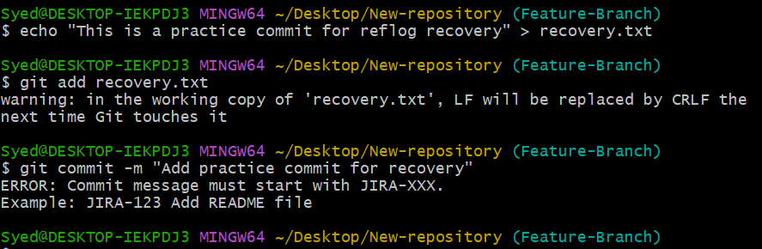
Verify the commit history:
git log --oneline -5
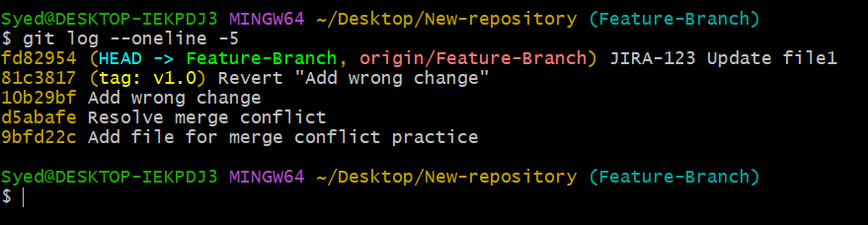
You should see a new commit similar to:
abc1234 Add practice commit for recovery

Note: Your commit hash will be different.
Screenshot evidence: Capture the successful commit and its message.
Step 3: Reset the commit
First, check the current commit:
git log --oneline -3
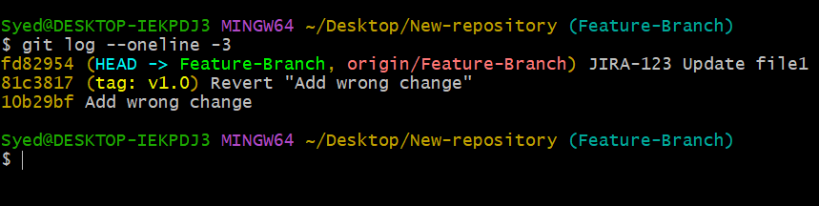
Now reset the branch back to the previous commit:
git reset --hard HEAD~1

Check the history and working tree status:
git log --oneline -5
git status

The practice commit should no longer appear in the normal branch history, and recovery.txt should no longer be present.
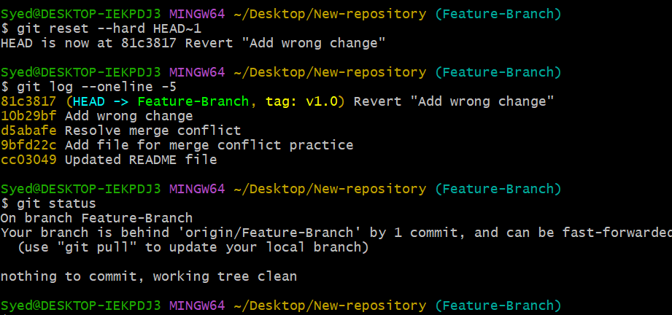
Important: git reset --hard discards tracked working-tree changes. Use it only for this controlled practice.
Step 4: Find the lost commit with reflog
Run the reference log command to view recent HEAD movements:
git reflog

Example output:
abc1234 HEAD@{0}: commit: Add practice commit for recovery
def5678 HEAD@{1}: reset: moving to HEAD~1
def5678 HEAD@{2}: commit: Previous commit

Find the hash next to the entry:
commit: Add practice commit for recovery

Copy your actual hash for the next step.
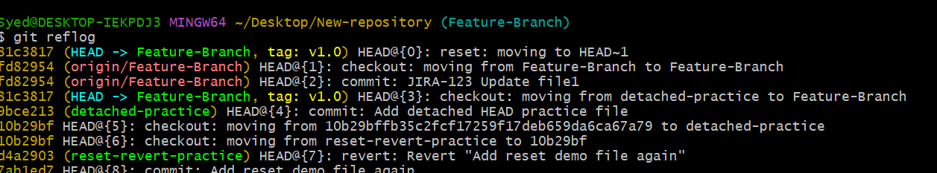.
Step 5: Recover the lost commit
Replace abc1234 with the actual commit hash shown in your reflog:
git reset --hard 81c3817
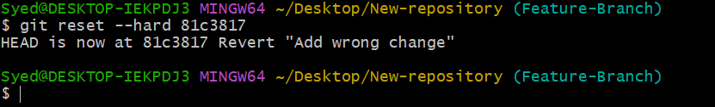
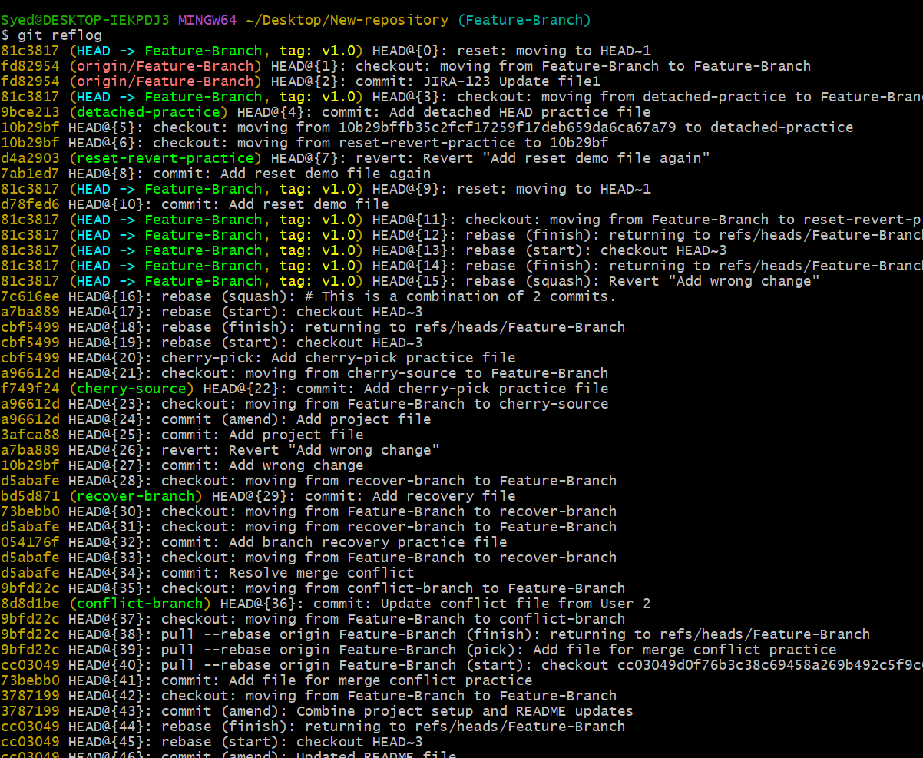
Verify the recovery with status and file checks:
git log --oneline -5
git status
ls
cat recovery.txt

You should see the recovered commit in your history and the recovery.txt file restored.
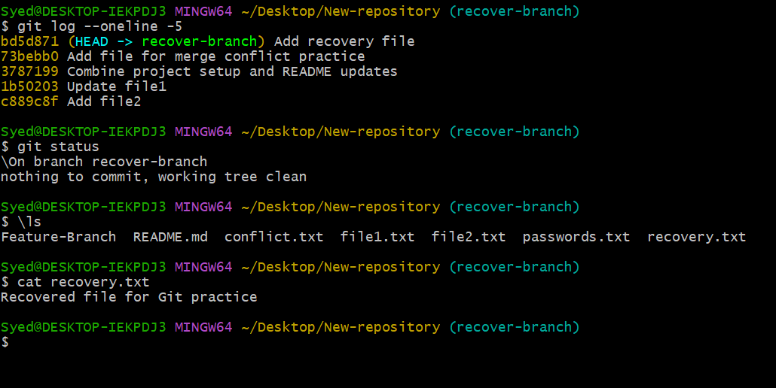
Step 6: Verify the result
Review the table below to verify that all check items match the expected results:
Check Command | Expected Result
git reflog | Shows the lost commit
git log --oneline | Shows the recovered commit
ls | Shows recovery.txt
cat recovery.txt | Displays the practice message

If you also want to push the recovered commit to GitHub, run:
git push origin Feature-Branch
This assumes the remote branch can accept the update without a non-fast-forward rejection.
Final Result & Summary
You have demonstrated how git reflog can help recover a commit after git reset --hard moves the branch pointer backward.
Key difference: git log shows the current reachable commit history, while git reflog records recent movements of local references, which can help you locate commits that are no longer in the branch history.

