Task 11: Clone Only a Branch from GitHub to Local

Outcome
A specific branch from a GitHub repository is cloned to your local computer. Git fetches the selected branch rather than the full history of all branches.

Objective
To learn how to clone only the required branch from GitHub to a local system using Git Bash.

Prerequisites
- Git installed on your computer.
- Git Bash installed.
- A GitHub repository with an existing branch.
- The repository URL and the exact branch name.

Step-by-Step Implementation

Step 1: Open your GitHub repository
- Open https://github.com/.
- Select your repository, for example, New-repository.
- Click the green Code button.
- Select HTTPS and copy the repository URL.
Example repository URL:
https://github.com/syedi7254-gif/New-repository.git

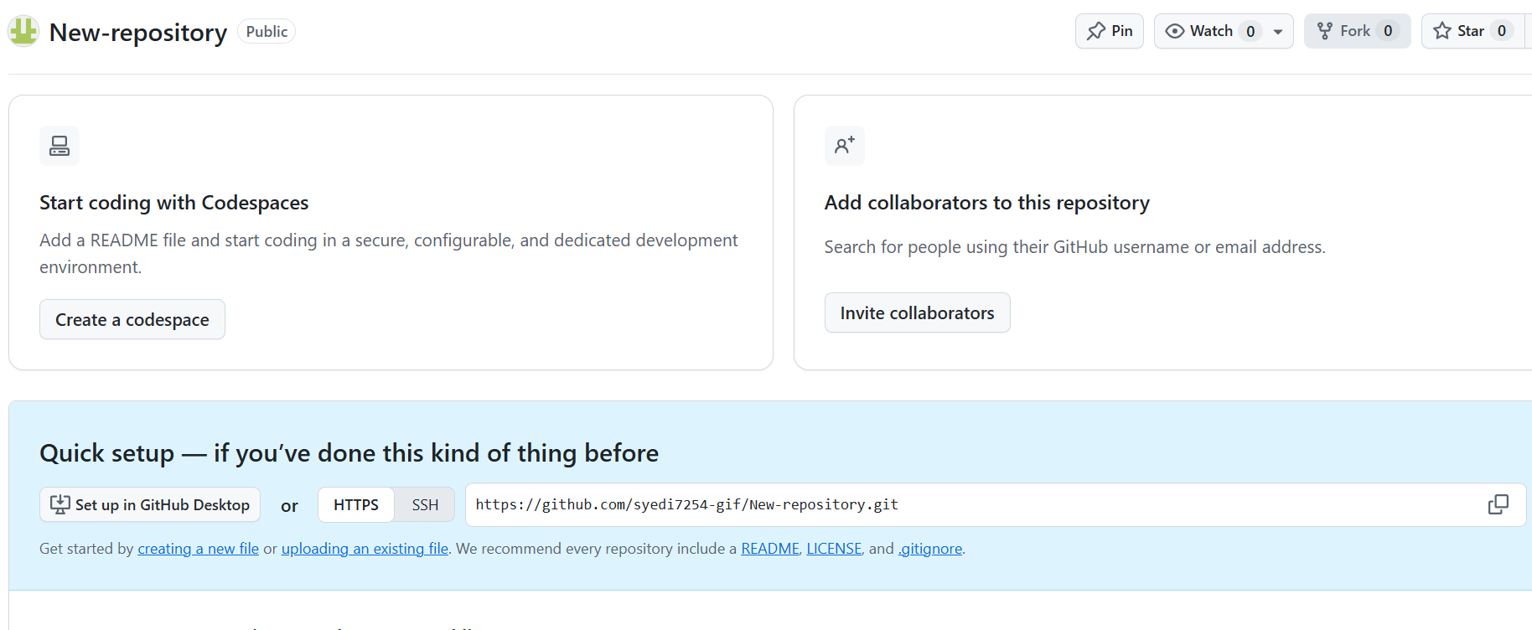

Step 2: Open Git Bash
Open Git Bash and navigate to the folder where you want to download the repository:
cd ~/Desktop
Screenshot Evidence: Capture Git Bash showing the command and current directory.

Step 3: Clone only the required branch
Run the following command. Replace the branch name or repository URL if needed:
git clone --branch Feature-Branch --single-branch https://github.com/syedi7254-gif/New-repository.git
Command explanation:
- git clone — downloads the repository.
- --branch Feature-Branch — selects the branch to clone.
- --single-branch — fetches only that branch by default.
- The URL — identifies the GitHub repository.

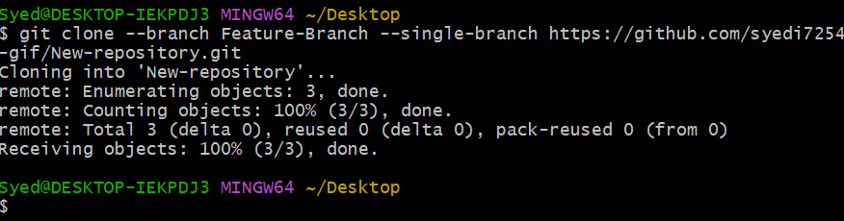

Step 4: Enter the repository folder
cd New-repository

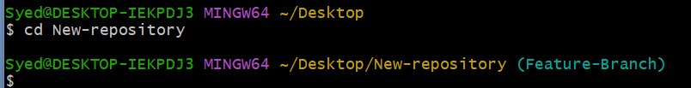

Step 5: Verify the current branch
Run:
git branch
Expected output:
* Feature-Branch
The asterisk (*) indicates the branch currently checked out.

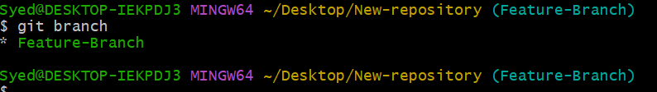

Step 6: Verify the remote branch
Run:
git branch -r
Expected output:
origin/Feature-Branch
Because --single-branch was used, Git fetches only the selected branch by default.

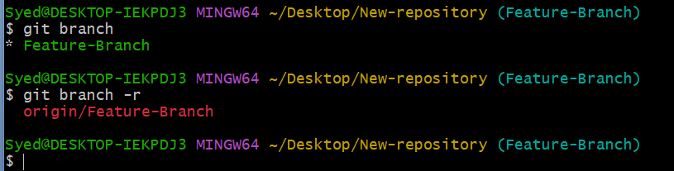

Commands Summary
cd ~/Desktop
git clone --branch Feature-Branch --single-branch https://github.com/syedi7254-gif/New-repository.git
cd New-repository
git branch
git branch -r

Important Note
If a folder named New-repository already exists on your Desktop, clone into a different folder or rename the existing folder first to avoid a destination-path error. Use the exact branch name as it appears on GitHub.

