Task 12: Create a Password File and Make It Untracked by Git

Outcome
A password file is created locally, and Git is configured to ignore it so that it is not accidentally uploaded to GitHub.

Objective
To understand how to use the .gitignore file to prevent sensitive files from being tracked by Git.

Prerequisites
- Git installed on your computer.
- GitHub repository: New-repository.
- Local repository cloned to your computer.
- Git Bash terminal.
Security note: Use dummy passwords only for this exercise. Never store real passwords in a normal text file or commit them to GitHub.

Step-by-Step Implementation

Step 1: Open your local repository
Open Git Bash and navigate to your repository:
cd ~/Desktop/New-repository
Check your current location and branch:
pwd
git branch

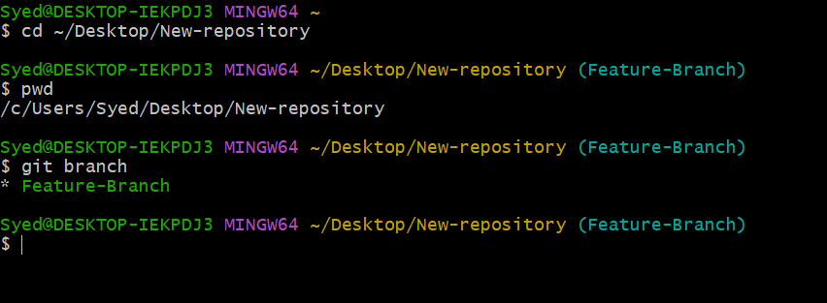Step 2:

Create a password file
Create a file named passwords.txt:
touch passwords.txt
Open it using Notepad:
notepad passwords.txt
For practice, enter dummy data such as:
username=testuser
password=DummyPassword123
Save and close the file.

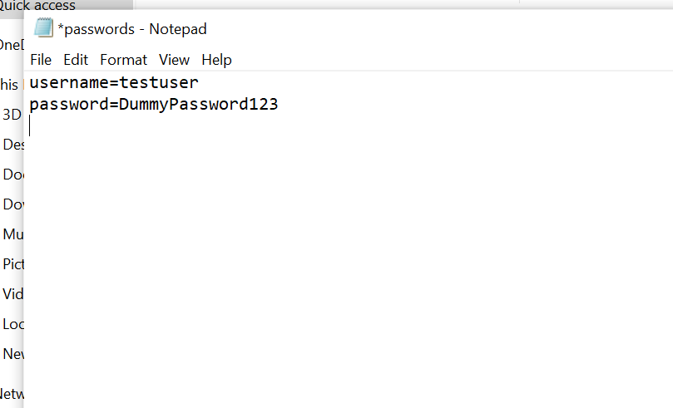Step 3: Create a .gitignore file
Open or create the .gitignore file:
notepad .gitignore
Add the following line, then save and close the file:
passwords.txt
This tells Git to ignore passwords.txt in this repository.

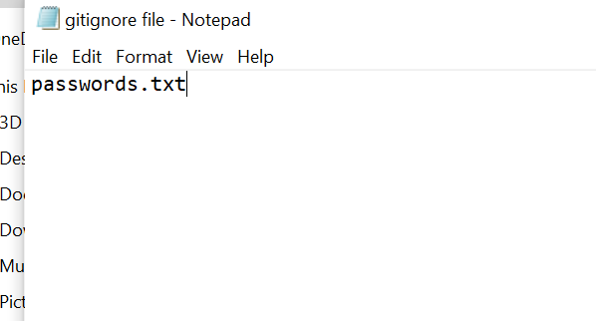

Step 4: Check Git status and verify the ignore rule
Run:
git status
If passwords.txt has never been tracked, it should not appear under Untracked files. The .gitignore file may appear as untracked until you add it.
Verify the ignore rule directly:
git check-ignore -v passwords.txt
Git should display the .gitignore rule that ignores the file.

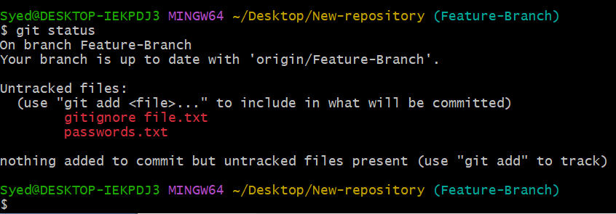

Step 5: Track and push .gitignore
Add and commit only the .gitignore file:
git add .gitignore
git commit -m "Add password file to gitignore"
Push your current branch to GitHub:
git push
If Git says the upstream branch is not configured, use the following command. Replace Feature-Branch if your branch has a different name:
git push -u origin Feature-Branch

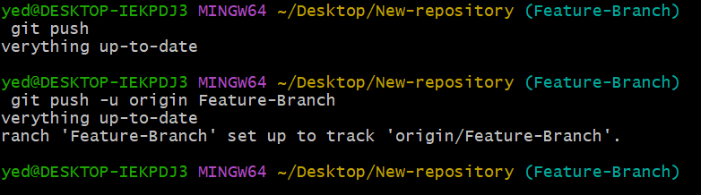

Step 6: Verify on GitHub
1. Open your GitHub repository, New-repository.
2. Select your current branch.
3. Confirm that .gitignore is present.
4. Confirm that passwords.txt is not uploaded.

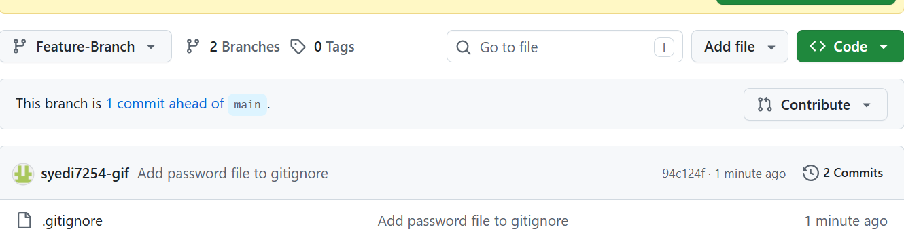

Important Notes
.gitignore prevents Git from tracking new, untracked files that match its rules. If passwords.txt was already tracked or committed, adding it to .gitignore will not stop tracking it.
To stop tracking the file while keeping your local copy, run:
git rm --cached passwords.txt
git commit -m "Stop tracking password file"
git push
This removes the file from Git’s current tracking but does not erase it from previous commits. If real credentials were exposed, change them immediately.

Final Result
You have learned how to create a local password file, ignore it using .gitignore, verify the rule, and push the ignore configuration to GitHub without uploading the password file.

