Task 13: Make a Commit and Reset That Commit Without Saving Changes

Outcome
A Git commit is created and then removed from the current local branch using git reset --hard. The changes introduced by that commit are discarded from the working directory.

Objective
To practice creating a commit and resetting it without keeping the changes in the working directory.

Prerequisites
- Git is installed and Git Bash is available.
- The New-repository repository has already been cloned to the local computer.
- Work on a test file and confirm that any changes being discarded are not needed.
Important safety note: git reset --hard permanently discards uncommitted changes to tracked files and resets the index and working tree. Use it only when you are sure you do not need the changes. The steps below use a new test file.

Step 1: Open your repository
Open Git Bash and run:
cd ~/Desktop/New-repository

Step 2: Check your current branch
Run:
git branch

Step 3: Create a test file
Run:
echo "This is my Task 13 file" > task13.txt
cat task13.txt
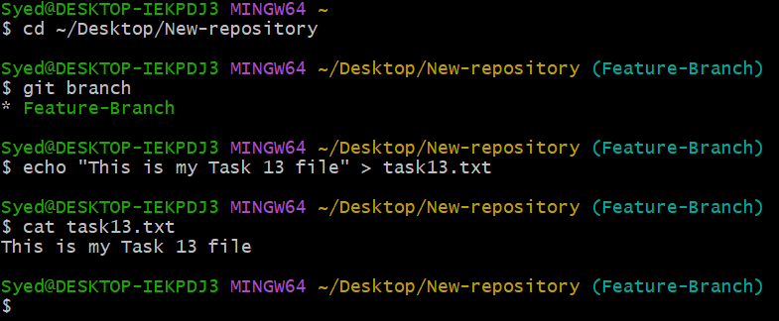

Step 4: Stage the file
Run:
git add task13.txt
git status
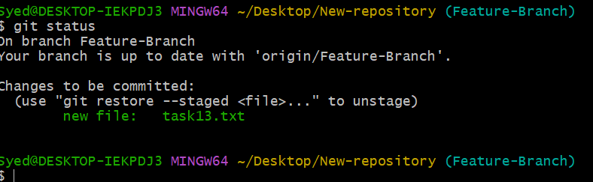

Step 5: Create a commit
Run:
git commit -m "Task 13: Create test file"
git log -1 –oneline
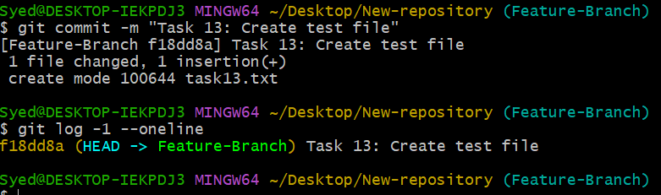

Step 6: Reset the latest commit
Run:

git log --oneline -5

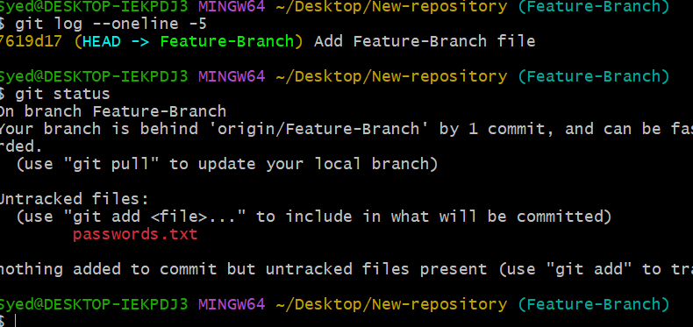

Step 7: Verify the reset
Run each command:
git log -1 --oneline
git status
ls task13.txt

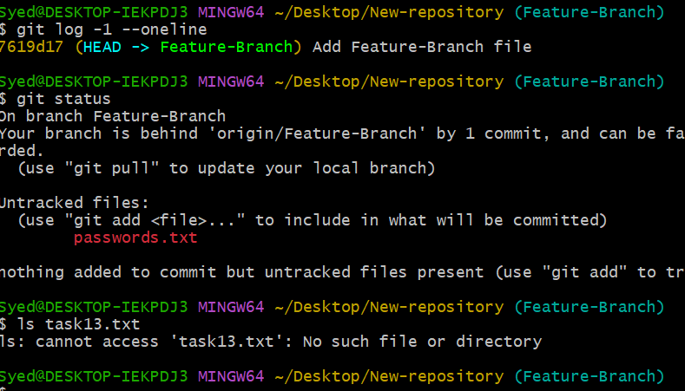

Expected Result
- The test file is created and committed.
- The latest local commit is reset.
- If task13.txt was introduced only by that commit, it no longer exists in the working directory.
- git status should show a clean working tree, assuming there were no other changes.

Note
This command changes local history only. If the commit was already pushed to GitHub, the remote branch will still contain it unless remote history is changed separately.

