Task 14: Revert a Committed Commit to the Older Version in Git

Outcome
The latest committed changes are reverted, and the project returns to an older version while preserving the commit history.

Objective
To learn how to use the git revert command to undo a commit safely without deleting the previous commit history.
Important: In the previous task, you used git reset --hard HEAD~1. For Task 14, use git revert. It creates a new commit that reverses the changes.

Prerequisites
- Git installed on your computer.
- Local repository: New-repository.
- Branch: Feature-Branch.
- At least one commit containing changes you want to undo.

Step-by-Step Implementation

Step 1: Open Git Bash
Open Git Bash and navigate to your repository:
cd ~/Desktop/New-repository
Check your current branch:

Check the current branch
git branch
If you are not on Feature-Branch, switch to it:

Switch to Feature-Branch
git switch Feature-Branch

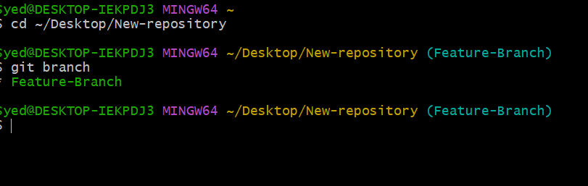

Step 2: Check the commit history
Run:
git log --oneline
Example output:

Example commit history
a1b2c3d Add a new file
94c124f Add password file to gitignore
123abcd Initial commit
The first line is the latest commit. Note the ID of the commit you want to undo.

Step 3: Revert the commit
Copy the commit ID you want to undo and run the command below. Replace a1b2c3d with your actual commit ID:
git revert a1b2c3d
If a text editor opens, save and close it to complete the revert. If Git opens Vim, press Esc, type :wq, and press Enter.
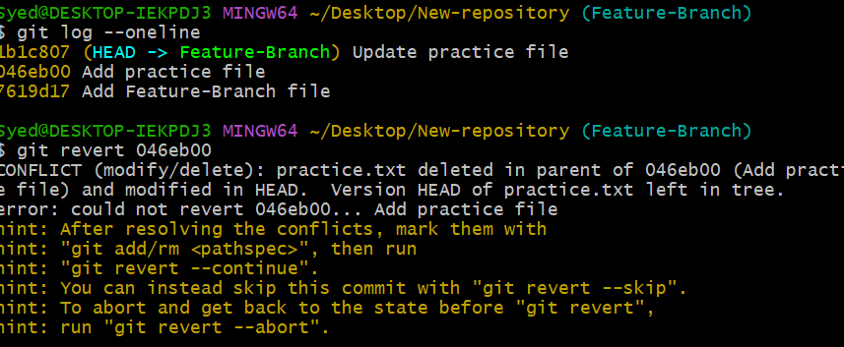

Step 4: Verify the revert
Run:
git log --oneline
Example output:

Example after reverting
b2c3d4e Revert "Add a new file"
a1b2c3d Add a new file
94c124f Add password file to gitignore
The original commit remains in the history, and the new revert commit reverses its changes.
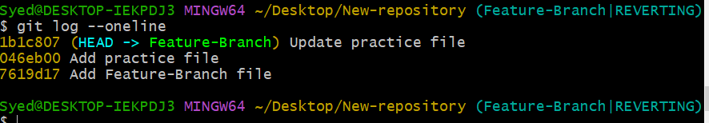

Step 5: Check the working directory
Run:
git status
If all changes have been committed, you should see:

Expected status
nothing to commit, working tree clean

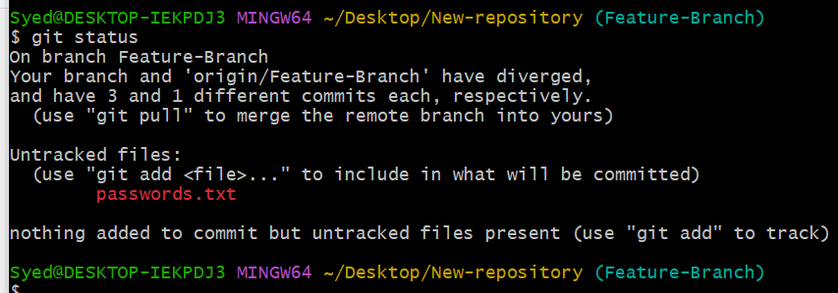

Step 6: Push the changes to GitHub (optional)
If you also want to update GitHub, run:
git push origin Feature-Branch
Open your GitHub repository and check the commit history to verify the revert.
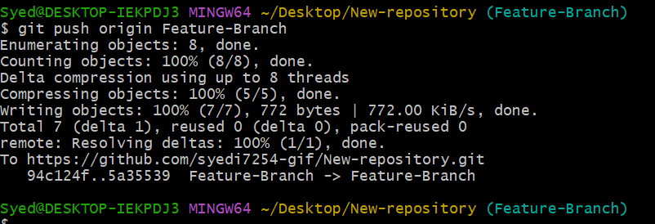

Difference Between git revert and git reset --hard
Command | What it does
git revert COMMIT_ID | Reverses a commit by creating a new commit.
git reset --hard HEAD~1 | Moves the branch back one commit and discards changes from the working tree.
Recommendation: For Task 14, use git revert. It is generally safer when the commit has already been pushed to GitHub because it preserves shared history.

Screenshot Evidence (Mandatory)
- git log --oneline before reverting.
- The git revert command and its output.
- git log --oneline after reverting.
- git status showing the final working-tree status.
- GitHub commit history after pushing, if applicable.

