Task 15: Push a File to Stash Without Saving the Changes and Work on Another File
Important: In Git, we use git stash to temporarily save changes without creating a commit. We can then work on another file and return to the original changes later.

1. Objective
To temporarily store changes in one file using Git Stash, work on another file, and recover the original changes later.

2. Prerequisites
- Git Bash installed on your computer.
- A local Git repository (New-repository).
- A branch such as Feature-Branch.

3. Step-by-Step Implementation

Step 1: Open your repository
Open Git Bash and enter:
cd ~/Desktop/New-repository
Check your current branch and status:
git branch
git status

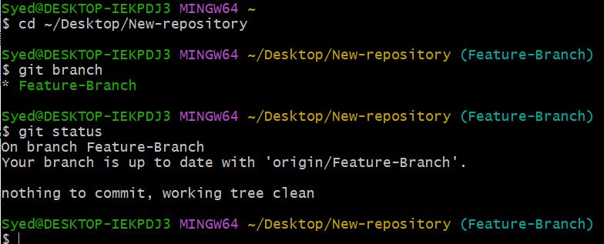

Step 2: Create the first file
Create a file named file1.txt:
echo "Original content" > file1.txt
Add it to Git and commit it:
git add file1.txt
git commit -m "Add file1"

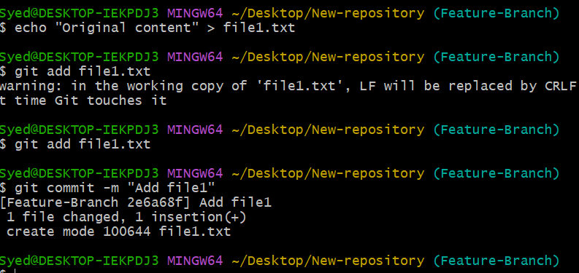

Step 3: Modify the first file
Add new content to the file:
echo "New changes in file1" >> file1.txt
Check the changes:
git status
You should see file1.txt listed as modified.
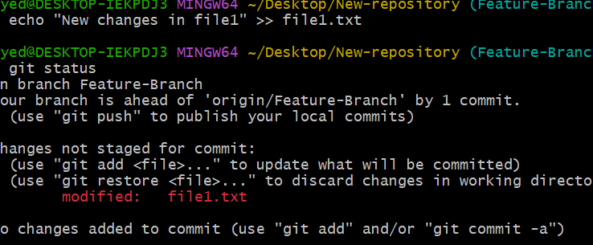

Step 4: Stash the changes
Temporarily store the changes without committing them:
git stash push -m "Save file1 changes temporarily"
Check the status:
git status
The working directory should now be clean, assuming there are no other changes.
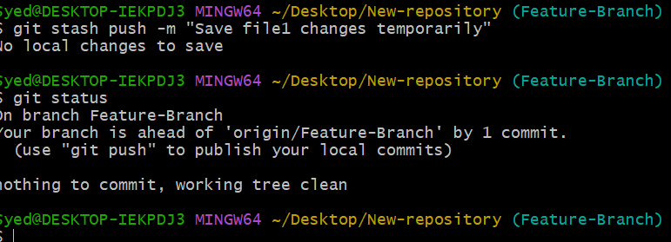

Step 5: Work on another file
Create a second file:
echo "Working on file2" > file2.txt
Stage and commit it:
git add file2.txt
git commit -m "Add file2"
Now you have committed your work on file2.txt while the changes to file1.txt remain in the stash.
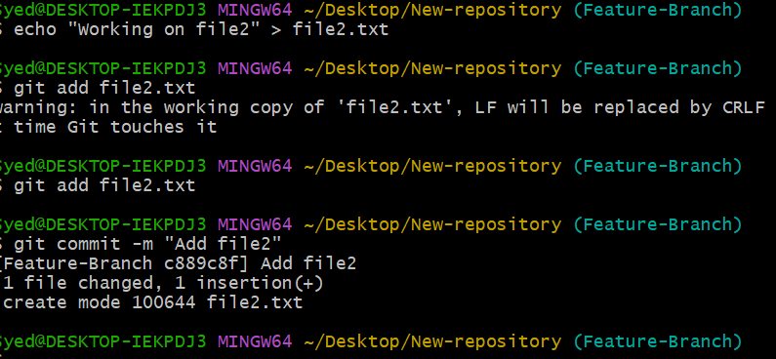

Step 6: Check the stash
Run:
git stash list
You should see an entry similar to:
stash@{0}: On Feature-Branch: Save file1 changes temporarily

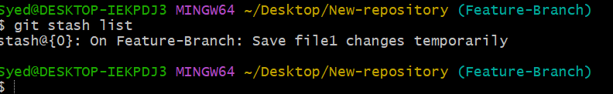

Step 7: Restore the original changes
When you want to continue working on file1.txt, run:
git stash pop
Check the file:
cat file1.txt
Expected output:
Original content
New changes in file1
The changes have been restored to your working directory.
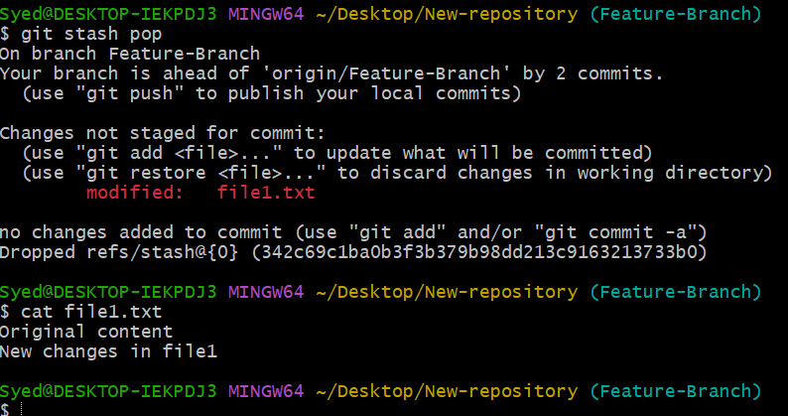

4. Important Commands
Command | Purpose
git stash | Temporarily store tracked changes
git stash list | Display saved stashes
git stash pop | Restore changes and remove that stash entry
git stash apply | Restore changes but keep the stash entry
git status | Check the working directory status
Note: git stash normally handles changes to tracked files. For new, untracked files, use git stash -u.

5. Expected Outcome
- Changes to file1.txt are temporarily stored without a commit.
- You can work on file2.txt independently.
- You can restore the original changes later using git stash pop.
Remember: Git Stash is like temporarily putting your unfinished work in a drawer so you can work on something else and come back to it later.

