Task 16: Undo the Stash File and Start Working on It Again

1. Objective
To recover previously saved changes from Git Stash and continue working on the same file in a local Git repository.

2. Prerequisites
- Git Bash installed on your Windows computer.
- A Git repository already created and cloned locally.
- A file with changes saved using git stash.
- Access to the local repository.

3. Step-by-Step Implementation

Step 1: Open Git Bash and Navigate to the Repository
Open Git Bash and navigate to your project directory.
cd ~/Desktop/linux-practice
pwd
The pwd command displays the path to your linux-practice repository.
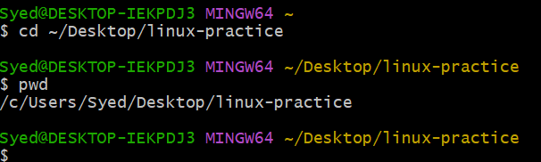

Step 2: Check the Current Git Status
Run the following command:
git status
This command shows the current state of your working directory.
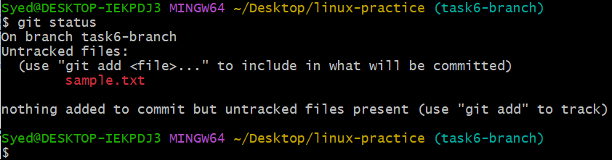

Step 3: Check the Available Stashes
Run:
git stash list
Example output:
stash@{0}: WIP on main: temporary changes
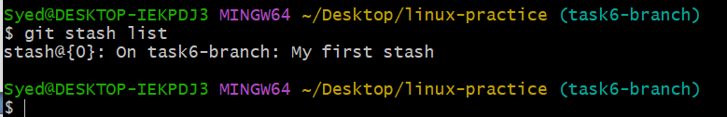
This shows the changes that were saved previously.

Step 4: Restore the Stashed Changes
Run the following command:
git stash pop
git stash pop restores the latest stashed changes to your working directory and removes that stash entry after successfully applying the changes. You can now continue editing the file.
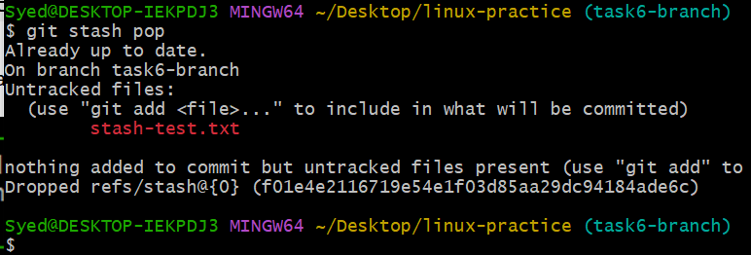

Step 5: Verify the Restored File
Run these commands:
git status
git diff
These commands help you confirm that your previously saved changes have been restored.
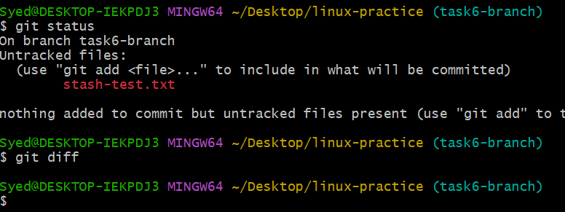

Step 6: Continue Working on the File
Open the file using Notepad from Git Bash. For example:
notepad file1.txt
Add or modify some text, then save and close the file. Check the updated contents with:
cat file1.txt

Step 7: Commit the Changes
Stage the file and commit the changes:
git add file1.txt
git commit -m "Continue work after restoring stash"
This records the updated file in the local Git repository.
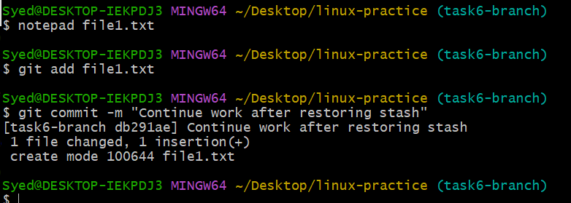

Step 8: Push the Changes to the Central Repository
Run:
git push origin main
This pushes your committed changes to the remote repository, assuming your current branch is main and the remote is named origin.

5. Expected Outcome
- Previously stashed changes are restored.
- You can continue working on the same file.
- The updated file is committed to Git.
- The changes are pushed to the central repository.

Important Note
If you want to restore the changes but keep the stash entry as a backup, use git stash apply instead of git stash pop.

