Task 17: Generate an SSH Key and Configure It in GitHub

Objective
To generate an SSH key on your computer, add the public key to GitHub, and connect your local Git repository to GitHub securely without entering your username and password for every Git operation.

Prerequisites
- Git for Windows installed, including Git Bash.
- A GitHub account.
- A local Git repository cloned to your computer.
- Access to the internet.

Step-by-Step Implementation

Step 1: Open Git Bash
Open the Windows Start menu, search for Git Bash, and launch it.

Step 2: Generate an SSH key
Run the following command. Replace the example email with the email address associated with your GitHub account.
ssh-keygen -t ed25519 -C "your_email@example.com"
Press Enter to accept the default file location. Enter a passphrase if desired, then enter it again when prompted. For no passphrase, press Enter twice.
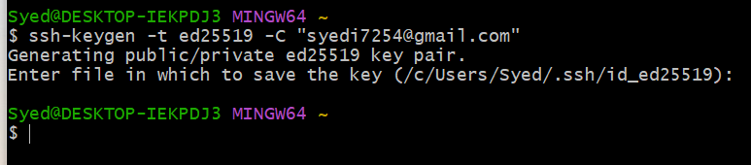

Step 3: Check the generated SSH keys
ls -la ~/.ssh
You should see files similar to:
id_ed25519
id_ed25519.pub
Important: id_ed25519 is your private key and must never be shared. id_ed25519.pub is your public key, which you add to GitHub.
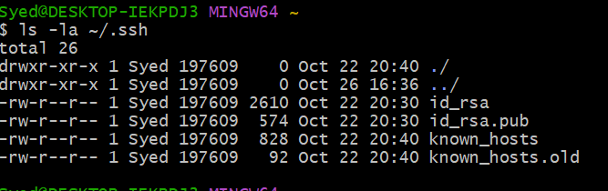

Step 4: Copy the public key
clip < ~/.ssh/id_ed25519.pub
This copies the public key to the Windows clipboard. If the command does not work, display the key using the command below and copy the complete output.
cat ~/.ssh/id_ed25519.pub

Step 5: Add the SSH key to GitHub
- Sign in to GitHub at https://github.com/.
- Click your profile picture, then select Settings.
- In the left sidebar, select SSH and GPG keys.
- Click New SSH key.
- Enter a title such as My Windows PC.
- Choose Authentication Key as the key type.
- Paste the public key into the Key field, then click Add SSH key.
- Confirm your account password if GitHub asks you to.
Direct link: https://github.com/settings/keys

Step 6: Test the SSH connection
ssh -T git@github.com
The first time, you may be asked whether you trust the GitHub host key. Verify the displayed fingerprint against GitHub’s official documentation before accepting it. If verified, type yes.
A successful connection displays a message similar to:
Hi YOUR_USERNAME! You've successfully authenticated, but GitHub does not provide shell access.
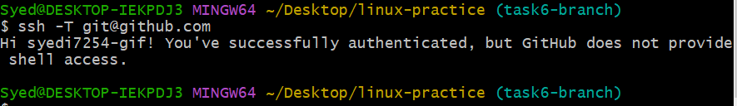

Step 7: Configure your local repository to use SSH
Navigate to your local repository. The example below uses the linux-practice folder:
cd ~/Desktop/linux-practice
Check the current remote URL:
git remote -v
If the URL starts with https://github.com/, change it to the SSH URL below. Replace YOUR_USERNAME and YOUR_REPOSITORY with your actual GitHub username and repository name.
git remote set-url origin git@github.com:YOUR_USERNAME/YOUR_REPOSITORY.git
Example only:
git remote set-url origin git@github.com:syed123/linux-practice.git
Verify the remote URL:
git remote -v
The remote URL should now begin with git@github.com:.
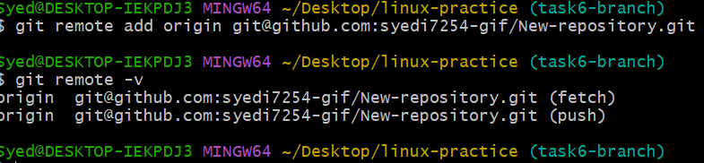

Step 8: Verify GitHub access
git fetch origin
If this completes without an authentication error, your repository can communicate with GitHub over SSH.
To publish task6-branch, make sure it is the branch you intend to push, then run:
git push -u origin task6-branch
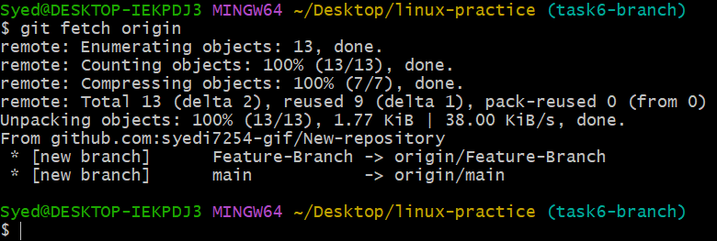
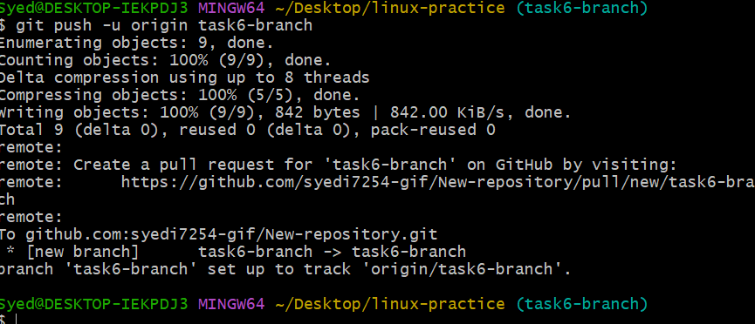

Expected Outcome
An SSH key pair is generated, the public key is registered with GitHub, SSH authentication succeeds, and the local repository is configured to communicate with GitHub using SSH.

Important Security Note
Never upload or share your private key file (id_ed25519). Only the public key file (id_ed25519.pub) should be added to GitHub.

