Task 18: Configure Webhooks in GitHub

1. Outcome
A GitHub webhook is configured successfully to send event notifications from a GitHub repository to a specified webhook URL whenever a selected event occurs.

2. Objective
The objective of this task is to configure a webhook in GitHub to automatically notify an external application or service when specific repository events occur, such as pushing code, creating a pull request, or releasing a new version.
Webhooks help automate development workflows and integrate GitHub with CI/CD tools such as Jenkins.

3. Prerequisites
- A GitHub account.
- An existing GitHub repository.
- Admin access to the repository to configure webhooks.
- A valid webhook URL provided by a receiving application or service.
- Internet connectivity.
- A test endpoint or CI/CD server, such as Jenkins, if required.
- Permission to access the receiving service and inspect incoming webhook events.

4. Step-by-Step Implementation

Step 1: Log in to GitHub
Navigation path: Open a web browser → visit https://github.com → sign in to your GitHub account.
- Enter your GitHub username or email address.
- Enter your password or complete the configured authentication process.
- Open your GitHub dashboard.
- Select the repository in which you want to configure the webhook.

Screenshot Evidence (Mandatory)

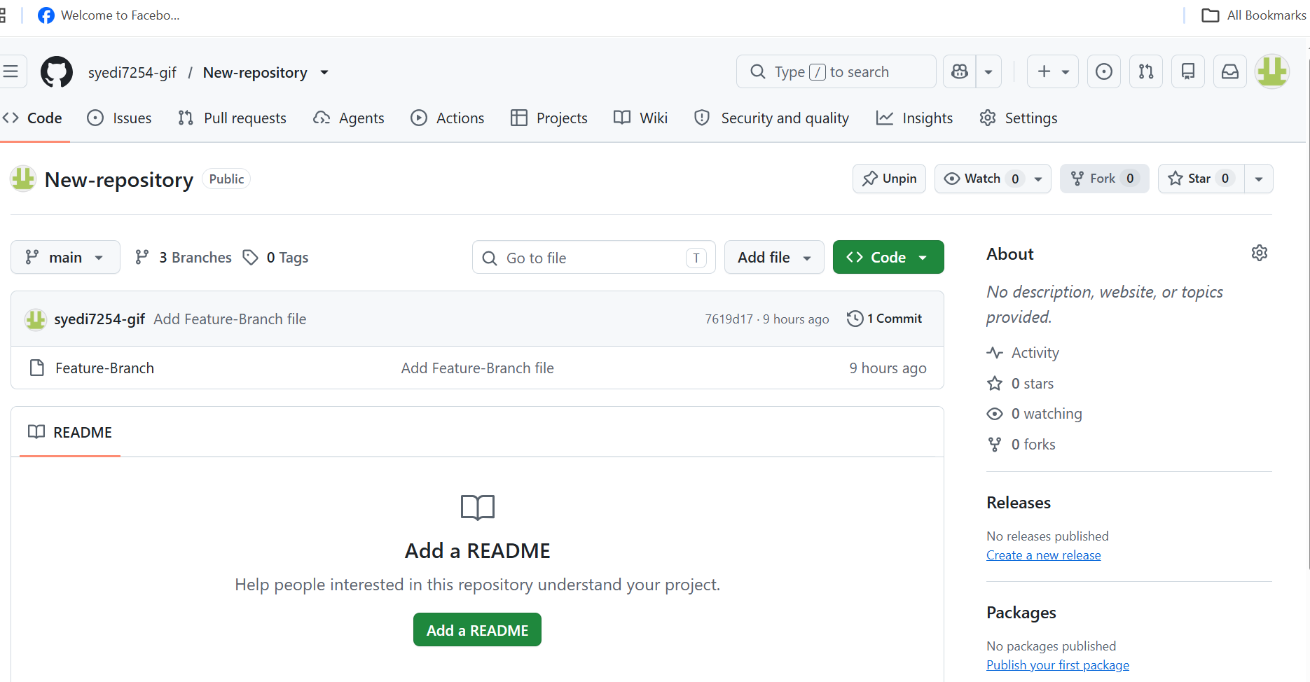

Step 2: Open Repository Settings
Navigation path: GitHub Dashboard → Select Repository → Settings → Webhooks.
- Open your selected repository.
- Click the Settings tab.
- In the left-hand sidebar, locate the Webhooks option.
- Click Webhooks to open the webhook configuration page.

Screenshot Evidence (Mandatory)

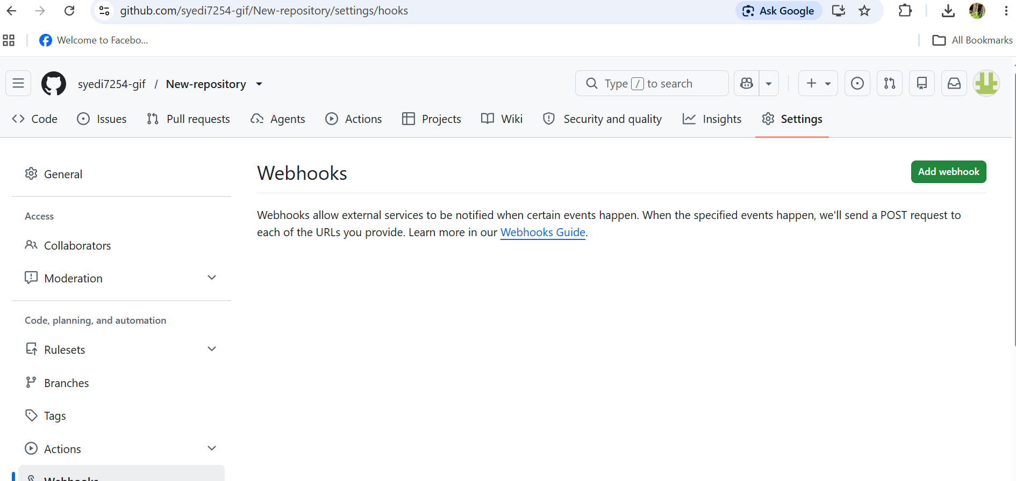

Step 3: Add a New Webhook
On the Webhooks page, click Add webhook. GitHub displays a form containing the webhook configuration fields. Enter the required configuration values.

Configuration Table
Parameter | Value
Payload URL | Enter your receiving application’s webhook URL
Content type | application/json
Secret | Enter a strong secret shared with the receiving application, if supported
SSL verification | Enable SSL verification for HTTPS endpoints
Events | Select individual events or all events, depending on the requirement
Active | Enabled
Important: The payload URL must be a real, reachable endpoint. Do not enter a sample URL unless you have configured a service to receive the requests.

Screenshot Evidence (Mandatory)

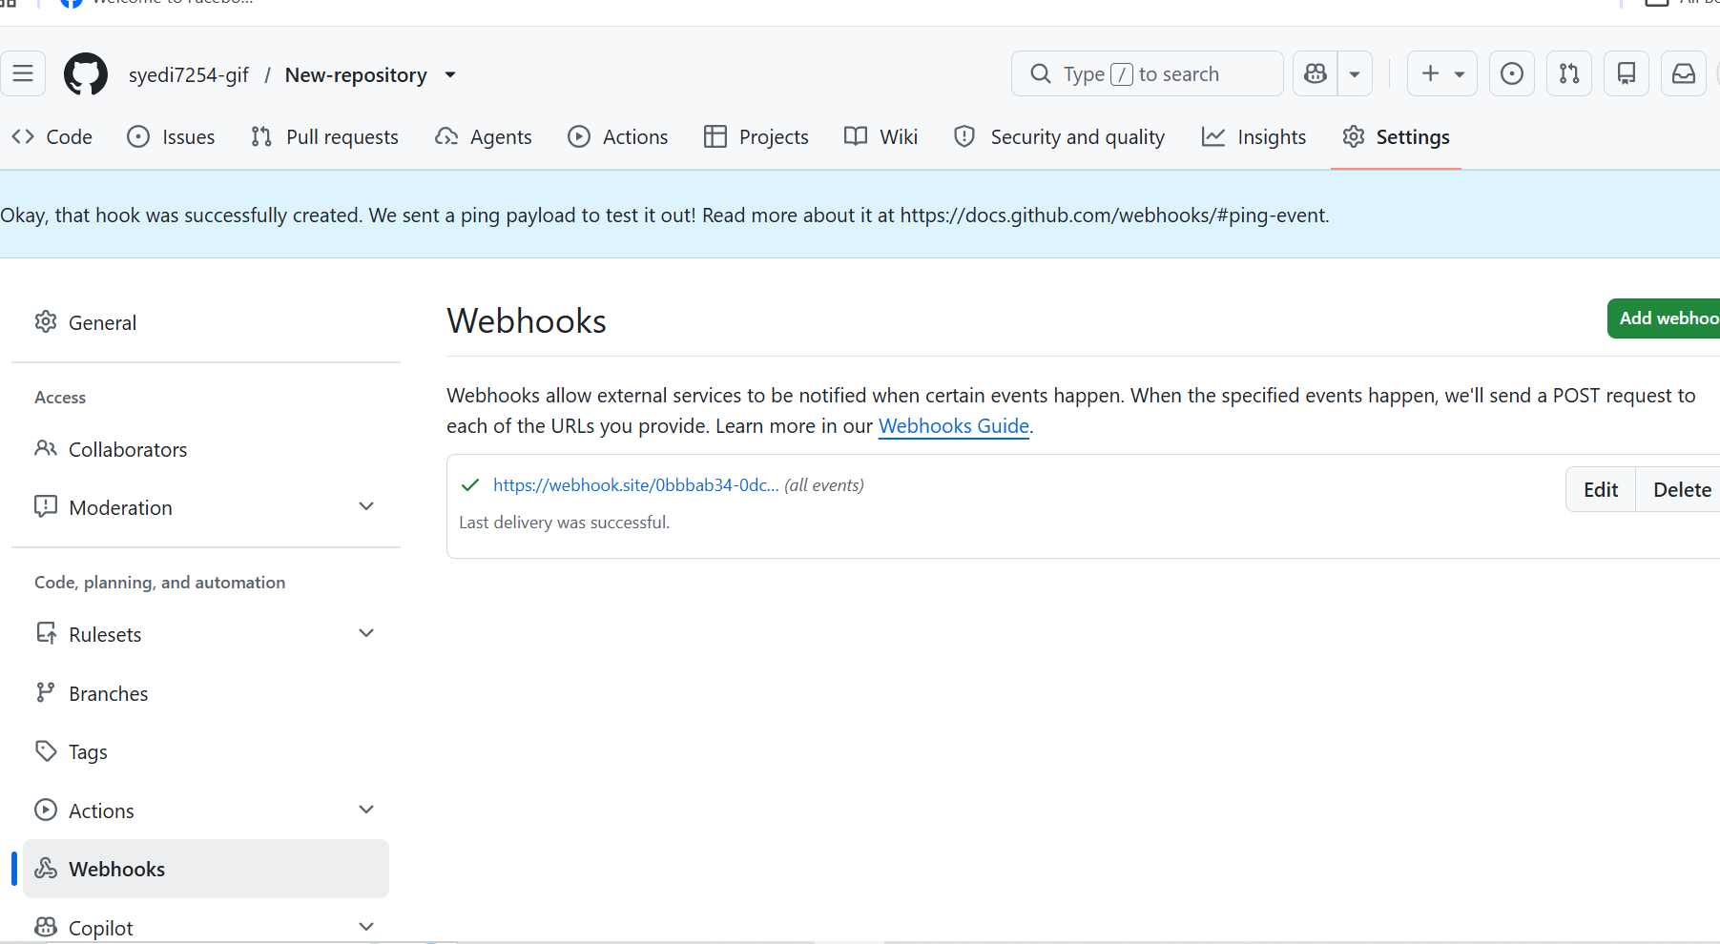

Step 4: Select Repository Events
- Under the event selection section, choose the events that should trigger the webhook.
- For a basic demonstration, select Just the push event.
- This sends a webhook notification when commits are pushed to the repository.
- Alternatively, select pull request or release events if your integration requires them.
- Confirm that the webhook is marked Active and review the configuration.

Screenshot Evidence (Mandatory)

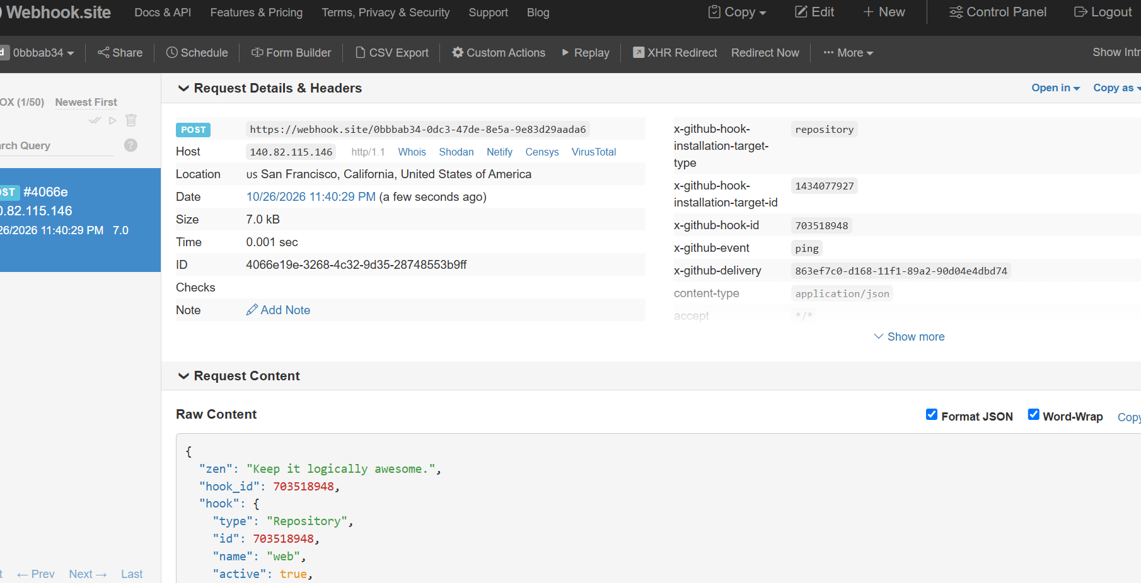

Step 5: Create the Webhook
- Review the Payload URL.
- Verify the content type.
- Confirm the required events are selected.
- Check that the webhook is active.
- Click Add webhook.
GitHub saves the configuration and displays the webhook in the repository’s Webhooks list.

Screenshot Evidence (Mandatory)

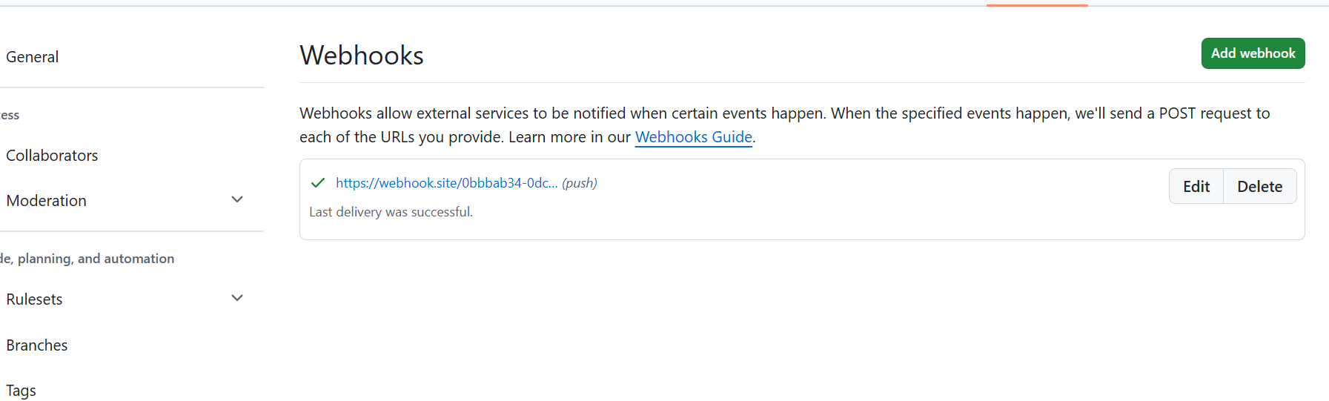

5. Validation Steps
- Open the repository and navigate to Settings → Webhooks.
- Click the newly created webhook.
- Locate the Recent Deliveries section.
- If no delivery is listed, push a small test commit to the repository.
- Open the latest delivery and inspect the request and response details.
- Check whether the receiving endpoint returned a successful HTTP response, such as 200 OK or another expected success status.

Expected Result
- The webhook appears in the repository’s Webhooks list.
- The webhook is active.
- A selected repository event triggers a delivery.
- The receiving application accepts and processes the request successfully.
A webhook being saved successfully does not by itself prove that the receiving application is working. Verify an actual delivery.

Validation Screenshot (Mandatory)

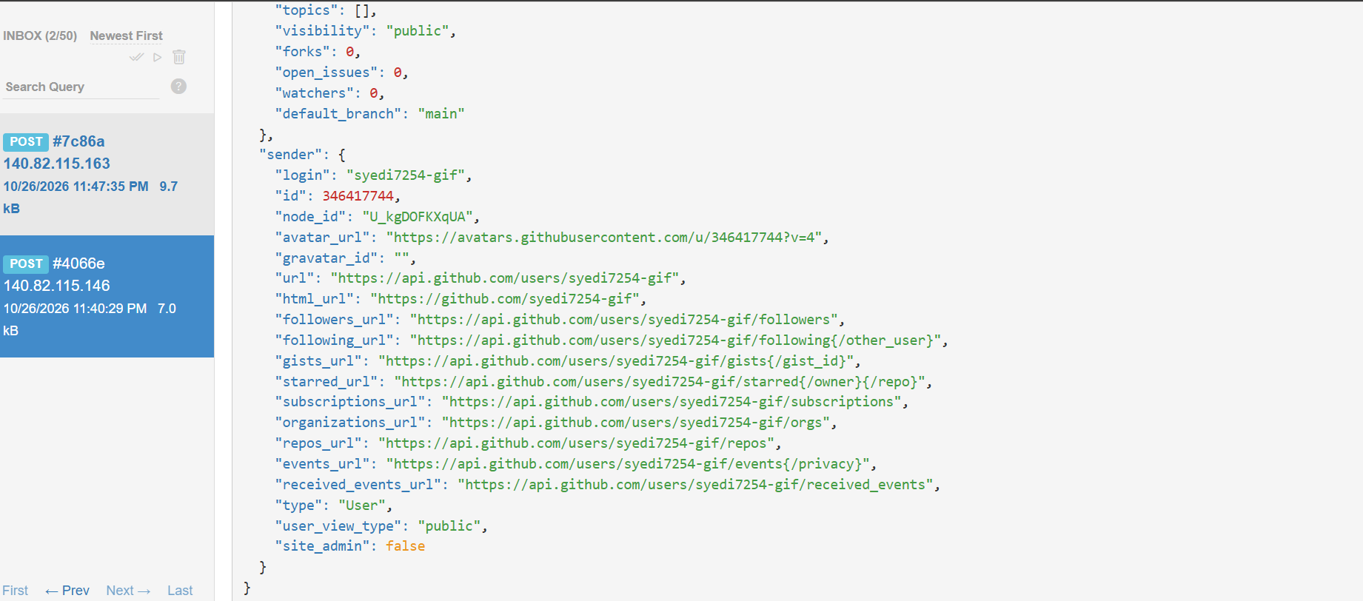 6. Explanation
A GitHub webhook is a mechanism that sends an HTTP request to another application when a specified event occurs in a repository.
For example, when a developer pushes new code to GitHub, GitHub can send a JSON payload to a configured endpoint. The receiving application can then process the event and start an automated workflow.
Webhooks reduce the need for applications to repeatedly check GitHub for changes. They help connect source code management systems with CI/CD tools, testing systems, notification platforms, and deployment automation.

7. Real-Time Use Case
In a software development company, developers push their code changes to GitHub. A webhook sends a notification to Jenkins whenever a push event occurs. Jenkins receives the notification and can start a pipeline to pull the latest code, build the application, execute automated tests, and prepare a deployment.
This integration improves automation, reduces manual work, and helps development teams deliver software more efficiently.
Example workflow: Developer → Push Code to GitHub → GitHub Webhook → Jenkins Pipeline → Build and Test → Deployment (if approved).

8. Common Errors and Troubleshooting
Error | Possible Cause | Resolution
Invalid payload URL | URL is incorrect or incomplete | Enter the correct, reachable endpoint
Connection refused | Receiving server is stopped or unreachable | Start the service and verify network connectivity
SSL certificate error | Invalid, expired, or untrusted certificate | Install a valid certificate and keep SSL verification enabled
HTTP 404 | Incorrect endpoint path | Verify the receiving application’s webhook route
HTTP 401 or 403 | Authentication or authorization failure | Check credentials, permissions, and endpoint security
HTTP 500 | Server-side application error | Inspect the receiving application’s logs
No webhook delivery | Selected event did not occur or webhook is inactive | Verify event selection and Active setting; test with a new push
Jenkins does not start a job | Jenkins endpoint or integration is misconfigured | Verify the Jenkins webhook endpoint, plugin configuration, and job settings
Secret verification fails | Sender and receiver use different secrets | Configure matching secrets and verify signature validation

9. Conclusion
In this task, a GitHub webhook was configured to send notifications when selected repository events occur. The configuration was reviewed, and the delivery status was checked through the Recent Deliveries section.
GitHub webhooks are useful for integrating source code repositories with automation and CI/CD tools. They enable event-driven workflows and help streamline software development and deployment processes.

Final Evidence Checklist
- ☐ GitHub dashboard and repository.
- ☐ Repository Settings → Webhooks.
- ☐ Add webhook configuration form.
- ☐ Selected events and Active setting.
- ☐ Created webhook in the Webhooks list.
- ☐ Recent Deliveries showing the test result.
Note: Insert actual screenshots from your GitHub account in the marked sections. Use your own repository name and a valid receiving endpoint for the practical implementation.

