Task 19: Basic Understanding of the .git Directory
Lab Manual & Implementation Guide
1. Outcome
Understand the purpose of the .git directory, its contents, and how Git uses it to track changes and manage a repository.
2. Objective
To learn about the .git directory in a Git repository and understand how it stores repository information, commits, branches, configuration, and other Git data.
3. Prerequisites
- Git installed on Windows or Linux.
- Git Bash or a Linux terminal.
- A local Git repository created or cloned.
- Basic knowledge of Git commands such as git init, git status, and git log.
4. Step-by-Step Implementation
Step 1: Open Git Bash
Open Git Bash and navigate to your existing local repository.
cd ~/Desktop/New-repository

Explanation: This command moves into your local Git repository folder.
Step 2: Display hidden files
Run the following command:
ls -la

Explanation: This displays all files and directories, including hidden items such as .git.
Expected output may look like this:
. .. .git README.md file1.txt

The .git directory is hidden because its name starts with a dot.
Step 3: Check whether the folder is a Git repository
Run:
git status

Explanation: This command displays the current branch and the status of your files. If the folder is a Git repository, Git displays information such as the current branch and whether files have changes.
Step 4: View the contents of the .git directory
Run:
ls -la .git

Explanation: This displays the internal files and folders Git uses to manage the repository.
Common contents include:
File or Directory | Purpose
HEAD | Identifies the current branch or commit reference.
config | Stores repository-specific Git configuration.
objects/ | Stores Git objects, including file contents, commits, and trees.
refs/ | Stores references to branches and tags.
index | Stores the staging area's information.
hooks/ | Contains sample or configured scripts that can run during Git events.
logs/ | Stores reference update history when logging is enabled.

The exact contents may differ depending on the repository and Git version.
Step 5: Check the current branch reference
Run:
cat .git/HEAD

Example output:
ref: refs/heads/main

Explanation: This indicates that the current branch is main. Your repository may show another branch name, such as Feature-Branch.
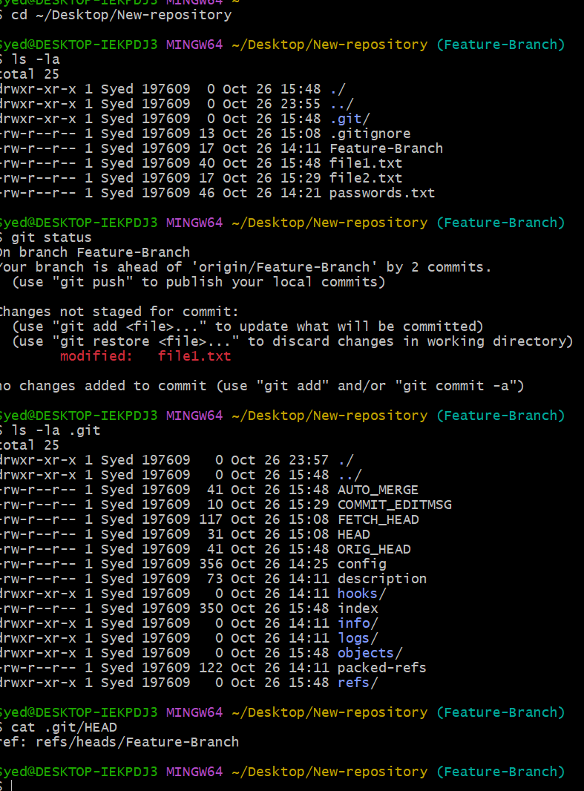
Step 6: View Git configuration
Run:
cat .git/config

Explanation: This displays repository-specific configuration, such as remote repository details and branch settings.
Example:
[core]
repositoryformatversion = 0
bare = false

Your actual configuration may contain additional sections.
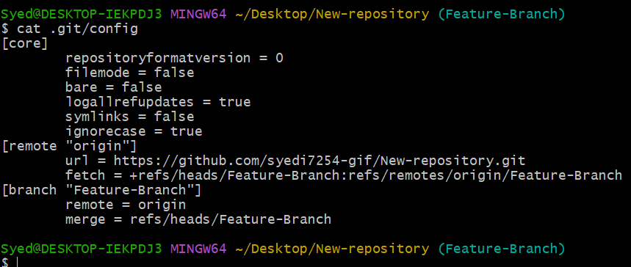
Step 7: View the commit history
Run:
git log --oneline

Explanation: This displays the commit history in a compact format.
Example output:
a1b2c3d Add README file
d4e5f6a Initial commit

The commit IDs and messages will differ in your repository.
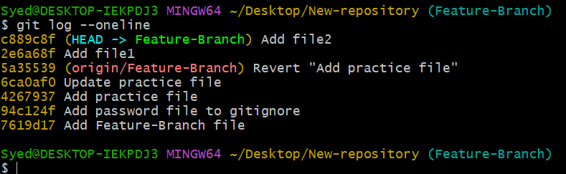
Step 8: Check the staging area
Run:
git ls-files

Explanation: This lists files tracked by Git in the index. The command helps you understand which files Git is tracking, although it does not display every detail stored in the index.
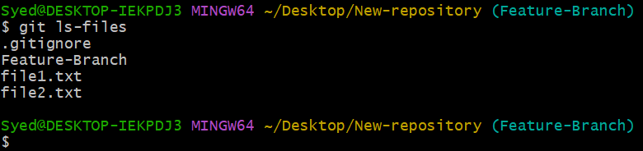

Step 9: Check the repository's root directory
Run:
git rev-parse --show-toplevel

Explanation: This displays the full path of your Git repository's root directory.
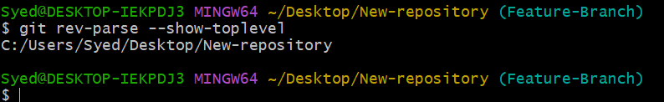
Step 10: Understand the importance of .git
The .git directory is essential because it stores the metadata and object database Git uses to manage the repository.
Important: Do not manually delete the .git directory. Deleting it can remove the repository's Git history and metadata, leaving the working files without their normal Git repository.
5. Important Commands Summary
Command | Purpose
ls -la | Show hidden files and directories.
git status | Check repository status.
ls -la .git | View .git contents.
cat .git/HEAD | Check the current branch reference.
cat .git/config | View repository configuration.
git log --oneline | View commit history.
git ls-files | List tracked files in the index.
git rev-parse --show-toplevel | Display the repository root path.

7. Final Result
Successfully understood the basic structure and purpose of the .git directory, including how Git stores repository metadata, tracks branches, manages the staging area, and maintains commit history.

