Task: Resolve Merge Conflicts in Git
Objective: Create a merge conflict intentionally by editing the same line in two branches, resolve the conflict, and push the changes to GitHub.

Step 1: Open Your Repository
Open Git Bash and run:
cd ~/Desktop/New-repository
git status
git branch
Make sure you are working in the New-repository folder.
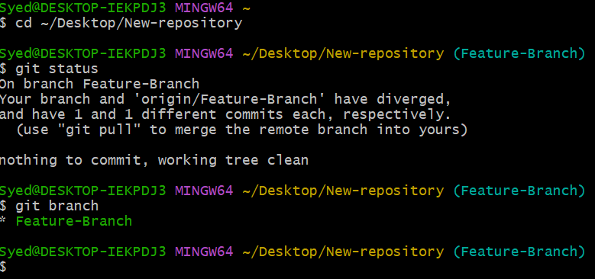

Step 2: Create a File on Feature-Branch
Run these commands:
git switch Feature-Branch
echo "This is the original project line." > conflict.txt
git add conflict.txt
git commit -m "Add file for merge conflict practice"
git push origin Feature-Branch
This creates conflict.txt and pushes it to GitHub.
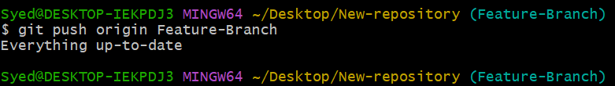

Step 3: Create Another Branch
Run:
git switch -c conflict-branch
Change the same line in conflict.txt:
echo "This line was changed by User 2." > conflict.txt
git add conflict.txt
git commit -m "Update conflict file from User 2"

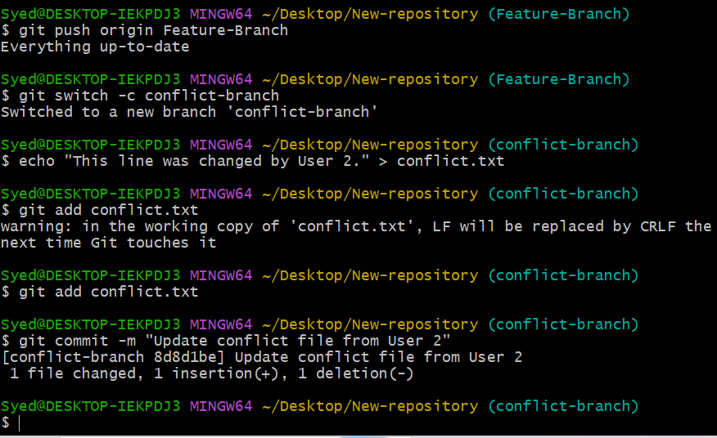

Step 4: Change the Same Line in Feature-Branch
Switch back to the first branch:
git switch Feature-Branch
echo "This line was changed by User 1." > conflict.txt
git add conflict.txt
git commit -m "Update conflict file from User 1"
Both branches now contain different changes to the same line.

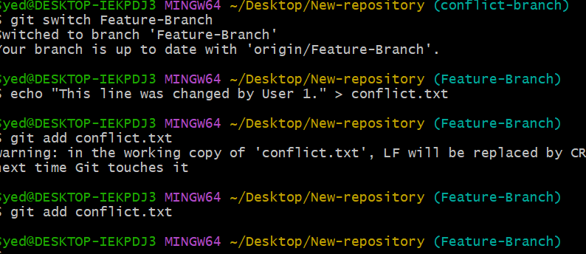

Step 5: Merge the Branches to Create a Conflict
git merge conflict-branch
git status
Git should report a merge conflict because both branches changed the same line.
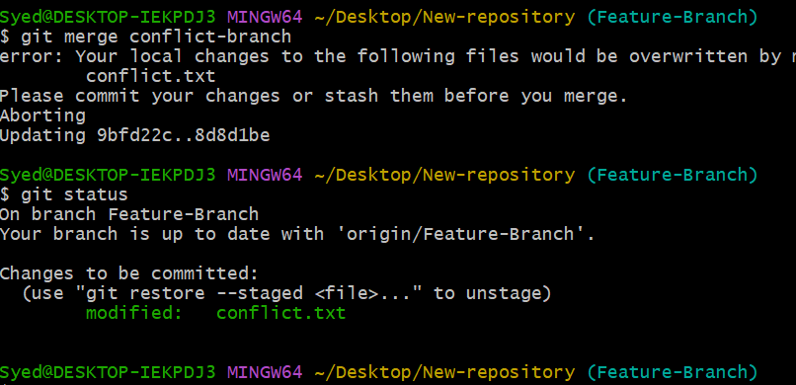

Step 6: Open and Resolve the Conflict
Display the file:
cat conflict.txt
You should see conflict markers similar to:
<<<<<<< HEAD
This line was changed by User 1.
=======
This line was changed by User 2.
>>>>>>> conflict-branch
The markers show the competing changes. Replace the entire contents of conflict.txt with this resolved line:
The merge conflict has been resolved successfully.
To edit using Notepad, run:
notepad conflict.txt
Save the file and close Notepad.
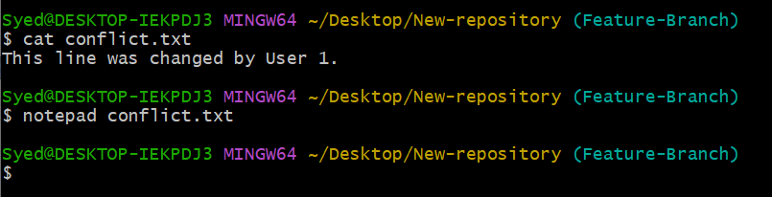

Step 7: Mark the Conflict as Resolved
git add conflict.txt
git commit -m "Resolve merge conflict"
git status
The working tree should be clean after the commit.
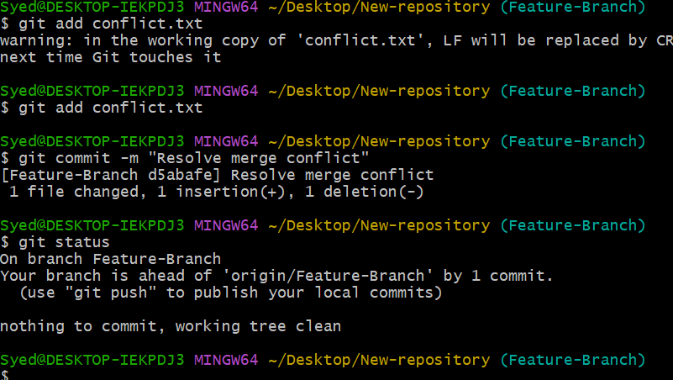

Step 8: Push the Resolved Changes to GitHub
git push origin Feature-Branch
git log --oneline --graph --all
Check that the conflict-resolution commit appears in the history.
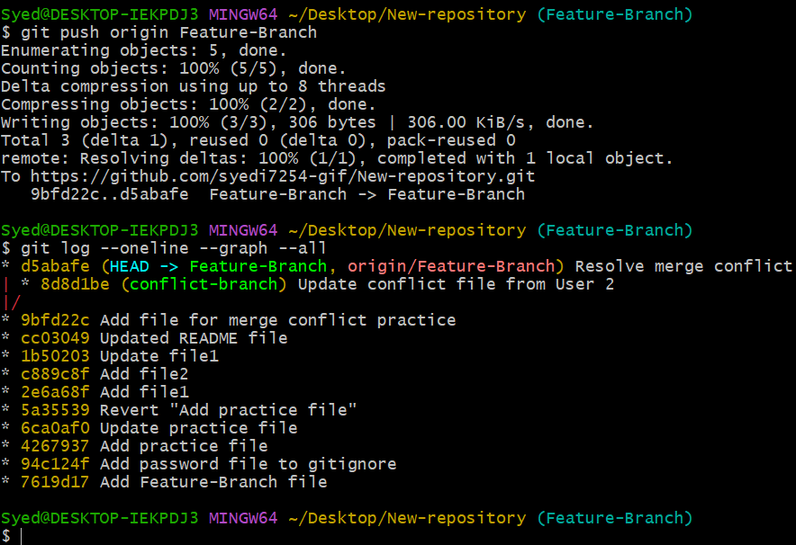

Expected Outcome
- Created two branches with different changes to the same line.
- Intentionally generated a merge conflict.
- Resolved the conflict manually.
- Committed the resolution.
- Pushed the resolved changes to GitHub.

Troubleshooting Note
If git merge conflict-branch says “Already up to date” instead of showing a conflict, run git status and git log --oneline --graph --all, then review the branch setup before continuing.

