Task 20: Check All the Logs of Git
1. Outcome
Understand how to view Git logs and check the history of commits, authors, dates, branches, and changes made in a Git repository.
2. Objective
To learn and execute Git log commands to inspect commit history and track changes made by different users in a local repository.
3. Prerequisites
- Git installed on Windows or Linux.
- Git Bash or a Linux terminal.
- A local Git repository created or cloned.
- At least one commit in the repository to display meaningful commit history.
4. Step-by-Step Implementation
Step 1: Open Git Bash
Open Git Bash and navigate to your local repository.
cd ~/Desktop/New-repository
Explanation: This command moves into your local Git repository. Replace the path if your repository is stored elsewhere.
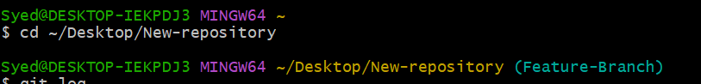
Step 2: Check the basic Git log
git log
Explanation: Displays the commit history, including commit ID, author, date, and commit message.
Example output:
commit a1b2c3d4e5f6
Author: Syed
Date: Mon Oct 26 10:00:00 2026
Add README file
Your output will contain your actual commit details.
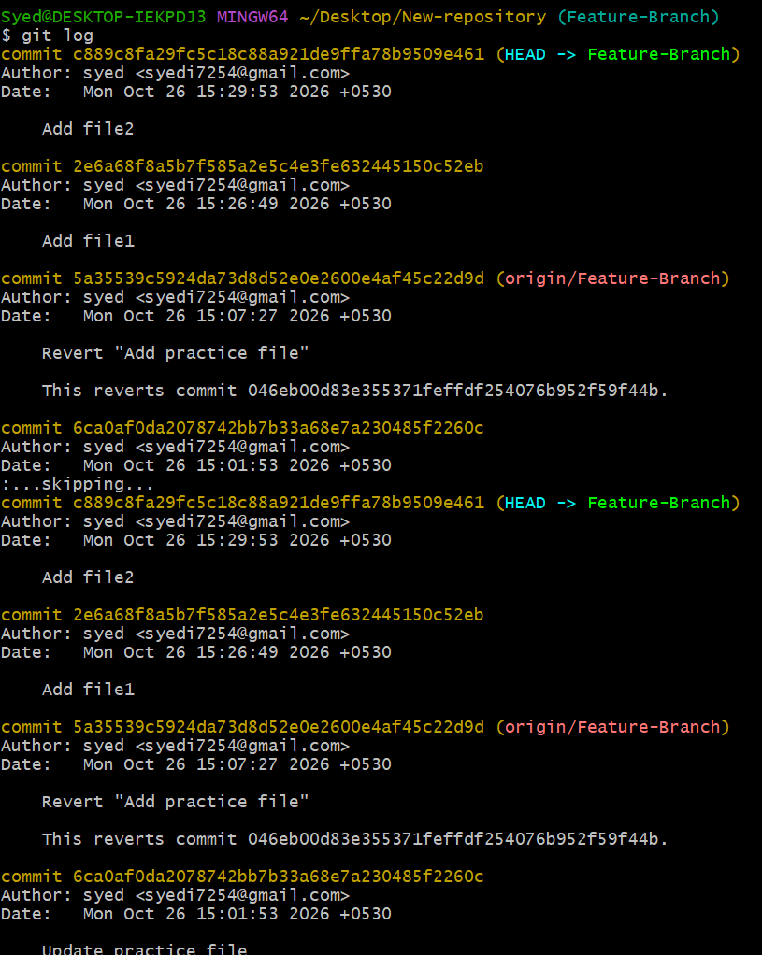
Step 3: Check logs in one-line format
git log --oneline
Explanation: Displays each commit in a compact format, making it easier to review the history.
Example:
a1b2c3d Add README file
d4e5f6a Update configuration
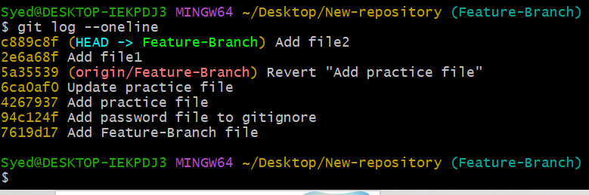
Step 4: Check all logs with detailed statistics
git log --stat
Explanation: Displays each commit along with a summary of files changed and the number of lines added or deleted.
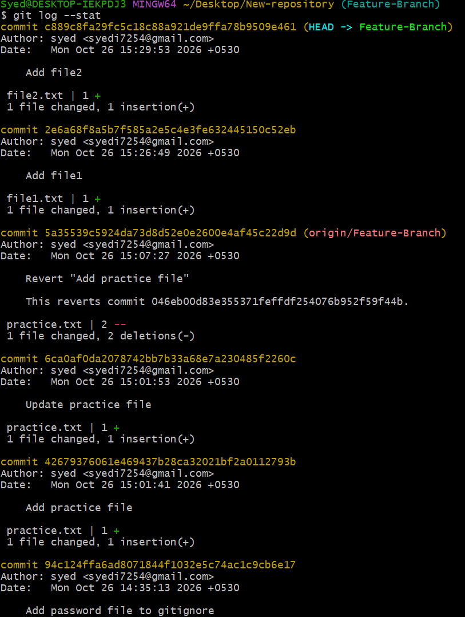
Step 5: Check logs with the full commit details
git log --format=fuller
Explanation: Displays detailed information about each commit, including the author and committer names and dates.
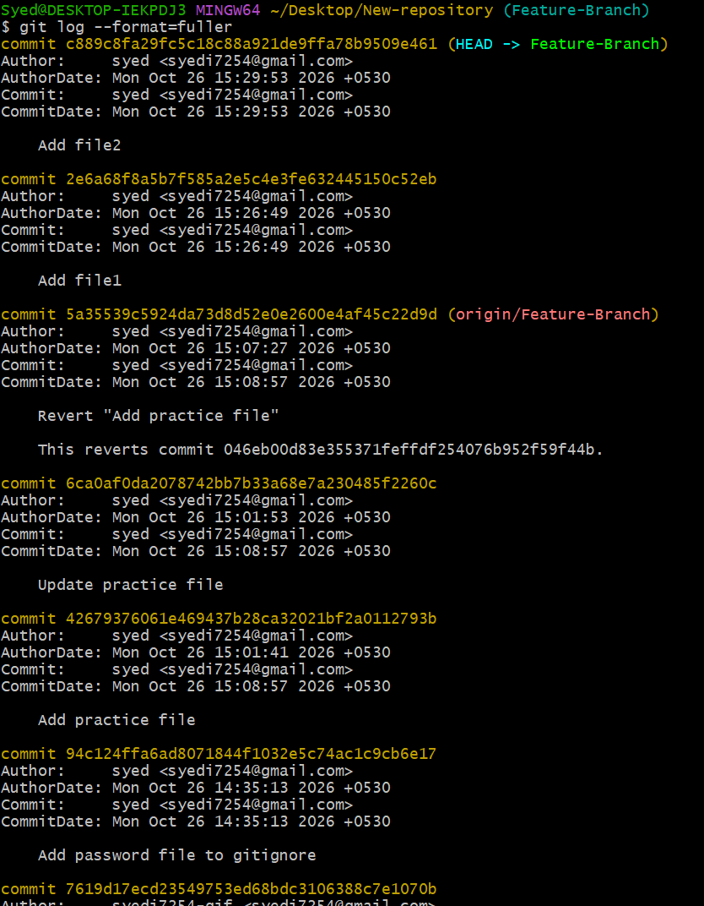
Step 6: Check logs for a specific file
git log -- README.md
Explanation: Displays the commit history associated with README.md. Replace README.md with the name of the file you want to investigate.
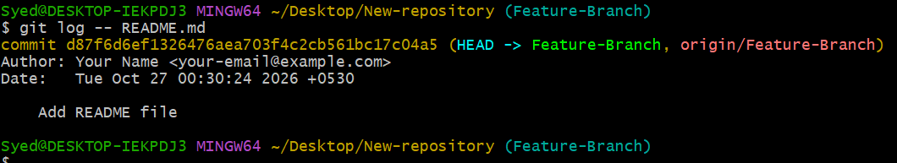
Step 7: Check logs with the changes made
git log -p
Explanation: Displays commit history along with the actual changes introduced by each commit.
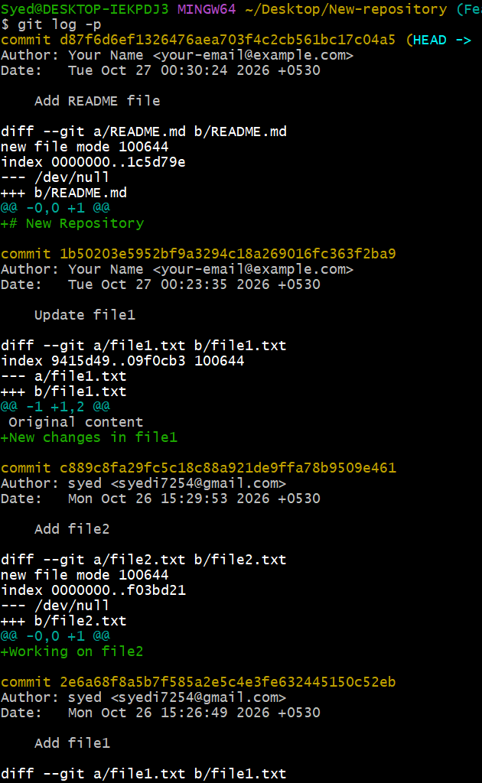
To inspect changes for only one file, run:
git log -p -- README.md
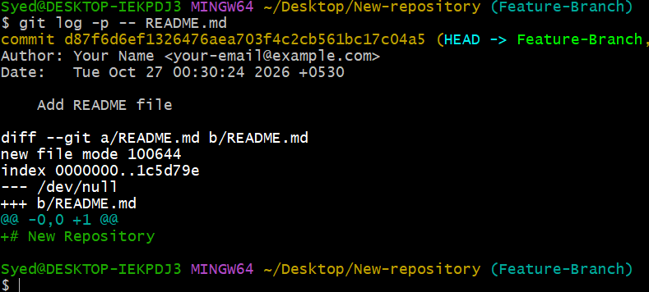
Step 8: Check the last five commits
git log -5 --oneline
Explanation: Displays only the latest five commits in a compact format.
Step 9: Check logs in graphical form
git log --oneline --graph --decorate --all
Explanation: Displays commit history as a graph, including branch and tag references. This is useful for understanding how branches diverge and merge.
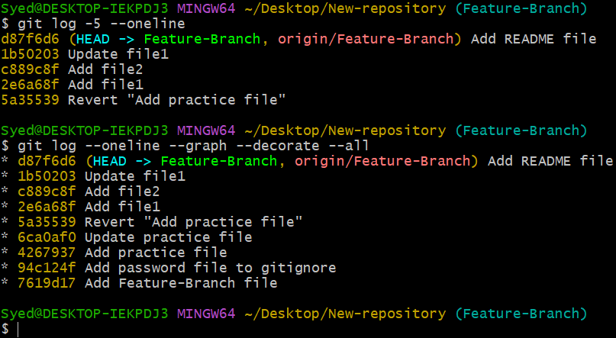
Step 10: Check who changed each line of a file
git blame README.md
Explanation: Shows the last recorded commit responsible for each line of the file, along with author information. It helps investigate the history of individual lines.
Step 11: Check the remote repository configuration
git remote -v
Explanation: Displays configured remote repository names and URLs. This does not display commit logs, but helps identify which remote repository is associated with your local project.
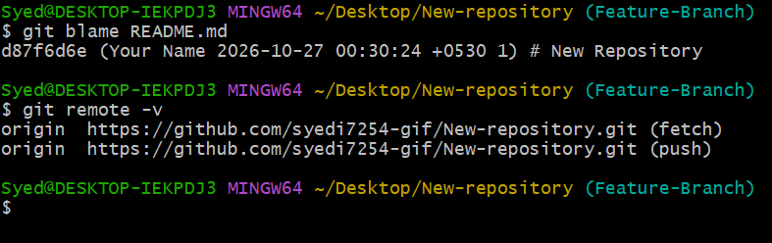
Step 12: Check logs from the terminal
Run the following command:
git log --oneline --all
Explanation: Displays commits reachable from all local references, including local branches and remote-tracking branches that have been fetched. It does not necessarily show every commit on the remote server that has not been fetched.
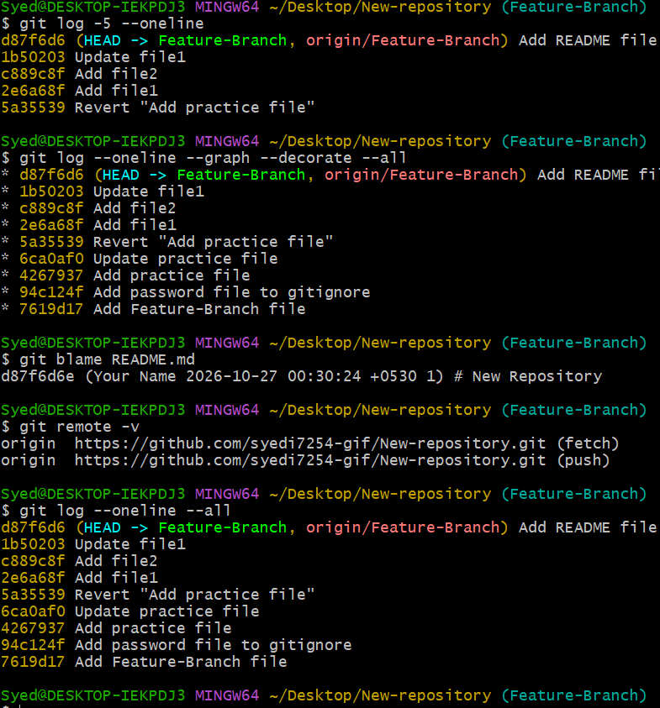
5. Important Git Log Commands Summary
Command | Purpose
git log | Display complete commit history.
git log --oneline | Display compact commit history.
git log --stat | Display file change statistics.
git log --format=fuller | Display detailed author and committer information.
git log -- README.md | Display history for a specific file.
git log -p | Display commits and their changes.
git log -5 --oneline | Display the latest five commits.
git log --oneline --graph --decorate --all | Display a graphical history of branches and commits.
git blame README.md | Identify the last commit responsible for each line.
git log --oneline --all | Display commits reachable from all local references.
git remote -v | Display configured remote repository URLs.
6. Final Result
Successfully learned how to inspect Git commit history, review file changes, identify authors, and visualize branch history using Git log commands. These commands help DevOps engineers investigate code changes, troubleshoot issues, and track the development history of a project.

