Task 21
Rename the Commit Message in Git
1. Objective
To rename the most recent Git commit message using Git Bash.
2. Prerequisites
- Git installed on your computer.
- A local Git repository created.
- At least one commit available.
3. Step-by-Step Implementation
Step 1: Open Git Bash
Open Git Bash and navigate to your repository:
cd ~/Desktop/New-repository

Step 2: Check the Existing Commit Message
Run the following command to list commit history:
git log --oneline

Example Output:
a1b2c3d Add README file
e4f5g6h Initial commit

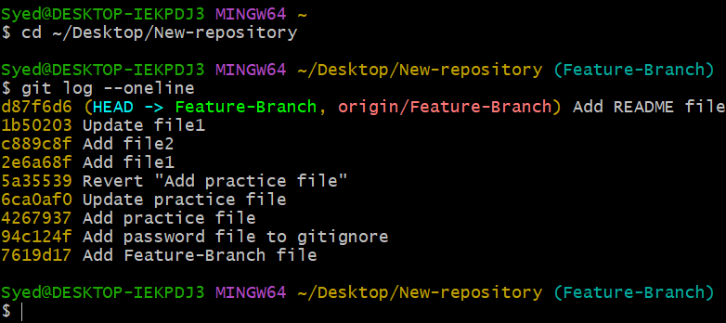
Step 3: Rename the Latest Commit Message
Use git commit --amend -m to change the most recent commit message:
git commit --amend -m "Updated README file"

Note: You can replace "Updated README file" with your desired commit message.
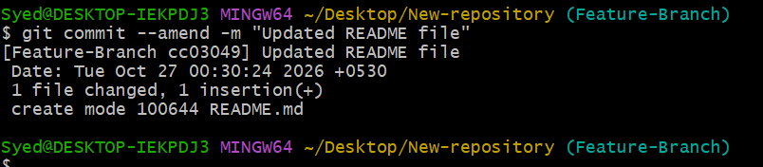
Step 4: Verify the Updated Commit Message
Run the log command again to verify the update:
git log --oneline

Example Output:
a1b2c3d Updated README file
e4f5g6h Initial commit

The latest commit message is now changed successfully.
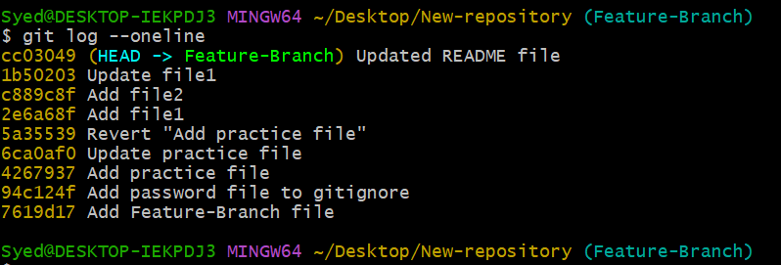
Step 5: Push Changes to the Central Repository (if required)
If the original commit was already pushed to GitHub, use force push:
git push --force-with-lease
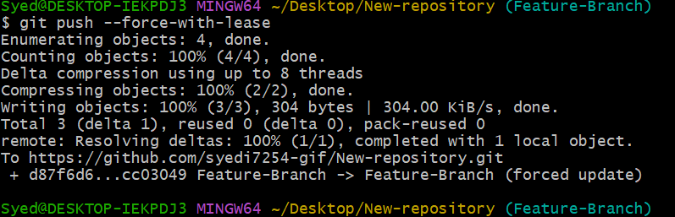

Important: Amending a commit changes its commit ID. Use force pushing only when appropriate, especially if others share the branch.

6. Expected Outcome
The latest commit message is successfully renamed without changing the commit's file contents.
Remember: git commit --amend -m "New message" renames the latest commit; it does not rename an older commit.

