Task 22: Merge Multiple Commits into a Single Commit in Git
1. Outcome
To combine multiple Git commits into one single commit using Git Interactive Rebase.
2. Objective
To learn how to merge multiple commits into a single commit using the git rebase -i command.
3. Prerequisites
- Git installed on your system.
- A local Git repository.
- At least three commits in the repository.
- Git Bash or a terminal.
4. Step-by-Step Implementation
Step 1: Open Git Bash and navigate to your repository
You are working in the New-repository folder, so run:
cd ~/Desktop/New-repository

Step 2: Check the current branch
Make sure you are on the correct branch, such as Feature-Branch.
git branch
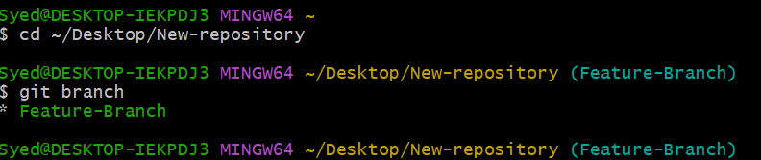
Step 3: Check the commit history
Check your commit log history: git log --oneline
git log --oneline
# Example output:
# a1b2c3d Update README
# e4f5g6h Add sample file
# i7j8k9l Initial commit

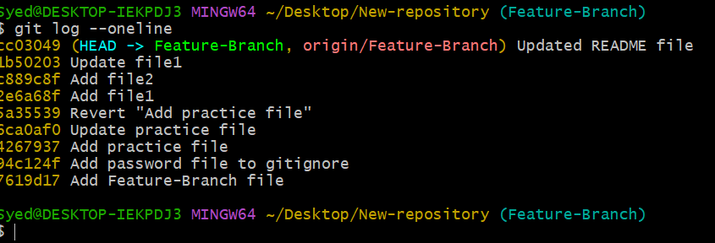
Step 4: Start interactive rebase
To combine the latest three commits into one, execute:
git rebase -i HEAD~3

Your configured text editor will open with content similar to:
pick i7j8k9l Initial commit
pick e4f5g6h Add sample file
pick a1b2c3d Update README

Step 5: Change pick to squash
Keep the first commit as pick and change the remaining two to squash:
pick i7j8k9l Initial commit
squash e4f5g6h Add sample file
squash a1b2c3d Update README

Save the file and close the editor.
Note: If you are using Vim, press i to edit, then press Esc, type :wq, and press Enter to save and exit.

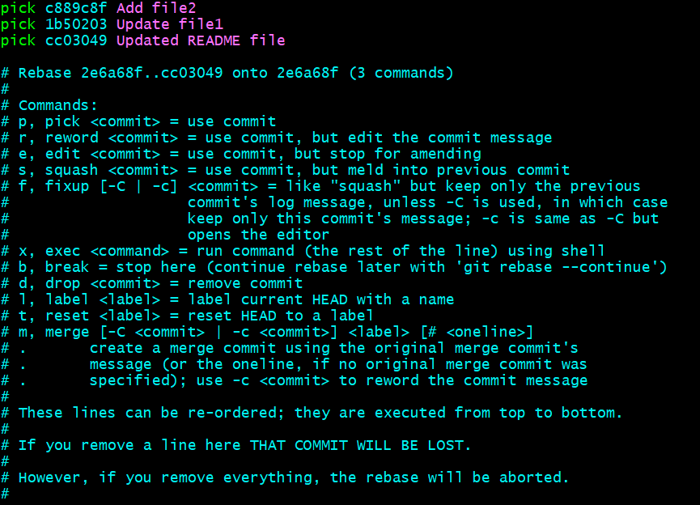

Step 6: Enter the final commit message
Git may open another editor window for the combined commit message. Remove the old messages if needed and enter one message, for example:
git commit --amend -m "Combine project setup and README updates"
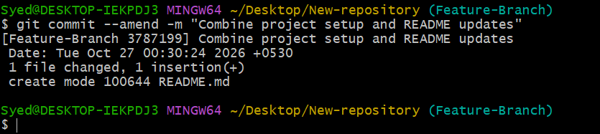
Save and close the editor.
Step 7: Verify the result
Execute the log command to verify:
git log --oneline

You should now see one combined commit in place of the three commits you squashed, along with any older commits that were not included in the rebase.
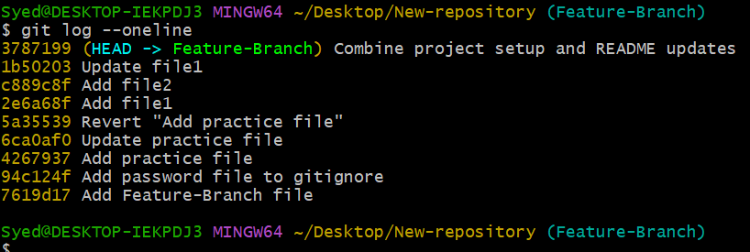
Step 8: Check the repository status
Confirm that your working tree is clean:
git status

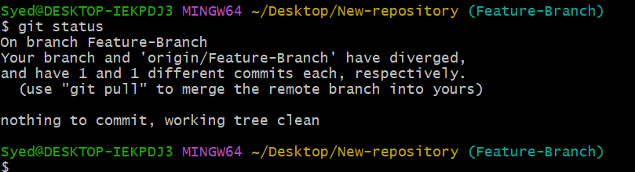
5. Important Notes
- pick: keeps a commit.
- squash: combines a commit with the preceding commit and lets you edit the final message.
- fixup: also combines commits but discards the later commit's message.
- Interactive rebase rewrites commit history. Avoid doing this to shared commits that other people depend on unless the team agrees.
- If you have already pushed these commits to a remote repository, updating the remote may require a carefully coordinated git push --force-with-lease.

7. Expected Result
Multiple commits are combined into a single commit, making the Git history cleaner and easier to read.

