Task 1: Create a GitHub Repository with README.md and .gitignore

Outcome
A GitHub repository is created successfully with README.md and .gitignore files.

Objective
To create a repository on GitHub to store project files, track code changes, and collaborate with other developers.

Prerequisites
- GitHub account
- Internet connection
- Web browser
- Git installed (if using Git Bash)

Step-by-Step Implementation

Step 1: Open GitHub
Navigation path:
Browser → https://github.com/ → Sign in
- Open https://github.com/ in your browser.
- Sign in to your account.
- Click the + icon in the top-right corner.
- Select New repository.

Screenshot Evidence

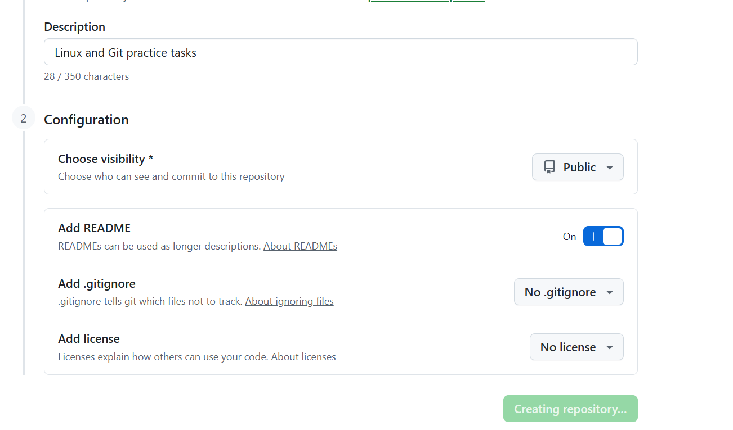Step 2: Configure the Repository
Enter the following values:
Parameter | Value
Repository name | linux-practice
Description | Linux and Git practice tasks
Visibility | Public (or as required)
Add README | Checked
Add .gitignore | None; create manually in Step 4
Click Create repository.

Step 3: Verify README.md
After creating the repository, GitHub automatically creates README.md when the Add README option is selected.
Example README.md content:
# Linux Practice
## Objective
Practice Linux commands and Git operations.
## Topics
- Linux commands
- Bash scripting
- Git and GitHub
Open README.md. If you want to edit it, click the pencil icon, make changes, and commit them.

Screenshot Evidence

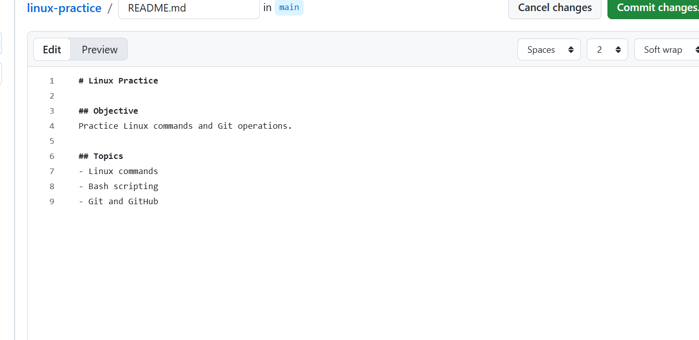Step 4: Create the .gitignore File
Navigation path:
Repository → Add file → Create new file
- Click Add file.
- Select Create new file.
- Enter the filename exactly as .gitignore.
- Add the example content below.
- Click Commit changes.
Example .gitignore content:
# Temporary files
*.tmp
*.log
# Environment files
.env
# Backup files
*.bak

Screenshot Evidence
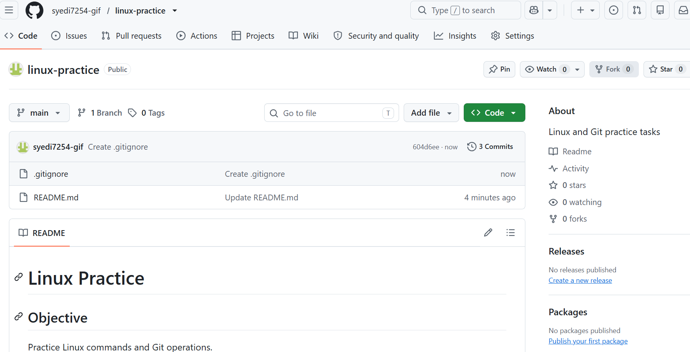

Step 5: Verify the Repository
The repository homepage should display both files:
- README.md
- .gitignore

Validation Screenshot

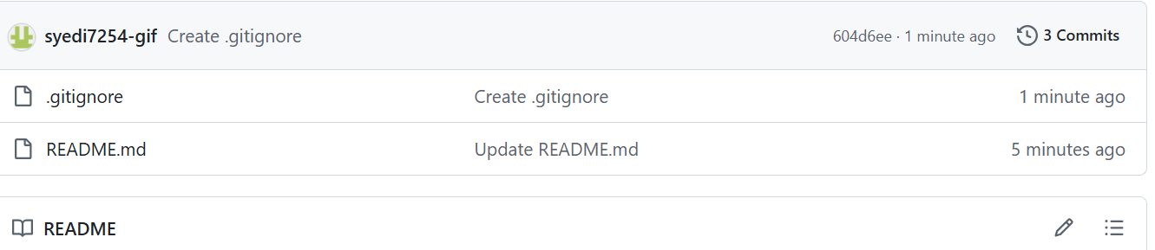Validation Steps
☐ Confirm that the repository exists.
☐ Confirm that README.md is present.
☐ Confirm that .gitignore is present.
☐ Confirm that both files are committed.

Explanation
A GitHub repository stores project files and tracks changes using Git. The README.md file explains the purpose of the project, while .gitignore specifies which untracked files Git should ignore, such as temporary files, logs, and environment configuration files.
Note: The standard filename is .gitignore, not .ignore.

Real-Time Use Case
DevOps engineers use GitHub repositories to store Bash scripts, automation code, deployment configurations, and project documentation. The README helps team members understand the project, and .gitignore helps prevent unnecessary files from being committed.

Common Errors and Troubleshooting
Error | Cause | Resolution
Repository name already exists | Name is already in use under the selected owner | Choose another name
README missing | README option was not selected | Create README.md manually
.gitignore missing | File was not created or committed | Create and commit .gitignore
Permission denied | Incorrect account or insufficient access | Sign in to the correct account
Sensitive file committed | File was already tracked by Git | Remove it from tracking and rotate exposed credentials

Final Result
The repository should contain README.md and .gitignore.
Repository URL example: https://github.com/YOUR-USERNAME/linux-practice
Replace YOUR-USERNAME with your GitHub username. Take screenshots of the major steps and attach them to your assignment document as evidence.

