Task 1: Clone the Created Repository to Local Using Git Bash

Outcome
Clone a repository from GitHub to your local computer using Git Bash.

Objective
To download the project files from a GitHub repository and access them locally.

Prerequisites
- A GitHub repository that you can access.
- Git installed on your computer.
- Git Bash available on your Windows computer.
- The repository URL copied from GitHub.

Step-by-Step Implementation

Step 1: Open Git Bash
Open Git Bash on your Windows computer.

Step 2: Navigate to the destination folder
To clone the repository onto your Desktop, run:
cd ~/Desktop
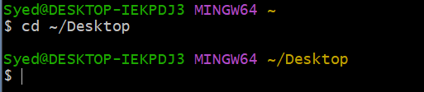

Step 3: Copy the repository URL
- Open your repository on GitHub.
- Click the green Code button.
- Select HTTPS.
- Copy the repository URL.
Example URL: https://github.com/username/my-project.git

Step 4: Clone the repository
Run the command below. Replace the example URL with your actual repository URL.
git clone https://github.com/username/my-project.git
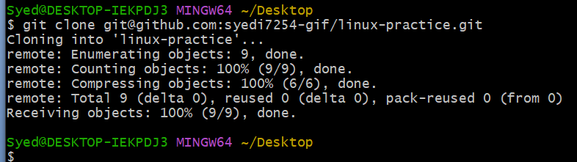

Step 5: Enter the cloned repository folder
Replace my-project with the actual folder name created by Git.
cd linux-practice
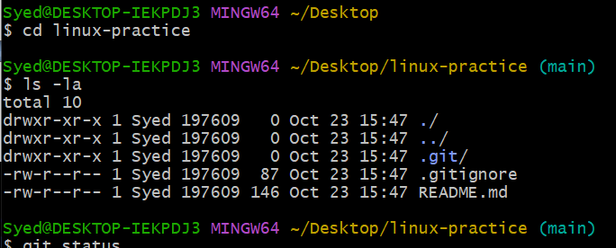

Step 6: Verify the repository
List the files and folders:
ls
Check the Git repository status:
git status
Example output (your branch name or status may differ):
On branch main
Your branch is up to date with 'origin/main'.
nothing to commit, working tree clean
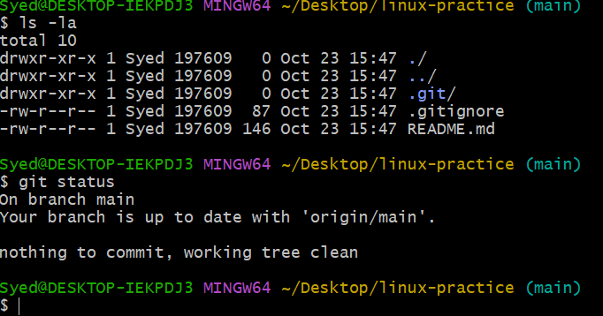

Important Commands
Command | Purpose
pwd | Show the current directory.
git clone URL | Clone the repository from GitHub.
cd folder-name | Enter the repository folder.
ls | List files and folders.
git status | Check the repository status.

Screenshot Evidence (Mandatory)
Capture screenshots of the following major steps and add them to your assignment document:
- Git Bash opened on your computer.
- The git clone command and successful cloning output.
- The cd command showing that you entered the cloned folder.
- The ls output showing the downloaded project files.
- The git status output confirming the repository status.

Result
The GitHub repository is cloned to the local computer and is ready for use.
Note: Replace all example URLs and folder names with the actual details of your repository.

