Task 5: Commit Two Files and Push to Central Repository

Outcome
Successfully commit two files to the local Git repository and push them to the central GitHub repository.

1. Objective
To learn how to stage two files, commit them with a message, and push the commit from the local repository to GitHub.

2. Prerequisites
- Git installed on your computer.
- A GitHub account.
- A repository created on GitHub.
- Repository cloned to your local computer.
- Two files created in the local repository.

3. Step-by-Step Implementation

Step 1: Open Git Bash
Open Git Bash and navigate to your cloned repository folder.
cd ~/Desktop/linux-practice
Replace my-project with your actual repository folder name.
pwd

Step 2: Create Two Files
Create two sample files:
echo "This is file one" > file1.txt
echo "This is file two" > file2.txt
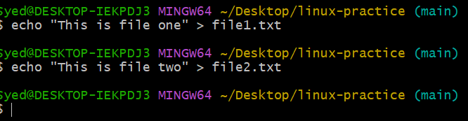
Verify that both files exist:
ls
Expected output: file1.txt and file2.txt should appear in the listing.

Step 3: Check Git Status
git status
You should see both files listed as untracked files.

Step 4: Stage Two Files
Add both files to the staging area:
git add file1.txt file2.txt
Verify the staged files:
git status
Both files should appear under “Changes to be committed”.
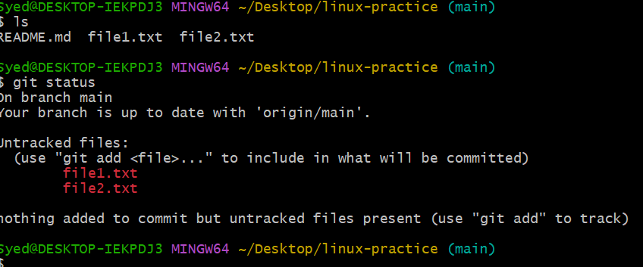

Step 5: Commit Two Files
Commit the staged files with a message:
git commit -m "Add two files"
Expected result: Git creates a commit containing the two files.
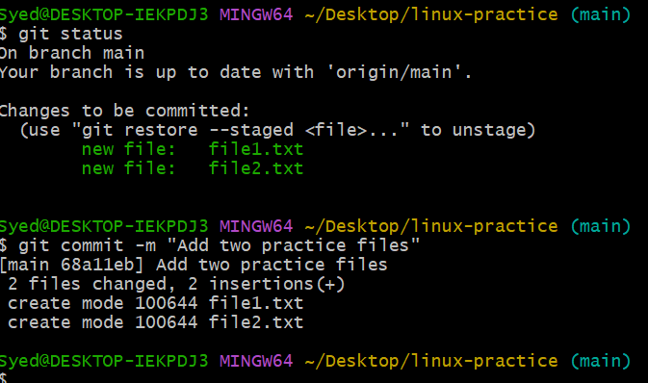

Step 6: Push to the Central Repository
Push the commit to GitHub:
git push origin main
If your branch is named master instead of main, use:
git push origin master
If Git requests authentication, follow the GitHub authentication prompt.
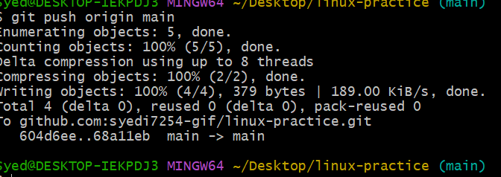
Step 7: Verify the Push
git status
Expected output should indicate that your branch is up to date with the remote repository and the working tree is clean.
Open your GitHub repository in your browser and refresh the page. Verify that file1.txt and file2.txt are visible.
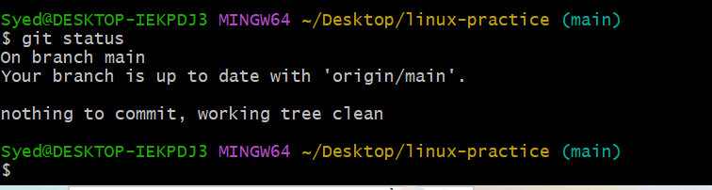

4. Complete Command Summary
Run these commands in Git Bash from inside your repository:
echo "This is file one" > file1.txt
echo "This is file two" > file2.txt
git status
git add file1.txt file2.txt
git status
git commit -m "Add two files"
git push origin main
git status

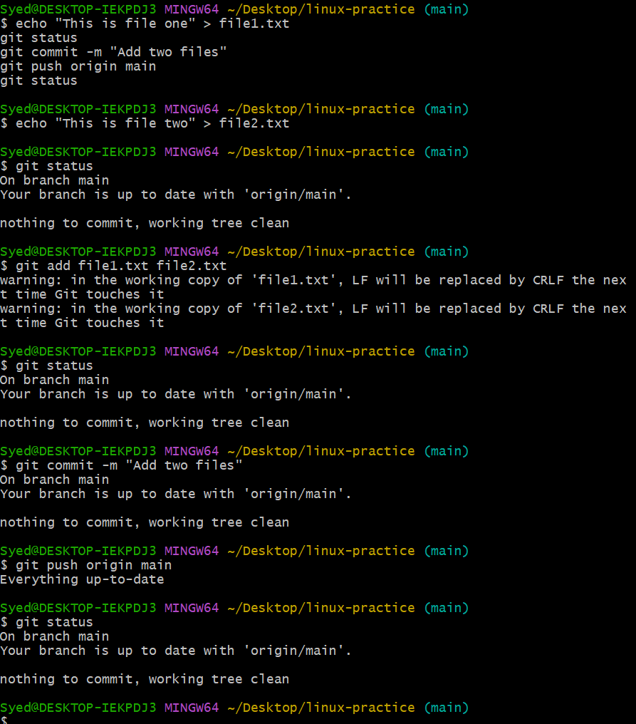

Final Result
Both files are committed to your local Git repository and pushed to the central GitHub repository.

