ASK 6: CREATE A GIT BRANCH AND PUSH TO GITHUB
Create a sample file, commit the changes, and push the branch to the central repository

Outcome
Create a new branch in the local Git repository, add a sample file, commit the changes, push the branch to GitHub, and verify that the branch is available in the central repository.

1. Objective
- Create a new branch locally.
- Create a sample file in the branch.
- Add and commit the file.
- Push the new branch to GitHub.
- Verify that the branch is available in the central repository.

2. Prerequisites
- Git installed on your computer.
- A GitHub repository already created.
- Repository cloned to your local computer.
- GitHub authentication configured.

3. Step-by-Step Implementation

Step 1: Open Git Bash and navigate to the repository
cd ~/Desktop/linux-practice
Check the files and current branch:
ls
git branch

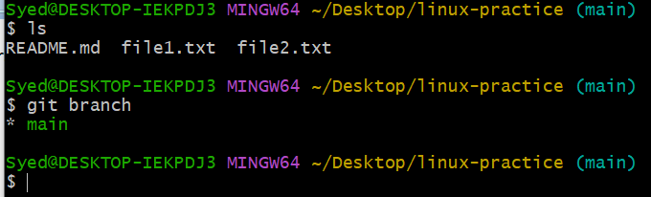

Step 2: Create a new branch
Create a branch named task6-branch and switch to it:
git branch task6-branch
git checkout task6-branch
Alternatively, create and switch to the branch in one command:
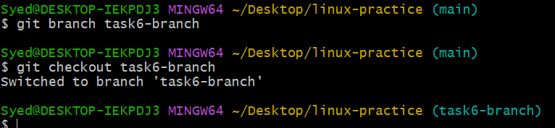
task6-branch
Verify the current branch:
git branch
The output should show task6-branch with an asterisk (*) beside it.
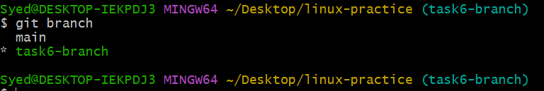

Step 3: Create a sample file
Create sample.txt and add the sample content:
touch sample.txt
echo "This is my Task 6 sample file" > sample.txt
Verify the file content:
cat sample.txt
Expected output:
This is my Task 6 sample file

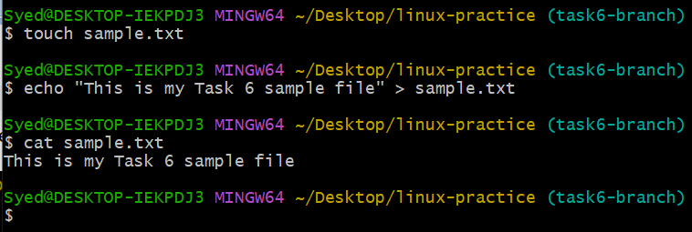

Step 4: Check the Git status
git status
The output should show sample.txt as an untracked file.

Step 5: Add the file to Git
git add sample.txt
git status
The file should now appear under changes to be committed.
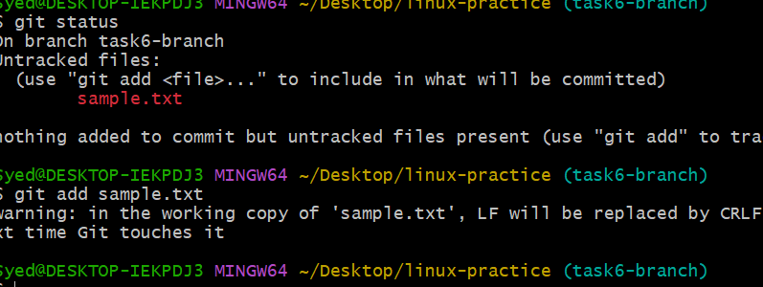

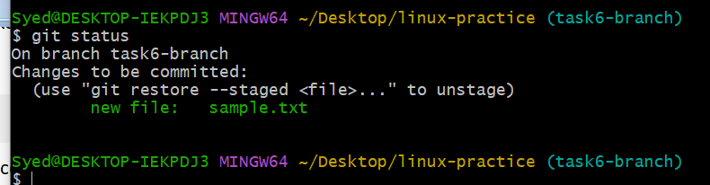

Step 6: Commit the file
git commit -m "Add sample file in task6 branch"
This saves the file changes in your local Git repository.
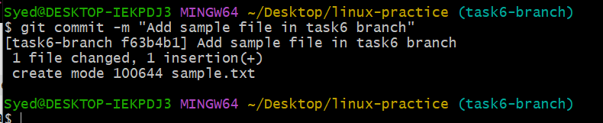

Step 7: Push the branch to the central repository
git push -u origin task6-branch
This uploads the new branch and its committed file to GitHub.
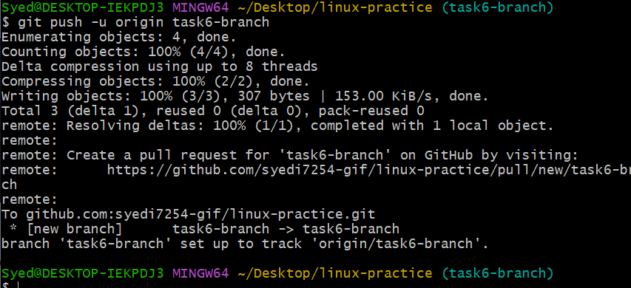

Step 8: Verify the branch
Check your local branches and remote branches:
git branch
git branch -r
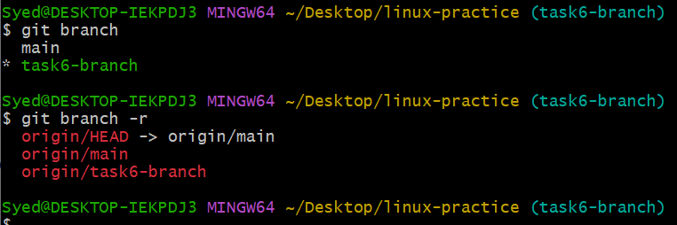
Open your GitHub repository in a browser and refresh the page. Select the task6-branch branch and verify that sample.txt is present.
Expected result: A new branch named task6-branch exists locally and on GitHub, containing the committed sample.txt file. If the branch already exists locally, use git checkout task6-branch instead of creating it again.

