Task 7: Create a Branch in GitHub and Clone It to Local

Outcome
A new branch is created in a GitHub repository, and the repository is cloned to the local computer. The student verifies that the local repository is connected to GitHub and that the newly created branch is available locally.

Objective
To understand Git branching and repository cloning. Branches allow developers to work on new features, bug fixes, and experiments without directly modifying the main branch. Cloning creates a local copy of a remote GitHub repository so developers can work on the project from their computers.

Prerequisites
- A GitHub account.
- An existing GitHub repository, or permission to create one.
- Git installed on the local computer.
- Internet connectivity.
- A terminal, Command Prompt, PowerShell, or Git Bash.
- Git configured with a username and email address (recommended).

Step-by-Step Implementation

Step 1: Open GitHub
Navigation path:
Open Browser → https://github.com → Sign in → Open Your Repository
- Log in to your GitHub account.
2. Select an existing repository.
3. If no repository exists, create one using New repository and complete the required details

Screenshot Evidence

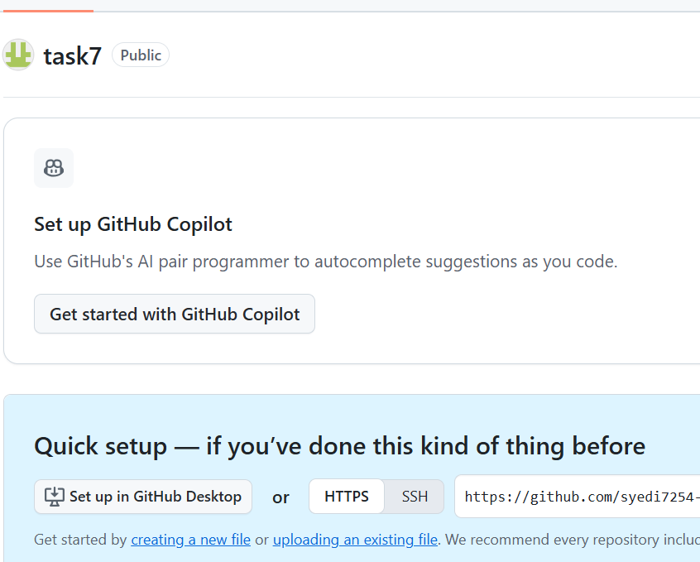

Step 2: Create a New Branch in GitHub
Navigation path:
GitHub Repository → Code → Branch Selector → Type New Branch Name → Create Branch
- Open the repository’s Code tab.
2. Click the branch selector, usually displaying main.
3. Type the new branch name, for example, feature-task7.
4. Select the option to create a branch with that name from main.
- 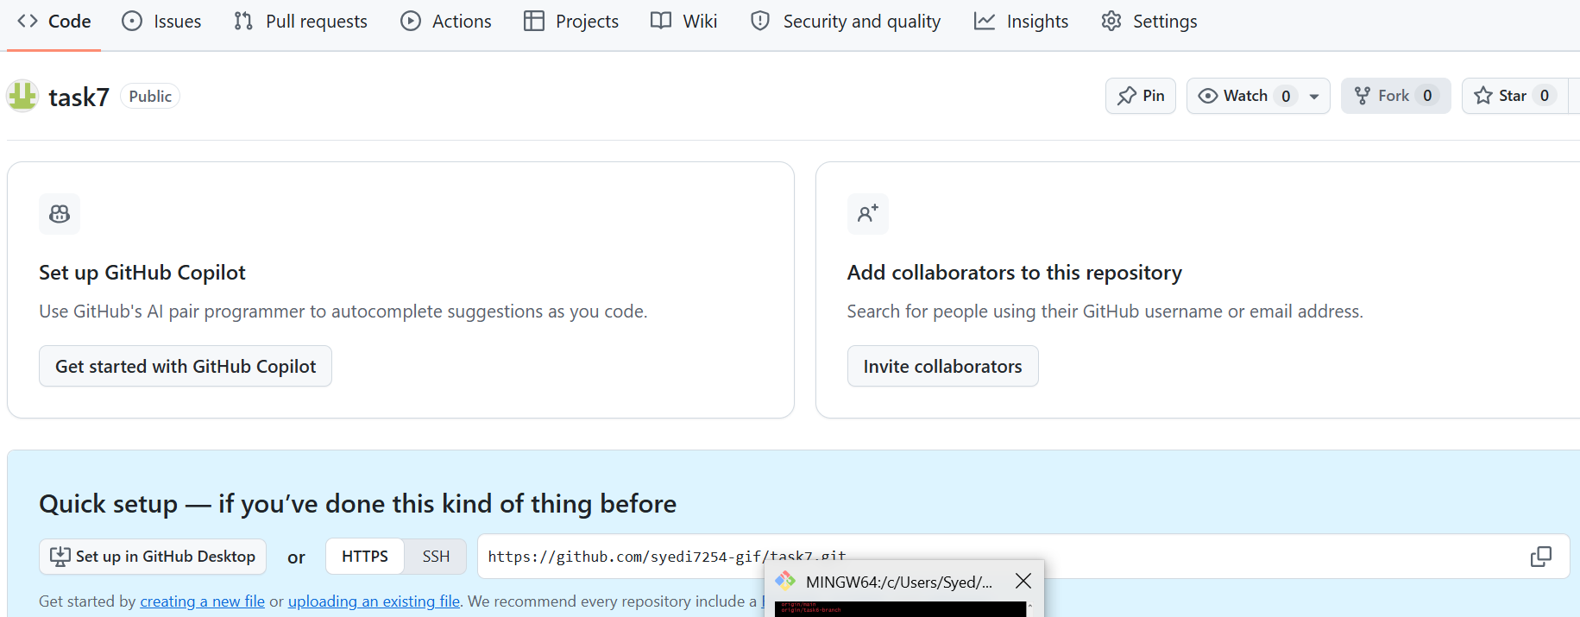
Configuration table:
Parameter | Value
Repository | Your existing GitHub repository
Base branch | main
New branch name | feature-task7
Visibility | Same as the repository

If the repository uses master or another default branch, select the appropriate base branch instead of main.

Screenshot Evidence

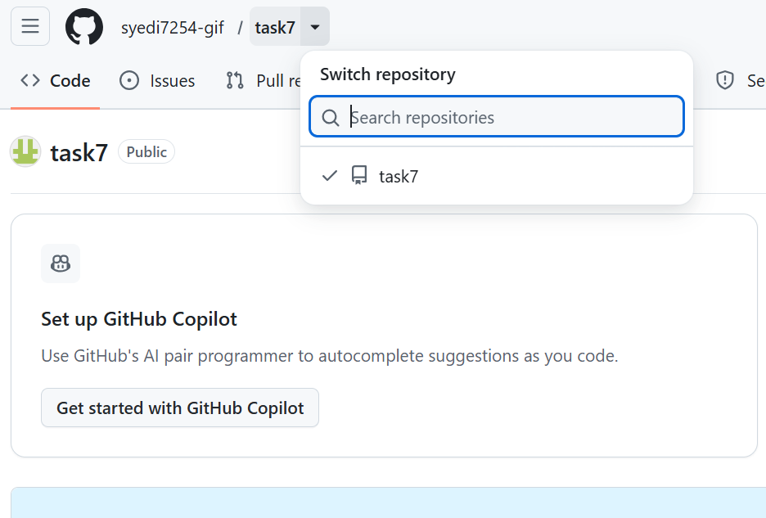

Step 3: Verify the Branch in GitHub
1. Open the branch selector again.
2. Search for feature-task7.
3. Confirm that the new branch appears in the branch list.
Expected result:
Branch name: feature-task7
Status: Successfully created in GitHub

Screenshot Evidence

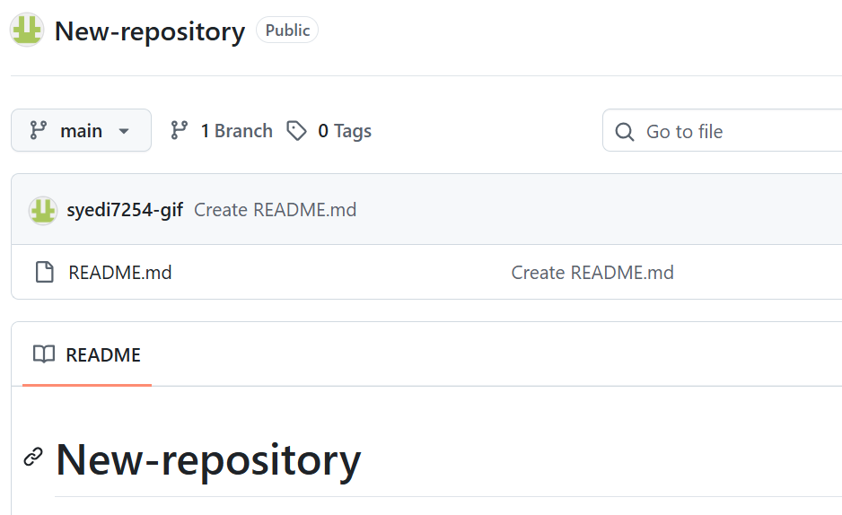Step 4: Copy the Repository Clone URL
Navigation path:
GitHub Repository → Code → Local → HTTPS → Copy URL
1. Click the green Code button.
2. Select the Local or HTTPS option, depending on the interface.
3. Copy the repository URL.
Example URL:
https://github.com/USERNAME/REPOSITORY.git
Replace USERNAME and REPOSITORY with the actual GitHub username and repository name.

Screenshot Evidence
[Insert screenshot: Code dropdown showing the HTTPS clone URL. Do not expose credentials or tokens.]

Step 5: Open the Local Terminal
Open Command Prompt, PowerShell, or Git Bash. Navigate to the directory where you want to store the project.
cd Documents
Check whether Git is installed:
git --version
Expected output example:
git version 2.x.x
The exact version will depend on the installed Git release.

Step 6: Clone the GitHub Repository to the Local Computer
Run the following command, replacing the example URL with your copied repository URL.
git clone https://github.com/USERNAME/REPOSITORY.git
Wait for the cloning process to finish.
Example output:
Cloning into 'REPOSITORY'...
remote: Enumerating objects...
Receiving objects: 100% ...
Resolving deltas: 100% ...
The git clone command downloads the repository’s files and Git history to your local computer and configures the remote repository connection.

Screenshot Evidence

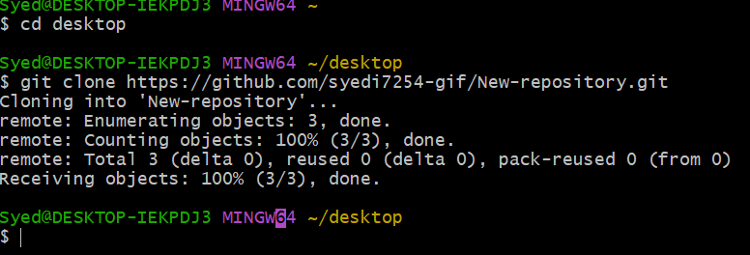

Step 7: Enter the Cloned Repository
Navigate to the cloned directory:
cd New-repository
Replace New-repository with the actual directory name created during cloning.
Verify the current branch:
git branch
The output may look like this:
* main
Important: Cloning a repository normally checks out its default branch, not necessarily the new branch you created. Switch to main if you want to work on that branch locally.

Screenshot Evidence
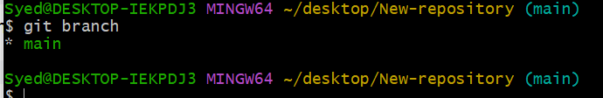

Step 8: Fetch and Switch to the Newly Created Branch
Run the following commands inside the cloned repository:
git fetch origin
git push -u origin main

The second command creates a local branch named feature-task7 that tracks the remote branch.
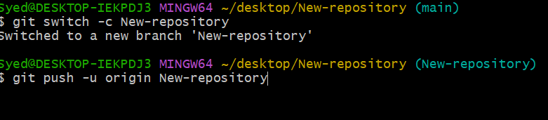
If the local branch already exists, use:
git switch New-repository
Expected result:
Switched to a new branch /New-repository
The exact output may vary by Git version.

Screenshot Evidence

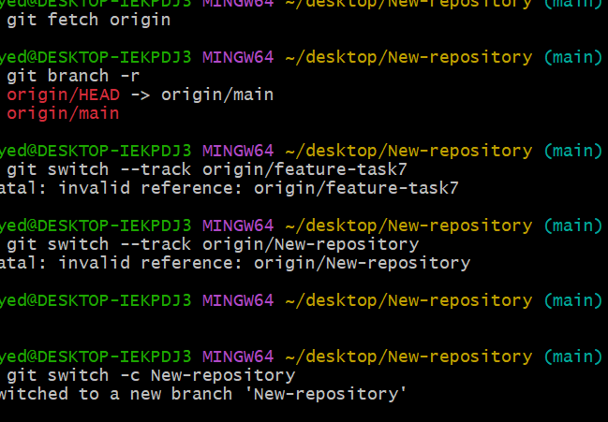Step 9: Verify the Local Repository and Remote Connection
Execute the following commands:
git status
git branch
git remote -v
Expected results:
Command | Expected verification
git status | Shows that you are on feature-task7 and reports working-tree status
git branch | Displays * feature-task7
git remote -v | Displays the GitHub repository URL for origin

Example output:
On branch feature-task7
Your branch is up to date with 'origin/feature-task7'.
nothing to commit, working tree clean
The status message can differ if you have uncommitted changes or new commits.

Screenshot Evidence
[Insert screenshot: Terminal showing all three verification commands and their outputs.]

Validation Steps
Confirm each of the following:
☐ The new branch feature-task7 exists in GitHub.
☐ The repository was cloned successfully to the local computer.
☐ The local branch feature-task7 is checked out.
☐ The origin remote points to the correct GitHub repository.
☐ git status reports the expected branch.
Validation command:
git status
Expected result:
On branch /New-repository

Validation Screenshot
[Insert screenshot: Final terminal output showing On branch feature-task7 and the working-tree status.]

Explanation
GitHub is a hosting platform for Git repositories, while Git is the version control system used to manage changes to project files. A branch is an independent line of development that lets developers make changes without directly affecting the main branch. In this task, the feature-task7 branch is created in the remote GitHub repository.
The git clone command downloads a local copy of the repository, including its commit history, and configures the remote named origin. The git fetch origin command retrieves information about remote branches, and git switch --track origin/feature-task7 creates and checks out a local branch that tracks the remote branch. This workflow prepares the student to develop, test, and collaborate on changes using Git.

Real-Time Use Case
Software development teams use branches to develop new application features, fix bugs, and test changes independently. For example, a developer can create a branch called payment-integration, clone the project to a local computer, implement a payment feature, and push the completed changes to GitHub for review through a pull request. This approach supports teamwork, code review, and safer software releases.

Common Errors and Troubleshooting
Error | Possible cause | Resolution
git is not recognized | Git is not installed or is missing from PATH | Install Git and reopen the terminal
Repository not found | Incorrect URL or insufficient repository permissions | Verify the URL and GitHub access
destination path already exists | A folder with the repository name already exists | Choose another directory or inspect the existing clone
Remote branch not found | The branch name is incorrect or the branch was not created remotely | Verify the branch name in GitHub and run git fetch origin
pathspec did not match any files | The local branch does not exist or the branch name is incorrect | Run git fetch origin, then check git branch -r
Authentication failed | Credentials or authentication configuration are incorrect | Use an approved HTTPS authentication method or configure SSH
Your branch is behind | The local branch has not incorporated newer remote commits | Run git pull after confirming the correct branch

Final Result
A GitHub branch named feature-task7 has been created, the repository has been cloned to the local computer, and the local branch has been switched to and verified against the remote branch.

Submission Checklist
Include screenshots for all major steps, the final validation screenshot, and the actual repository URL (if permitted by your instructor). Use your own GitHub repository and terminal screenshots as evidence; illustrative images are only references and do not replace mandatory screenshots.

