Task 8: Merge the Created Branch with Master in Git Local

Outcome
The changes from the created branch are successfully merged into the local master branch (or main, depending on the repository’s default branch), and the merged content is verified.

Objective
To understand how to integrate changes from a feature branch into the main development branch using Git. Merging helps combine code changes, maintain project history, and prepare completed work for further development.

Prerequisites
- Git installed on the local system.
- A local Git repository initialized or cloned from GitHub.
- A source branch containing at least one commit to merge.
- A target branch named master or main.
- Access to the repository through Git Bash or a terminal.

Step-by-Step Implementation

Step 1: Open Git Bash and Navigate to the Repository
Open Git Bash and move to your local repository directory.
cd ~/desktop/New-repository
Check the current repository location and status:
pwd
git status
Screenshot Evidence: Capture Git Bash showing the repository path and the output of git status.

Step 2: Check the Available Branches
List all local branches:
git branch
List local and remote-tracking branches:
git branch -a
Example output:
* main
feature-task8
remotes/origin/main
In this example, feature-task8 is the branch containing the changes to merge. Your actual branch names may differ.
Screenshot Evidence
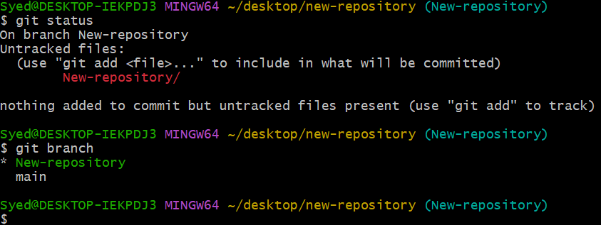

Step 3: Switch to the Source Branch
Switch to the branch that contains the changes you want to merge.
git switch feature-task8
Replace feature-task8 with the actual name of your created branch.
Verify the branch:
git branch
The asterisk (*) should appear next to feature-task8.
Screenshot Evidence:
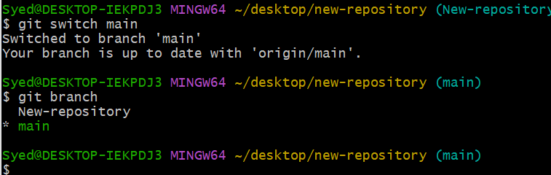

Step 4: Verify and Commit the Changes
Check whether the source branch has any uncommitted changes.
git status
If you have files to include in the merge, stage and commit them:
git add .
git commit -m "Add Task 8 changes"
If Git reports that there is nothing to commit, continue to the next step.
Screenshot Evidence.
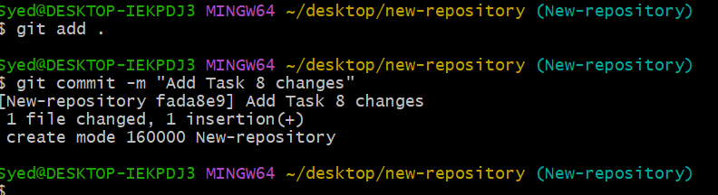

Step 5: Switch to the Master Branch
Switch to the target branch.
git switch master
If your repository uses main instead of master, execute:
git switch main
Verify the active branch:
git branch
Screenshot Evidence
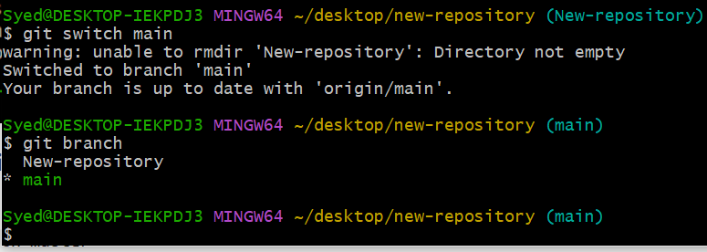

Step 6: Merge the Created Branch
Run the appropriate command for your source branch:
git merge feature-task8
The command is the same when the target branch is main, because you have already switched to main.
Example successful output:
Updating abc1234..def5678
Fast-forward
task8.txt | 1 +
1 file changed, 1 insertion(+)
The exact output depends on your repository and commit history.
Screenshot Evidence:
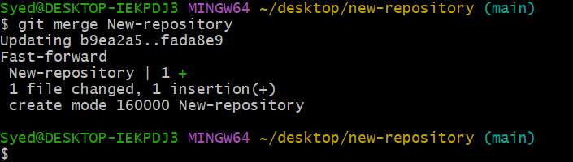

Step 7: Verify the Merge
Check the repository status:
git status
Review the commit history:
git log --oneline --graph --all
List the files to confirm the merged content is present:
git ls-files
If the merge completed successfully, the target branch should contain the changes from the source branch.
Screenshot Evidence:
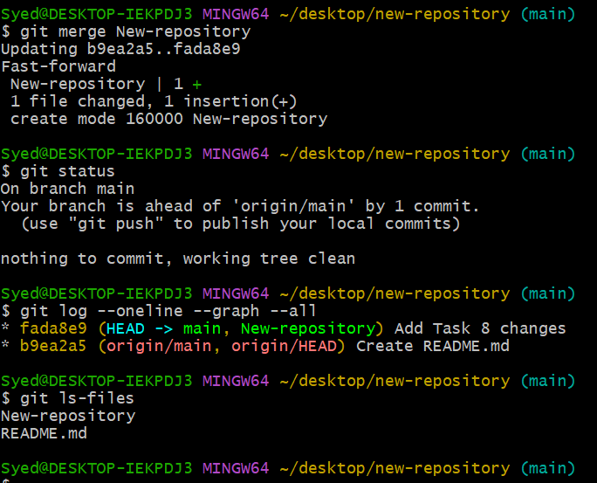

Validation Steps
Verify the following:
- The target branch (master or main) is active.
- The merge command completed successfully.
- The expected files or changes are present.
- The working tree is clean, unless you intentionally have additional uncommitted changes.
Example validation commands:
git switch master
git merge feature-task8
git status
git log --oneline --graph -5
If you already merged the branch, you do not need to repeat the merge command. Use the status and log commands to validate the result.
Validation Screenshot: Capture the terminal showing the target branch, the merged commit history, and the final status.

Explanation
Git merging combines the changes from one branch into another. In this task, the created feature branch is merged into the local master or main branch. This allows completed work to become part of the main development line without manually copying files between branches.
The git merge command preserves the repository’s version history. Depending on the commit history, Git may perform a fast-forward merge or create a merge commit. If conflicting changes exist in the same part of a file, Git may pause the merge and require manual conflict resolution.

Real-Time Use Case
In software development, developers often create separate feature branches to build new features or fix bugs. After completing and testing their work, they merge those branches into the main development branch. This approach supports collaboration, organized development, and controlled integration of code changes.

Common Errors and Troubleshooting
Error | Cause | Resolution
error: pathspec ... did not match any file(s) known to git | Branch name is incorrect or the branch does not exist locally. | Run git branch -a and verify the exact name.
Already up to date. | The target branch already contains the source branch’s commits. | Check git log --oneline --graph --all to verify.
Your local changes would be overwritten | Uncommitted changes conflict with the branch switch. | Commit the changes or safely stash them before switching.
CONFLICT (content) | Both branches modified overlapping parts of a file. | Edit conflicted files, resolve conflict markers, stage the files, and run git commit to complete the merge.
fatal: refusing to merge unrelated histories | The branches have unrelated repository histories. | Verify that the correct repositories and branches are being used before considering any special merge option.

Final Result
The created branch has been merged into the local master or main branch, and the merged changes have been verified using Git commands.
Important: If your actual repository uses main, use main throughout the task instead of master. Branch names are case-sensitive.

