Task 9: Merge the Created Branch with Master in GitHub Using a Pull Request

Outcome
The feature branch is merged into the master branch on GitHub after creating, reviewing, and merging a pull request. The changes from the feature branch become part of the main project.

Objective
To understand how to merge changes from a feature branch into the main branch using a GitHub pull request. Pull requests enable developers to review code, discuss modifications, identify issues, and safely integrate changes into a shared repository.

Prerequisites
- A GitHub account.
- An existing GitHub repository.
- A feature branch containing committed changes.
- Permission to create pull requests and merge branches.
- The target branch (master) must exist in the repository.

Step-by-Step Implementation

Step 1: Open the GitHub Repository
- Log in to your GitHub account.
- Navigate to the repository containing your feature branch.
- Open the repository's main page.
Navigation path:
GitHub → Your Repositories → Select Your Repository

Screenshot Evidence

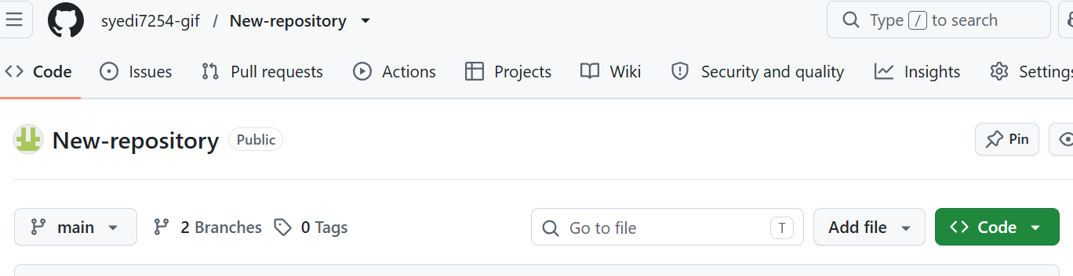Step 2: Select the Feature Branch
- Click the branch dropdown menu.
- Select the feature branch that contains your committed changes, for example, feature-task9.
- Confirm that the expected files and commits are present.
Navigation path:
Repository → Branches → Select Your Feature Branch

Screenshot Evidence

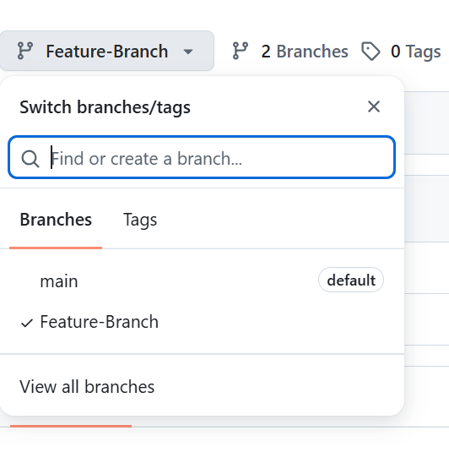Step 3: Open a Pull Request
- Click the Pull requests tab.
- Click New pull request.
- Configure the source and destination branches.
Configuration:
Parameter | Value
Base repository | Your GitHub repository
Base branch | master
Compare branch | feature-task9 (your feature branch)
Pull request title | Merge feature-task9 into master
Description | Merge the changes from the feature branch into master after review.

Important: If your repository uses main instead of master, select main as the base branch. The base is the destination; the compare branch is the source.

Screenshot Evidence

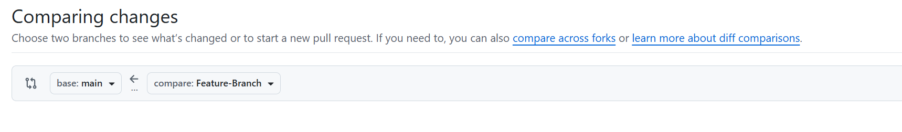Step 4: Create the Pull Request
- Review the changes displayed under the Commits and Files changed sections.
- Enter the title and description from Step 3.
- Click Create pull request.
- Record the pull request number or URL for your assignment.
Navigation path:
Pull requests → New pull request → Review Changes → Create pull request

Screenshot Evidence

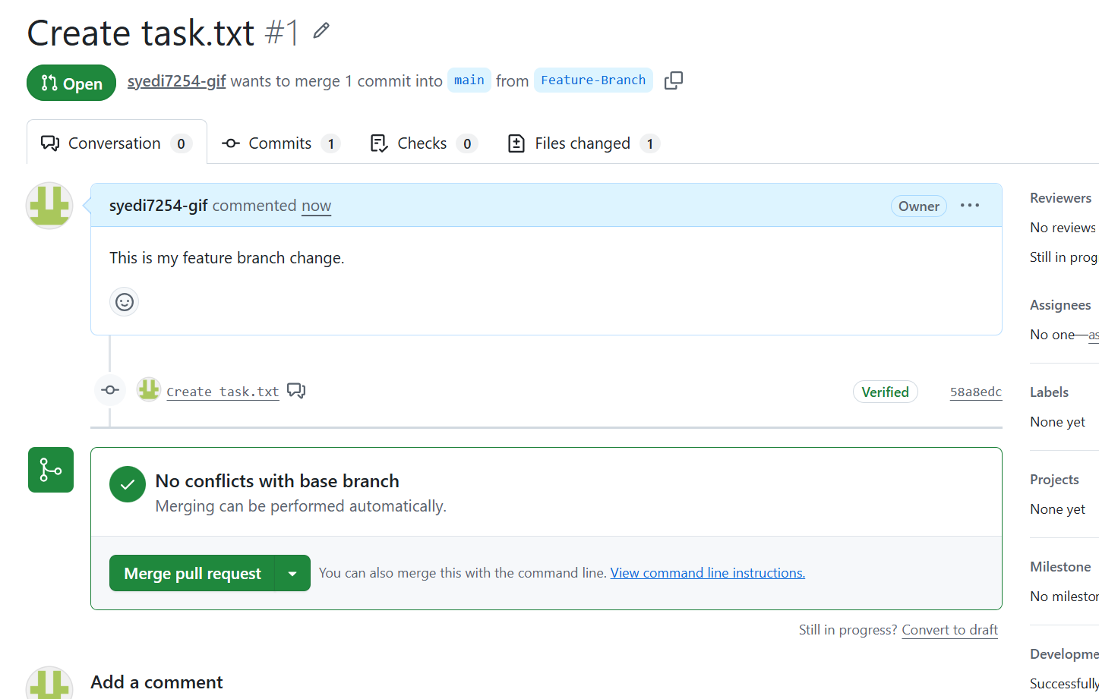Step 5: Review and Merge the Pull Request
- Open the pull request you created.
- Review the changes under Files changed.
- Confirm that required reviews and automated checks have passed.
- Scroll to the bottom of the pull request.
- Click Merge pull request.
- Click Confirm merge to complete the merge.
Navigation path:
Pull requests → Select Your Pull Request → Review Changes → Merge pull request → Confirm merge

Screenshot Evidence

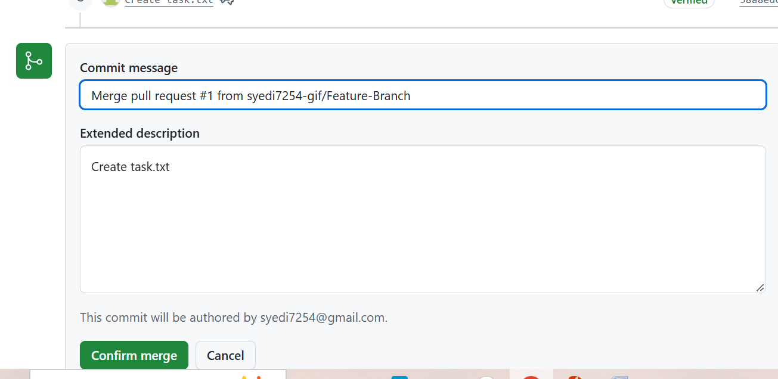Step 6: Verify the Merge
- Navigate to the repository's Code tab.
- Select the task.txt.s
- Check that the files and changes from the feature branch are present.
- Open the Pull requests tab and confirm that the pull request status is Merged.

Screenshot Evidence

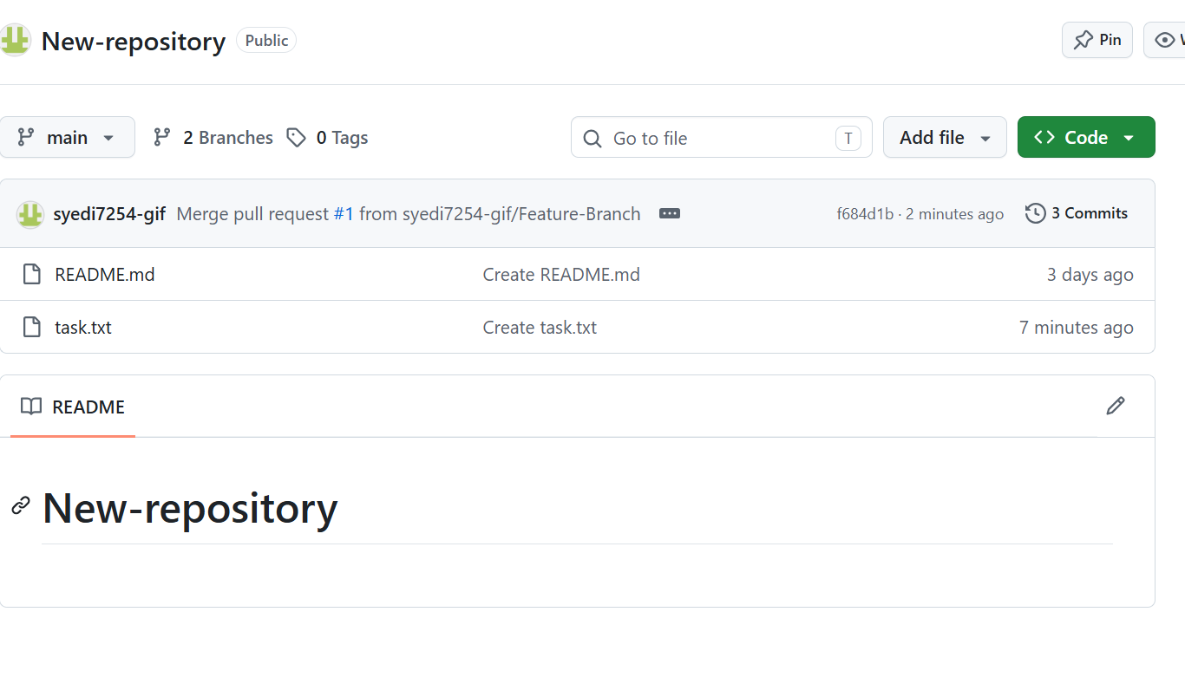Validation Steps
- The pull request was created successfully.
- The base branch was set to master.
- The compare branch was set to the correct feature branch.
- The pull request was successfully merged.
- The changes are visible in the master branch.
- The pull request status displays Merged.
Expected validation result:
Pull request successfully merged.
The feature branch changes are now available in the master branch of the GitHub repository.

Explanation
A pull request is a GitHub feature that allows developers to propose changes from one branch to another. It provides a structured way to review modifications, discuss code, and check for errors before merging changes into the target branch.
In this task, the feature branch is selected as the compare branch, while master is selected as the base branch. After reviewing the changes and confirming the merge, GitHub integrates the feature branch changes into master. This process supports collaboration, code quality, and controlled project development.

Real-Time Use Case
In software development teams, developers commonly create separate feature branches to implement new functionality or fix bugs. They then open pull requests to merge their changes into a shared branch. Team members can review the code, run automated tests, and identify problems before approving the merge. This workflow is widely used in collaborative projects and CI/CD pipelines.

Common Errors and Troubleshooting
Error | Possible Cause | Resolution
No changes to compare | The feature branch has no new commits | Commit and push the required changes
Wrong base branch | main was selected instead of master, or vice versa | Select the intended destination branch
Merge conflicts | Both branches changed the same lines | Resolve conflicts and update the pull request
Merge button unavailable | Required reviews or checks are incomplete | Complete the repository's merge requirements
Permission denied | Insufficient repository permissions | Request the necessary access from the repository owner

Reference
Official GitHub documentation:
Creating a pull request: https://docs.github.com/en/pull-requests/how-tos/create-pull-requests/creating-a-pull-request
Merging a pull request: https://docs.github.com/en/pull-requests/how-tos/merge-and-close-pull-requests/merging-a-pull-request

Assignment Submission Reminder
Insert your actual screenshots under each Screenshot Evidence heading. Make sure the final screenshot shows the pull request as Merged; creating a pull request alone does not complete the merge.

