Task: Undo Wrong Push in Git
Objective: Push an incorrect commit to GitHub, then undo it safely without deleting commit history.
Recommended Method: git revert
It creates a new commit that reverses the changes from the wrong commit, preserving the original commit in the history.

1. Prerequisites
- Git Bash installed on Windows.
- A GitHub repository connected to your local repository.
- Work in your existing New-repository project on Feature-Branch.
2. Step-by-Step Implementation
Step 1: Open your repository
Navigate to your repository and switch to the target feature branch.
cd ~/Desktop/New-repository
git switch Feature-Branch
git status
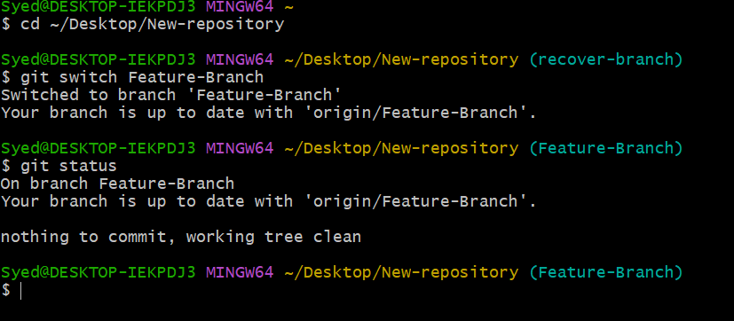
Step 2: Create a wrong commit for practice
Create a sample file representing an incorrect change.
echo "Wrong change for practice" > wrong.txt
git add wrong.txt
git commit -m "Add wrong change"
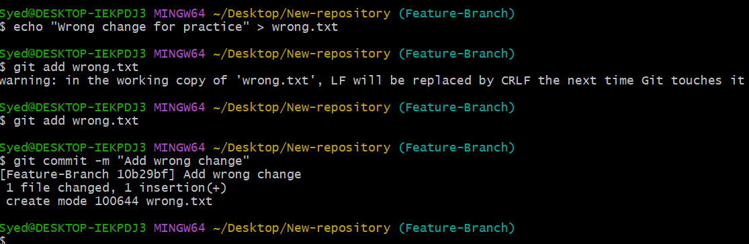
Step 3: Push the wrong commit to GitHub
Push the incorrect commit to the remote branch on GitHub.
git push origin Feature-Branch

Step 4: Check the commit history
Verify the commit history to identify the commit hash.
git log --oneline -5

Example output:
abc1234 Add wrong change
def5678 Previous commit
Note: Your commit IDs will be different. The first entry is the latest commit.
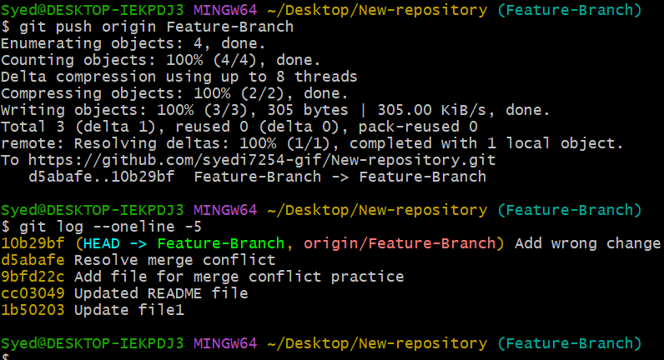
Step 5: Undo the wrong commit without deleting history
Revert the latest commit. Git will open an editor for the revert commit message. Save and close the editor to complete the revert. If Git uses Vim, press Esc, type :wq, and press Enter.
git revert HEAD

Alternative (skip editor):
To use a default revert message without opening the text editor, run:
git revert --no-edit HEAD
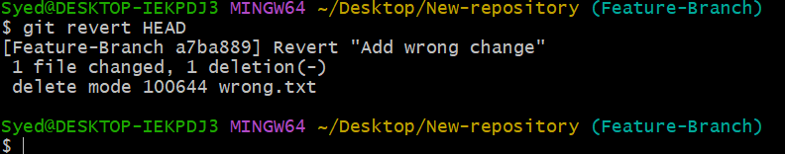
Step 6: Push the revert commit to GitHub
Push the newly created revert commit to update the remote repository.
git push origin Feature-Branch
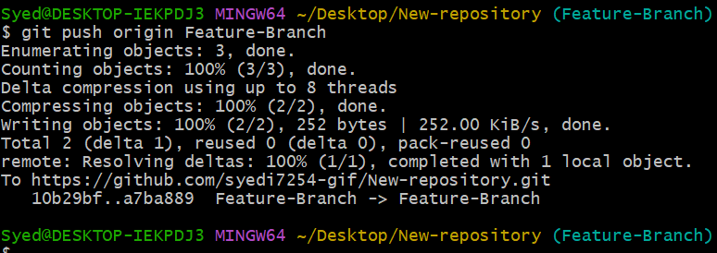
Step 7: Verify the result
Check your commit history and repository status to confirm the revert was successful.
git log --oneline -5
git status

Example output:
789abcd Revert "Add wrong change"
abc1234 Add wrong change
def5678 Previous commit
Outcome: The wrong.txt file should no longer be present in the latest version of the branch, but the original commit remains preserved in the history.
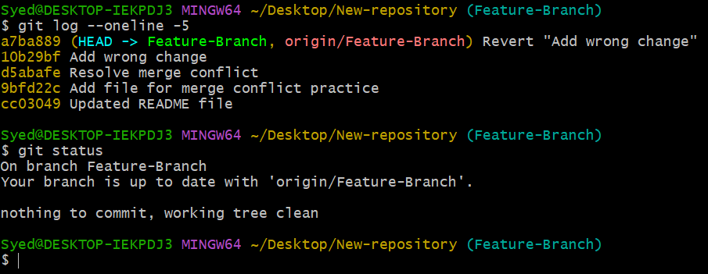
3. Expected Outcome
- The incorrect commit was successfully pushed to GitHub.
- The mistake was safely undone using git revert.
- The original commit history was completely preserved.
- The revert commit was pushed to GitHub to sync remote states.

📌 Best Practice & Safety Tip: For a commit already pushed to a shared branch, always prefer git revert over git reset and force-pushing (git push --force). This preserves shared history, prevents overwriting collaborators' work, and ensures a clean, safe workflow.

